Ministry of Education and Research of the Republic of Moldova
Technical University of Moldova
Faculty of Computers, Informatics and Microelectronics
Department of Software Engineering and Automatics
REPORT
on laboratory work no. 3
Course: Operating Systems
Topic: The Command Line: Shell, Pipes and Text Filters
Done by: st. gr. FAF-242, Olga Saban
Checked by: assist. univ. Patricia Reițman
Chișinău, 2026

1. Purpose of the work
The purpose of this lab is to learn to work faster in the bash shell, to understand what the shell does with a command line before the command runs (globbing, quotes, expansions), to redirect the output of commands to files, and to answer questions about data with small filters (grep, cut, sort, uniq, wc, head, tail, tr) joined by pipes. At the end I also wrote my first shell script.
I worked on Ubuntu Linux in a virtual machine (user vboxuser). Before running every command marked PREDICT I wrote down what I think it will print. When my prediction was wrong, I explain what I understood after running it.

2. The work done

Preparation: the data set
I created the folder ~/os-lab3 and generated the artificial web access log with the for loop from the task. Every line has five fields: date, time, user, result (OK or FAIL) and page. The last command printed 500 access.log, so the file is correct. (I ran the generation block two times, but > rewrites the file each time, so it still has exactly 500 lines.)
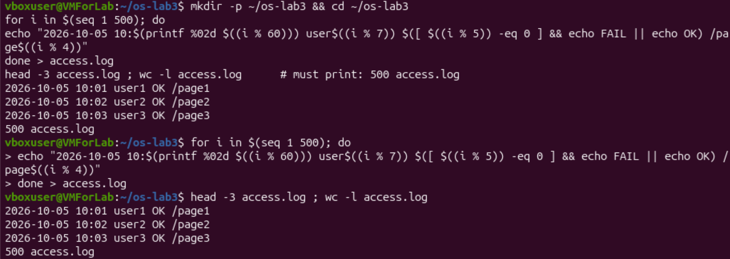
Figure 0.1 – Generating access.log and checking it

Part 1. Move fast, find help

1.1 Tab completion and history
Prediction: I thought Tab only shows a list of all names that start with the letters I typed.
What happened: For ls /usr/sh the first Tab completed the name to /usr/share/, because it is the only directory in /usr that starts with “sh”. The second Tab showed what is inside it. For cd /et one Tab completed the line to cd /etc/. So Tab finishes the name when only one variant is possible, and shows the variants when there are several.
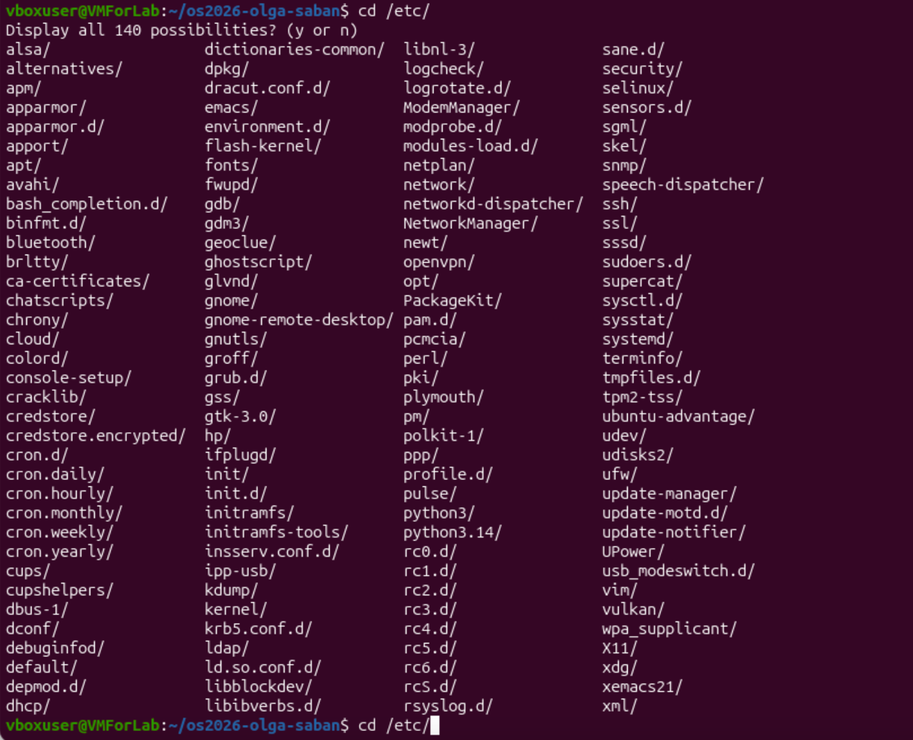
Figure 1.1 – Tab completion
Then I ran three different commands and pressed Ctrl+R. The shell started a “reverse search” in the history: when I typed the first letters of my first command, it showed that command, and Enter ran it again. It is much faster than pressing the up arrow many times.

1.2 Built-in or external command, and PATH
Prediction: I thought that cd, ls and echo are all normal programs stored somewhere on the disk, like /bin/ls. I also thought the PATH has about 5 directories, and that a command which does not exist returns exit code 1.
Real result: See Figures 1.2, 1.3 and 1.4. cd and echo are shell builtins. For ls the shell says it is an alias for ls --color=auto, and which ls shows the real program: /usr/bin/ls. The PATH has 10 lines. The missing command printed “command not found” and the exit code was 127, not 1.
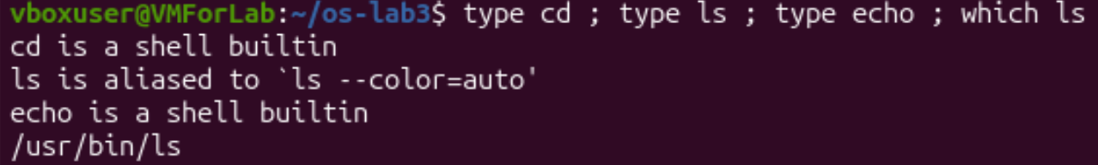
Figure 1.2 – Output of type and which
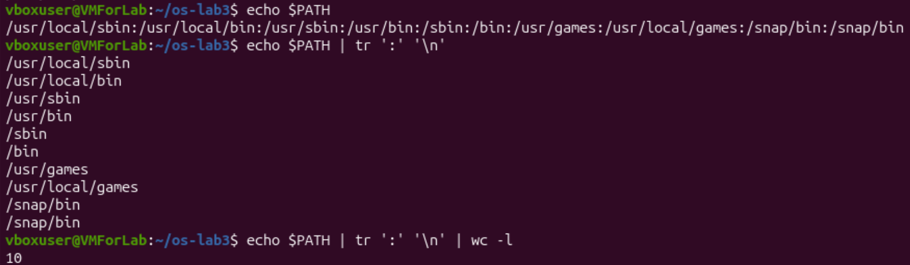
Figure 1.3 – The directories in PATH
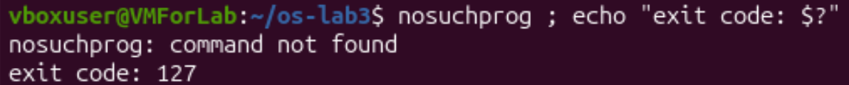
Figure 1.4 – Exit code of a missing command

1.3 Finding help without a browser
I opened man ls (Figure 1.5) and searched inside it with /sort and n (Figure 1.6). Then I ran ls --help | head, man -k "list directory" (Figure 1.7) and help cd (Figure 1.8). man -k searches the short descriptions of all manual pages. In its result I also saw rust-ls and rust-dir, so I think my Ubuntu has a Rust version of these tools. For this lab it behaves the same.
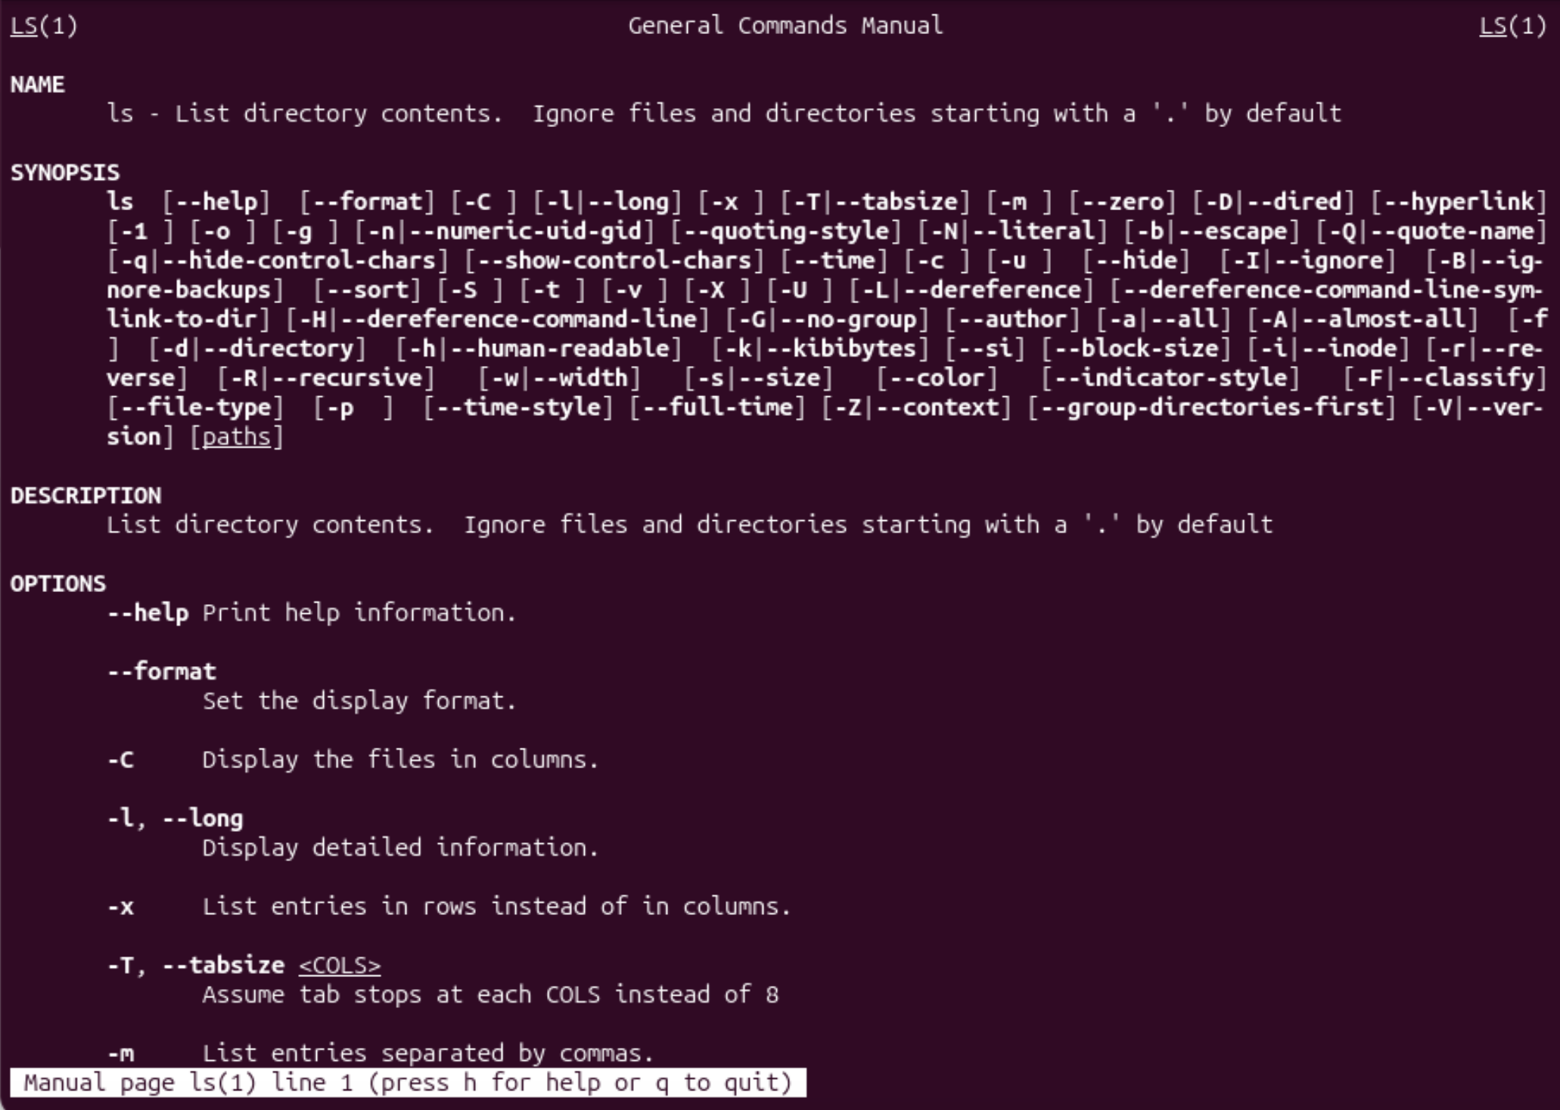
Figure 1.5 – The manual page of ls
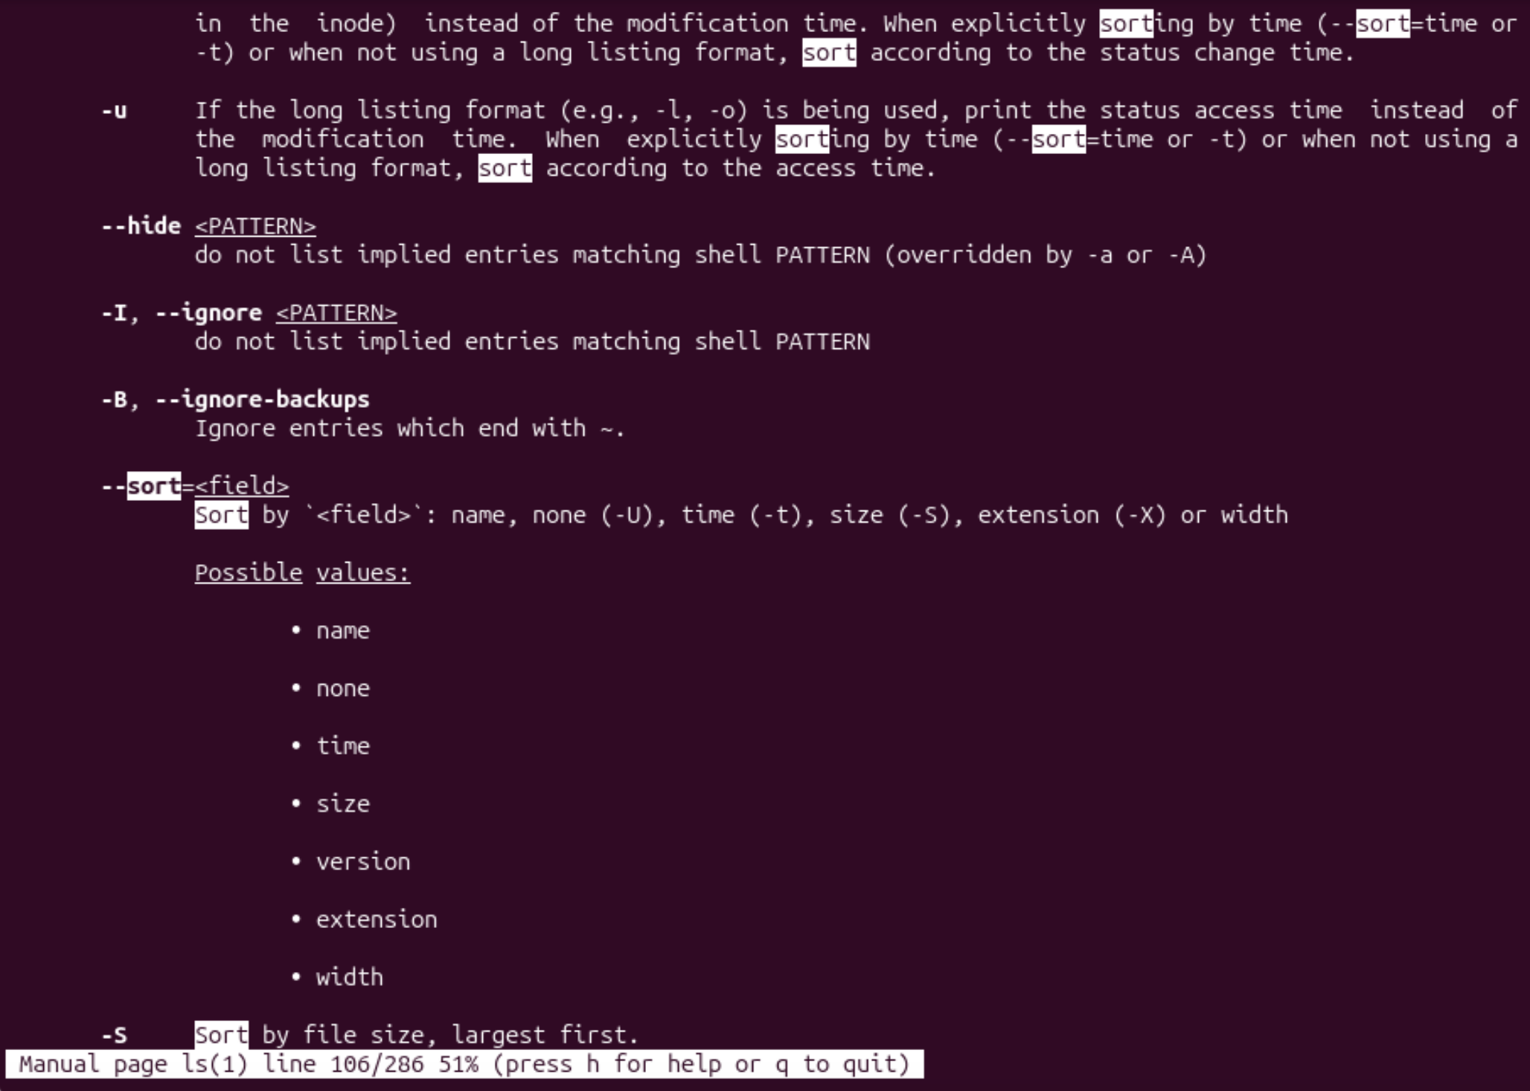
Figure 1.6 – Searching for “sort” inside man ls
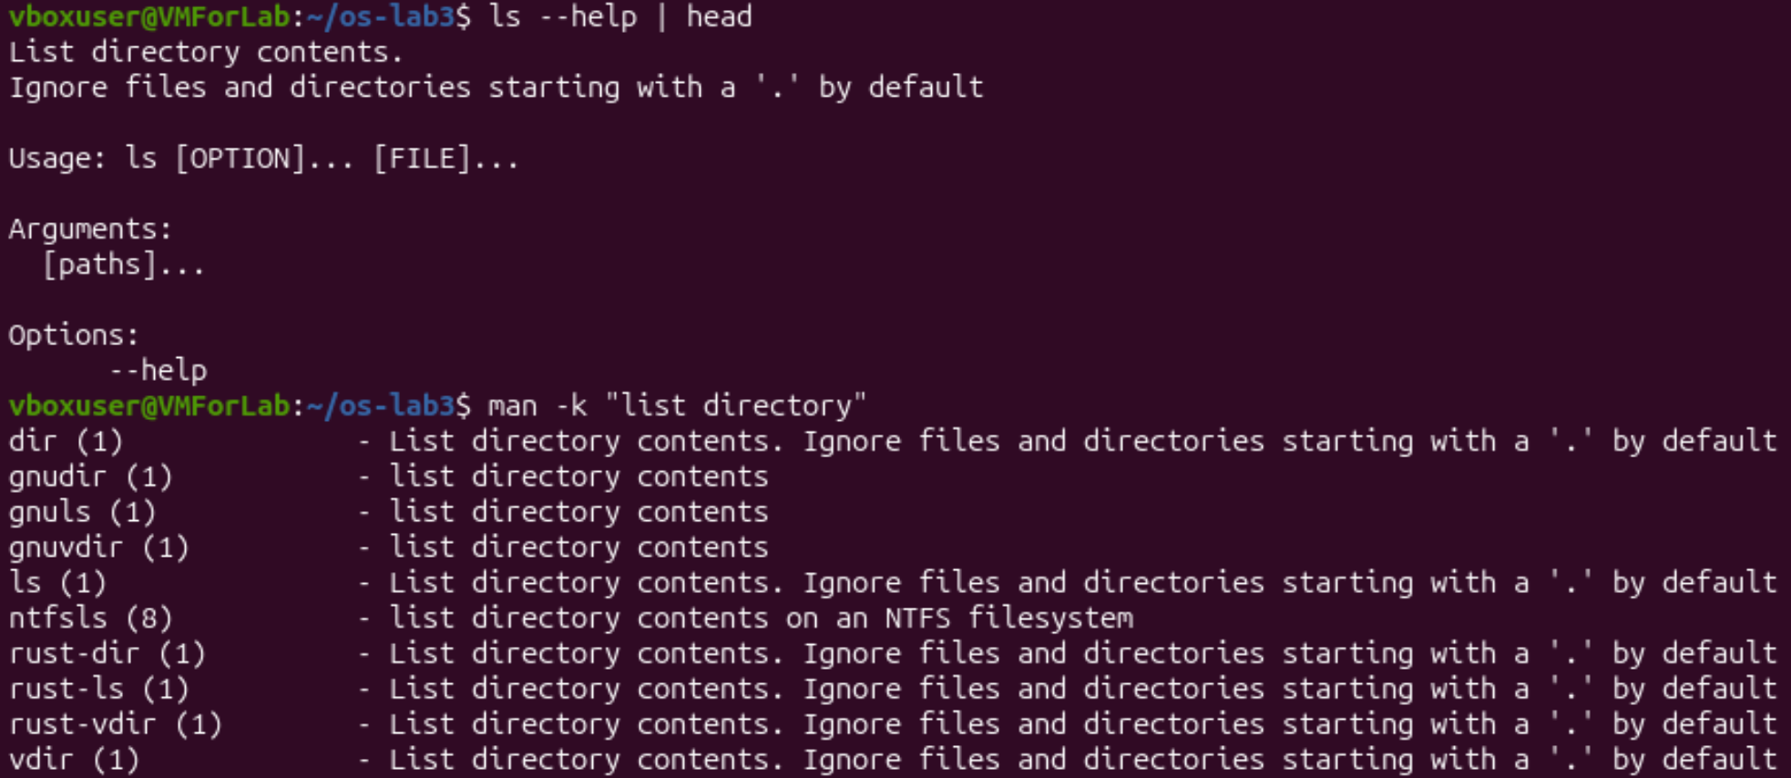
Figure 1.7 – ls --help and man -k "list directory"
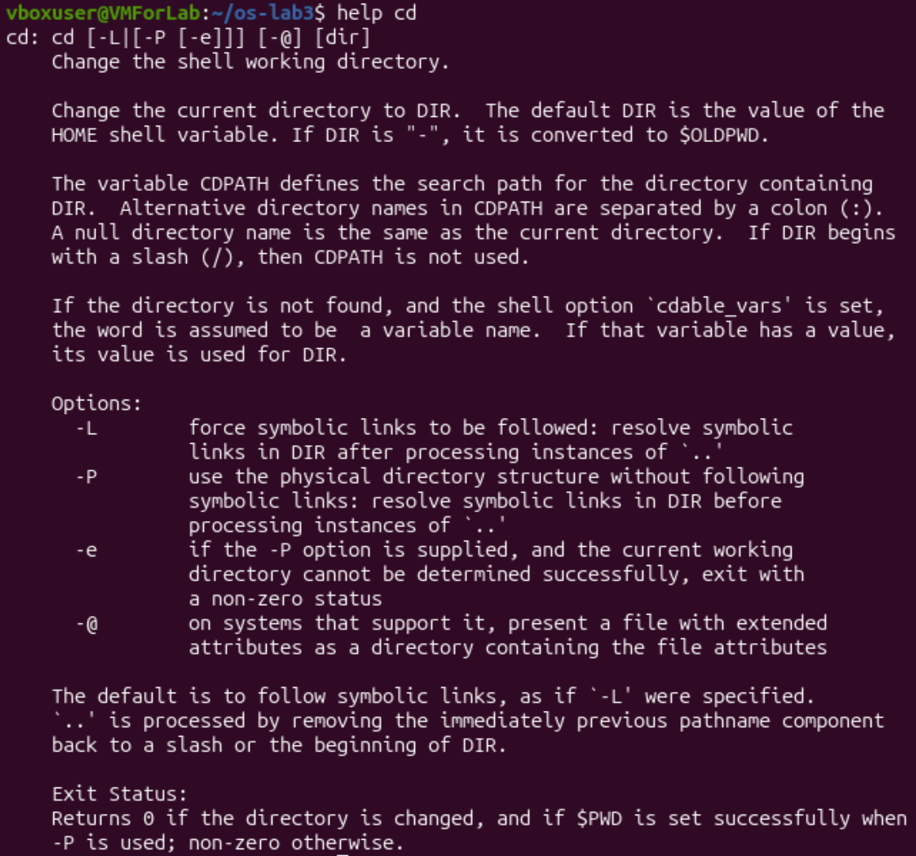
Figure 1.8 – help cd (help for a shell builtin)

Observe, Part 1
1. cd and echo are built-ins. ls is an external program (/usr/bin/ls); type ls shows an alias only because my shell has an alias that adds colors. cd MUST be a built-in because an external program runs in a separate child process. If cd was a program, it could change the directory only of its own process, and when it ends, the shell would stay in the old directory. Only the shell itself can change its own current directory.
2. My PATH has 10 entries. One of them, /snap/bin, is written twice, so there are 9 different directories. ls is in /usr/bin.
3. A command that is not found returns exit code 127.
4. The option -t sorts by modification time (in the man page it is --sort=time or -t), newest first.

Part 2. What the shell does to your line
I created the test directory ~/os-lab3/play with six files, one of them has a space in its name. ls sorted them in alphabetical order and put quotes around the name with the space (Figure 2.1).
Figure 2.1 – Files created in the play directory
For each line I first wrote my prediction in the notes and then ran it. The results are in the table below.
Command | My prediction | Real output | Explanation (if different)
echo *.c | a.c b.c | a.c b.c | Same as I thought. The shell replaces *.c with the names of all matching files.
echo file?.txt | file1.txt file2.txt | file1.txt file2.txt | Same. The ? replaces exactly one character.
echo [a-b]* | a.c b.c | a.c alfa beta.txt b.c | I forgot that “alfa beta.txt” also starts with a. [a-b] is one letter from a to b, and * is anything after it.
echo *.xyz | (an empty line) | *.xyz | No file matches, so the shell leaves the pattern unchanged and echo prints it as plain text. I thought nothing would be printed.
ls alfa beta.txt | alfa beta.txt | ls: cannot access 'alfa': No such file or directory  ls: cannot access 'beta.txt': No such file or directory | The shell splits the line at the space, so ls got two arguments: alfa and beta.txt. Neither of them exists.
ls "alfa beta.txt" | alfa beta.txt | 'alfa beta.txt' | The file is found. The quotes in the output are added by ls, not by me (see the note below).
echo '$HOME' "$HOME" \$HOME | $HOME /home/vboxuser /home/vboxuser | $HOME /home/vboxuser $HOME | I thought the backslash does nothing. In fact \ switches off the special meaning of the next character, so \$HOME stays as text.
echo {1..5} ; echo $((7 * 6)) | {1..5}  42 | 1 2 3 4 5  42 | The shell expands {1..5} into a list of numbers. $(( )) does arithmetic, so 42 was right.
echo "today is $(date +%A), I am $(whoami)" | today is Mon, I am vboxuser | today is Monday, I am vboxuser | $( ) runs the command and puts its output into the line. %A gives the full name of the weekday; the short name would be %a.
touch log{1..3}.txt && ls log* | log1.txt log2.txt log3.txt | log1.txt log2.txt log3.txt | Same. After the previous line I understood that the braces make three names.

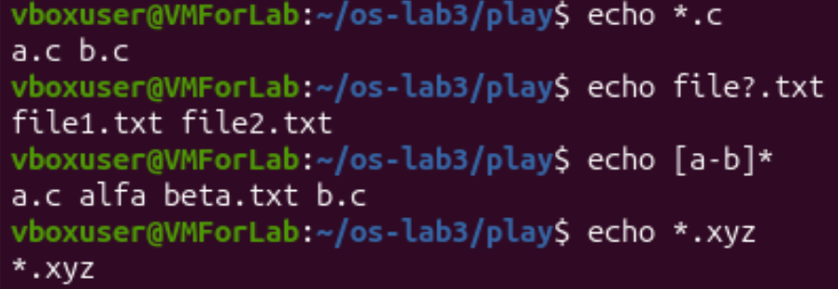
Figure 2.2 – Globbing results
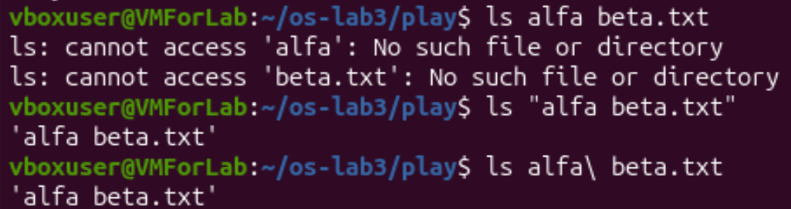
Figure 2.3 – The ls error on a name with a space, and two fixes
Figure 2.4 – Single quotes, double quotes and backslash
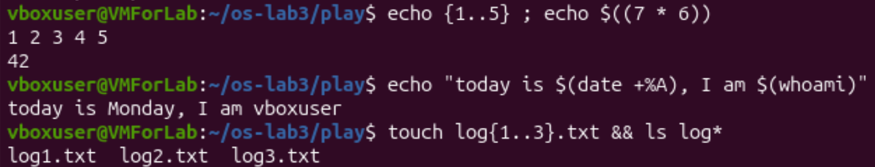
Figure 2.5 – Brace expansion, arithmetic and command substitution

Observe, Part 2
1. The predictions, real outputs and explanations are in the table above. I was right on the simple patterns, but wrong on [a-b]*, on the pattern with no match, on ls alfa beta.txt, on the backslash, and on the weekday format.
2. The file names were produced by the shell, not by echo. This is called globbing. Before the command starts, the shell replaces the pattern *.c with the sorted list of file names that match it. Then echo just receives “a.c b.c” as its arguments and prints them. It does not know anything about files.
3. ls alfa beta.txt failed because the shell splits the line on spaces, so ls got two arguments, “alfa” and “beta.txt”, and none of them exists. Two ways to fix it: put the name in quotes, ls "alfa beta.txt", or escape the space with a backslash, ls alfa\ beta.txt. Both are shown in Figure 2.3.
4. Inside single quotes the shell changes nothing: '$HOME' is printed as text. Inside double quotes the text is kept together as one word (spaces and * do not split or expand), but $VARIABLE, $( ) and the backslash still work, so "$HOME" became /home/vboxuser. A backslash protects only the one character after it.
Note about the quotes in the ls output. The real file name is alfa beta.txt and it has no quote characters. New versions of ls put quotes around names that contain a space or other special characters, so the name can be copied and pasted into the shell safely and it is clearly visible that it is one name.

Part 3. Redirection, chaining and jobs

3.1 stdout and stderr in separate files
Prediction: For ls /etc /nope > out.txt 2> err.txt I thought that both the listing and the error would go to out.txt, because > means “save the output”, and err.txt would be empty.
Real result: out.txt has 238 lines (only the listing) and err.txt has the message “ls: cannot access '/nope': No such file or directory”. So there are two different output streams: stdout (number 1) and stderr (number 2). > is the same as 1>, and 2> is for errors.
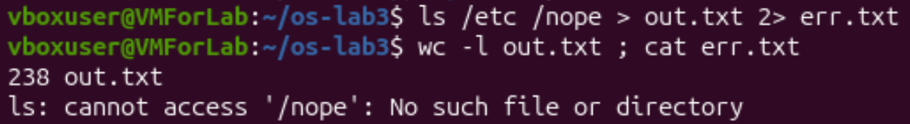
Figure 3.1 – stdout and stderr in separate files

3.2 The order of redirections
Prediction: I thought > all.txt 2>&1 and 2>&1 > all.txt are the same, because they have the same two parts, just written in another order.
Real result: They are different (Figure 3.2). With > all.txt 2>&1 nothing was printed on the screen when ls ran, because the error went to the file to-gether with the listing. With 2>&1 > all.txt the error message “ls: cannot access '/nope'…” appeared on the screen, and the file had only the listing.
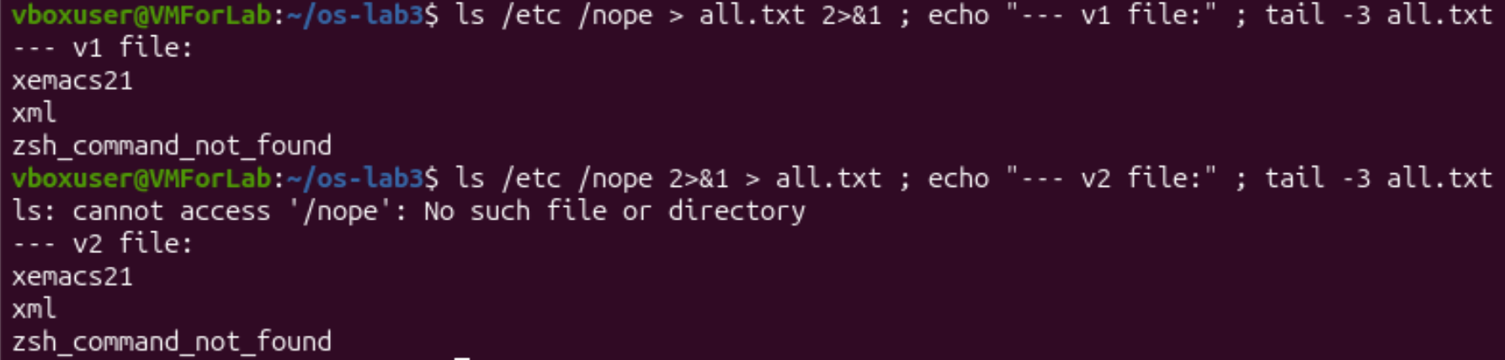
Figure 3.2 – Comparing the order of redirections

3.3 The operators ; && ||
Prediction: For ls /nope 2> /dev/null || echo "failed with code $?" I thought the code would be 1, like in most error cases.
Real result: It printed “failed with code 2”, so ls uses code 2 for a missing file. The second line, mkdir -p tmp && cd tmp && echo "I am in $(pwd)" ; cd ~/os-lab3, printed the path of the new tmp directory, as I expected, and the last cd returned me to os-lab3.
Figure 3.3 – The ; && || operators

3.4 Background job
Prediction: I thought the second jobs after kill %1 would print nothing, because the job is already killed.
Real result: sleep 100 & printed [1] and the process number 17429. The first jobs showed it as Running. After kill %1 the second jobs still showed Running, and the line “Terminated” came only after that (Figure 3.4). I think the shell needs a moment to notice that the process is dead and reports it at the next prompt.
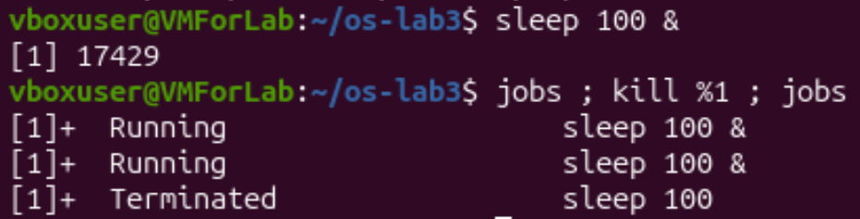
Figure 3.4 – Running a background job and stopping it

3.5 Other redirection commands from the task
ls /etc /nope > all.txt 2>&1 ; tail -2 all.txt put both streams into one file. echo first > notes.md created the file and echo second >> notes.md added a second line at the end, so cat showed “first” and “second”. wc -l < access.log printed only 500.
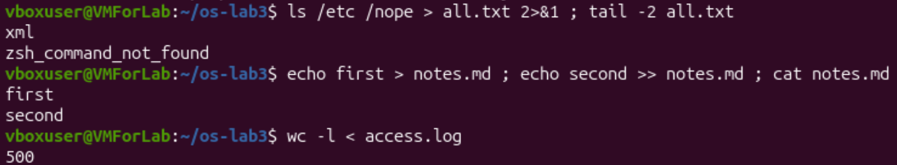
Figure 3.5 – Both streams in one file, appending and input redirection

Observe, Part 3
1. The listing went to out.txt and the error message went to err.txt.
2. The shell processes redirections from left to right. In > all.txt 2>&1: first stdout is sent to all.txt, then “stderr goes to the same place where stdout goes now”, which is all.txt. So both are in the file. In 2>&1 > all.txt: first stderr is connected to the place where stdout goes now, which is still the screen; only after that stdout is moved to all.txt. So the errors stay on the screen and only the listing is in the file.
3. In wc -l < access.log the shell opens the file and gives its content to wc as standard input, so wc does not know the file name and prints only the number. In wc -l access.log the file name is an argument, so wc knows it and prints it after the number. (I predicted “500 access.log” for the first one, which was wrong.)
4. ; runs the next command always, no matter what happened before. && runs the next command only if the previous one succeeded (exit code 0). || runs the next command only if the previous one failed (exit code is not 0).

Part 4. Answering questions with one-liners
Each line of access.log has the fields: date, time, user, result, page. With the space as separator, the user is field 3, the result is field 4 and the page is field 5. I saved all commands in oneliners.sh, one per question, with the question as a comment (Figure 4.10), and ran it with bash oneliners.sh (Figure 4.9). In the figures below, the upper part is the command from the script and the lower part is its output.

Q1. How many requests failed?
grep -c ' FAIL ' access.log
grep -c counts the matching lines. I put spaces around FAIL so that only the result field matches. Result: 100. I expected it, because every fifth request fails (500 / 5).
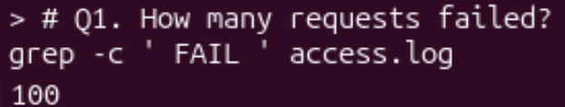
Figure 4.1 – Number of failed requests

Q2. How many different pages were requested, and which?
cut -d' ' -f5 access.log | sort -u | wc -l ; cut -d' ' -f5 access.log | sort -u
cut -d' ' -f5 takes the 5th field (the page), sort -u sorts and removes the repeated lines, and wc -l counts what is left. I use sort and not only uniq, because uniq removes only equal lines that are next to each other. Result: 4 pages: /page0, /page1, /page2, /page3.
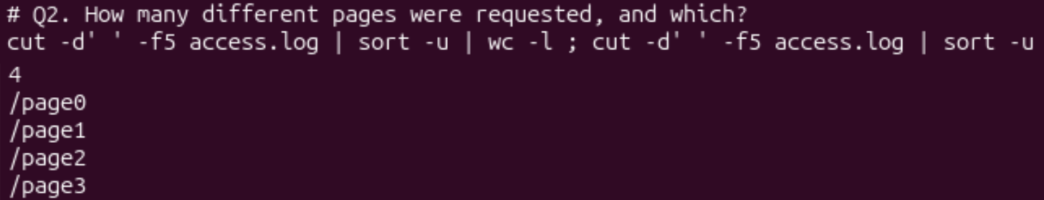
Figure 4.2 – Different pages

Q3. How many requests did each page get?
cut -d' ' -f5 access.log | sort | uniq -c
uniq -c puts the number of repeats before each line. Every page got 125 requests. Check: 4 × 125 = 500, as the task says.
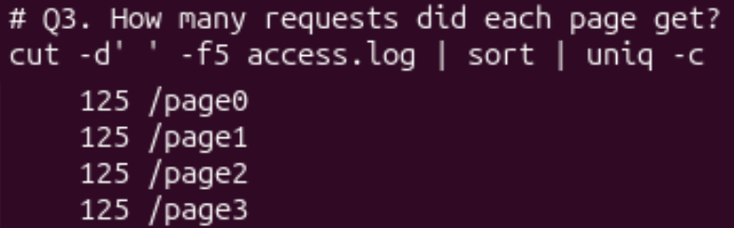
Figure 4.3 – Requests per page

Q4. Which user or users have the most failed requests, and how many?
grep ' FAIL ' access.log | cut -d' ' -f3 | sort | uniq -c | sort -rn | awk 'NR==1{m=$1} $1==m'
Prediction: I expected one user with the biggest number, so I wanted to use head -1.
Real result: Two users have the same number: user5 and user3 with 15 failures each. head -1 would show only one of them. So I used awk: it remembers the number from the first line (the biggest, because of sort -rn) and prints every line with the same number. Check: the per-user failures from my script in Part 5 are 14 + 14 + 14 + 15 + 14 + 15 + 14 = 100, which is equal to Q1.
Figure 4.4 – Users with the most failed requests

Q5. How many requests did user3 make, and how many of them failed?
grep -c ' user3 ' access.log ; grep ' user3 ' access.log | grep -c ' FAIL '
Prediction: I calculated 500 / 7 ≈ 71, so I thought user3 made 71 requests.
Real result: 72 requests and 15 of them failed. 500 is not divisible by 7: 500 = 7 × 71 + 3, so the first three users in the cycle (user1, user2, user3) get one extra request. The 15 failures agree with Q4.
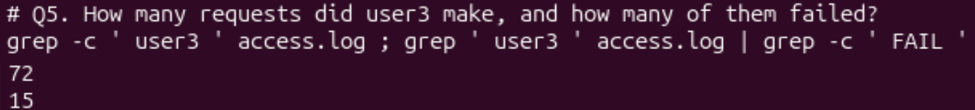
Figure 4.5 – Requests of user3

Q6. The last 3 failed requests (time and user)
grep ' FAIL ' access.log | tail -3 | cut -d' ' -f2,3
First I keep only the failed lines, then tail -3 takes the last three, and cut -f2,3 leaves the time and the user. Result: 10:10 user0, 10:15 user5, 10:20 user3.
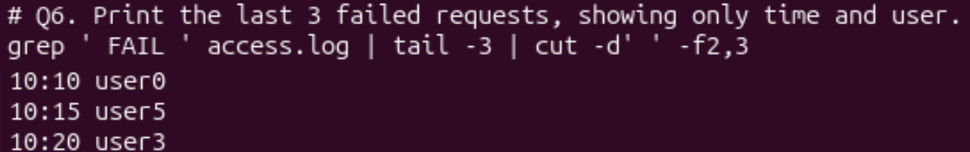
Figure 4.6 – The last three failed requests

Q7. Login shells in /etc/passwd and how many accounts use each
cut -d: -f7 /etc/passwd | sort | uniq -c | sort -rn
Prediction: I thought that most accounts use /bin/bash.
Real result: Most accounts use /usr/sbin/nologin (40), then /bin/false (5), /bin/bash (2) and /bin/sync (1). So only two accounts are normal users with a real shell; the others are system accounts that cannot log in.
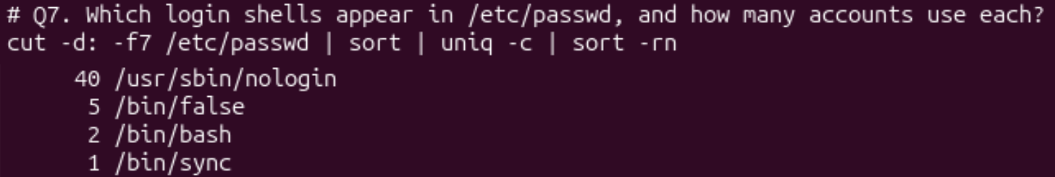
Figure 4.7 – Login shells in /etc/passwd

Q8. Why do ls /etc | wc -l and ls -l /etc | wc -l differ by exactly one?
ls /etc | wc -l ; ls -l /etc | wc -l
Prediction: I thought ls -l also shows hidden files, so it has one more line.
Real result and explanation: The numbers are 237 and 238. My prediction was wrong, because hidden files are shown only with -a. The extra line is the first line of the long format: ls -l starts its output with a line “total N” that shows the disk blocks used by the files. It is not a file, but wc -l counts it as a line, and this is the difference of exactly one.
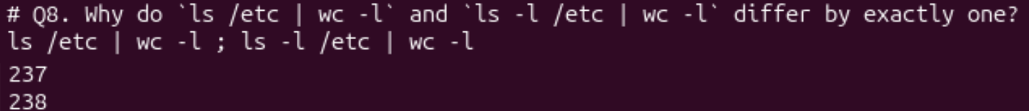
Figure 4.8 – Comparing the two listings

Full run and the script file
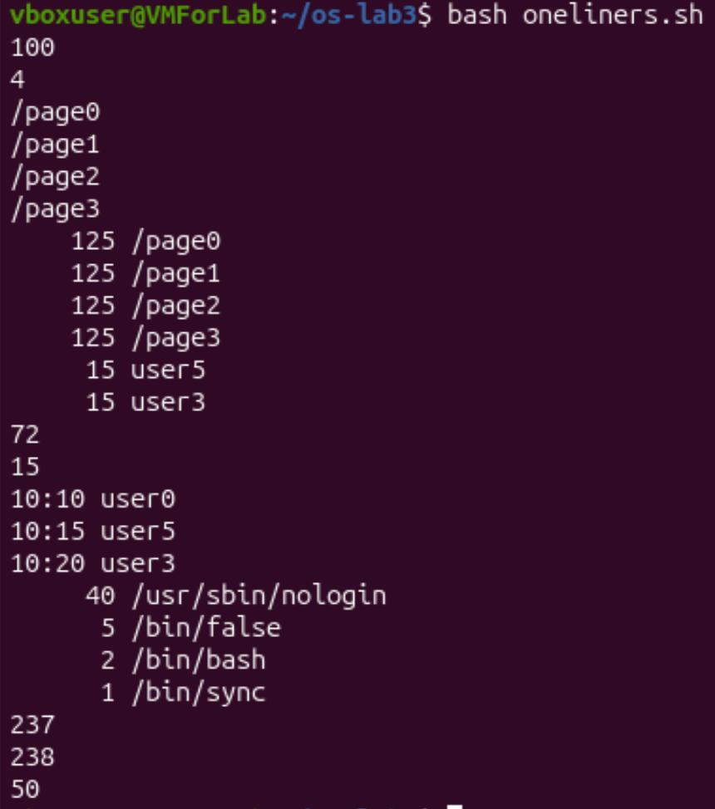
Figure 4.9 – Full run of oneliners.sh
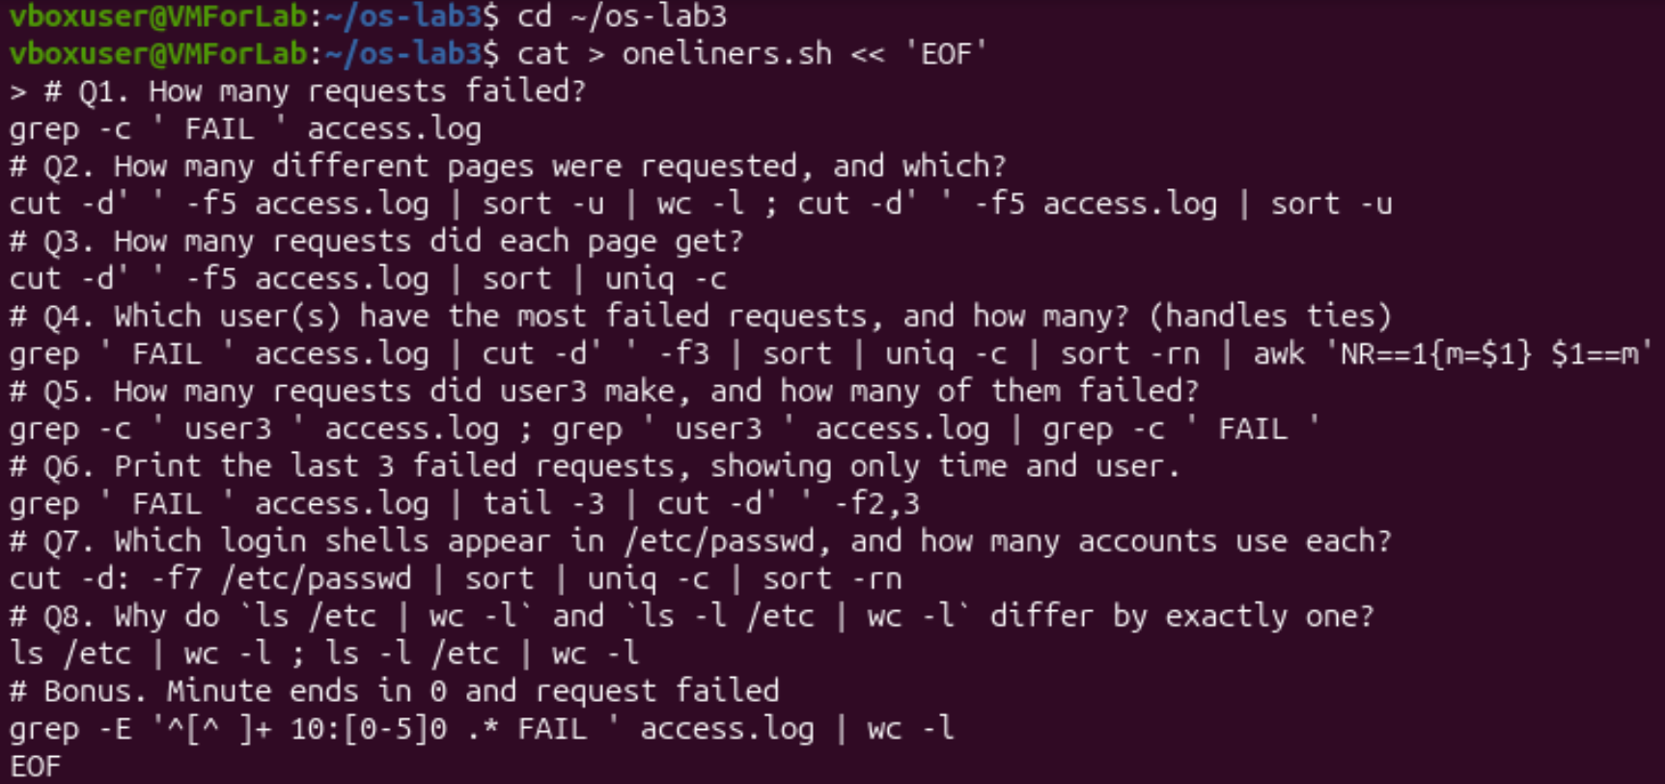
Figure 4.10 – Creating oneliners.sh

Bonus. Failed requests where the minute ends in 0
grep -E '^[^ ]+ 10:[0-5]0 .* FAIL ' access.log | wc -l
The pattern means: ^[^ ]+ is the first field (the date), then a space, then “10:”, a minute from 00 to 50 that ends in 0, and later the word FAIL. The answer is 50. It makes sense: the minute ends in 0 for every 10th request and the request fails for every 5th, so both are true for every 10th request, and 500 / 10 = 50.
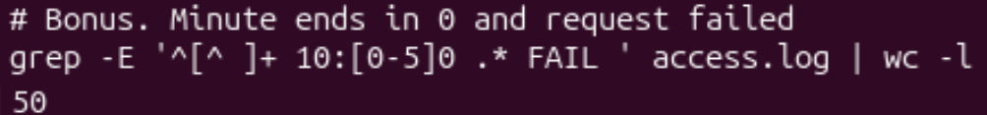
Figure 4.11 – Bonus: failed requests with the minute ending in 0

Part 5. Your first script
I created report.sh with the text from the task (Figure 5.1) and completed the TODO with a loop over the users 0…6:
for n in 0 1 2 3 4 5 6; do
c=$(grep -c " user$n FAIL" "$log")
echo "user$n: $c failures"
done
On every pass n gets the next number, and grep -c counts the lines like “ user3 FAIL”. The loop is much shorter than seven separate grep commands.
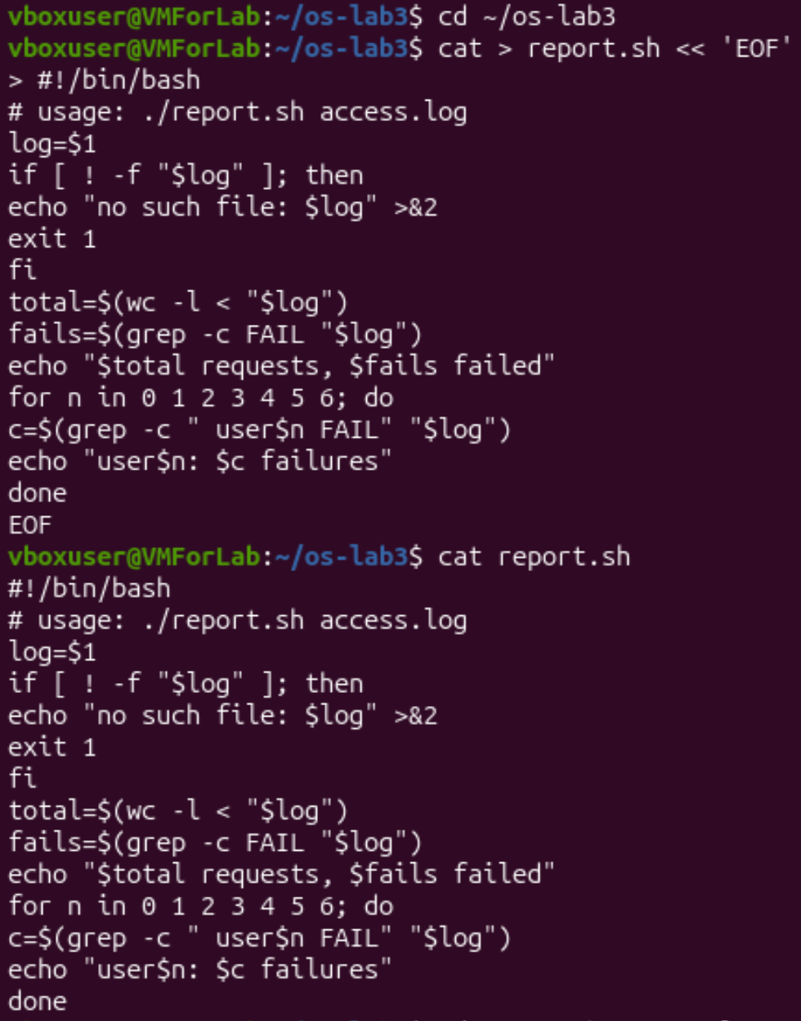
Figure 5.1 – Creating report.sh and its contents
Prediction: I thought ./report.sh access.log would work even before chmod +x, because the file is a normal text file with commands.
Real result: Before chmod +x bash printed “Permission denied”. After it, the script printed “500 requests, 100 failed” and the failures of every user (Figure 5.2). The sum 14 + 14 + 14 + 15 + 14 + 15 + 14 is 100. For a missing file the script printed “no such file: nope.log” and the exit code was 1 (Figure 5.3).
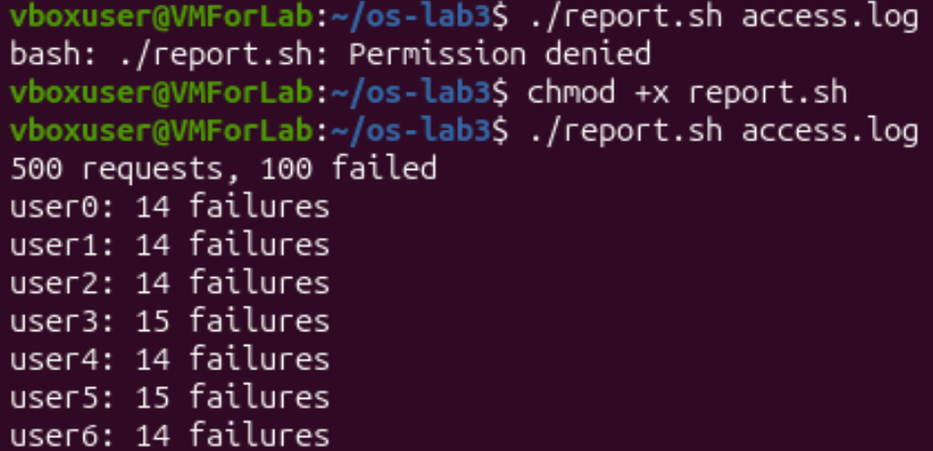
Figure 5.2 – Running the script on access.log (before and after chmod +x)
Figure 5.3 – Error handling for a missing file

Observe, Part 5
1. The first line #!/bin/bash (shebang) tells the system which program must run the file, here bash. Without chmod +x the file has no execute permission, so ./report.sh gives “Permission denied” (Figure 5.2).
2. The shell looks for commands only in the directories of PATH, and the current directory is not there. So report.sh would give “command not found”. With ./ I give the path explicitly: “the file report.sh in this directory”.
3. >&2 sends the error message to stderr, not to stdout, so error messages do not mix with the normal output and can be redirected separately. exit 1 ends the script with a non-zero code, which means “failure”. Other commands and scripts can check it with $?, && and ||. If I did not write it, the script would end with code 0 (success) even if the file was missing.

Bonus: running the script with cron
I added this line to my crontab (full paths, and >> … 2>&1 to append both normal output and errors to the log):
* * * * * /home/vboxuser/os-lab3/report.sh /home/vboxuser/os-lab3/access.log >> /home/vboxuser/os-lab3/report.log 2>&1
The five stars mean “every minute”. Full paths are needed because cron starts the job without my current directory and with a very small PATH.
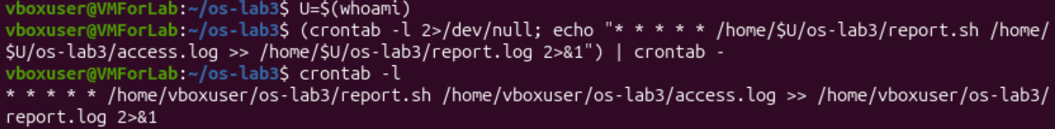
Figure 5.4 – The crontab line
Prediction: I thought the log would contain only one report, because the old text would be replaced by the new one every minute.
Real result: After about two minutes report.log contained the report two times (Figure 5.5). >> adds to the end of the file and does not replace the old text. At the end I removed the crontab with crontab -r, and crontab -l said “no crontab for vboxuser” (Figure 5.6).
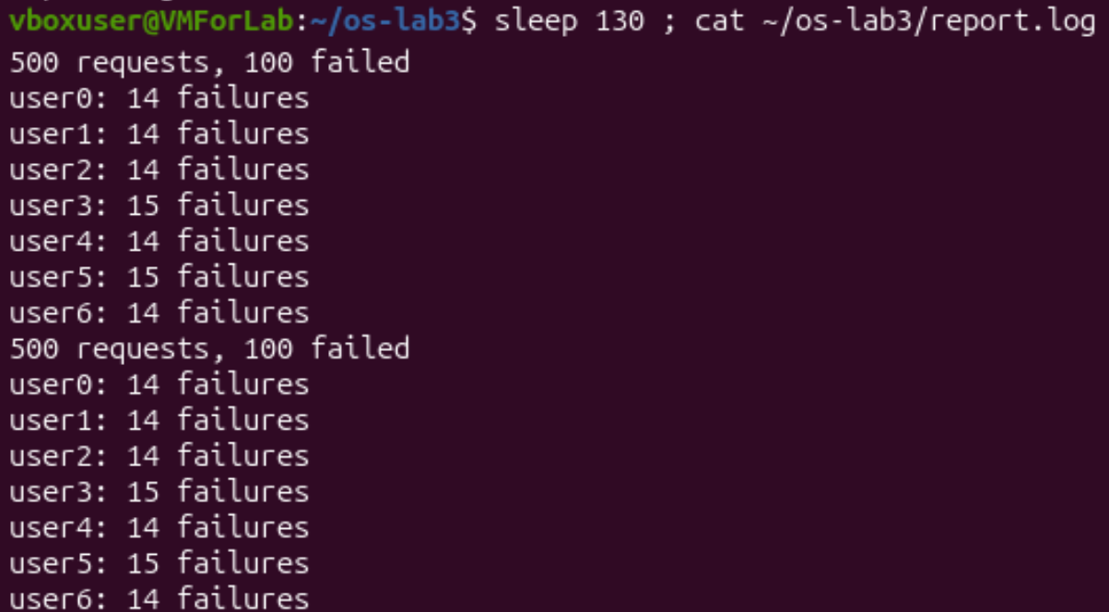
Figure 5.5 – The log after two minutes
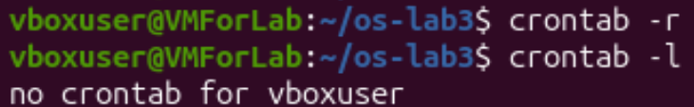
Figure 5.6 – Removing the crontab

3. Conclusions
In this lab I learned how to work in the bash shell and how it prepares a command line before running a command. My main findings are:
- Some commands are shell built-ins (cd, echo) and some are external programs found through PATH (ls). cd must be a built-in because only the shell can change its own directory. A missing command returns the exit code 127.
- The shell, not the command, expands patterns like *.c, braces, variables and $( ) before the command starts. Quotes and the backslash control this: single quotes switch everything off, double quotes keep spaces together but allow $, and a backslash protects one character.
- A program has two output streams, stdout and stderr, and they can be redirected separately with >, >>, 2> and 2>&1. The order of redirections matters. I also learned that ;, && and || chain commands depending on the exit code.
- Small filters joined by pipes (grep, cut, sort, uniq, wc, tail) can answer real questions about data in one line. Checking the results (500 requests in total, the failures sum to 100) helped me to see that the pipelines are correct.
- A shell script needs the shebang line and the execute permission, errors should go to stderr with a non-zero exit code, and cron can run the script automatically every minute.
Many of my predictions were wrong, especially for patterns without a match, backslashes, the order of redirections and the “total” line of ls -l. These mistakes were the most useful part of the lab, because now I understand better what the shell does with my line before the command runs.

