Ministry of Education and Research of the Republic of Moldova
Technical University of Moldova
Faculty of Computers, Informatics and Microelectronics
Department of Software Engineering and Automatics
REPORT
on laboratory work no. 4
Course: Operating Systems
Topic: The xv6 Shell from the Outside
Done by: st. gr. FAF-242, Olga Saban
Checked by: assist. univ. Patricia Reițman
Chișinău, 2026

1. Purpose of the work
The purpose of this lab is to look at the xv6 shell (user/sh.c, about 500 lines) from the outside and to compare it with bash. By running the same commands in both shells I wanted to find out what a shell must do and what bash adds on top of it. I also wrote a very small program that prints the arguments it receives, to see exactly who expands * and who removes the quotes. Before that, I had to make my sleep program from Lab 2 build on the current xv6, where the system call sleep() was renamed to pause().
I worked on Ubuntu Linux in a virtual machine (user vboxuser). xv6 is in ~/xv6-riscv and I started it with make qemu. For bash tests I used the folders ~/shtest and ~/argtest.

2. The work done

Part 1. Fix sleep for the current xv6
Check of the name. First I checked which name is used in my tree with grep -n "pause\|sleep" user/user.h (Figure 1.1). In my screenshot the beginning of the line is cut, only the end "nt);" is visible, but I think it is the declaration of pause(int), so my tree already uses the new name and the old sleep() call from Lab 2 had to be changed.
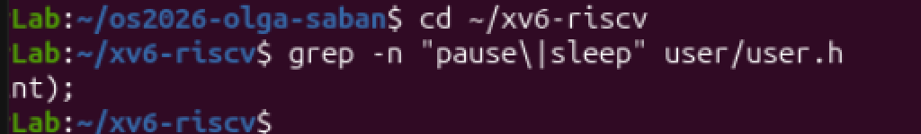
Figure 1.1 – The grep result in user.h
The program. I rewrote user/sleep.c as in the task: the program checks that there is exactly one argument, otherwise it prints "usage: sleep <ticks>" to stderr (file descriptor 2) and exits with code 1; then it calls pause(atoi(argv[1])) and exits with 0. The comment "was sleep() before Aug 2025" is also in the file (Figure 1.2). Again, the left part of the screenshot is cut by the terminal window.
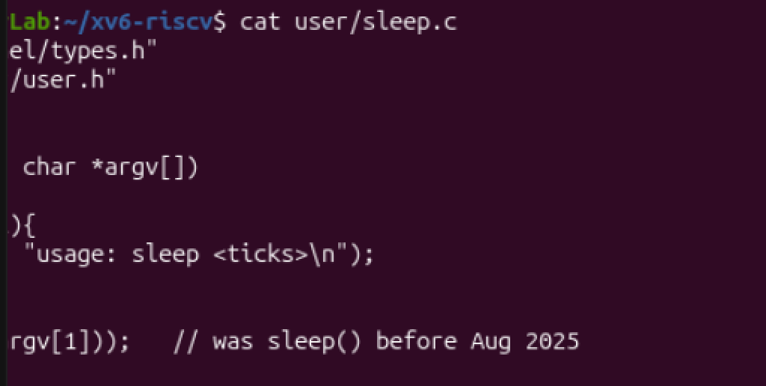
Figure 1.2 – The updated sleep.c
Test. After the build (see below) and make qemu, xv6 booted and I ran sleep 20 and sleep without an argument (Figure 1.3). The first command returned to the prompt after a short pause (20 ticks, I think about two seconds), and the second one printed "usage: sleep <ticks>", as expected.
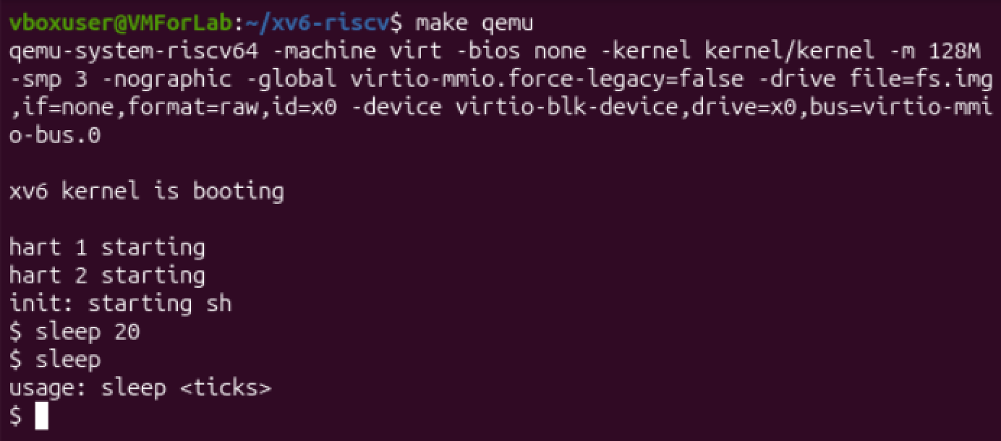
Figure 1.3 – sleep running in xv6, with and without an argument
Makefile. I added $U/_sleep and $U/_args to UPROGS after the line with $U/_zombie, using a small python script (Figure 1.4), and checked the result with grep ... | cat -A to see that every line ends with a backslash and has nothing after it. My first make qemu stopped with "No rule to make target 'user/_args', needed by 'fs.img'". I think this happened because user/args.c did not exist yet (I created it right after, see Part 3). When both files existed, make compiled sleep.c and args.c, linked user/_sleep and user/_args and put them into fs.img (Figure 1.5).
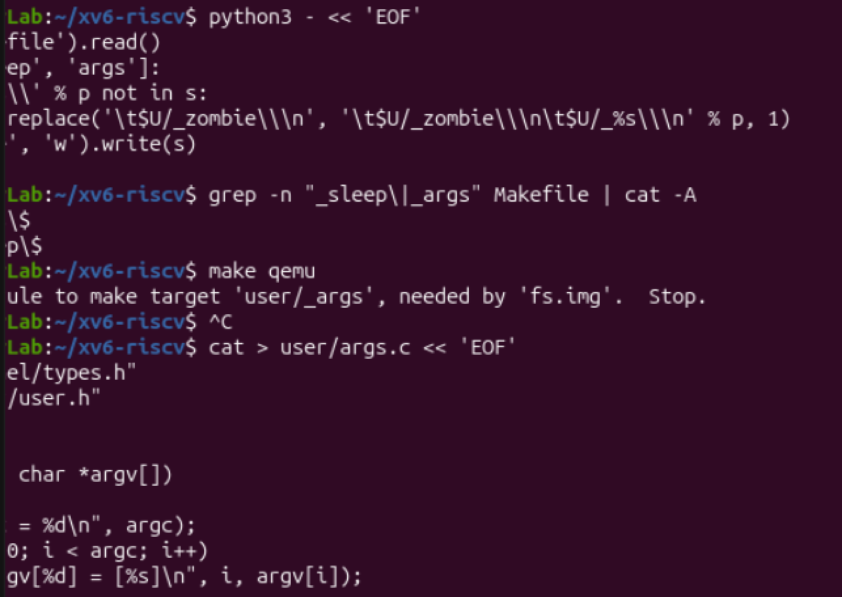
Figure 1.4 – Adding the programs to UPROGS and the first make error
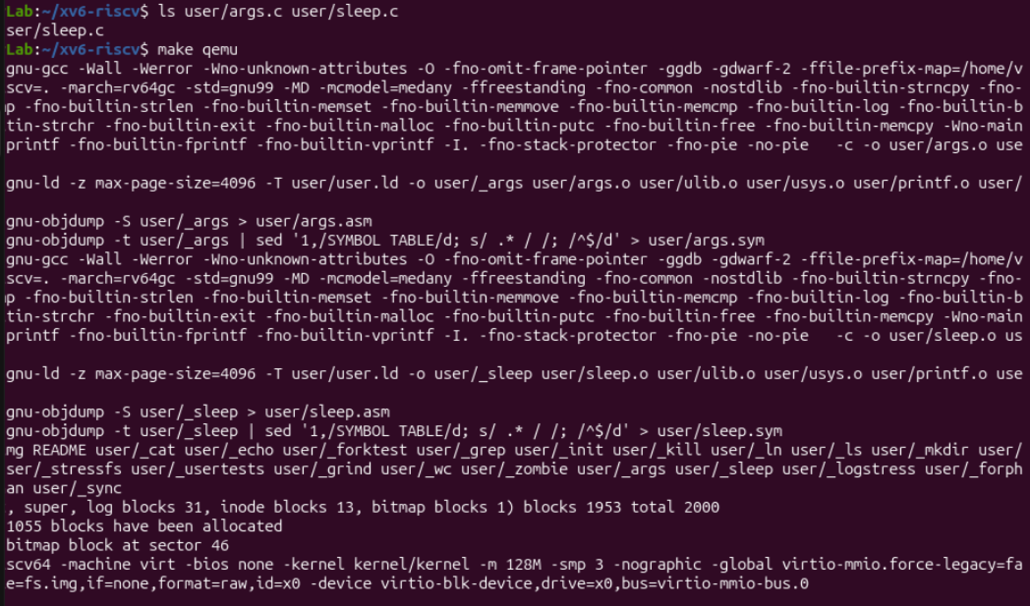
Figure 1.5 – Building sleep and args and creating fs.img
A failed attempt. In one of my earlier runs the same test ended differently: sleep 20 was accepted, but sleep without an argument printed "exec sleep failed" (Figure 1.6). I did not find the exact reason. I think the program that was in fs.img at that moment was not the correct build, because after I checked user.h, wrote sleep.c again as in the task and rebuilt everything, the test worked (Figure 1.3).
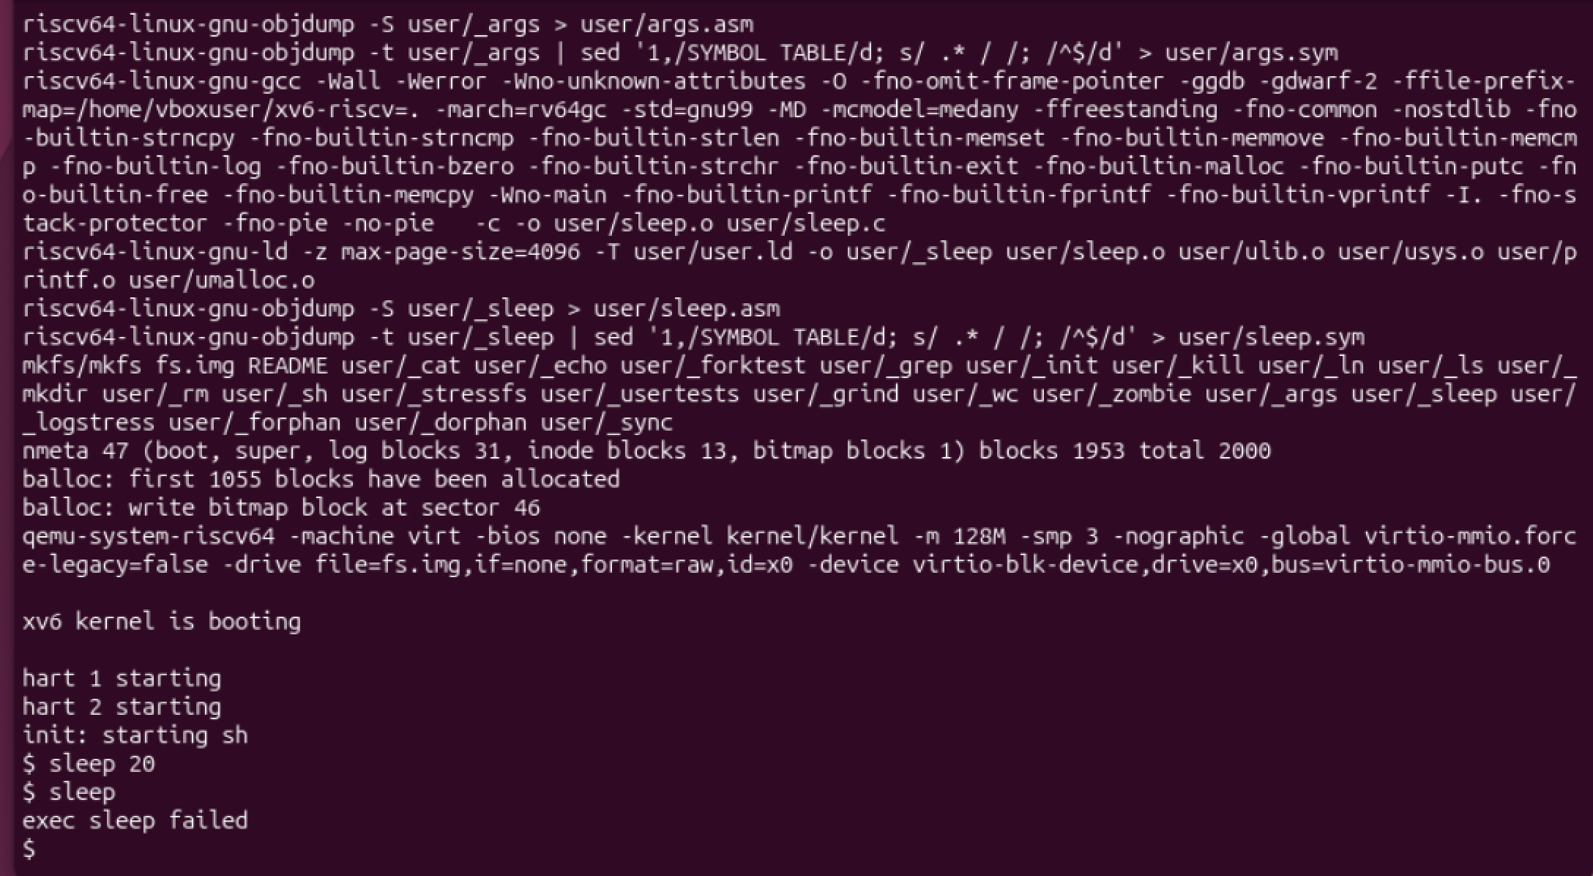
Figure 1.6 – An earlier run: "exec sleep failed"

Part 2. bash versus the xv6 shell
I created an empty test folder with a file README (mkdir ~/shtest && cd ~/shtest && touch README) and ran the commands from the task in bash (Figure 2.1). Then I ran the same commands at the xv6 $ prompt (Figure 2.2). The table below shows what each shell printed and why. The bash column is what my screenshot shows. For xv6 I write what I expect from the shell code and from the behaviour I saw in Part 4; the exact text of the messages may be a little different from what I wrote.
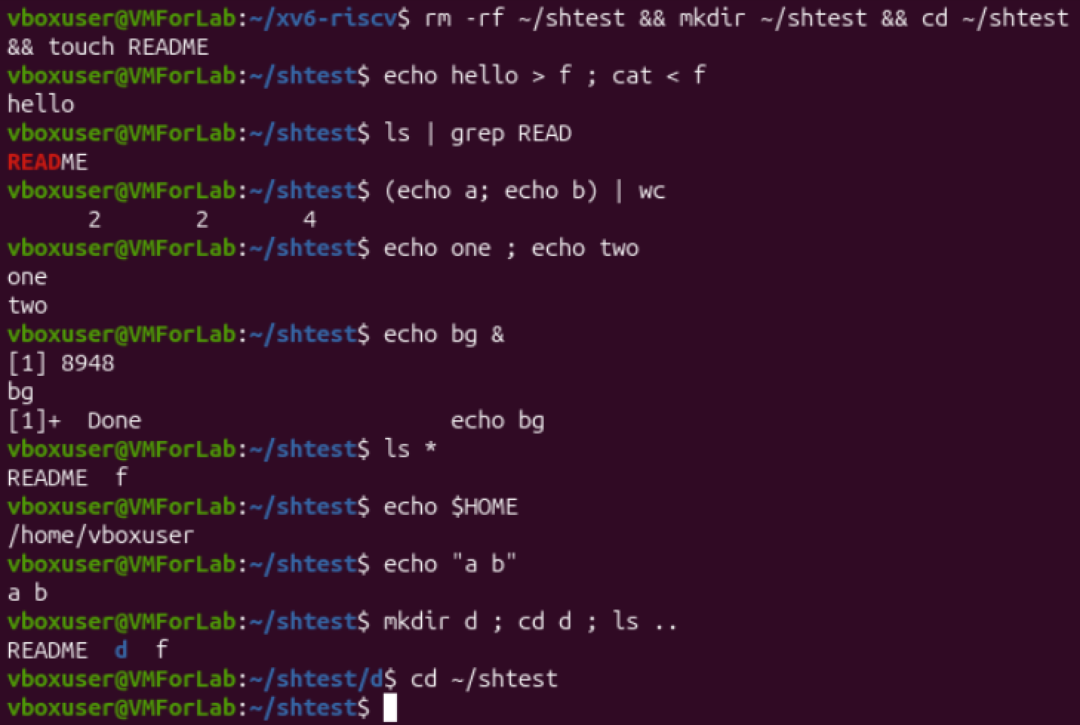
Figure 2.1 – The commands run in bash
Command | Tests | bash (real output) | xv6 (expected) and why
echo hello > f ; cat < f | redirection | hello | Same, "hello". The xv6 shell knows < > >> (REDIR) and ; (LIST), so this works the same way.
ls | grep READ | pipe | README (READ in red, because of grep color) | A line with README. xv6 ls prints more than the name (type, inode, size), so the whole line is shown. The pipe (PIPE, |) is supported.
(echo a; echo b) | wc | grouping, list | 2 2 4 (lines, words, bytes) | I think the same "2 2 4". Parentheses are in the list of special symbols of sh.c, so grouping should work.
echo one ; echo two | sequence | one  two (two lines) | Same, two lines. ; is the LIST kind.
echo bg & | background | [1] 8948  bg  [1]+ Done echo bg | Only "bg". The xv6 shell has & (BACK) but no job list, so no job number and no "Done" message. The prompt may appear before or after "bg".
ls * | globbing | README f (the shell replaced * with the file names) | Most likely an error from ls, something like "ls: cannot ..." with the text *, because the shell does not expand * and ls receives a file called "*".
echo $HOME | variables | /home/vboxuser | The text $HOME as it is, because xv6 sh has no variables.
echo "a b" | quotes | a b (quotes removed by the shell) | I think "a b" with the quote characters, because the shell has no code for quotes and splits at the space.
mkdir d ; cd d ; ls .. | PATH | README d f | mkdir and cd work, but ls is not found: "exec ls failed". There is no PATH, programs are searched in the current directory (see Observe 2).
arrow up, Tab, Ctrl+R | history, completion | Work (I did not capture them in the screenshot). | Not available. The xv6 console only has very simple line editing; I think arrow keys just print strange characters.

Observe, Part 2
1. Both shells have: redirection of input and output (<, >, >>), pipes (|), sequences with ;, grouping with ( ), running in the background with &, and cd as a built-in. Only bash has: globbing (* and ?), variables ($HOME), quotes, the PATH search, job messages like "[1] Done", and the interactive help for the user (history with arrow up and Ctrl+R, Tab completion). bash also has many other things from Lab 3 (&&, ||, $( ), {1..5}), which I did not test here.
2. In xv6 there is no PATH. When I type ls, the shell calls exec with the name "ls", and exec looks for a file with this name in the current directory. In the root directory it finds the program, but after cd d the folder d has no file ls, so exec fails ("exec ls failed"). The xv6 programs all live in the root directory /. So I can call the program with its full path: /ls .. (or /ls) works from inside d, because the path starts at the root. The same is true for /echo, /cat and the others.
3. I think I would miss most the command history (arrow up) together with globbing, because without them every long command must be typed again and every file written by hand. The easiest one to add is, I think, a fallback in the EXEC case: if exec of "name" fails, try again with "/name". It is only a few lines in runcmd and it would solve the problem from question 2.

Part 3. Who expands *? A program that prints its argv
args for xv6. I created user/args.c exactly as in the task: it prints argc and then every argv[i] in square brackets, so the spaces at the beginning and at the end of an argument would be visible. The line $U/_args\ is in UPROGS (line 149 of the Makefile, Figure 3.1).
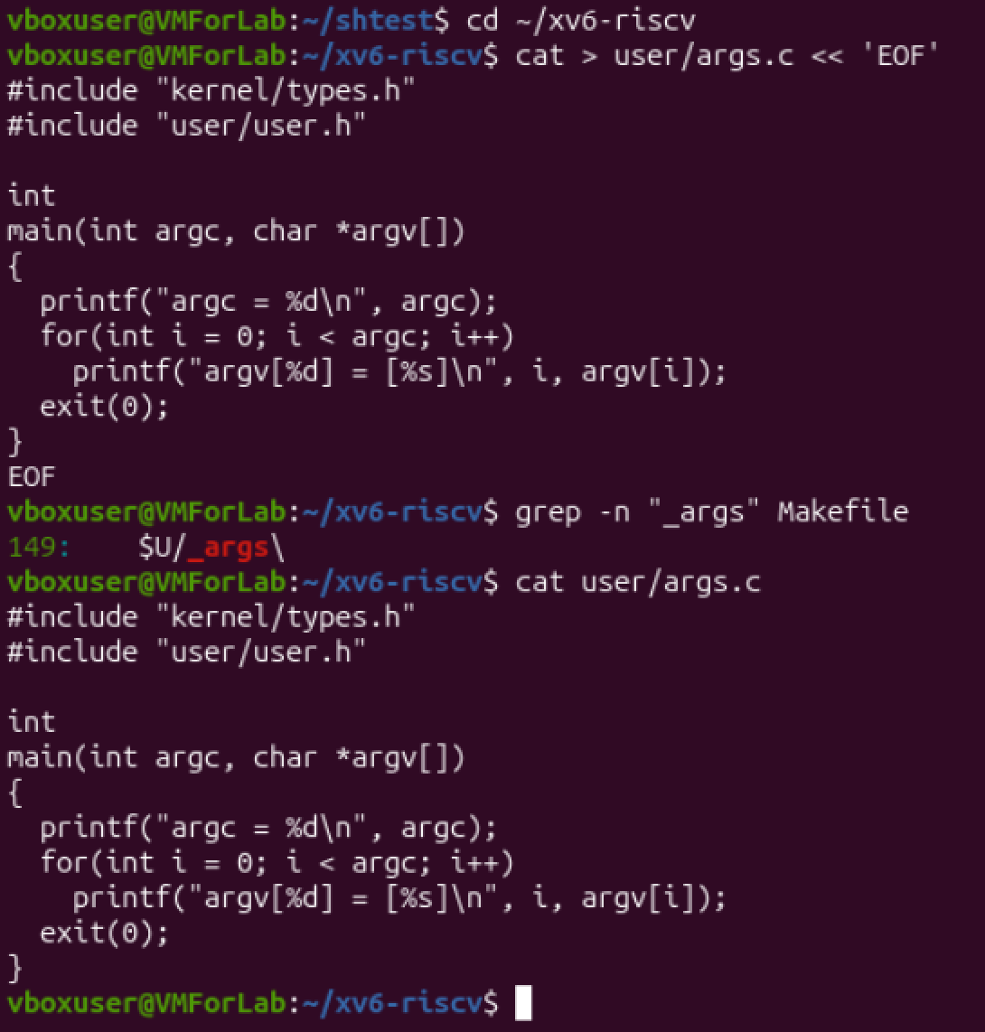
Figure 3.1 – args.c and the UPROGS line
Running in xv6. I started xv6 and ran the four lines from the task at the $ prompt (Figure 3.2).

args for Linux. I wrote the same program as args_linux.c with #include <stdio.h> and return 0, compiled it with gcc -o args args_linux.c, created two empty files a.c and b.c in ~/argtest and ran the four lines from the task with ./args (Figure 3.3).
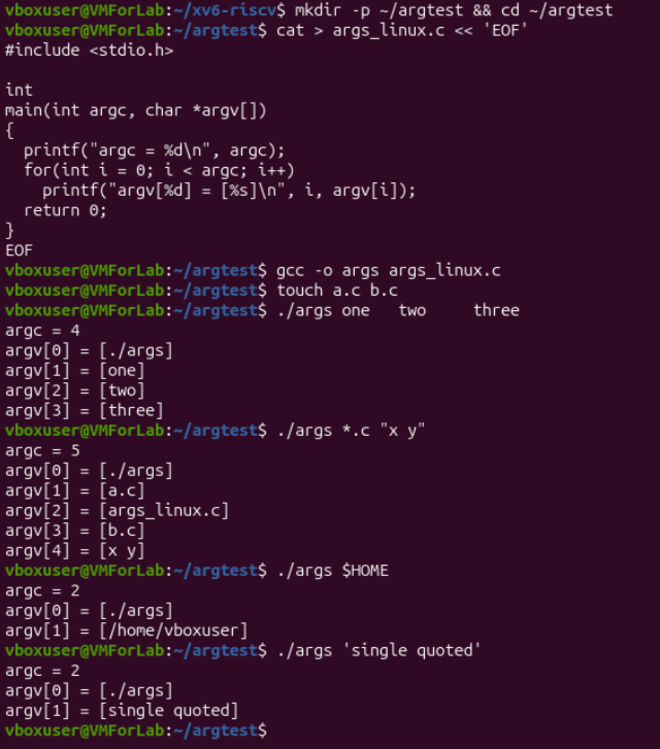
Figure 3.2 – args_linux output in bash
Command | bash (real output) | xv6 (expected)
args one two three | argc = 4: ./args, one, two, three | argc = 4: args, one, two, three. The same, because the xv6 shell also splits on spaces.
args *.c "x y" | argc = 5: ./args, a.c, args_linux.c, b.c, x y | I think argc = 4: args, *.c, "x, y" . The pattern stays as text, the quotes stay, and the argument is cut at the space.
args $HOME | argc = 2: ./args, /home/vboxuser | argc = 2: args and the text $HOME.
args 'single quoted' | argc = 2: ./args, single quoted | I think argc = 3: args, 'single, quoted' (quote characters are kept).

Observe, Part 3
1. Output in bash for ./args *.c "x y":
argc = 5
argv[0] = [./args]
argv[1] = [a.c]
argv[2] = [args_linux.c]
argv[3] = [b.c]
argv[4] = [x y]
So bash gave the program 5 arguments. In xv6 I expect the program to receive about 4 arguments (args, *.c, "x and y"), and the lines would look like argv[1] = [*.c], argv[2] = ["x], argv[3] = [y"] (the exact result must be checked in Figure 3.2).
2. The program only prints what it gets in argv, and the kernel only copies the argument strings through exec. So it is the shell that turns *.c into file names (a.c, args_linux.c, b.c) and removes the quotes, so that "x y" becomes one argument without quote characters. In bash the program never sees the * or the quotes. The xv6 shell does not do it, that is why the programs there get the text as it was typed.
3. The extra spaces in one two three disappeared. The shell uses spaces only as separators between words, so any number of spaces gives the same result: argc = 4 and the arguments one, two and three without spaces (Figure 3.3). The program never sees how many spaces were typed. To keep spaces inside one argument, the text must be put in quotes, as with "x y" in bash.

Part 4. Read the shell
In ~/xv6-riscv I ran the commands from the task. wc -l shows that user/sh.c has 499 lines. grep -n "#define" shows the numbers of the five kinds of commands (Figure 4.1), and grep -n "case " shows where each kind is used (Figure 4.2).
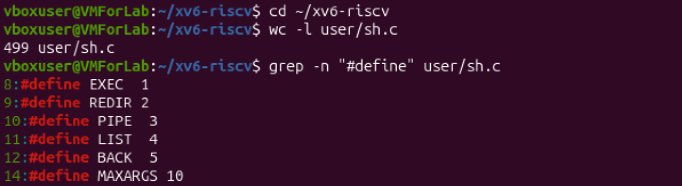
Figure 4.1 – The command kinds defined in sh.c
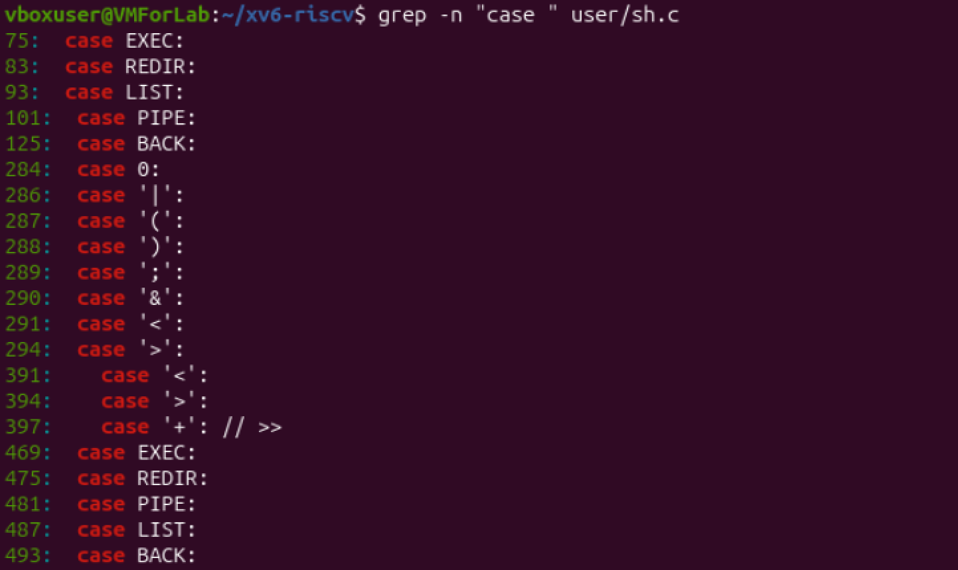
Figure 4.2 – Where each kind is run
The first group of case lines (75, 83, 93, 101, 125: EXEC, REDIR, LIST, PIPE, BACK) is, I think, the function runcmd, which really runs a command. The lines 284–297 list the special symbols that the tokenizer knows: | ( ) ; & < >, and lines 391–397 show < > and + (the code for >>) in the redirection parser. The second group (469–493) has the same five names again; I think it belongs to a function that finishes the strings of the parsed command, but I did not read it in detail.
For cd I used sed -n '/^main/,$p' user/sh.c | head -40 to read the function main (Figure 4.3) and grep -n "cd" user/sh.c | head (Figure 4.4). In my screenshot the grep finds only one line, the error message "cannot cd %s".
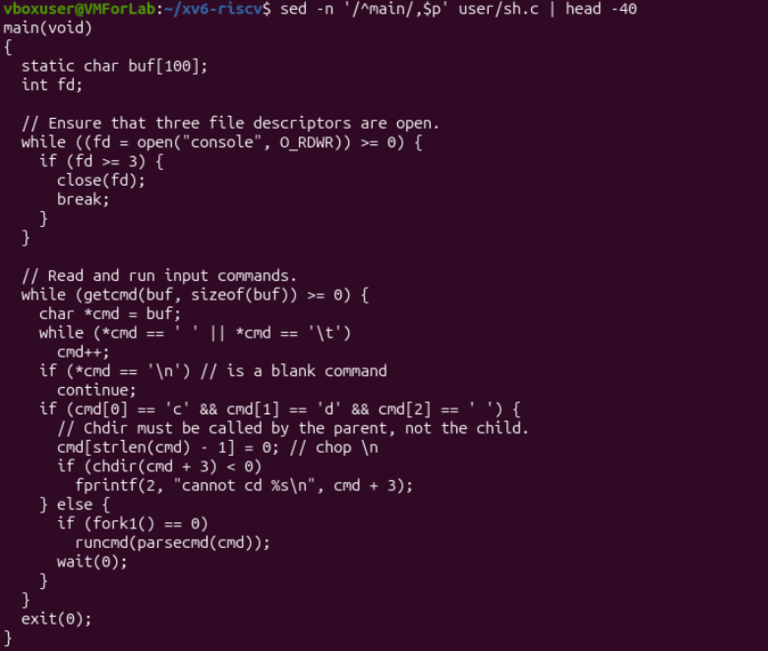
Figure 4.3 – The code that handles cd
Figure 4.4 – grep for "cd" in sh.c
At the end I searched for the characters * and $ written in single quotes: grep -n "'\*'\|'\$'" user/sh.c. It printed nothing (Figure 4.5).
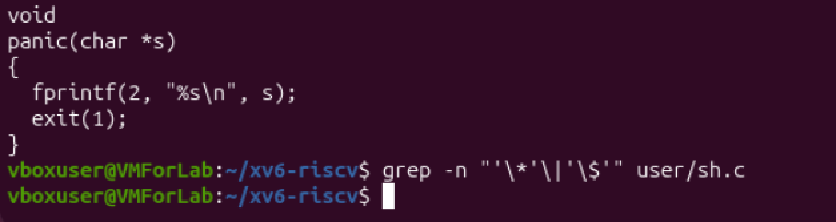
Figure 4.5 – Search for * and $ in sh.c (no result)
Observe, Part 4
1. The five kinds of command, from the #define lines, and the character that produces each of them:
Kind | Value | Produced by
EXEC | 1 | a simple command: a program name with arguments, there is no special character (for example echo hi). Parentheses ( ) are used only to group other commands.
REDIR | 2 | < (input from a file), > (output to a file), >> (append, the tokenizer calls it "+")
PIPE | 3 | | (the output of the left command goes to the input of the right one)
LIST | 4 | ; (one command after another)
BACK | 5 | & (run the command in the background)

2. cd is handled directly in the function main() of sh.c, before the shell does fork. The code checks if the line starts with the letters "c", "d" and a space, removes the new line character and calls chdir(cmd + 3) in the shell process itself; if it fails, it prints "cannot cd ...". Other commands go to fork1() and the child calls runcmd(parsecmd(cmd)), while the parent waits. cd is not a separate program for the same reason as in Lab 3: the current directory belongs to a process. A child process would change its own directory and then exit, and the shell (the parent) would stay in the old directory. So only the shell itself can do it.
3. I found no code for * or $. The list of special symbols in the tokenizer (lines 286–294) has only | ( ) ; & < >, and my grep for the quoted * and $ gave nothing. I know this search is not a complete proof (a character can be written in another way), but together with reading main() it is enough for me. It explains Part 2: the xv6 shell does not do globbing and does not have variables, so ls * and echo $HOME give the text * and $HOME to the programs without any change. All this work is done by bash in Linux.

3. Conclusions
In this lab I looked at the xv6 shell from the outside and compared it with bash. My main findings are:
- The sleep program from Lab 2 had to be changed because the call sleep() was renamed to pause() in the current xv6. After the change and a rebuild it works: it sleeps for the given ticks and prints a usage message without an argument.
- The xv6 shell is very small, but it has the main ideas: simple commands, redirection (< > >>), pipes (|), sequences (;), grouping with parentheses and background commands (&). These are the five kinds of commands EXEC, REDIR, PIPE, LIST and BACK.
- bash adds a lot of convenience on top: globbing, variables, quotes, the PATH search, job messages, history and completion. In xv6 there is no PATH, so after cd d the command ls is not found and I must call /ls.
- With the args program I saw that the program only gets the final list of arguments. The shell expands *, removes the quotes and throws away the extra spaces before exec. The kernel only passes the strings. In xv6 the shell does not do the first two.
- cd is built into the shell because chdir changes the directory of the calling process only. In sh.c it is done in main() before fork.
Some parts of the xv6 behaviour in this report (the xv6 column of the tables) are what I expect from the code and may differ a little in the exact text of the messages.

