Ministry of Education and Research of the Republic of Moldova
Technical University of Moldova
Faculty of Computers, Informatics and Microelectronics
Department of Software Engineering and Automatics
REPORT
on laboratory work no. 5
Course: Operating Systems
Topic: The File System with Your Own Hands (Linux)
Done by: st. gr. FAF-242, Olga Saban
Checked by: assist. univ. Patricia Reițman
Chișinău, 2026

1. Purpose of the work
The purpose of this lab is to check on a real Linux system what was explained in the lecture about the file system: the directory tree and the file types, the inodes behind the file names, hard and symbolic links, permissions, and the disks and kernel interfaces (/proc) underneath. There is no programming in this lab, only commands, careful observation and short explanations.
I worked on Ubuntu Linux in a virtual machine, as the normal user vboxuser and not as root, because root ignores most of the permission checks and the experiments of Part 3 would not show the real behaviour. For every part this report gives the commands, the screenshots and the answers to the “Observe” questions. I also did all four optional “Stretch” tasks.

2. The work done

Preparation
The command whoami printed vboxuser, so I am not root. Then I created the working folder and went into it: mkdir -p ~/os-lab5 && cd ~/os-lab5 (the first lines of Figure 1.1). All files of the lab were created in this folder.

Part 1. The tree and the file types
I listed the root directory with ls / and looked at the details of five paths with ls -ld /etc /etc/passwd /bin /dev/null /tmp. Then I looked at the beginning of /dev with ls -l /dev | head, asked file about three paths, and measured two directories with du -sh (Figure 1.1). In the output of ls / the names bin, lib and sbin have the colour of a link, which agrees with what I saw later for /bin.
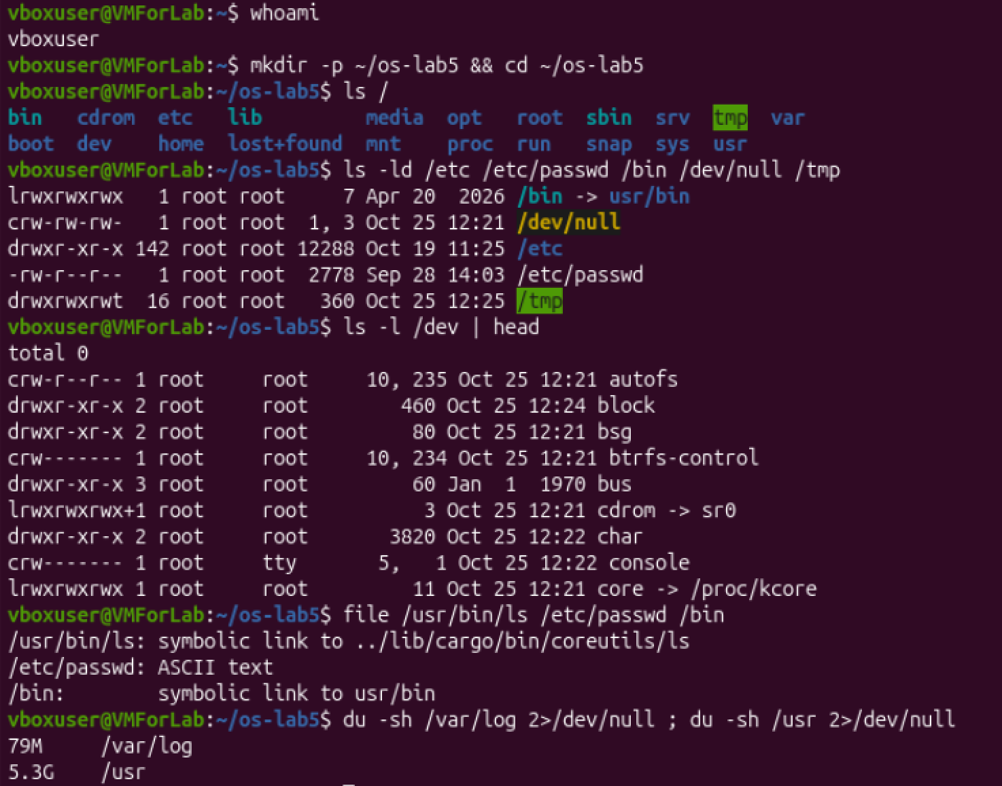
Figure 1.1 – The tree, the file types and the size of directories
To answer the questions about /bin and about the devices I ran three more commands (Figure 1.2): readlink -f /bin shows where the link really goes, and grep with ^c or ^b selects the lines of ls -l /dev that begin with the type letter of a character or a block device.
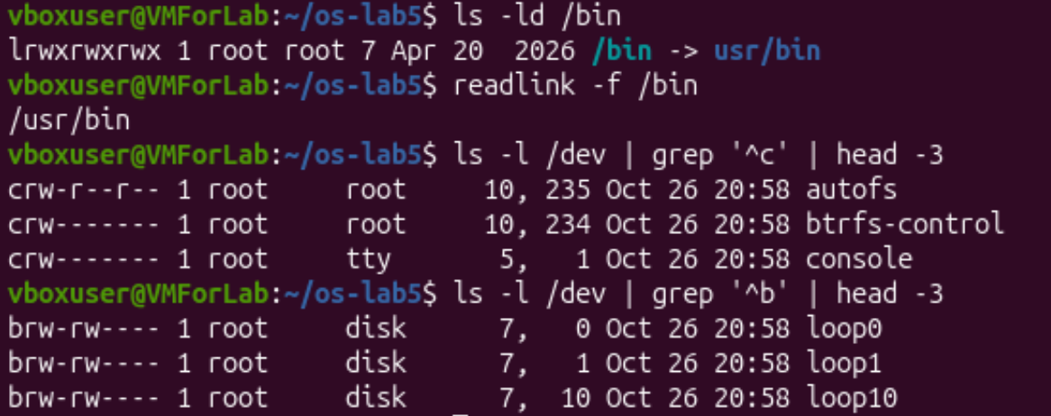
Figure 1.2 – Target of /bin, a character device and a block device

Observe, Part 1
1. The type of a file is the first letter of the ls -l line:
Path | First letter | Type | Comment
/etc | d | directory | drwxr-xr-x
/etc/passwd | - | regular file | file says “ASCII text”
/bin | l | symbolic link | /bin -> usr/bin
/dev/null | c | character device | major 1, minor 3
/tmp | d | directory | drwxrwxrwt, the t is the sticky bit

2. /bin is not a directory but a symbolic link (lrwxrwxrwx) to usr/bin. readlink -f /bin prints the full target /usr/bin (Figure 1.2). So on my system the old /bin is merged into /usr/bin. Even /usr/bin/ls is a link: file says that it points to ../lib/cargo/bin/coreutils/ls, which is the Rust version of the tools that I already noticed in Lab 3.
3. A character device: /dev/console (crw------- root tty 5, 1), also /dev/autofs (10, 235) and /dev/null (1, 3). A block device: /dev/loop0 (brw-rw---- root disk 7, 0), also loop1 and loop10. The letter is c or b instead of -, and instead of the size there are two numbers, the major and minor number of the device driver. A character device gives a stream of bytes (a terminal, /dev/null), a block device gives access to data in blocks (a disk).
4. /usr is bigger: it is 5.3G and /var/log is 79M. The difference is about 5.2 GB, so /usr is roughly 70 times bigger. This is logical, because /usr keeps all programs and libraries of the system, and /var/log has only log files.

Part 2. Inodes and links

2.1 An inode, and a name that is not part of it
I created notes.txt with echo hello > notes.txt and looked at it with stat and ls -li. The file has size 6 (five letters of “hello” and the new line), it uses 8 blocks of 512 bytes (one 4096-byte block), its inode number is 1188253 and it has 1 link. ls -li prints the same inode number in the first column.

2.2 Hard link and removing the “original”
After ln notes.txt hard.txt both names show the same inode 1188253 and the link count 2. Then I ran rm notes.txt. The command cat hard.txt still printed hello, and the link count of hard.txt went back to 1.

2.3 Symbolic link and removing its target
ln -s hard.txt soft.txt created a file with a new inode (1188264), the type l and the size 8. cat soft.txt printed hello. After rm hard.txt the command cat soft.txt failed with “No such file or directory”, while ls -l soft.txt still showed the link (in red, because it is broken).
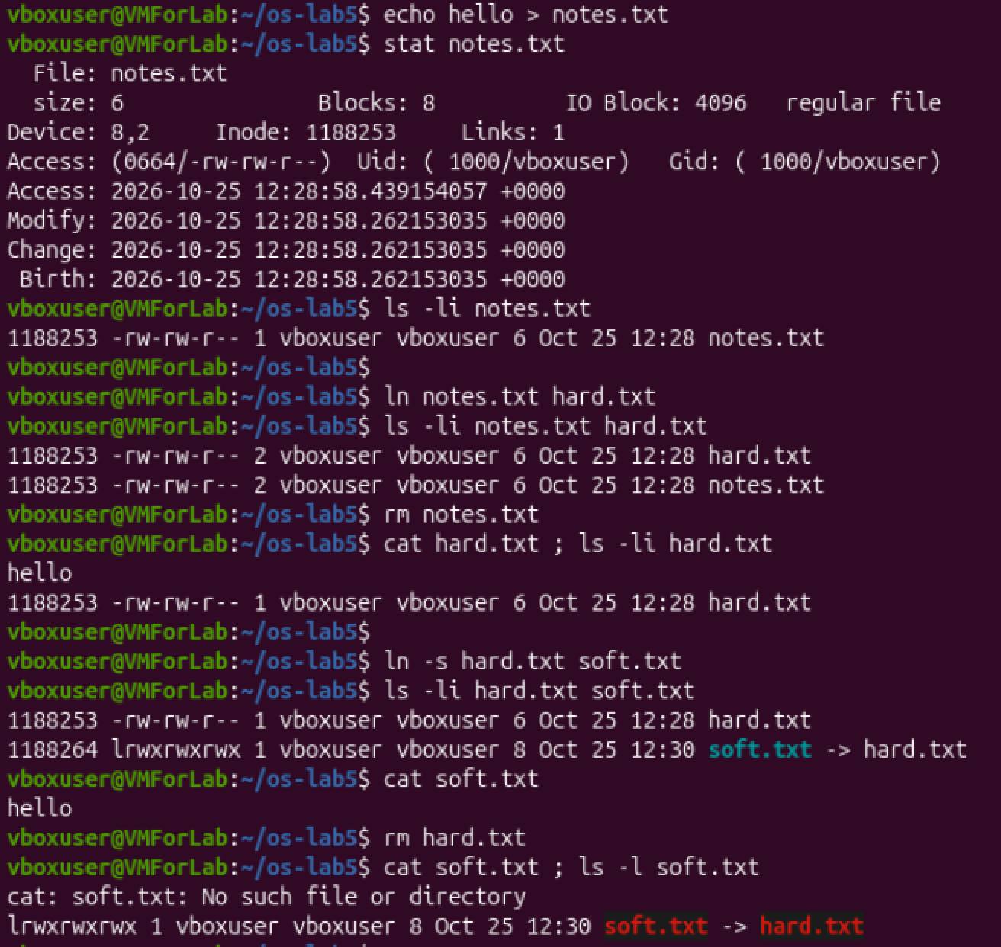
Figure 2.1 – stat, hard link and symbolic link

2.4 Link count of directories and 2.5 Size is not space
A new directory d had 2 links, and after mkdir d/x d/y it had 4. For the second experiment a file with the one line x (2 bytes) was shown by ls -l as 2 bytes but by du -h as 4.0K. The file big.img created with truncate -s 1G was 1.0G for ls -lh and 0 for du -h. I removed it with rm big.img at the end (Figure 2.2).
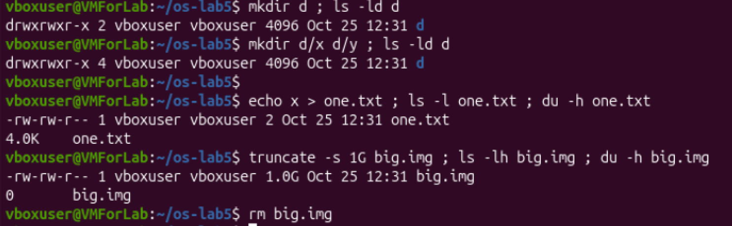
Figure 2.2 – Link count of a directory and size against used space

Observe, Part 2
1. The inode is the number after Inode: in the stat output (1188253). The number of names of the file is Links: (1 at the beginning). The same two numbers are in ls -li: the inode is the first column and the link count is the column after the permissions.
2. hard.txt and notes.txt were two names of one inode, so after rm notes.txt the inode and the data were still there and I could read hard.txt. rm does not remove the file itself: it removes one name (a directory entry) and decreases the link count (from 2 to 1). The data is freed only when the link count is 0 and no process keeps the file open.
3. soft.txt has its own inode and contains only a path, the text hard.txt. When I removed hard.txt, this path pointed to nothing (a dangling link), so cat could not open it, but the link file itself still existed. Its size is 8 because the path hard.txt has exactly 8 characters (the content of the target does not matter).
4. An empty directory has 2 links: the first is its name d in the parent directory, and the second is the entry . inside the directory itself. Every subdirectory has an entry .. which points back to the parent. So d/x and d/y added two more links to d, and the count became 4. (Ordinary files inside a directory do not change the count.)
5. ls -l shows the size of the data (2 bytes), but the file system gives space only in whole blocks, so a file with even one byte takes one block of 4096 bytes, and du shows 4.0K. big.img is a sparse file: truncate only set its length to 1 GB and did not write any data, so the file system did not allocate any block for it and du shows 0.

Part 3. Permissions
I did the three experiments of this part in one session (Figure 3.1). For the files I made s.txt and changed its mode to 600, then to 000 and then I added u+r. I also checked umask and created new.txt and newdir. For the directories I made box with the file box/f inside and tried two modes: read only (u=r,go=) and execute only (u=x,go=), and then I returned the mode with chmod 755 box. At the end I looked at /usr/bin/passwd, /tmp, /etc/shadow.
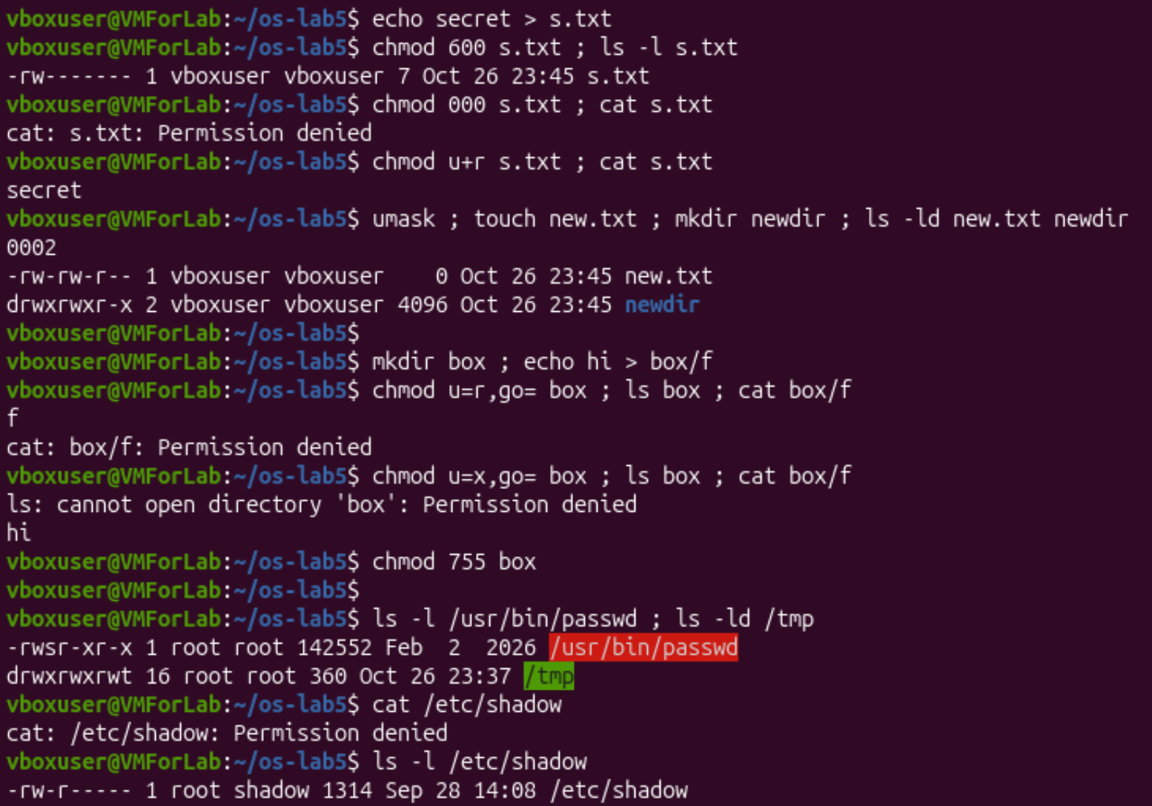
Figure 3.1 – Permissions of files and directories, special bits
Results: with 600 the file was -rw-------; with 000 cat s.txt gave “Permission denied”; after chmod u+r it printed secret. For box with read only, ls box printed f but cat box/f gave “Permission denied”; with execute only, ls box gave “cannot open directory” but cat box/f printed hi. The line -rwsr-xr-x was shown for /usr/bin/passwd, drwxrwxrwt for /tmp, and cat /etc/shadow gave “Permission denied” (its mode is -rw-r-----, owner root, group shadow).

Observe, Part 3
1. The four modes as rwx strings, each with one real use:
Mode | rwx string | Real use
600 | rw------- | a private file that only the owner may read and write, for example a private SSH key (my file s.txt)
644 | rw-r--r-- | an ordinary document or configuration file that everybody may read, for example /etc/passwd
755 | rwxr-xr-x | a program or a public directory, for example the files in /usr/bin
700 | rwx------ | a private directory, for example ~/.ssh

2. The kernel looks at the permission bits of the class to which the user belongs. I am the owner, so only the owner bits are used, and they were ---; the group and “others” bits are not tried as a second chance. Ownership gives the right to change the mode with chmod, not the right to read. That is why I could not read s.txt after chmod 000, but I could give the permission back with chmod u+r.
3. My umask is 0002. It removes the listed bits from the default mode: a new file starts from 666 and becomes 664 (-rw-rw-r--), and a new directory starts from 777 and becomes 775 (drwxrwxr-x). Only the write bit for “others” is removed. This is exactly what ls -ld new.txt newdir showed.
4. On a directory, r allows to read the list of names inside, and x allows to go through the directory and use a name inside it (open box/f). With read only, ls box worked because it can read the names, but cat box/f failed because I could not go through the directory. With execute only it was the opposite: ls failed because it could not read the list, but cat box/f worked, because I knew the name and could go through the directory.
5. The s in -rwsr-xr-x is the setuid bit: the program runs with the rights of its owner (root), not with the rights of the user who started it. passwd needs it because a user changes his password by writing into /etc/shadow, and this file belongs to root and is closed for normal users (-rw-r-----, I could not even read it). The t in drwxrwxrwt is the sticky bit: everybody can create files in /tmp, but only the owner of a file (or the owner of the directory, or root) may delete or rename it.

Part 4. Disks and the kernel as files
I started with lsblk -f (Figure 4.1). Then I ran df -h, mount | grep " / ", grep -c processor /proc/cpuinfo, head -3 /proc/meminfo, head -5 /proc/self/status and ls -l /proc/self/fd (Figure 4.2). At the top of Figure 4.2 there is also the ls -l /etc/shadow of Part 3.
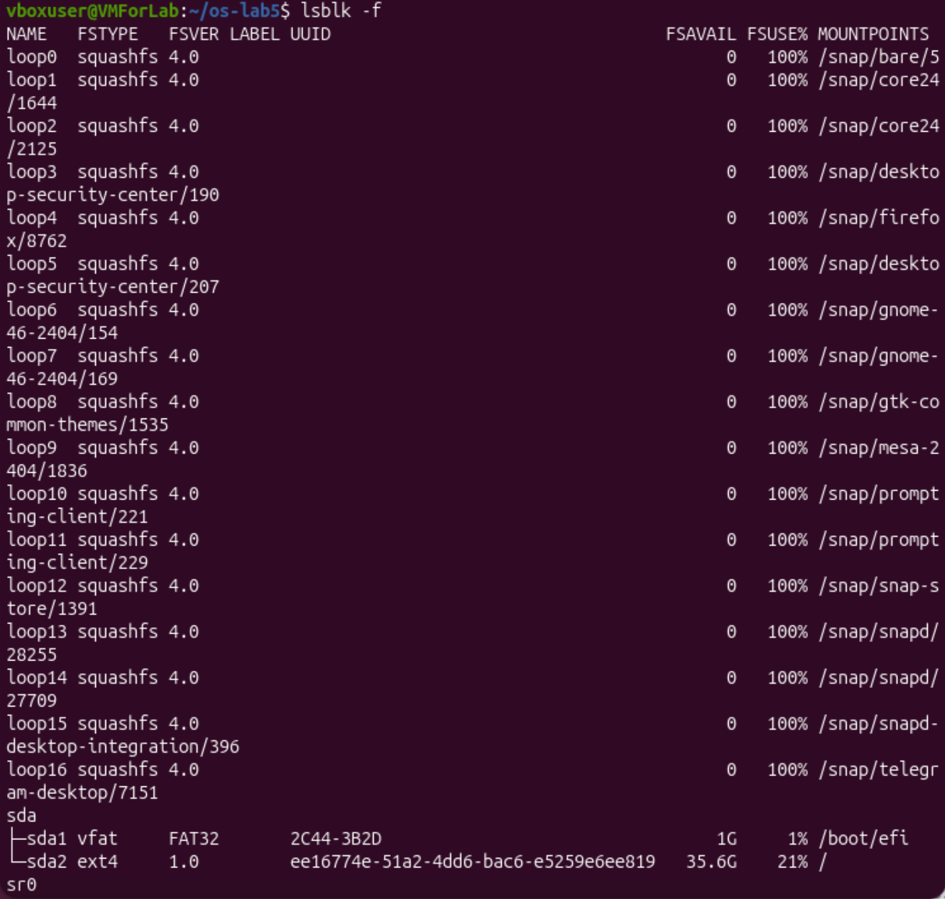
Figure 4.1 – The block devices and their file systems (lsblk -f)
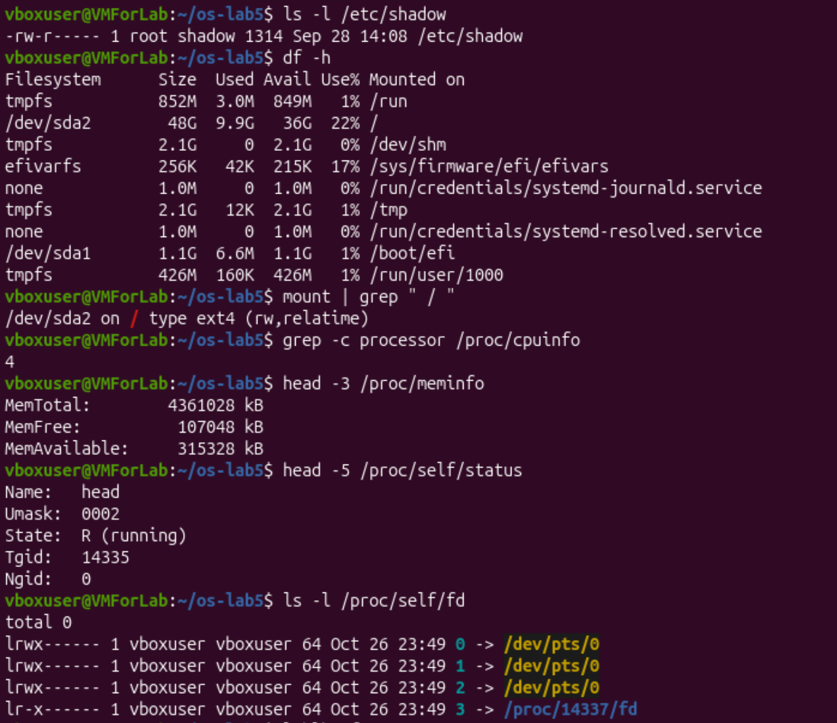
Figure 4.2 – df, mount and the files in /proc

Observe, Part 4
1. My disk is sda (about 50 GB). It has two partitions. sda2 is mounted at / and its file system type is ext4 (/dev/sda2 on / type ext4 (rw,relatime)).
sda (disk, about 50 GB)
|-- sda1 vfat (FAT32) 1.1G mounted at /boot/efi
`-- sda2 ext4 48G mounted at /
sr0 (virtual CD/DVD drive, empty)
loop0..loop16 squashfs (snap packages, read-only)

Besides the real disk, lsblk shows sr0 (the CD drive of the virtual machine) and 17 loop devices loop0 … loop16. Each loop device is a file of a snap package mounted as a file system (squashfs, 100% used, because it is read-only).
2. The root file system is 22% full: df -h shows 9.9G used from 48G, with 36G available (lsblk shows 21% and 35.6G free, the small difference comes from rounding and from the reserved blocks of ext4).
3. According to /proc: 4 CPU cores (grep -c processor /proc/cpuinfo printed 4) and MemTotal: 4361028 kB, that is about 4.2 GiB of RAM. MemFree is only 107048 kB and MemAvailable is 315328 kB: most of the memory is used by programs and by the cache of the files.
4. /proc/self/status showed Name: head. /proc/self is always a link to the process that opens it, and the process which read the file was the program head, not the shell. The shell only started head, and head opened /proc/self/status, so it saw its own status (state R (running)). In the same way ls -l /proc/self/fd showed the descriptors of the ls process: 0, 1 and 2 go to the terminal /dev/pts/0, and descriptor 3 is the directory /proc/14337/fd which ls was reading.

Stretch tasks

(a) Magic numbers
I compressed /etc/passwd into a file with the wrong extension: gzip -c /etc/passwd > notes.txt. The command file notes.txt still said “gzip compressed data, was passwd”, with the original size 2778 bytes (it is the real size of /etc/passwd). The first line of xxd is 1f8b 0808 ae73 ba6a 0003 7061 7373 7764 (Figure 5.1).
file does not trust the name, it reads the first bytes of the file. The type is told by the “magic number” 1f 8b at the very beginning, which is the signature of gzip. The next byte 08 is the compression method (deflate), and the next 08 is the flag which says that the original file name is stored: this is the text passwd (bytes 70 61 73 73 77 64) at the end of the line.

(b) Hunt for setuid programs
The command find / -xdev -perm -4000 -type f 2>/dev/null found the files with the setuid bit (Figure 5.1). Besides the well-known ones (passwd, su, sudo, mount, umount, chsh, chfn, gpasswd) there are less obvious programs: dbus-daemon-launch-helper, ssh-keysign, pkexec, ntfs-3g, fusermount3 and pppd. Also sudo and su are in /usr/lib/cargo/bin (the Rust version), and there is /usr/bin/sudo.ws, which looks like the old classic sudo kept as an alternative. Every setuid program is a place where an ordinary user gets root rights for a moment, so the list should be as short as possible.
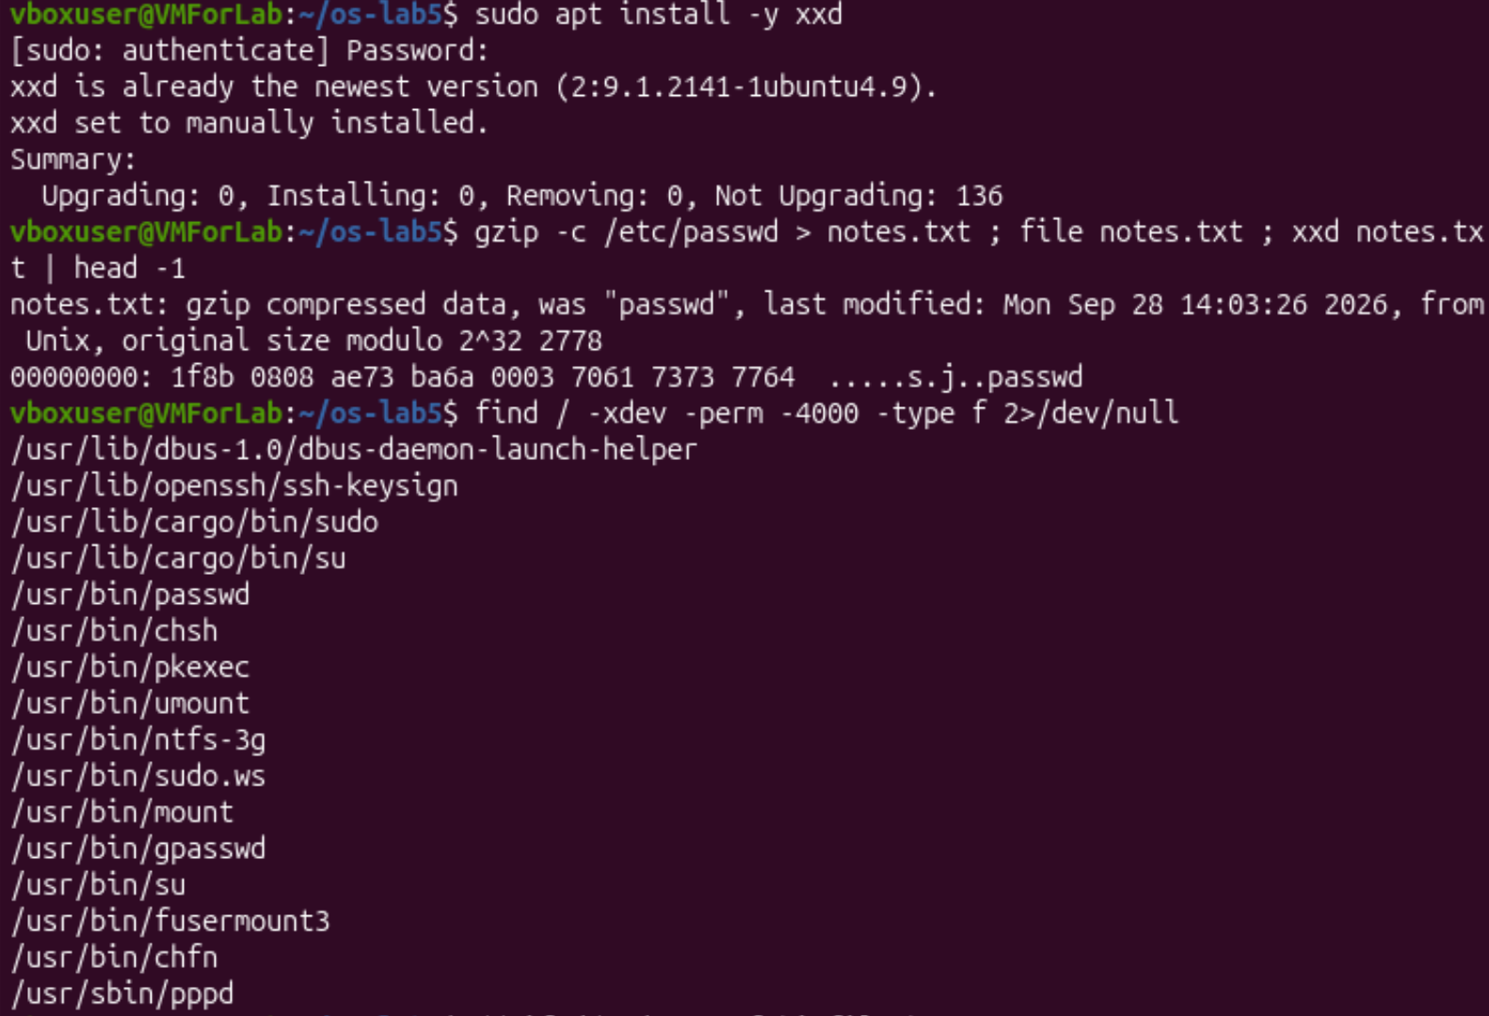
Figure 5.1 – Magic bytes of a gzip file and the setuid programs

(c) Deleting a file that is still open
I created a 200 MB file with dd if=/dev/zero of=bigfile bs=1M count=200, opened it on descriptor 3 with exec 3< bigfile and removed it with rm bigfile. Then I looked at ls -l /proc/$$/fd (Figure 5.2).
The link of descriptor 3 says /home/vboxuser/os-lab5/bigfile (deleted): the name is already gone, but my shell still keeps the file open, so the inode and the data stay. The space was not freed: before and after rm df -h . showed the same 11G used (23%). (The value 11G is the result of rounding up: before the file there was 9.9G, and 9.9G + 200 MB is a little more than 10 GB.) After I closed the descriptor with exec 3<&-, df -h . showed 9.9G (22%) again. So the space is really freed when the last name is removed and the last process closes the file. This is the reason why a deleted big log file can still fill the disk until the program that writes it is restarted.
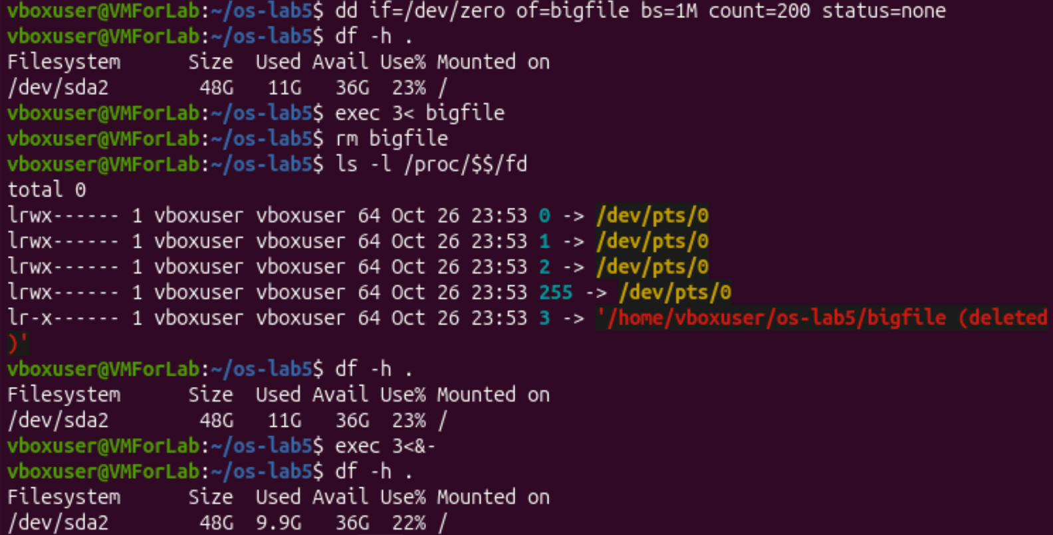
Figure 5.2 – Space is freed only after the file is closed

(d) A new file system in a file
With sudo I made a small disk in a file: truncate -s 64M disk.img, then mkfs.ext4 -F disk.img and sudo mount -o loop disk.img /mnt. It was mounted as /dev/loop17 (Figure 5.3). df -h /mnt showed the size 56M, 152K used and 52M available, and df -i /mnt showed 16384 inodes, 12 used and 16372 free. At the end I did sudo umount /mnt and rm disk.img.
mkfs created 16384 inodes (and 16384 blocks of 4 KB). So the number of files in this file system is limited to 16384 even if there is free space: when the inodes are finished, no new file can be created. 12 inodes are already used by the system (the reserved inodes, the root directory and lost+found). The size 56M is smaller than 64M because the inode tables (16384 inodes × 256 bytes = 4 MB) and the journal (1024 blocks = 4 MB) also take space; 5% of the blocks is reserved for root, which is why only 52M is available.
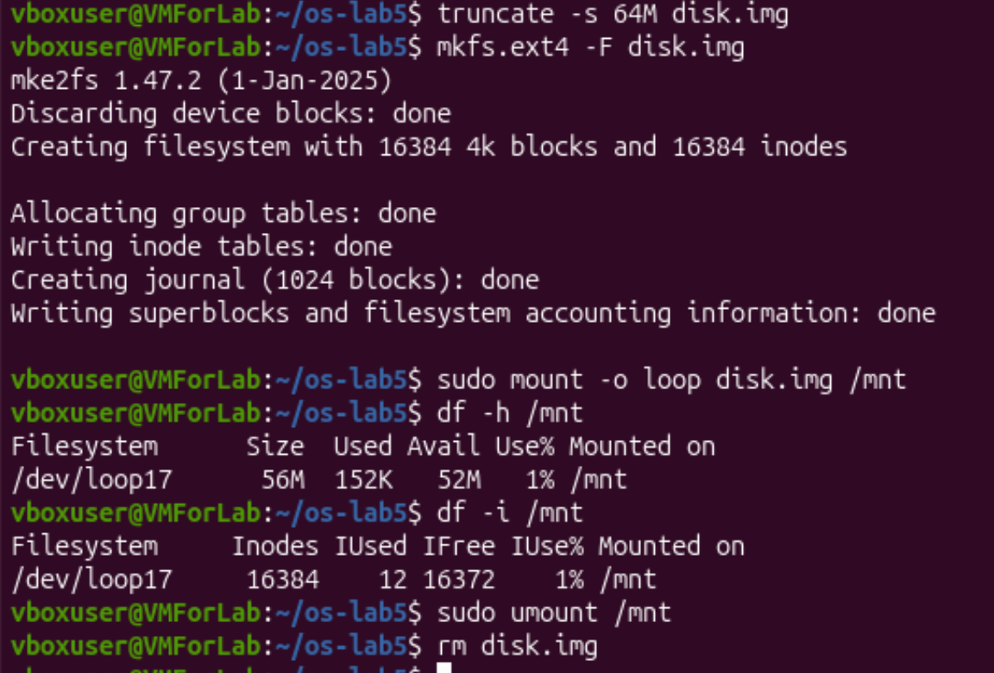
Figure 5.3 – A 64 MB ext4 file system in a file, mounted with a loop device

3. Conclusions
In this lab I checked on my own Ubuntu what the lecture said about the file system. My main findings are:
- In Linux everything is in one tree, and the first letter of ls -l tells the type: directory, regular file, symbolic link, character or block device. /bin on my system is only a link to /usr/bin, and even /usr/bin/ls is a link to the Rust version of the tools.
- A name is not the file. The file is an inode, and a name is a directory entry which points to it. A hard link is one more name of the same inode, and rm only removes a name and decreases the link count. The data is freed when there are no names left and no process keeps the file open (Stretch c).
- A symbolic link is a separate small file with a path inside. It breaks when the target is removed. A new directory has 2 links, and every subdirectory adds one through its ...
- The size from ls is not the space on the disk: a 2-byte file takes a 4096-byte block, and a sparse file of 1 GB takes nothing.
- Permissions are checked by the class of the user (owner, group, others), so being the owner does not give the right to read. On a directory r is for listing and x is for going through. The umask 0002 gives 664 for files and 775 for directories. The setuid bit (passwd) and the sticky bit (/tmp) solve special tasks.
- The disk of my machine is sda with an EFI partition (vfat) and a root partition sda2 (ext4, 22% used). The kernel shows information as files: /proc/cpuinfo (4 cores), /proc/meminfo (about 4.2 GiB of RAM) and /proc/self, which is always the process that reads it. I also saw that file recognizes the type by the magic bytes, and that a file system has a fixed number of inodes (16384 for a 64 MB ext4).
The most interesting experiments for me were the deleted file that still holds the disk space and the box directory, where ls worked without cat and the opposite. They show that the file system works with inodes and bits, and not with the names that I see in the terminal.

