Ministry of Education and Research of the Republic of Moldova
Technical University of Moldova
Faculty of Computers, Informatics and Microelectronics
Department of Software Engineering and Automatics
REPORT
on laboratory work no. 6
Course: Operating Systems
Topic: Inside the xv6 File System
Done by: st. gr. FAF-242, Olga Saban
Checked by: assist. univ. Patricia Reițman
Chișinău, 2026

1. Purpose of the work
The xv6 file system has the same ideas as ext4 (inodes, directories as tables, hard links, a journal), but in a few hundred lines of readable code. The purpose of this lab is to read what xv6 shows about its files, to write my own stat program (mystat), to measure the limits written in kernel/fs.h, and to write find, a program which walks the directory tree recursively.
I worked in my ~/xv6-riscv tree on Ubuntu in a virtual machine (user vboxuser). xv6 runs inside QEMU as a small RISC-V computer. The make qemu command (Figure 1.1) starts it with 128 MB of RAM, 3 processors (“hart 1/2 starting”) and a virtual disk, the file fs.img. In the xv6 shell I used Ctrl-A, then X to leave QEMU.

2. The work done

Preparation
I checked the environment with bash ~/os2026-olga-saban/os2026-setup.sh --check (Figure 0.1). The script found the system (Ubuntu 26.04.1 LTS), all the tools (git, make, gcc, bash, grep, sed, awk), the RISC-V compiler riscv64-linux-gnu-gcc and QEMU 10.2. It also found my xv6 in /home/vboxuser/xv6-riscv, built it and booted it once.
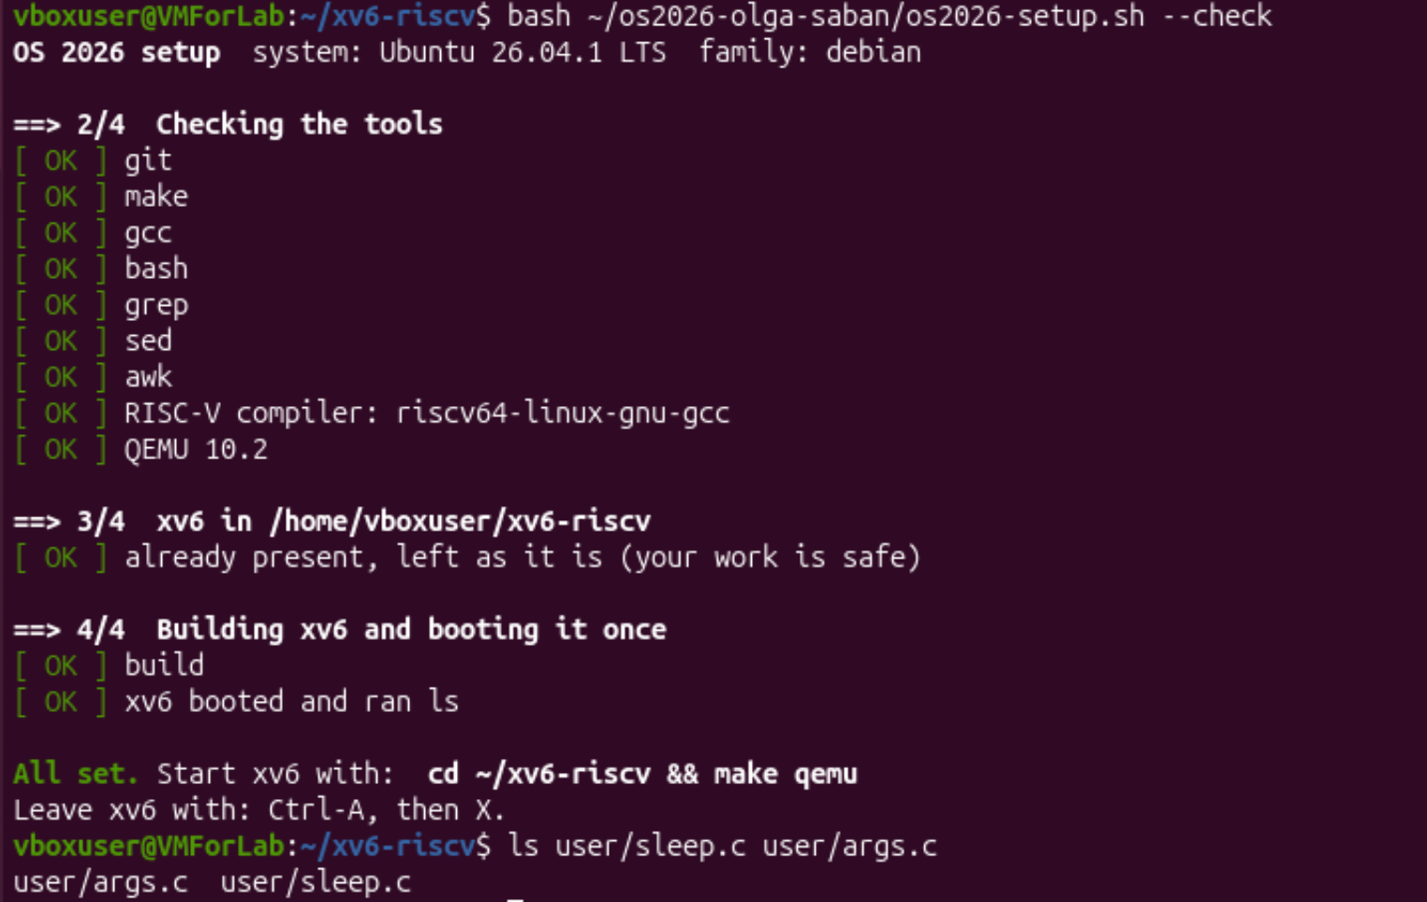
Figure 0.1 – Checking the toolchain, QEMU and xv6

Part 1. Read what xv6 shows you
First I opened kernel/stat.h to decode the file types, and with grep I found the constants ROOTINO and DIRSIZ in kernel/fs.h (Figure 1.1). Then I started xv6 with make qemu and ran ls. In xv6 every line of ls has four columns: the name, the type, the inode number and the size in bytes (Figure 1.2). After that I made an empty directory with mkdir a and listed it with ls a. The definitions of struct dinode and struct dirent are in Figure 1.3.
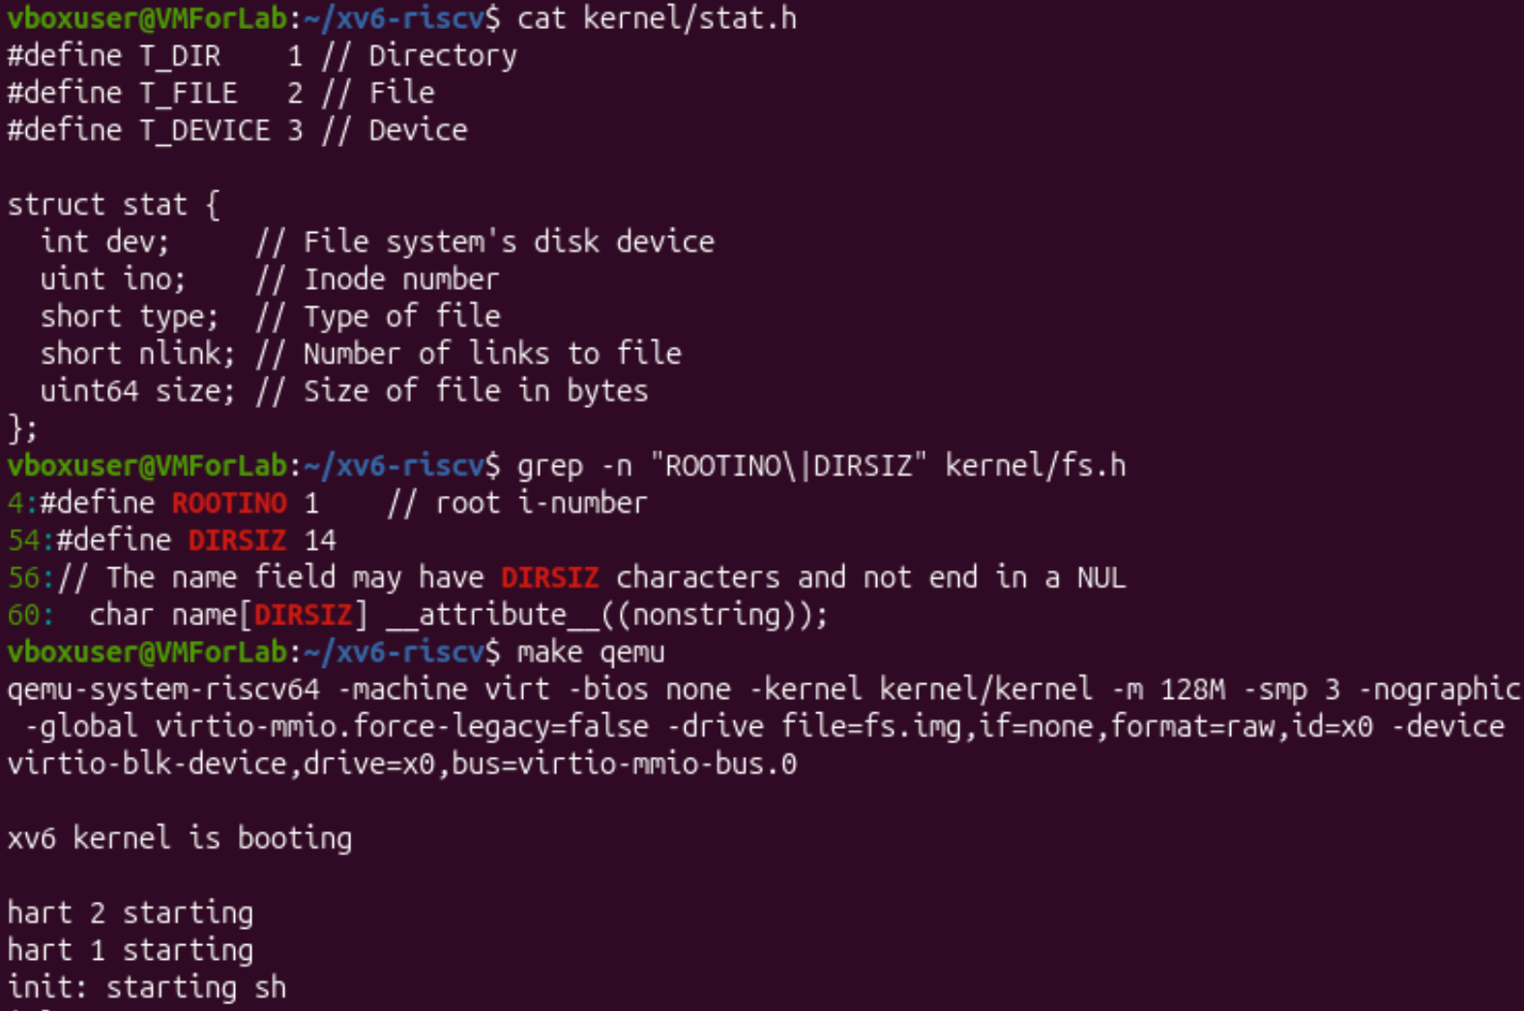
Figure 1.1 – kernel/stat.h, constants from fs.h and the start of xv6
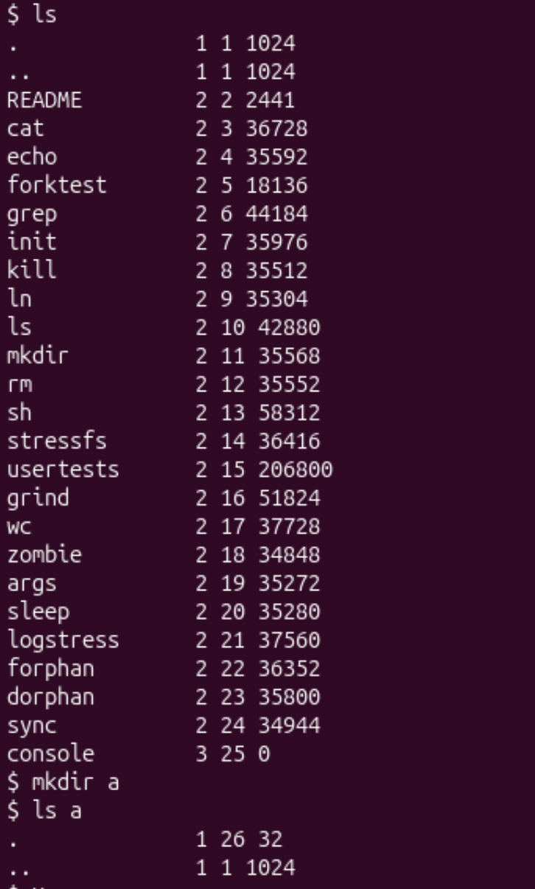
Figure 1.2 – ls in the root directory, then mkdir a and ls a
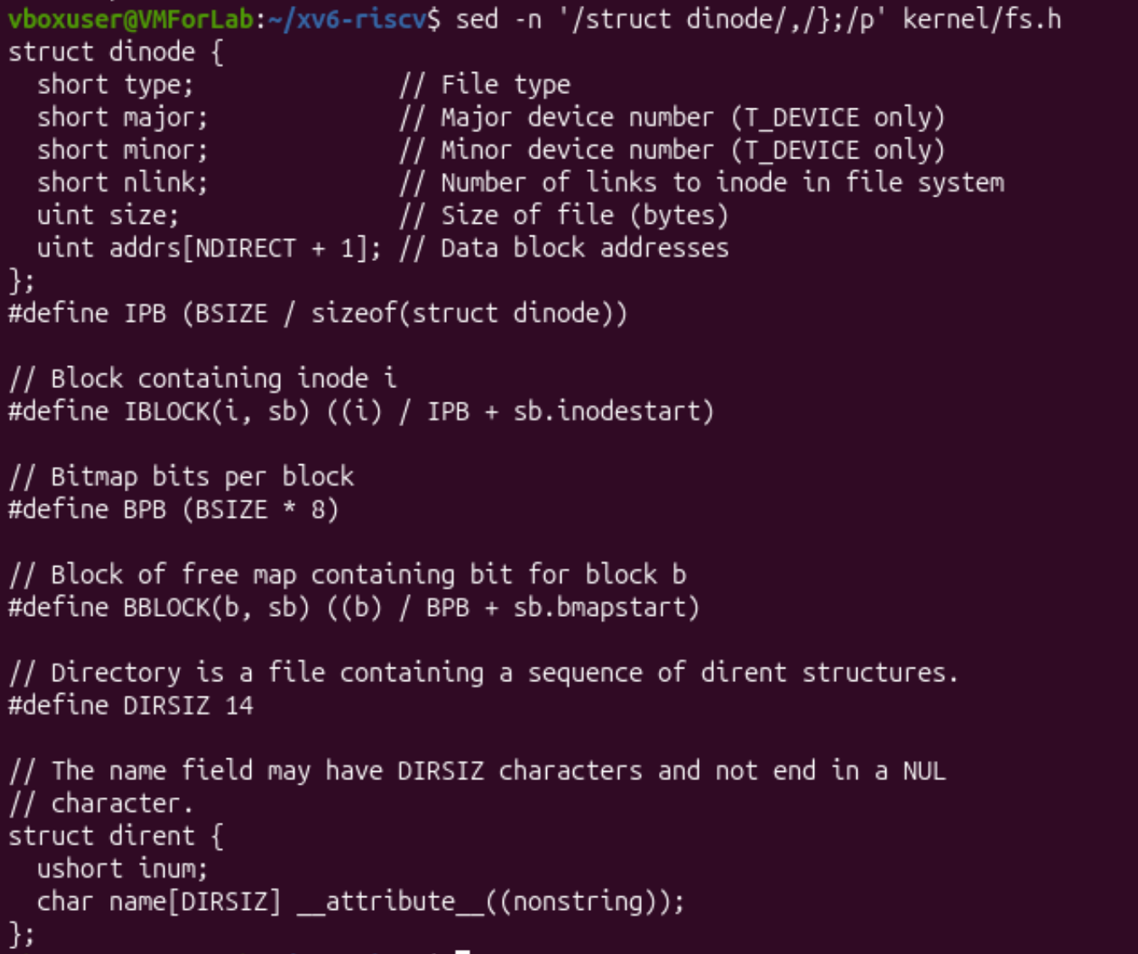
Figure 1.3 – struct dinode and struct dirent in kernel/fs.h

Observe, Part 1
1. In kernel/stat.h the types are T_DIR 1 (directory), T_FILE 2 (ordinary file) and T_DEVICE 3 (device). So in the output of ls the lines with type 1 (., ..) are directories, the lines with type 2 (README, cat, echo, …) are files, and console with type 3 is a device (its size is 0, because it has no data on the disk).
2. The root directory has the inode number 1 (#define ROOTINO 1 in fs.h). The root has no parent, so its entry .. points back to itself, and both . and .. show the same inode 1 (1 1 1024). It is the same as in Linux, where /.. is /. For the directory a the entry . is its own inode (26) and .. is the root (inode 1).
3. A directory is a file with a sequence of struct dirent records. One record is ushort inum (2 bytes) and char name[DIRSIZ] with DIRSIZ = 14 (14 bytes), so one entry is 16 bytes. An empty directory has size 32, that is 32 / 16 = 2 entries. These are . (inode 26, the directory itself) and .. (inode 1, the parent). This agrees with ls a in Figure 1.2.

Part 2. Write mystat
I wrote user/mystat.c (Figure 2.1). The function typename() returns “directory”, “file” or “device” for T_DIR, T_FILE and T_DEVICE (and “?” for anything else). In main() a loop goes over all arguments: stat(argv[i], &st) fills struct stat, and if it fails the program prints an error to descriptor 2 (stderr) and continues with the next argument. Otherwise it prints NAME: TYPE, inode N, links N, size N bytes. The size is converted with (int) because it is a 64-bit number and xv6 printf prints %d. The line $U/_mystat was added to UPROGS in the Makefile (see Figure 4.3).
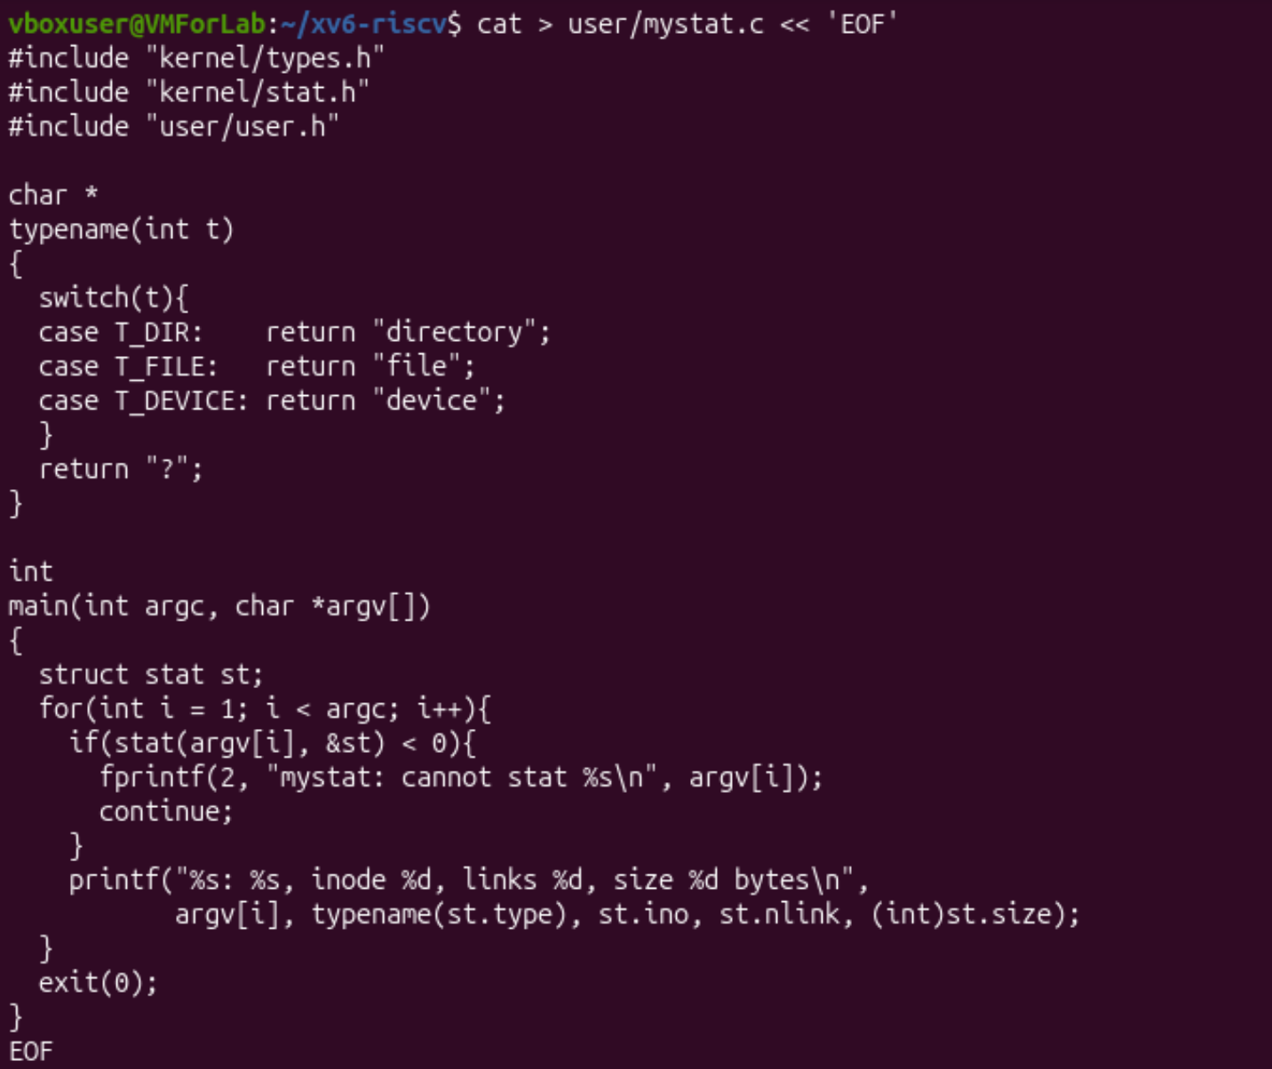
Figure 2.1 – user/mystat.c
Then I used it to watch the hard links at work (Figure 2.2). On the fresh disk mystat README . console gave: README is a file with inode 2, 1 link and 2441 bytes; . is a directory with inode 1 and 1024 bytes; console is a device with 0 bytes. (Its inode is 27 here and 25 in Figure 1.2, because I added two programs, find and mystat, which take two inode numbers before console.) For a file which does not exist, mystat printed the error and went on. In this run the error line also contained the name in brackets, its length (10) and the code of its last letter (101, the letter “e”).
After that I made the second name with ln README r2, checked both names with mystat README r2, removed the first name with rm README and checked the second one, then ran cat r2 | wc.
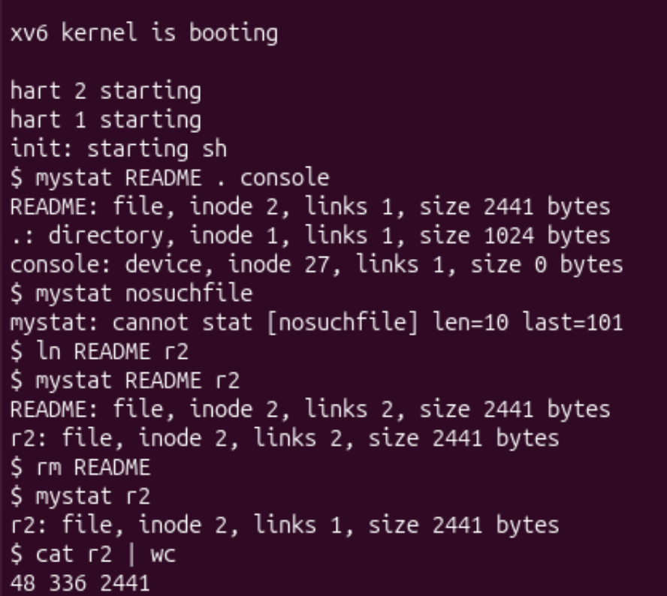
Figure 2.2 – mystat, a hard link and removing the first name
To find the code which changes the link count I used grep -n "nlink" kernel/sysfile.c (Figure 2.3).
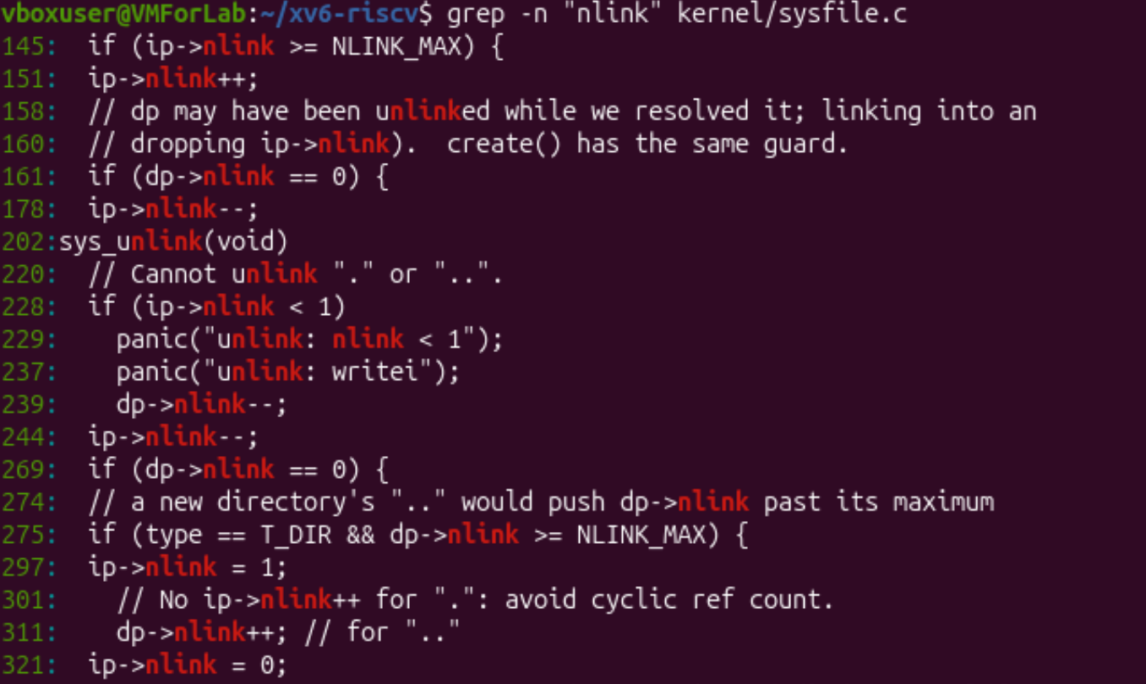
Figure 2.3 – Where kernel/sysfile.c changes nlink

Observe, Part 2
1. The outputs are in Figure 2.2. After ln README r2 both names show inode 2, links 2, size 2441. After rm README the name r2 shows inode 2, links 1, size 2441, and cat r2 | wc prints 48 336 2441 (48 lines, 336 words, 2441 bytes), so the whole text of README is still there. What changed: only the link count (1, then 2, then 1). What did not change: the inode number, the size and the content. A hard link is not a copy, and there is no “original”: both names were equal, so removing one did not touch the file. It is the same experiment as notes.txt and hard.txt in Lab 5.
2. In sys_unlink (it starts at line 202 of kernel/sysfile.c) the line 244, ip->nlink--;, decreases the link count of the file. Before it, the directory entry is erased by writing an empty dirent (the writei call with the panic message at line 237). Line 239, dp->nlink--;, is for the case when a directory is removed: its .. entry no longer points to the parent. The data blocks are not freed by unlink itself. They are freed when the link count is 0 and no process has the file open any more: the inode is released in iput() in kernel/fs.c, which truncates the file and frees its blocks. The same rule as for the deleted open file in Lab 5.
Other lines in Figure 2.3 show how the count grows: sys_link does ip->nlink++ (line 151) after checking NLINK_MAX; create() sets ip->nlink = 1 for a new inode (line 297) and dp->nlink++ for the .. of a new directory (line 311). Line 301 says that there is no nlink++ for ., “to avoid a cyclic ref count”. So in xv6 the entry . is not counted, and mystat . for the root shows links 1, while in Linux an empty directory has 2 links (Lab 5).
3. struct dinode (Figure 1.3) has only these fields: type, major and minor (for devices), nlink, size and addrs[NDIRECT + 1] (the addresses of the data blocks: 12 direct and 1 indirect). There is no owner, no permission bits, no time stamps and no name (the name lives in the directory). There is no type for a symbolic link either: the types are only directory, file and device. That is why xv6 has no symbolic links and no permissions. With these fields an inode takes 64 bytes (3 × 2 + 2 + 4 + 13 × 4), so one block of 1024 bytes holds IPB = 16 inodes.

Part 3. Measure the limits
With grep -n "define BSIZE\|define NDIRECT\|define NINDIRECT\|define DIRSIZ" kernel/fs.h I got the four constants. Then I rebuilt the disk with make clean ; make fs.img 2>&1 | grep nmeta to see the disk layout which the program mkfs prints (Figure 3.1). The same nmeta line appears in the full build output (Figure 3.2), where mkfs also reports how many blocks are already used by the programs.
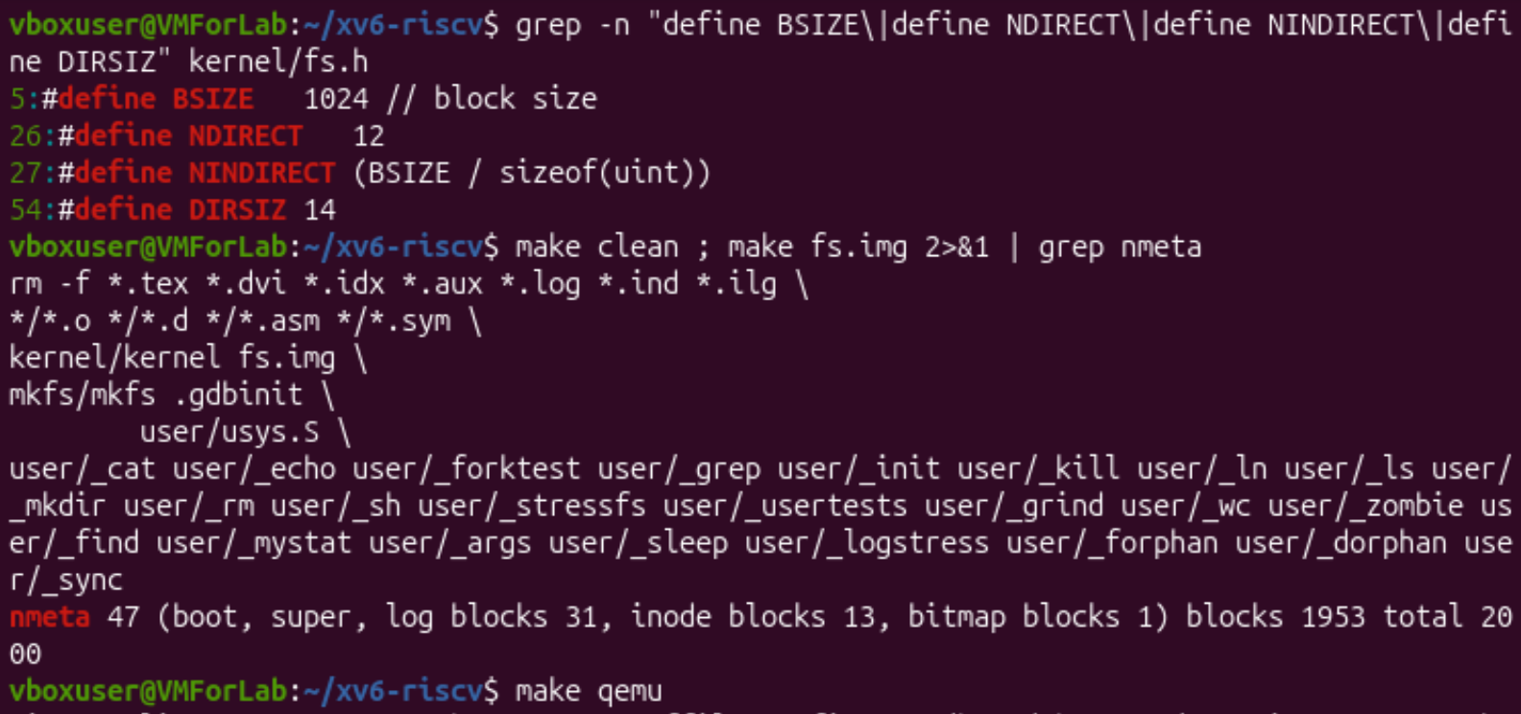
Figure 3.1 – The constants of fs.h and the nmeta line
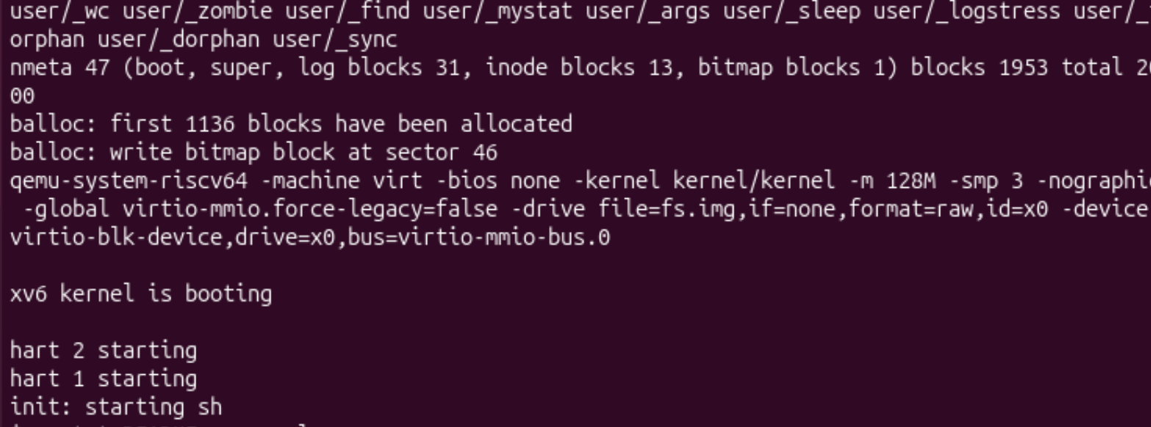
Figure 3.2 – Build of fs.img: nmeta and balloc lines, then xv6 starts
At the end I started xv6 and made a directory with a very long name: mkdir averyveryverylongname, then ls (Figure 3.3).
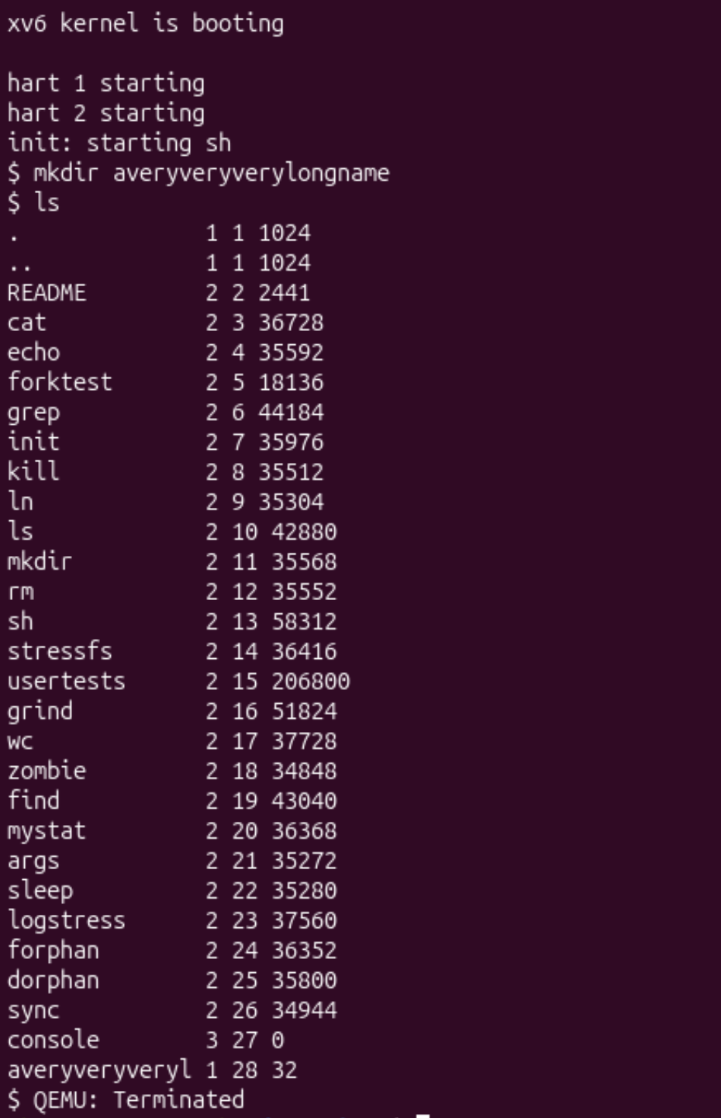
Figure 3.3 – A directory with a name longer than DIRSIZ

Observe, Part 3
1. ls shows averyveryveryl for the directory (type 1, inode 28, size 32). The name has 23 letters, but only the first 14 are kept. The constant DIRSIZ = 14 is the size of the name field of a directory entry, so a longer name is cut when it is stored. mkdir did not give any error. For xv6 two names with the same first 14 letters would be the same name.
2. The constants are BSIZE = 1024, NDIRECT = 12 and NINDIRECT = BSIZE / sizeof(uint) = 1024 / 4 = 256. An inode has 12 direct blocks, and one indirect block holds 256 block numbers of 4 bytes. So the largest file has 12 + 256 = 268 blocks:
(NDIRECT + NINDIRECT) * BSIZE = (12 + 256) * 1024
= 268 * 1024 = 274 432 bytes (268 KB)

3. The line is nmeta 47 (boot, super, log blocks 31, inode blocks 13, bitmap blocks 1) blocks 1953 total 2000. So the whole disk has 2000 blocks (2000 KB, because a block is 1 KB). The 47 blocks of metadata are: 1 boot block, 1 super block, 31 for the log, 13 for the inodes and 1 for the bitmap. The other 1953 blocks are for data. Check: 2 + 31 + 13 + 1 = 47 and 47 + 1953 = 2000.
Area | Blocks | Block numbers
boot block | 1 | 0
super block | 1 | 1
log (journal) | 31 | 2 – 32
inodes (13 × 16 inodes) | 13 | 33 – 45
free-block bitmap | 1 | 46
data | 1953 | 47 – 1999

The bitmap in block 46 agrees with the line “write bitmap block at sector 46” in Figure 3.2. The line “first 1136 blocks have been allocated” means that the metadata and the programs of the image already use 1136 blocks, i.e. 1136 − 47 = 1089 data blocks, and 1953 − 1089 = 864 data blocks are still free.

Part 4. Write find
I wrote user/find.c (Figures 4.1 and 4.2) starting from the idea of user/ls.c. The program is find <dir> <name> [-n] and it prints every path under <dir> whose last component is <name>. The logic is:
- lastname(path) returns the last component of a path (a/b/r2 → r2): it goes from the end of the string back to the last /.
- find(path, name, showino) opens the path and calls fstat. If lastname(path) is equal to name (strcmp), the path is printed (with the inode number when -n is given).
- If the path is a directory (T_DIR), the program copies the path into a buffer buf[512] (first it checks that the path is not too long), adds /, and reads the struct dirent entries one by one with read.
- Entries with inum == 0 (free slots) and the names . and .. are skipped, so the program never goes up or loops. For all other entries the name is copied after the /, the end of the string is set with p[DIRSIZ] = 0 (a name of 14 letters has no NUL), and find is called again for the new path (the recursion).
- Every opened descriptor is closed (close(fd)) on all the ways out, because a process can have only 16 open files. main checks argc and prints a usage message to stderr with exit(1); the third argument -n switches showino on.
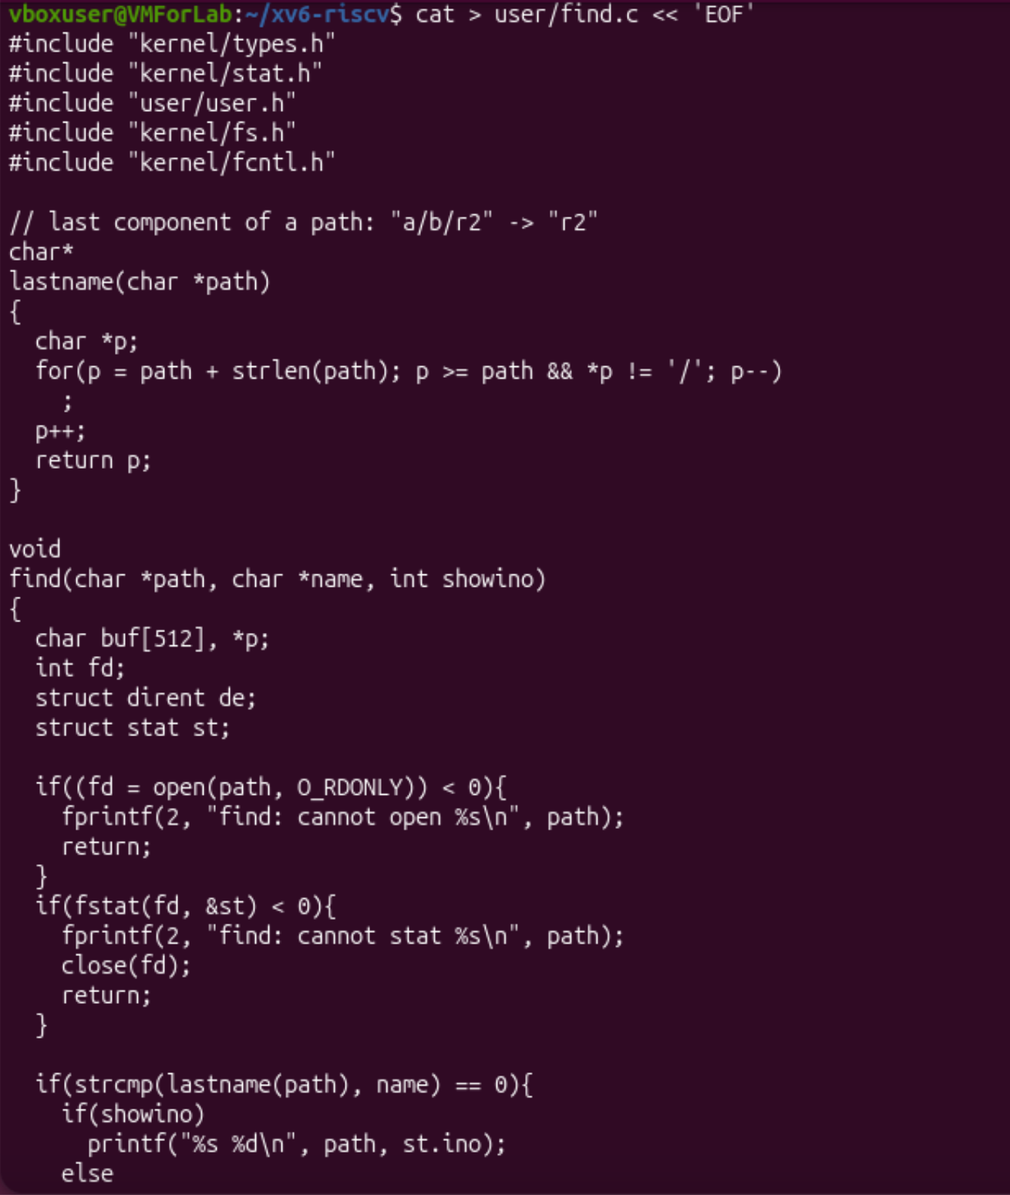
Figure 4.1 – user/find.c, the first part
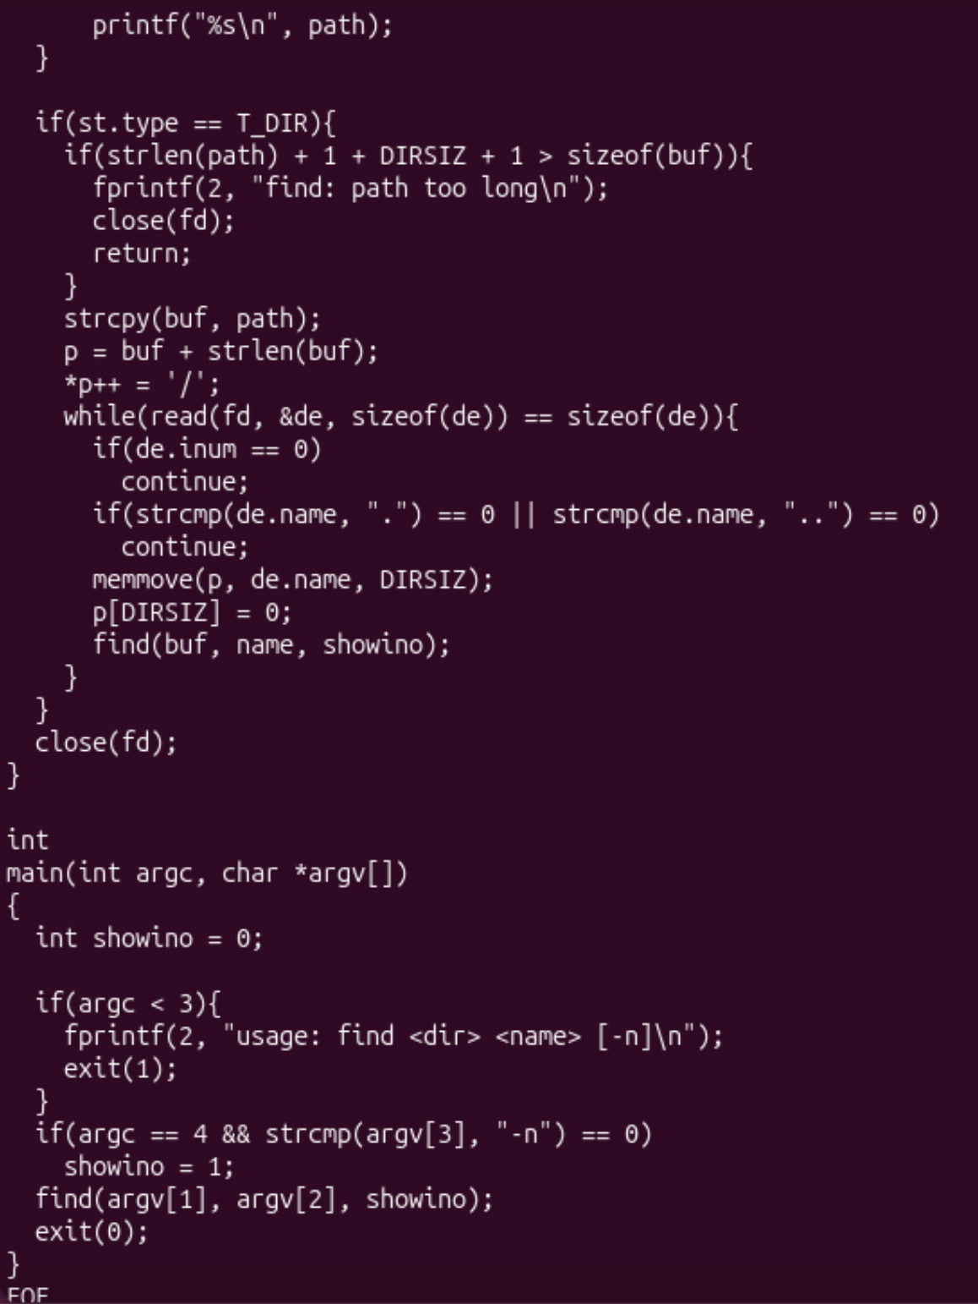
Figure 4.2 – user/find.c, the second part
Both programs must be in the Makefile. A small Python script added the lines $U/_find\ and $U/_mystat\ after $U/_zombie\ in UPROGS, but only if they were not there yet. I checked the result with grep -n "_mystat\|_find" Makefile | cat -A: both lines (149 and 150) begin with a TAB (^I) and end with the backslash and nothing after it (\$), as the task requires. Then make qemu compiled find.c and mystat.c, linked them and put them into fs.img (Figure 4.3).
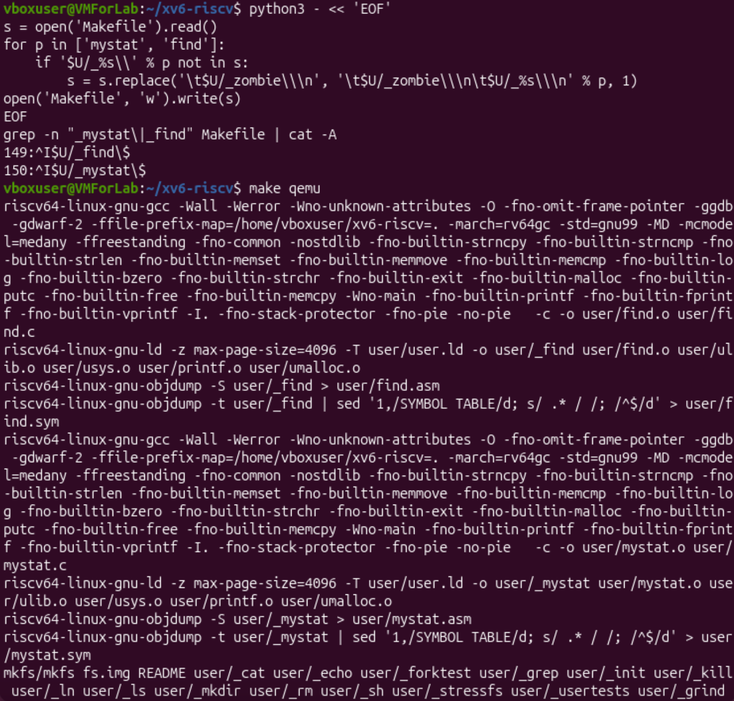
Figure 4.3 – Adding find and mystat to UPROGS and building them
I tested find on a fresh disk (make clean ; make qemu) with the commands from the task (Figure 4.4). find . r2 printed ./a/b/r2, ./a/r2 and ./r2, and find a b printed a/b: the program also finds a directory, not only files, because it compares the name of any entry. The order of the lines follows the order of the entries in the directories: first a (and inside it b), then r2 of the root.

Stretch: the option -n
The third argument -n is already in the code (variable showino). find . r2 -n printed the inode next to each path: ./a/b/r2 30, ./a/r2 31 and ./r2 3. For comparison mystat cat printed cat: file, inode 3, links 2, size 36728 bytes.
So only `./r2` is the same file as cat: it has the same inode 3, and cat has 2 links now, because it has two names (cat and r2, made with ln cat r2). The other two files, ./a/b/r2 (inode 30) and ./a/r2 (inode 31), have the same name but they are different files, created by echo x > a/b/r2 and echo y > a/r2. This shows that the name is not the file: the same name in different directories can mean different inodes, and different names can mean the same inode.
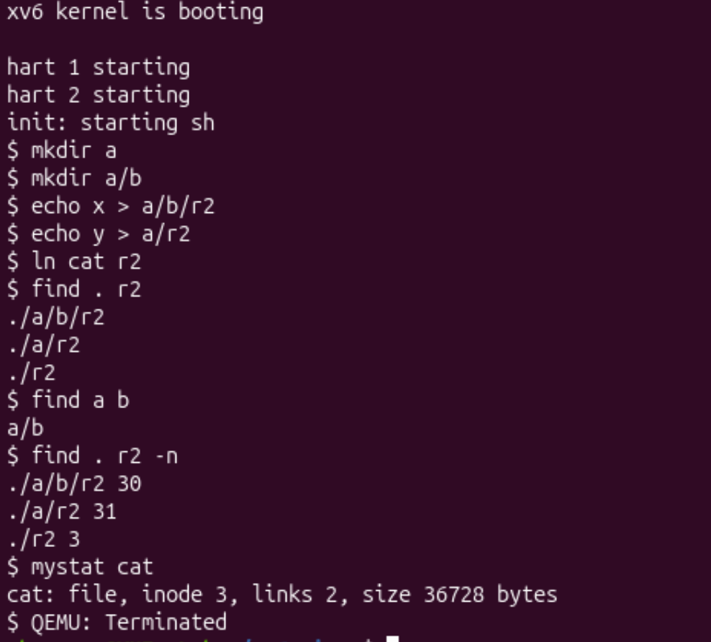
Figure 4.4 – Testing find, the option -n and mystat cat

Submission to Git
The task says that the report and the code must also be in my Git repository. I moved the xv6 folder into the folder of the course repository with mv ~/xv6-riscv ~/os2026-olga-saban/ and ran git add . (Figure 5.1). Inside xv6-riscv it worked, but in the outer folder git add . printed the warning “adding embedded git repository: xv6-riscv”. It means that xv6-riscv is itself a Git repository (it has its own .git), so the outer repository would only remember a pointer to it, and a clone of my repository would not contain mystat.c, find.c and the Makefile. Therefore these files must be added to the outer repository as ordinary files (or the inner repository must be a real submodule).
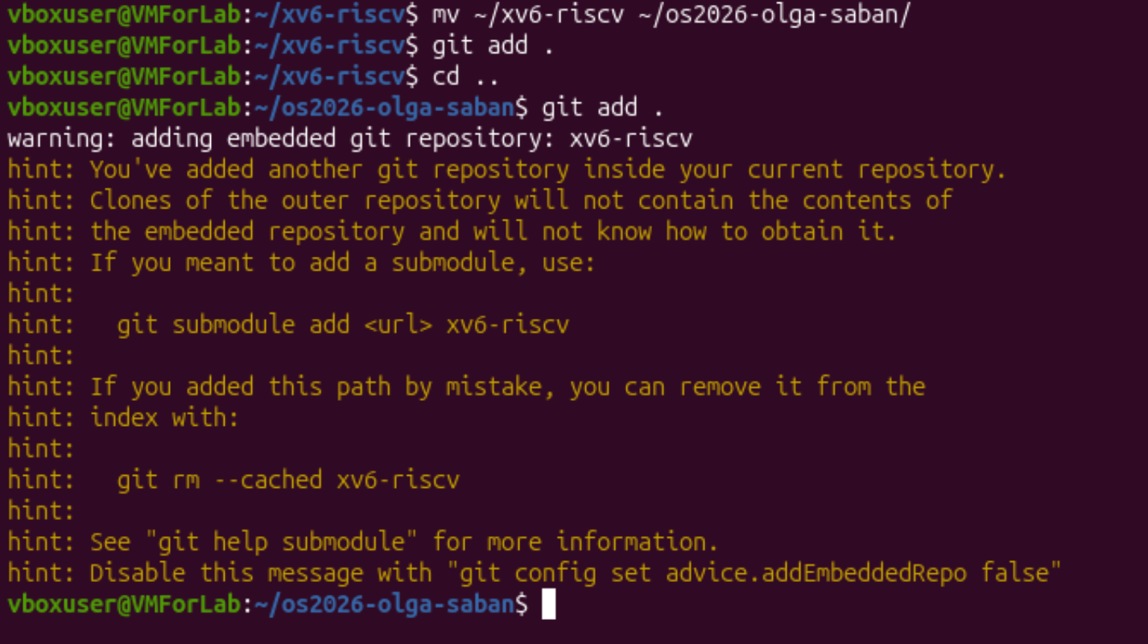
Figure 5.1 – git add and the warning about an embedded repository

3. Conclusions
In this lab I looked at a file system from the inside and compared it with what I did in Lab 5 on Linux. My main findings are:
- An xv6 file has only a type, a link count, a size and the block addresses (struct dinode). There are no names, permissions or owners in the inode: the name is in a directory, which is an ordinary file with 16-byte entries (a 2-byte inode number and a 14-byte name). The root directory is inode 1 and its .. points to itself.
- Hard links work like in Linux. After ln and rm the file kept its inode, size and text, and only nlink changed. sys_unlink decreases nlink (line 244), and the blocks are freed only when nlink is 0 and nobody has the file open. xv6 does not count the entry ., so the link counts of directories differ from Linux.
- The limits are written in fs.h: a name has at most 14 letters (a longer one is cut to averyveryveryl), and a file has at most 12 + 256 = 268 blocks of 1 KB, that is 274 432 bytes. The disk of 2000 blocks has 47 blocks of metadata (boot, super, 31 log, 13 inodes, 1 bitmap) and 1953 blocks of data.
- My mystat shows type, inode, links and size with the stat call, and my find walks the tree recursively using open, read of directory entries, fstat and close. The option -n showed that of three files named r2 only one is the same file as cat.
- The nmeta line shows the same parts as in ext4: the inode area, the bitmap and the log (journal), only much smaller and simpler. I also met the practical problem of an embedded Git repository when I tried to put the xv6 folder into the course repository.
The most useful part was reading sysfile.c and fs.h together with the experiments: when I saw the line ip->nlink--; and the output links 2 → links 1, the idea “a name is a link to an inode” became clear.

