1. import java.util.scanner;

public class Scan{

public static void main(String[]args)

{

System.out.println();

Scanner sc=new Scanner (System.in);

int n=sc.nextInt();

int i=2, sum=0;

do{

sum=sum+i;

i+=2;

}while (i<=n);

System.out.println(sum);

}  
}

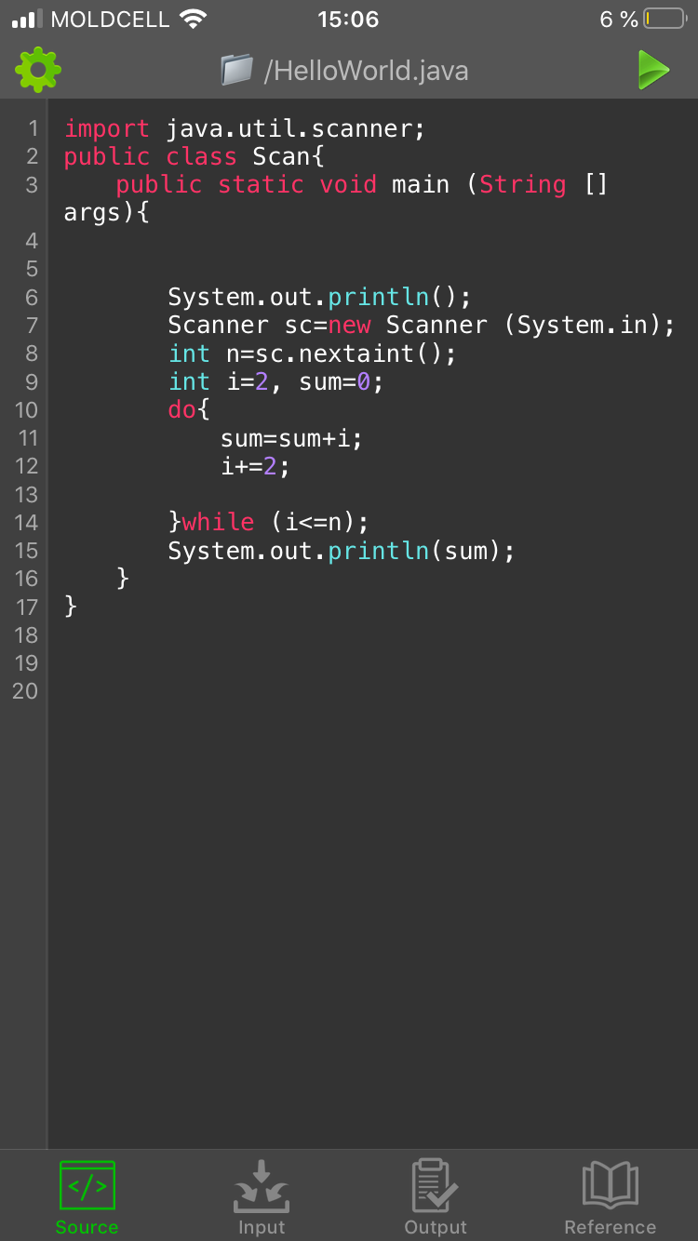

1. Import java.util.scanner;

public class Scan{

public static void main(String[]args)

{

System.out.println();

Scanner sc=new Scanner (System.in);

int n=sc.nextInt();

double i=1;

int i=1, sum=0;

do{

int p=(int)Math.pow(i,2.0);

sum=sum+i\*i;

}while (i<=n);

System.out.println(sum);

}

}

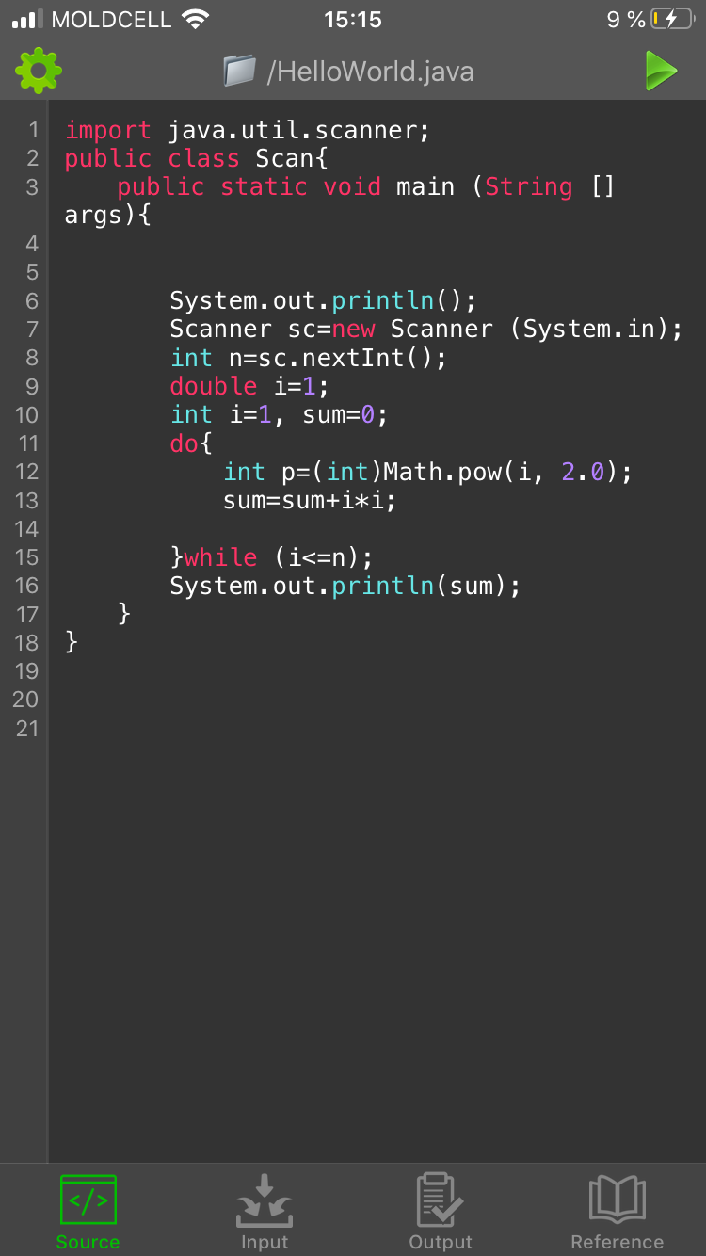

1. Import java.util.scanner;
2. public class Scan{

public static void main(String[]args

{

System.out.println();

double i=1;

do{

int p=(int)Math.pow(n,2.0);

double a=3;

int f=(int)Math.pow(a,2.0);

while(i<=3);

suma=i+n+a;

System.out.println(suma numerelor);

}

}

