In preparation for this assignment, I started opening up websites on my mobile phone of the various companies I could only think of. I then did some research online, trying to find worst mobile website and picking one to analyze it. What I came across is that many of the companies mentioned in the “worst mobile websites” lists just last year, have already created amazing mobile sites. Therefore, I will have couple smaller examples I will analyze, instead of focusing on just one company.

Nowadays, we expect all the companies/organizations to have a website. We also expect a lot of them to have mobile sites. I personally am very surprised when companies like Nikon, which sell products for those who have “esthetic eyes”, or University of Advancing Technology, whose scope is making students passionate about technology, are not at least up to date with modern design and technology trends.

Most of the examples presented below have poor aesthetic appeal, no user interaction (ex. swipe), misleading flow, not styled and unresponsive forms.

Nikon

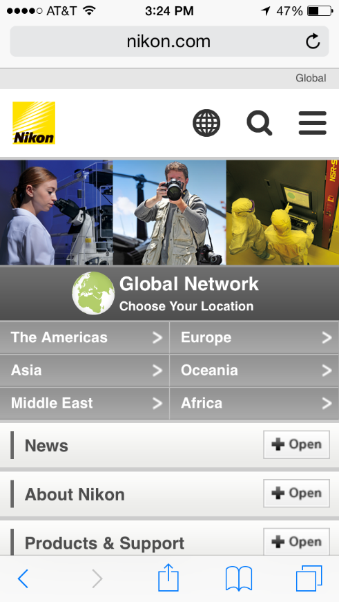 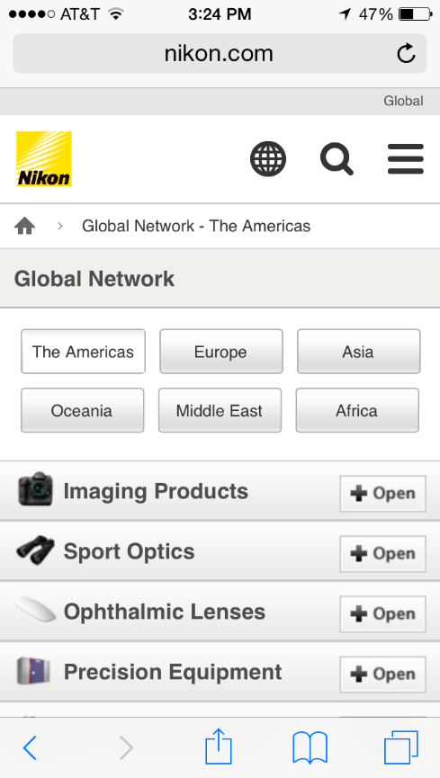

Overall, Nikon’s mobile site is poorly styled. Nikon could have done a lot better with the design. Navigation on the first page: News, About Nikon, Products and Support, is repeated once again bellow. Social media account buttons are different from one another. The icons used on the second snapshot are blurry. Once you click on any navigation button (ex. Imaging Products), you get a list of the stores that sell those products, instead of actual products.

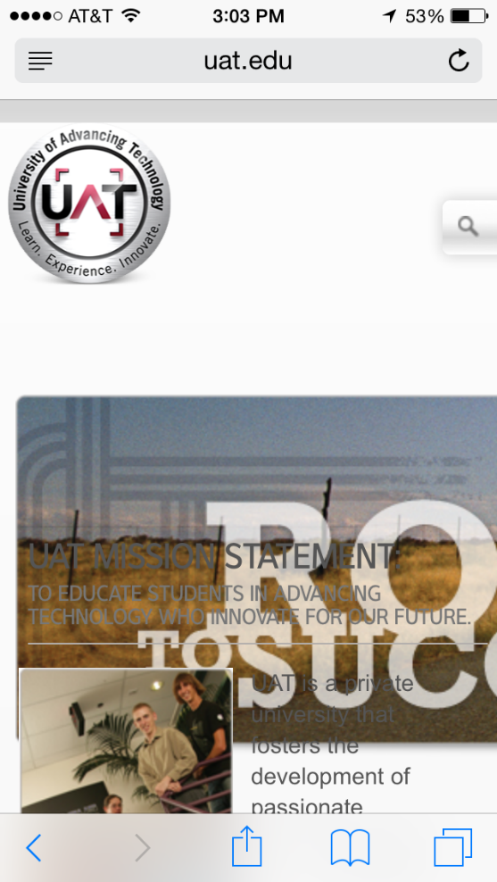University of Advancing Technology

University of Advancing Technology has a dysfunctional website. If we disregard the omitted visually appealing design, and only focus on content and functionality, this website is the worst out of the examples provided. Content is misplace. Search bar and search button collide with Menu and you cannot do a search as you will always click on Menu first. The content is also inconsistent. There is no grid and everything is positioned with no specific order colliding with each other.



Burt’s Bees

Burt’s Bees mobile site is an example of a very unappealing site of a great company. When I think Burt’s Bees, I think sun light, sweetness, flowers, softness. When I visit the site, I get plain yellow content, with too many options for a navigation bar. The button in the upper right hand corner, opens up a sliding navigation which includes same content as this first page. Navigation options are poorly nested in drawers.

Chateau Versailles

Chateau Versailles has a mobile site for tourists to use. Aside from the unappealing overall design, if you want to buy a ticket it takes you to a different site without any warning that you will be now transferred. Really unattractive design especially considering how beautiful Versailles is.

Yamaha

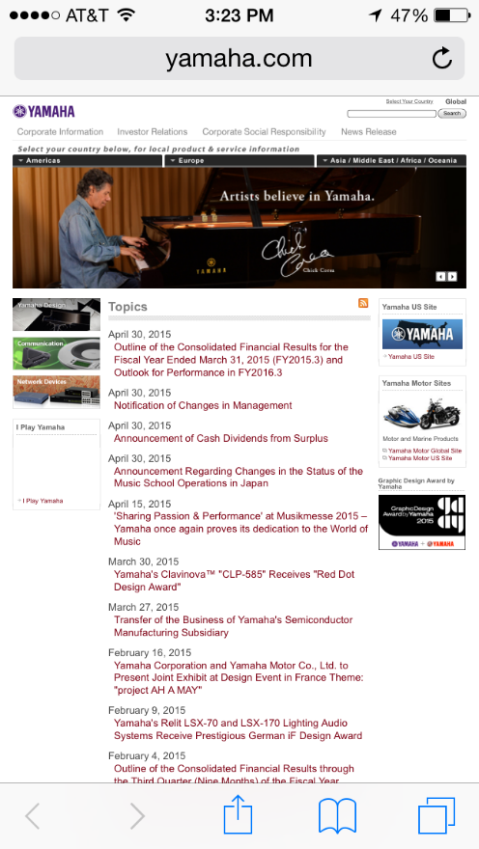 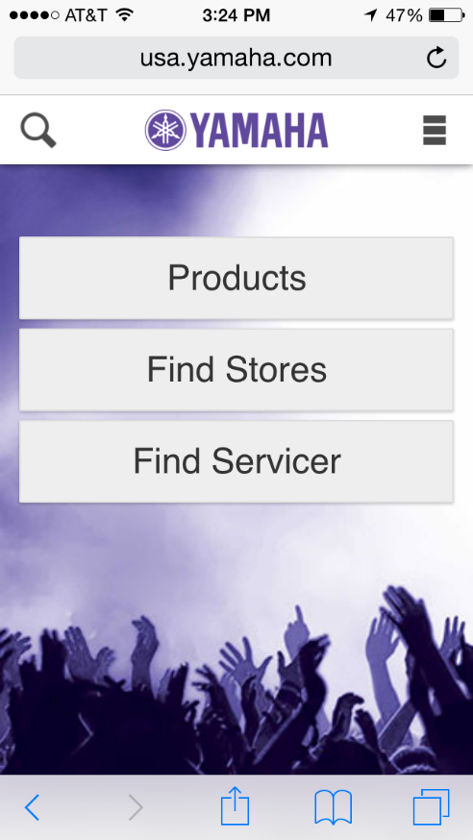

I thought of not including Yamaha in the list, since the landing page is clearly just a regular site and not a mobile one. Before I closed the site, I clicked forward and it brought me to what you see on the second picture. Have I not clicked forward, I would have never known that they have tried to adopt their page for mobile devices. The second page is too minimalist and poorly styled. For such an awesome brand they definitely need to spend more time on design though.

More thoughts and references:

We now have so many beautiful and responsive websites, applications and mobile sites, that when we see a bad one, we get quite disappointed and will most likely not visit it again soon because of the unappealing design, unambiguous content, or lack of content.

Companies working on their mobile sites should take into consideration Key Performance Indicators, to help determine what works and what needs improvement.

Appreciate UI and Inspired UI, are great sites, similar to mobile-pettern.com, that provide great examples for each pattern.

http://www.appreciateui.com/#/

http://inspired-ui.com/