Мануал для ДЭ 2026
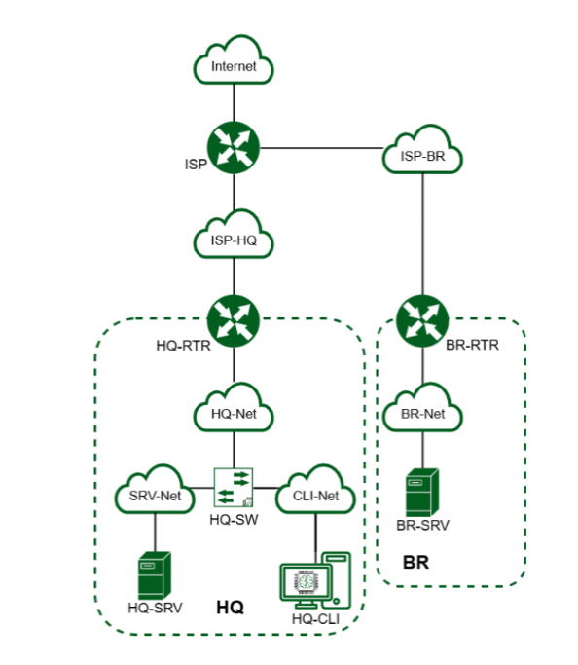

Устройство | Интерфейс | IP адрес | Маска подсети | Шлюз по умолчанию
ISP | eth0 | DHCP (автоматически) | - | DHCP (автоматически)
ISP | eth1 | 172.16.1.1/28 | 255.255.255.240 | -
ISP | eth2 | 172.16.2.1/28 | 255.255.255.240 | -
HQ-RTR | eth0 | 172.16.1.2/28 | 255.255.255.240 | 172.16.1.1
HQ-RTR | eth1.100 | 192.168.1.1/27 | 255.255.255.224 | -
HQ-RTR | eth1.200 | 192.168.2.1/28 | 255.255.255.240 | -
HQ-RTR | eth1.999 | 192.168.99.1/29 | 255.255.255.248 | -
HQ-RTR | gre1 (ip tunnel) | 10.0.0.1/30 | 255.255.255.252 | -
HQ-SRV | ens18 | 192.168.1.2/27 | 255.255.255.224 | 192.168.1.1
HQ-CLI | ens18 | DHCP (192.168.2.2/28) | 255.255.255.240 | DHCP (192.168.2.1)
BR-RTR | eth0 | 172.16.2.2/28 | 255.255.255.240 | 172.16.2.1
BR-RTR | eth1 | 192.168.3.1/28 | 255.255.255.240 | -
BR-SRV | ens18 | 192.168.3.2/28 | 255.255.255.240 | 192.168.3.1

Модуль 1
Задание 1 и Задание 11
- hostnamectl set-hostname isp.au-team.irpo && exec bash
- timedatectl set-timezone Asia/Yekaterinburg
HQ-RTR:
- nano /etc/network/interfaces
- auto eth0
iface eth0 inet static
address 172.16.1.2/28
gateway 172.16.1.1
auto eth1.100
iface eth1.100 inet static
address 192.168.1.1/27
vlan-raw-device eth1
auto eth1.200
iface eth1.200 inet static
address 192.168.2.1/28
vlan-raw-device eth1
auto eth1.999
iface eth1.999 inet static
address 192.168.99.1/29
vlan-raw-device eth1
- systemctl restart networking
BR-RTR:
- nano /etc/network/interfaces
- auto eth0
iface eth0 inet static
address 172.16.2.2/28
gateway 172.16.2.1
auto eth1
iface eth1 inet static
address 192.168.3.1/28
- systemctl restart networking
HQ-SRV:
- mcedit /etc/net/ifaces/ens18/options
- BOOTPROTO=static
TYPE=eth
DISABLED=no
- mcedit /etc/net/ifaces/ens18/ipv4address
- 192.168.1.2/27
- mcedit /etc/net/ifaces/ens18/ipv4route
- default via 192.168.1.1
- в настройках тег влан ставим 100
HQ-CLI:
- в настройках тег влан ставим 200

