**Week 2 – I.T 5 – Use of an array in a program**

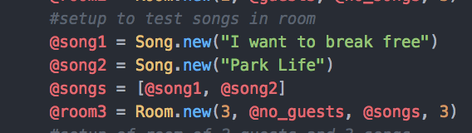

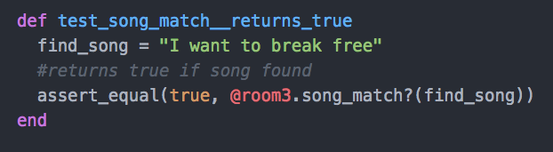

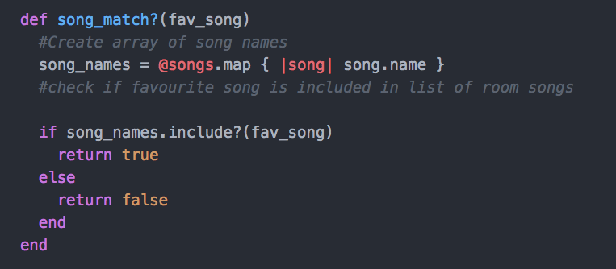

**Week 2 – I.T 5 – Use of an array in a program (Results)**

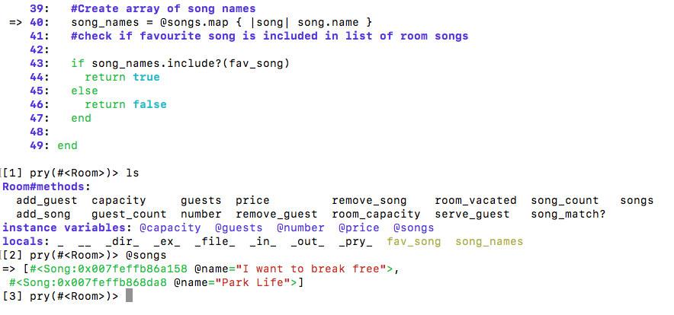

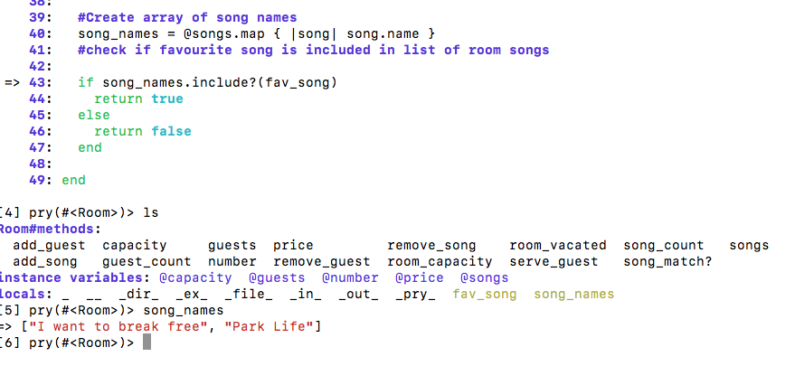

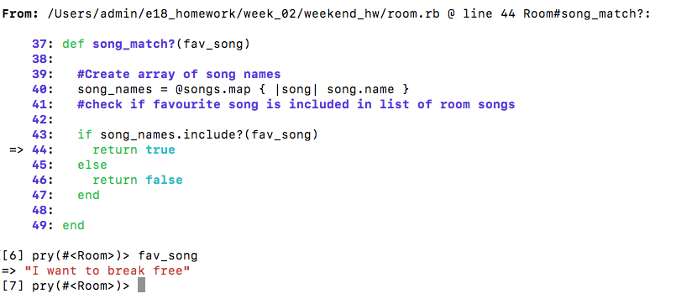

Week 2 – I.T 6 – Use of a hash in a program

“admin” hash contained within “pet_shop” hash

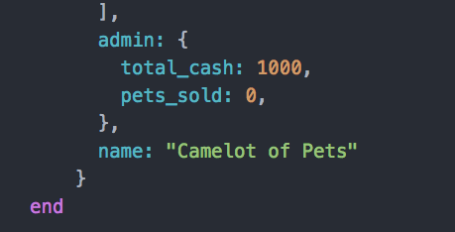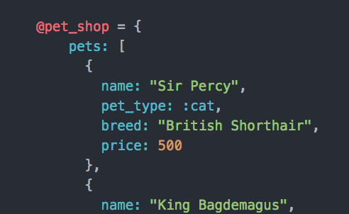

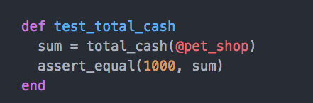

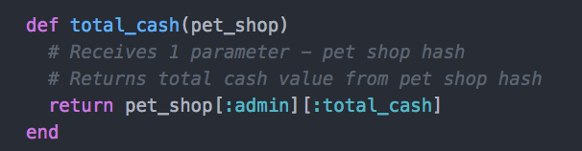

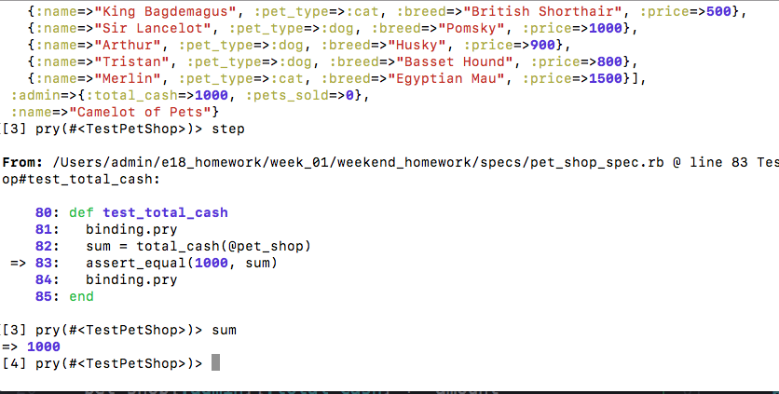

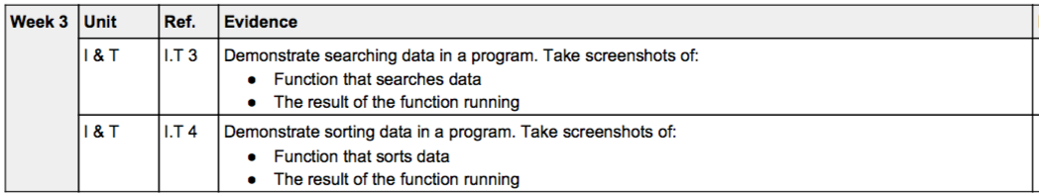

Week 5

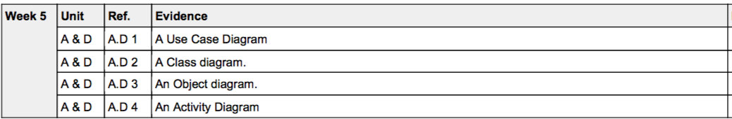

A.D 1 – A Use case diagram – Online Pizza Delivery System

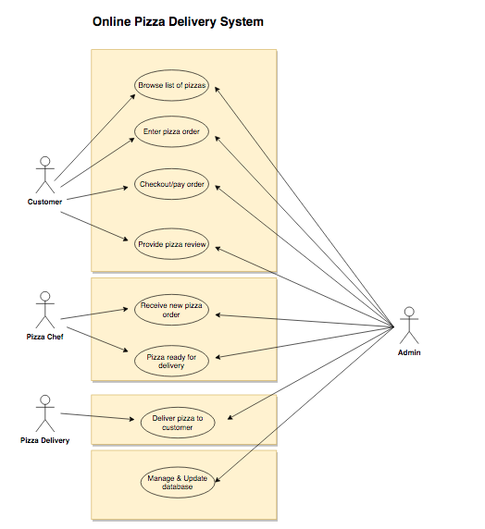

A.D 2 – Class Diagram – Money Tracker App

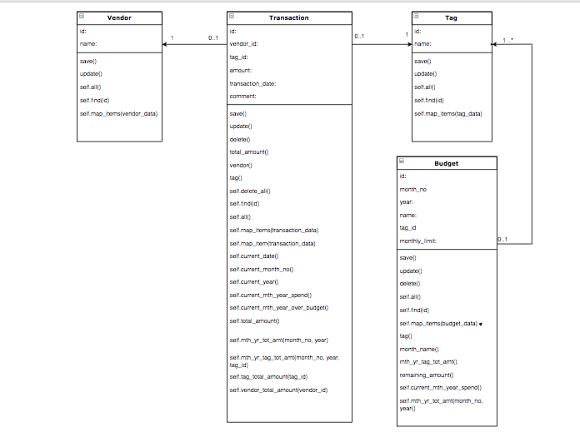

A.D 3 – Object Diagram – Money Tracker App

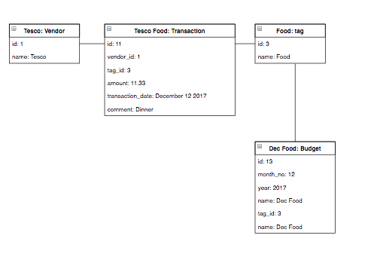

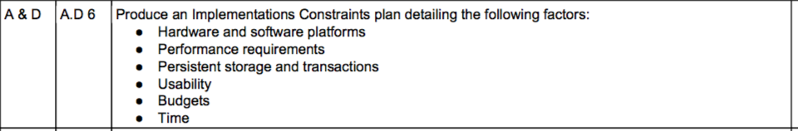

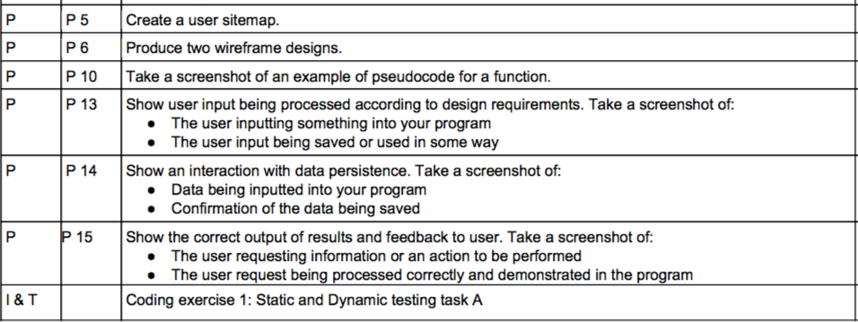

Week 5 – P5 – User Site Map – Money Tracker App

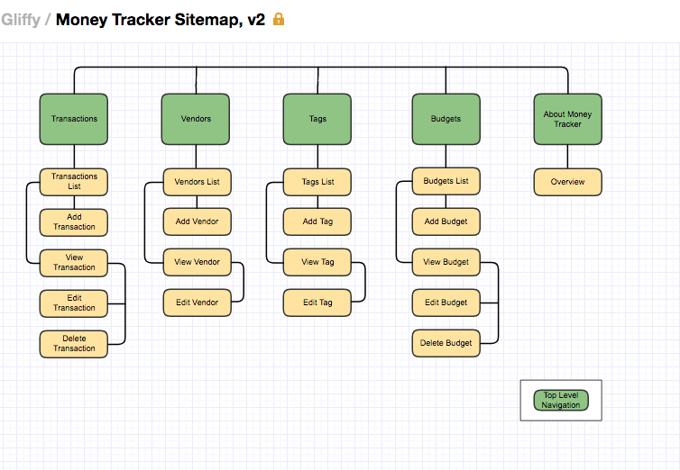

Week 5 – P6 – Two Wireframe Designs – Money Tracker App

