**REPORT**

Note: a "threaded tree" deals with the problem of NULL pointers. If a node does not have the right pointer, it stores a pointer to In-Order left-to-right successor of this node; if it does not have the left pointer, it stores a pointer to In-Order right-to-left successor of the node. "Successor" means the node that will be traversed after the node in question.

**Input**: T, B, E, A, H, F, D, R, I, O, L

**Binary Search Tree Representation**

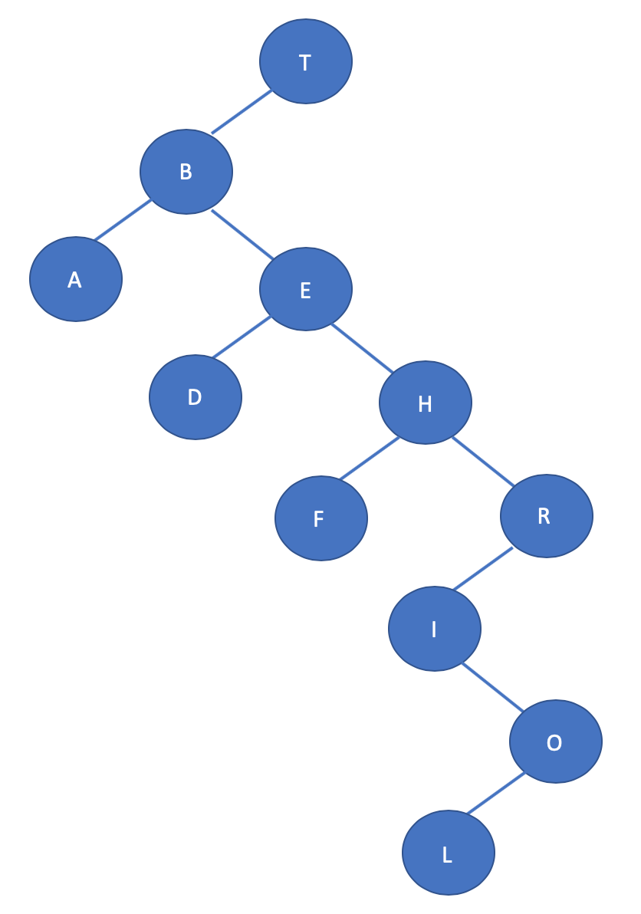

In-order Left-to-Right traversal (ascending alphabetical order): A B D E F H I L O R T In-order Right-to-Left traversal (descending alphabetical order): T R O L I H F E D B A

**Screenshot of Main Method:**

