Question 5.1
Using crime data from the file uscrime.txt (http://www.statsci.org/data/general/uscrime.txt, description at http://www.statsci.org/data/general/uscrime.html), test to see whether there are any outliers in the last column (number of crimes per 100,000 people). Use the grubbs.test function in the outliers package in R.

------------------------------------------------------------------------------------------------------------------------------------------
ANSWER - Question 5.1

Methodology
- Used the grubbs.test function in the outliers package in R to detect the outliers in the last column of the dataset:

#extracted last column crime
crime_col <- data$Crime

# applied grubbs.test function to detect outliers in the Crime column
grubbs.test(crime_col)

- Received the following results for the maximum value:

data: crime_col
G = 2.81287, U = 0.82426, p-value = 0.07887
alternative hypothesis: highest value 1993 is an outlier
#p value is > than 0.05

- Performed alternative Grubbs test for two opposite outliers:
grubbs.test(crime_col, type=11)

Received the following results:

data: crime_col
G = 4.26877, U = 0.78103, p-value = 1
alternative hypothesis: 342 and 1993 are outliers

Discussion and summary of the results:
The grubbs.test(crime_col, type=11) function checked if both the minimum (p value is < than 0.05) and maximum (p value is > than 0.05) values in the Crime column are outliers. The test
failed to reject the null hypothesis so no outliers exist; alternative hypothesis: 342 and 1993 are outliers.

------------------------------------------------------------------------------------------------------------------------------------------
Question 6.1
Describe a situation or problem from your job, everyday life, current events, etc., for which a Change Detection model would be appropriate. Applying the CUSUM technique, how would you choose the critical value and the threshold?

------------------------------------------------------------------------------------------------------------------------------------------
ANSWER - Question 6.1

A few examples when a Change detection model would be appropriate:

Unemployment rates: detecting sudden shift in job market. When applying the CUSUM technique, I would choose two-sided detection of changes (ex. increase or decrease in unemployment). Then, I would consider how to detect the changes – monthly, quarterly, annually. For short-term shifts, I would set a smaller critical value and threshold for more sensitivity; for long-term shifts – larger critical value and threshold.

------------------------------------------------------------------------------------------------------------------------------------------
Question 6.2
- Using July through October daily-high-temperature data for Atlanta for 1996 through 2015, use a CUSUM approach to identify when unofficial summer ends (i.e., when the weather starts cooling off) each year. You can get the data that you need from the file temps.txt or online, for example at http://www.iweathernet.com/atlanta-weather-records or https://www.wunderground.com/history/airport/KFTY/2015/7/1/CustomHistory.html . You can use R if you’d like, but it’s straightforward enough that an Excel spreadsheet can easily do the job too.
- Use a CUSUM approach to make a judgment of whether Atlanta’s summer climate has gotten warmer in that time (and if so, when).

-------------------------------------------------------------------------------------------------------------------------------------

ANSWER - Question 6.2 (1)

- Methodology:

Using July through October daily-high-temperature data for Atlanta for 1996 through 2015, used a CUSUM approach to identify when unofficial summer ends in excel (the excel file is attached, tab (1) CUSUM Minus) for each given year.

To calculate CUSUM, I performed the following:
- Calculated the mean (baseline) of July temperatures for each given year as July month represents a stable period of warm days: µ.
- Set recorded daily temperature as T.
- Calculated baseline deviation of July temperatures for each year - σ.
- Set a reference value k as σ/2 to detect gradual changes.
- Set decision threshold: 5* σ to detect when the cooling has sustained - H
- Calculated the difference between the recorded daily temperature and the mean temperature as T - µ
- Set the initial CUSUM (C₀) to equal 0.
- Calculated the negative CUSUM (C-) to keep only the cooling evidence:
- MIN(0, C- + (T - µ + k)
- Filtered the CUSUM results per each day to detect the transition point (date and temperature when it gradually started cooling off): C- <−H

(continued on the next page)

- Results and discussion of the results:

Received the following results for the date and transition point when the weather started gradually cooling off:

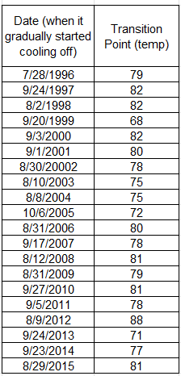

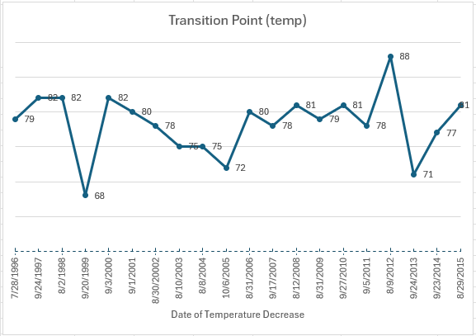

Based on the results received, for the most of transition temperature points are between 75°F – 82°F starting August towards the end of September.

ANSWER - Question 6.2 (2)

- Methodology:

Using July through October daily-high-temperature data for Atlanta for 1996 through 2015, used a CUSUM approach to identify if Atlanta’s summer climate has gotten warmer (the excel file is attached, tab (2) CUSUM Plus) across the years.

To calculate CUSUM, I performed the following:
- Calculated annual summer averages for July-August for each year.
- Calculated the baseline mean using annual summer averages for years 1996 – 2005: µ.
- Calculated baseline standard deviation using annual summer averages for years 1996 – 2005: σ.
- Calculated a reference value k as σ/2 to detect gradual changes.
- Calculated decision threshold: 5* σ for warming - H
- Calculated deviation as difference between annual summer averages for July-August for each year and baseline mean - D
- Set the initial CUSUM (C₀) to equal 0
- Calculated CUSUM (C) for each year using MAX(0, C + (D - k))
- Filtered the CUSUM results C >= H to detect any warming pattern.

- Results and discussion of the results:

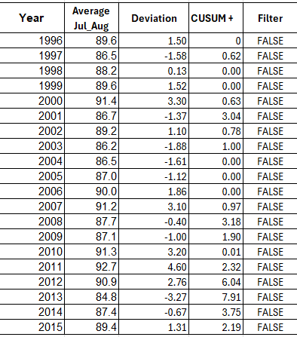

Based on the results received, the CUSUM never exceeded the threshold H, therefore Atlanta’s summer climate has not gotten warmer.

