Question 15.2
In the videos, we saw the “diet problem”. (The diet problem is one of the first large-scale optimization
problems to be studied in practice. Back in the 1930’s and 40’s, the Army wanted to meet the nutritional
requirements of its soldiers while minimizing the cost.) In this homework you get to solve a diet problem with real data. The data is given in the file diet.xls.

- Formulate an optimization model (a linear program) to find the cheapest diet that satisfies the maximum and minimum daily nutrition constraints, and solve it using PuLP. Turn in your code and the solution. (The optimal solution should be a diet of air-popped popcorn, poached eggs, oranges, raw iceberg lettuce, raw celery, and frozen broccoli. UGH!)
- Please add to your model the following constraints (which might require adding more variables) and solve the new model:
- If a food is selected, then a minimum of 1/10 serving must be chosen. (Hint: now you will need two variables for each food i: whether it is chosen, and how much is part of the diet. You’ll also need to write a constraint to link them.)
- Many people dislike celery and frozen broccoli. So at most one, but not both, can be selected.
- To get day-to-day variety in protein, at least 3 kinds of meat/poultry/fish/eggs must be selected. [If something is ambiguous (e.g., should bean-and-bacon soup be considered meat?), just call it whatever you think is appropriate – I want you to learn how to write this type of constraint, but I don’t really care whether we agree on how to classify foods!]

If you want to see what a more full-sized problem would look like, try solving your models for the file diet_large.xls, which is a low-cholesterol diet model (rather than minimizing cost, the goal is to minimize cholesterol intake). I don’t know anyone who’d want to eat this diet – the optimal solution includes dried chrysanthemum garland, raw beluga whale flipper, freeze-dried parsley, etc. – which shows why it’s necessary to add additional constraints beyond the basic ones we saw in the video!
[Note: there are many optimal solutions, all with zero cholesterol, so you might get a different one. It probably won’t be much more appetizing than mine.]
------------------------------------------------------------------------------------------------------------------------------------------
Solution - Question 15.2

Methodology:
      - Loaded and inspected the dataset:
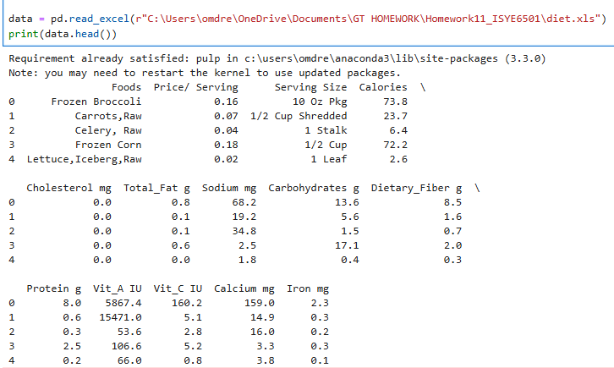
      - Created a list of Food values and a dictionary of Food-Costs value pairs:

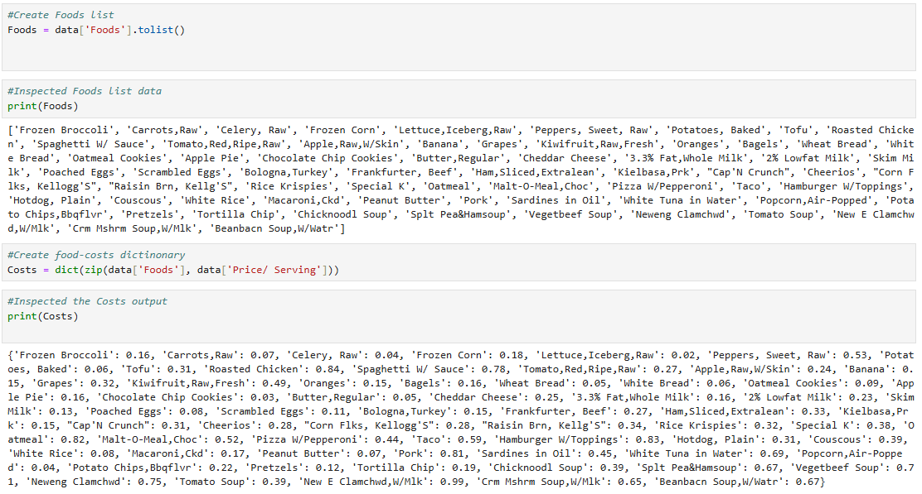

Created a list of all nutrient values and defined min/max constraints:

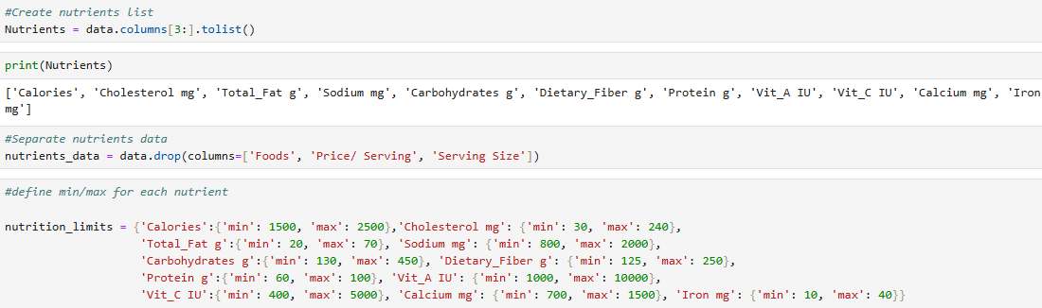

      - Created the problem variable, the food variables, and a binary variable to state that selected food in in the diet:

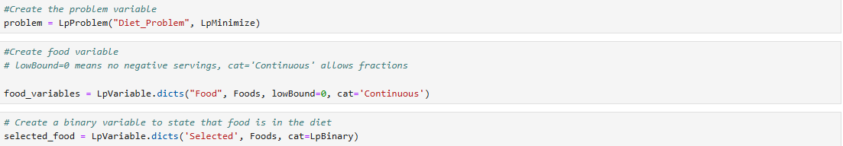

      - Part 1: Formulated an optimization model (a linear program) to find the cheapest diet that satisfies the maximum and minimum daily nutrition constraints, and solved it using PuLP:

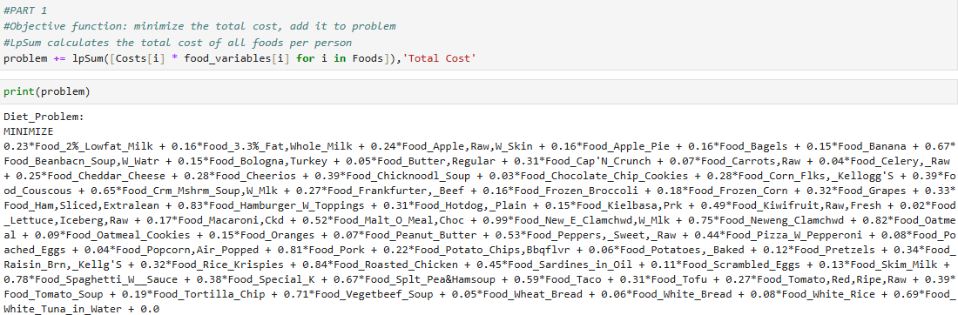

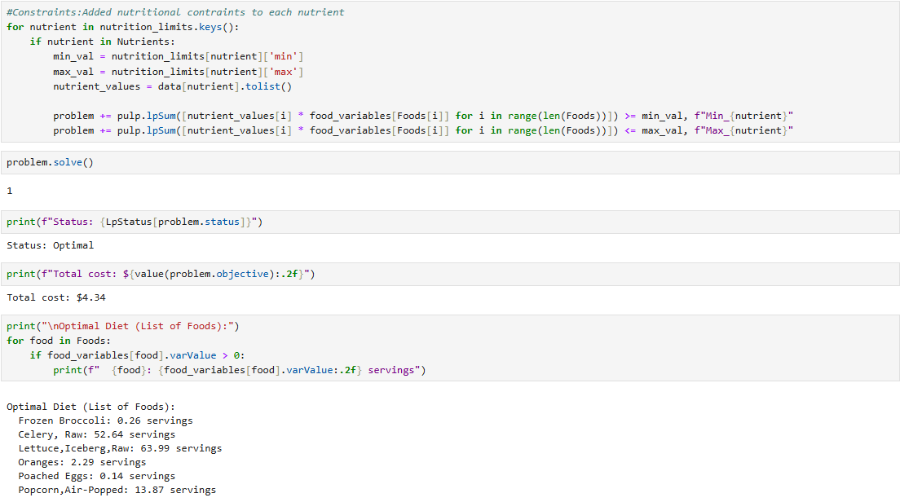

      - Part 2: Added to my model the following constraints: If a food is selected, then a minimum of 1/10 serving must be chosen; either celery or frozen broccoli should be selected; at least 3 kinds of meat/poultry/fish/eggs must be selected:
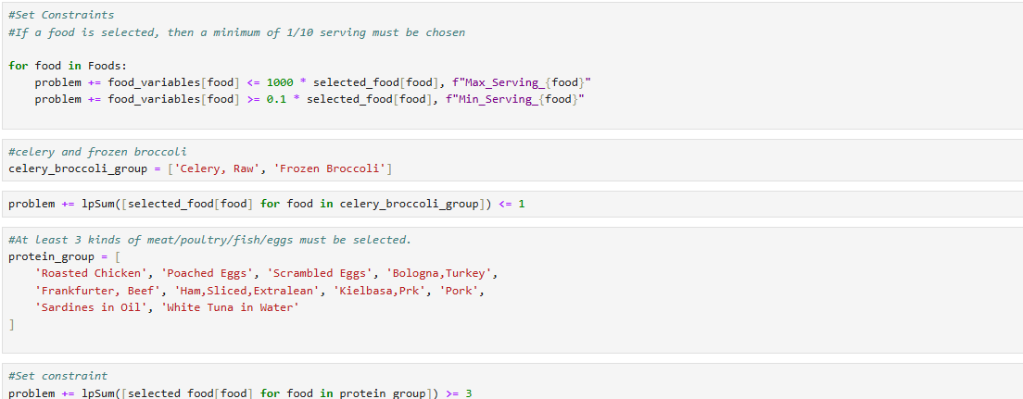

      - Solved the new model and printed the results:
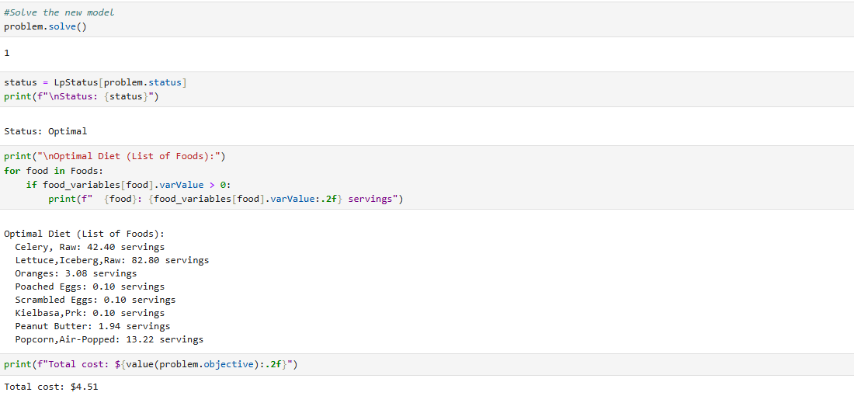

Results, discussion of the results:
To solve the diet problem, I first formulated a linear program to minimize cost subject to nutritional constraints, using a basic PuLP model. For the second part, added a new binary variable for each food to represent whether it is selected. Then, introduced a constraint linking the new binary variable to the original quantity variable, ensuring a minimum of 1/10 serving is selected if the binary variable is 1. Implemented the "at most one" constraint for celery and frozen broccoli with another binary variable and the appropriate logical constraint. Finally, added a constraint to ensure at least three types of meat/poultry/fish/eggs are selected.

The original diet problem model found the cheapest diet that satisfies the maximum and minimum daily nutrition constraints with the total cost of $4.34:
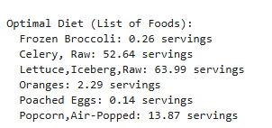

After adding the new three constraints (If a food is selected, then a minimum of 1/10 serving must be chosen; either celery or frozen broccoli should be selected; at least 3 kinds of meat/poultry/fish/eggs must be selected) to the model, the model produced the following list of foods as the cheapest diet:
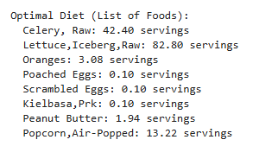
2a. If a food is selected, then a minimum of 0.1 serving must be chosen.
Status: Met. All items listed have a serving size of at least 0.1 servings (e.g., Poached Eggs: 0.10, Popcorn: 13.22). This proves that linking constraints are working correctly.

2b. At most one of Celery and Frozen Broccoli can be selected.
Status: Met. Celery, Raw (42.40 servings) is selected, but Frozen Broccoli is completely absent from the list (meaning 0 servings selected).

2c. At least 3 kinds of meat/poultry/fish/eggs must be selected.
Status: Met. The selected items from your protein group are:
Poached Eggs (0.10 servings)
Scrambled Eggs (0.10 servings)
Kielbasa, Prk (0.10 servings)

The model is working exactly as intended. The solver has found the cheapest combination of foods that satisfies all initial nutrient limits the three new variety constraints. Depending on dietary preferences, the model can be tweaked further by adding constraints to eliminate certain foods or to add variety.

