Question 8.1

Describe a situation or problem from your job, everyday life, current events, etc., for which a linear regression model would be appropriate. List some (up to 5) predictors that you might use.
------------------------------------------------------------------------------------------------------------------------------------------

I am in the construction industry and we could use the linear regression model to forecast maintenance costs for construction equipment based on its age, hours of operation, and recent repair history.

------------------------------------------------------------------------------------------------------------------------------------------Question 8.2

Using crime data from http://www.statsci.org/data/general/uscrime.txt (file uscrime.txt, description at http://www.statsci.org/data/general/uscrime.html ), use regression (a useful R function is lm or glm) to predict the observed crime rate in a city with the following data:

M = 14.0
So = 0

Ed = 10.0
Po1 = 12.0

Po2 = 15.5
LF = 0.640

M.F = 94.0
Pop = 150

NW = 1.1
U1 = 0.120

U2 = 3.6
Wealth = 3200

Ineq = 20.1
Prob = 0.04

Time = 39.0

Show your model (factors used and their coefficients), the software output, and the quality of fit.

Note that because there are only 47 data points and 15 predictors, you’ll probably notice some overfitting. We’ll see ways of dealing with this sort of problem later in the course.
------------------------------------------------------------------------------------------------------------------------------------------
Solution - Question 8.2

Methodology:

I have built seven lm models in total to test different combinations of the predictors and models performance. However, in this solution, I will focus on five models. The attached R code contains details on all models.

- Loaded and inspected the dataset:

data <-read.table('uscrime.txt', header=TRUE)
head(data)
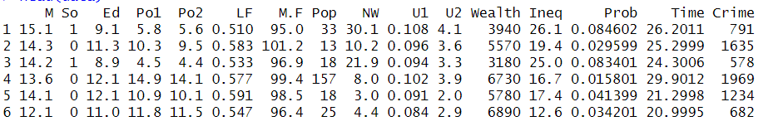
- Determined min/max crime values as we are to predict the observed crime rate:

min_max_crime <- c(min(data$Crime), max(data$Crime))
min_max_crime
- 342 1993

- Loaded the given predictors into dataframe:
given_preds <- data.frame(M = 14.0, So = 0, Ed = 10.0, Po1 = 12.0, Po2 = 15.5, LF = 0.640, M.F = 94.0, Pop = 150, NW = 1.1, U1 = 0.120, U2 = 3.6, Wealth = 3200, Ineq = 20.1, Prob = 0.04, Time = 39.0)

- Built a model using lm() function applying all predictors in the uscrime dataset except the crime predictor:

all_preds_model <- lm(Crime ~ M + So + Ed + Po1 + Po2 + LF + M.F + Pop + NW + U1 + U2 + Wealth + Ineq + Prob + Time, data=data)

- Inspected the model summary:
summary(all_preds_model)

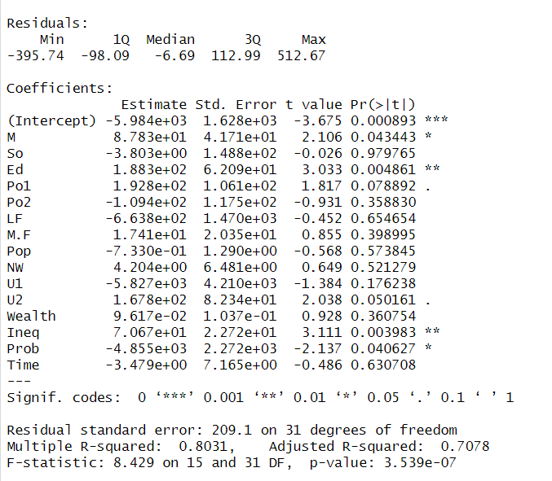

- Applied the given predictors and all_preds_model to predict crime rate:

all_preds_predicted <- predict(all_preds_model, given_preds)
all_preds_predicted

155.4349

- Built a new model using less predictors, removed: So, Time, Po2, Prob

less_preds_model1 <- lm(Crime ~ M + Ed + Po1 + LF + M.F + Pop + NW + U1 + U2 + Wealth + Ineq, data=data)

- Inspected the model summary:

summary(less_preds_model1)
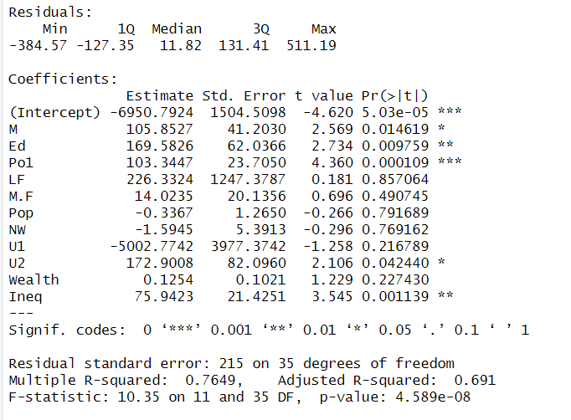

- Checked how less_preds_model1 performs when predicting crime rates:

less_preds_predicted <- predict(less_preds_model1, given_preds)
less_preds_predicted

827.7773

- Built a new model leaving out the following predictors: U1, Po1, P2, Time, NW, M.F, So, Pop, Wealth, Prob

less_preds_model3 <- lm(Crime ~ M + Ed + LF + U2 + Ineq, data=data)

- Inspected the model summary:

summary(less_preds_model3) #RSE is higher and R-squared is lower
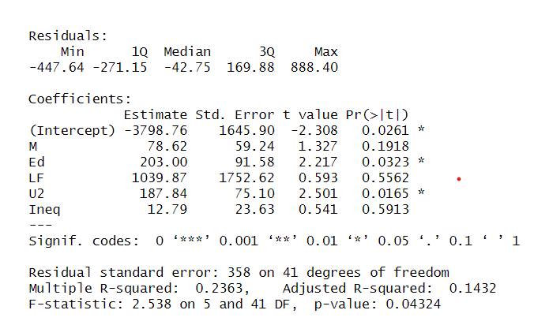

- Checked how less_preds_model3 performs when predicting crime rates:

less_preds_predicted3 <- predict(less_preds_model3, given_preds)
less_preds_predicted3
930.7027

- Built a new model using less predictors, eliminated So, Time, Po2, Wealth, NW:

less_preds_model5 <- lm(Crime ~ M + Ed + Po1 + LF + M.F + Pop + U1 + U2 + Ineq + Prob, data=data)

- Inspected the model summary:

summary(less_preds_model5)

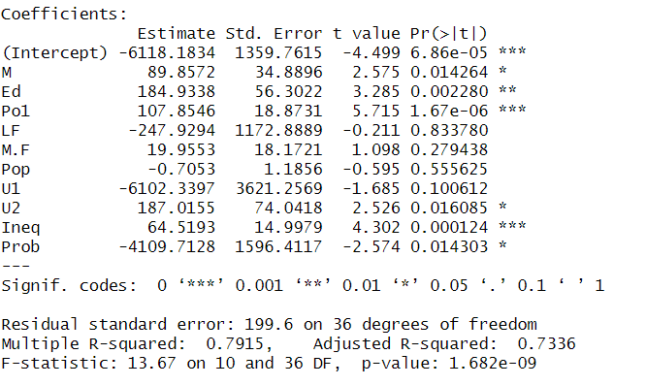

- Checked how less_preds_model5 performs when predicting crime rates:

less_preds_predicted5 <- predict(less_preds_model5, given_preds)
less_preds_predicted5
968.1572

- Plotted less_preds_model5 (the plots will be shared and discussed in Results and Discussion of the Results):

plot(less_preds_model6)

- Built a new model only using the predictors from a previous model, less_preds_model5, which are marked with an asterisk and have p-values <= 0.05 (see the model summary snip for predictor and p-values):

less_preds_model6 <- lm(Crime ~ M + Ed + Po1 + U2 + Ineq + Prob, data=data)

- Inspected the model summary:

summary(less_preds_model6)

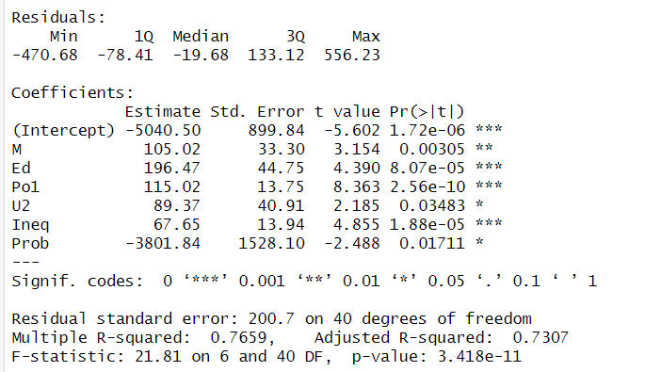

- Checked how less_preds_model6 performs when predicting crime rates:

less_preds_predicted6 <- predict(less_preds_model6, given_preds)
less_preds_predicted6
1304.245

- Plotted less_preds_model6 (the plots will be shared and discussed in Results and Discussion of the Results):

plot(less_preds_model6)

- Calculated corrected AIC for models - less_preds_model5 and less_preds_model6, as we are using a small dataset and compared the results to determine which model performs better:

aic_model5 <- AICc(less_preds_model5)
651.8901
aic_model6 <- AICc(less_preds_model6)

643.9556
diff <- aic_model5 - aic_model6
diff
7.934486

Results and discussion of the results:

The initial model, all_preds_model, was built to predict the crime rate based on all 15 available predictors and reported RSE value of 209.1, R-squared value of 0.80, and adjusted R-squared value of 0.70. The Adjusted R-squared value of 0.70 is considerably lower than R-squared value of 0.80 which suggests overfit of the data.
The model produced an unrealistic prediction for the crime rate (155.4349), which falls below the minimum observed crime rate in our dataset (342). Since there are only 47 data points and 15 predictors, this might be related to some overfitting.

The next model, less_preds_model3, reported a very high RSE value of 358 and very low R-squared value of 0.23, and adjusted R-squared value of 0.14 which suggests that the selected independent variables are not good predictors of the crime rate.

The model, less_preds_model1, reported RSE value of 215 and R-squared value of 0.76, and adjusted R-squared value of 0.69
The model produced a prediction for the crime rate of 930.7027.

The models, less_preds_model5, less_preds_model6, produced better results than the rest of the models:

less_preds_model5 | less_preds_model6
Predicted value - 968.1572 | Predicted value - 1304.245

Further, I plotted the models to compare and assess if the models are reliable.

Residuals vs fitted plot

less_preds_model5 | less_preds_model6
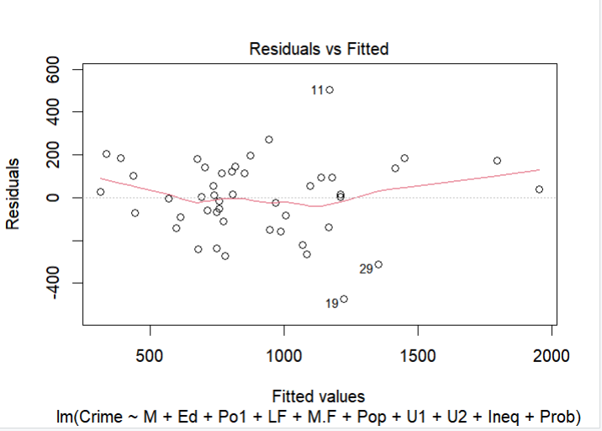 | 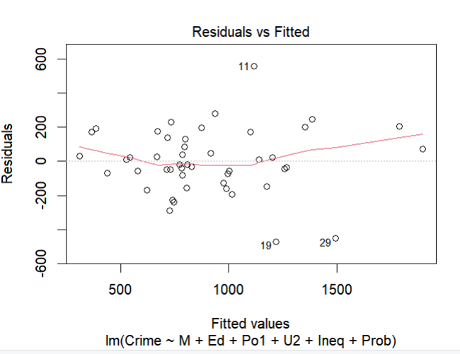

Both residuals vs fitted plots show a random, formless cloud of points with no discernible pattern. The positive and negative residuals (points above and below zero) are relatively evenly dispersed across the graph and are scattered randomly which indicates that models are a good fit for the data. However, a few outliers are observed.

Q Plot
less_preds_model5 | less_preds_model6
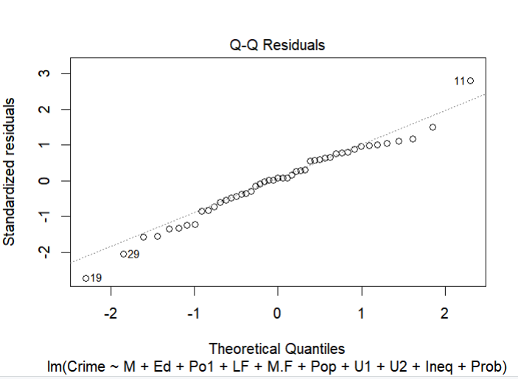 | 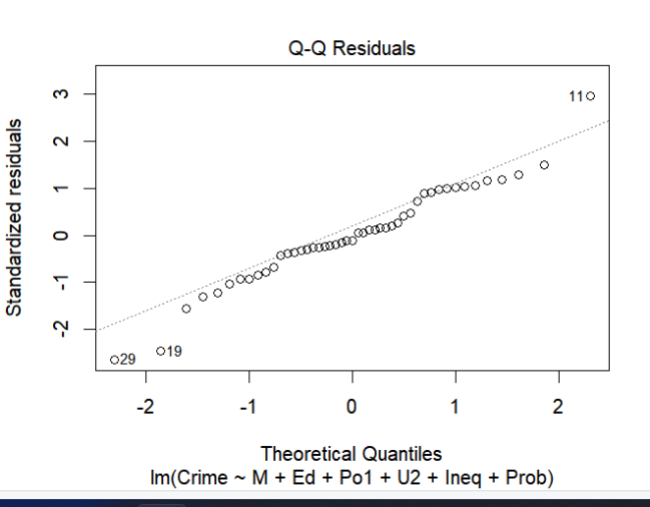

Points in both plots seem to follow a straight line which indicates that data aligns well with the theoretical distribution. However, the model, less_preds_model5, shows that points are distributed closer to the straight line and follow the line better.

Scale-Location

less_preds_model5 | less_preds_model6
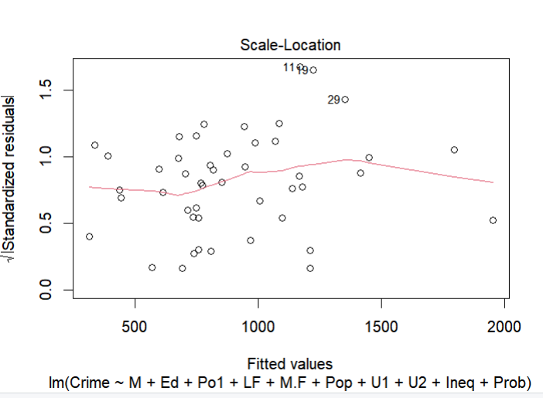 | 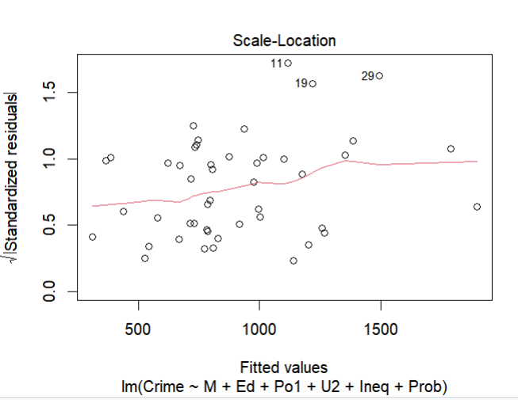

Both Scale-Location plots show the red line that is roughly horizontal across the plots which indicates that the assumption of homoscedasticity is likely satisfied for the given regression models and the spread of residuals is roughly equal to all fitted values.

Residuals vs Leverage

less_preds_model5 | less_preds_model6
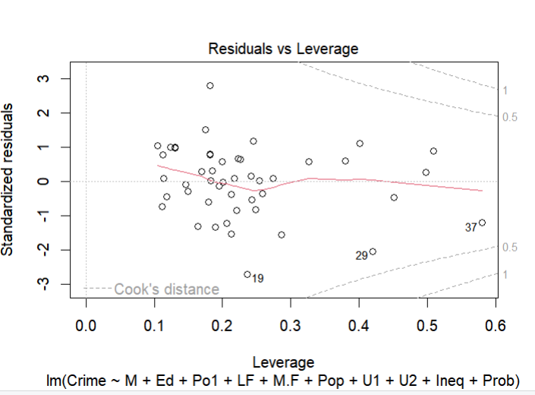 | 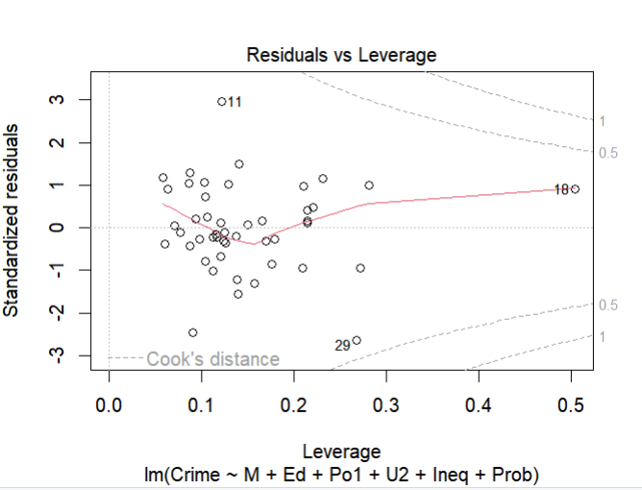

Both Residuals vs Leverage plots show that no points fall outside of the Cook’s distance (the dashed lines) and that most of the points are centered in the middle of the plots have little influence on the models.

Next, I used the corrected Akaike Information Criterion (AIC) model selection tool to determine which model is better.

The model, less_preds_model5, produced corrected AIC score of 651.8901. And the model, less_preds_model6, produced corrected AIC score of 643.9556.

The difference between two models' corrected AIC scores is 7.934486.
The difference between two models' corrected AIC scores indicates that there is less support for the model with the higher score, and the model with the lower corrected AIC is considered significantly better.

The model, less_preds_model6, with a lower corrected AIC score is considered better, as it indicates a better balance between fit and complexity.

