Question 14.1

The breast cancer data set breast-cancer-wisconsin.data.txt from https://archive.ics.uci.edu/dataset/15/breast+cancer+wisconsin+original (description available at the same URL) has missing values.
- Use the mean/mode imputation method to impute values for the missing data.
- Use regression to impute values for the missing data.
- Use regression with perturbation to impute values for the missing data.
- (Optional) Compare the results and quality of classification models (e.g., SVM, KNN) build using
(1) the data sets from questions 1,2,3;
(2) the data that remains after data points with missing values are removed; and
(3) the data set when a binary variable is introduced to indicate missing values.
------------------------------------------------------------------------------------------------------------------------------------------
Solution - Question 14.1

Methodology:

      - Loaded and inspected the data set, assigned column names:

#missing values in the bare_nuclei column, which are represented by the character ? and not an integer.
#To perform numerical imputation methods like mean imputation or regression, ? values should be interpreted as NA and the column is converted to a numeric.

data <-read.csv('breast-cancer-wisconsin.data.txt', na.strings = "?", header = FALSE)

colnames(data) <- c("Sample_code_number", "Clump_Thickness", "Uniformity_of_cell_size", "Uniformity_of_cell_shape","Marginal_Adhesion", "Single_epithelial_cell_size", "Bare_nuclei",
"Bland_chromatin","Normal_nucleoli", "Mitoses", "Class")

head(data)

      - Calculated number of na values in "Bare_nuclei" column:

sum(is.na(data$Bare_nuclei))

16 # 16 missing values in "Bare_nuclei" column

      - Converted values in "Bare_nuclei" column to numeric:

data$Bare_nuclei <- as.numeric(data$Bare_nuclei)

      - Used the mean/mode imputation method to impute values for the missing data:

#na.rm = TRUE tells a function to remove or ignore any NA (missing) values before performing its calculation

data_mean <- data

mean_Bare_nuclei <- mean(data_mean$Bare_nuclei, na.rm = TRUE)

- Replaced NA values in $Bare_nuclei with mean_Bare_nuclei output:

data_mean$Bare_nuclei[is.na(data_mean$Bare_nuclei)] <- mean_Bare_nuclei

sum(is.na(data_mean$Bare_nuclei))
[1] 0

print(colSums(is.na(data_mean)))

- Used regression to impute values for the missing data using mice function:

#The mice (Multivariate Imputation by Chained Equations) function in R is used for multiple imputation,
#an advanced statistical technique for handling missing data.
#Instead of simply replacing NA values with a single estimate (like the mean), mice creates several complete datasets by filling in the missing values with plausible imputed values.

install.packages("mice")
library(mice)

regression_data <- mice(data, m = 1, method = 'norm.predict', seed = 123, printFlag = FALSE)

#The complete function from the mice package takes an object containing multiple imputed datasets
#and returns a single, complete dataset

regression_data_imputed <- complete(regression_data, 1)

sum(is.na(regression_data_imputed$Bare_nuclei))
[1] 0

print(colSums(is.na(regression_data_imputed)))

- Use regression with perturbation to impute values for the missing data:

regression_data_perturbation <- mice(data, m = 1, method = 'norm.nob', seed = 123, printFlag = FALSE)

regression_data_perturbation_imputed <- complete(regression_data_perturbation, 1)

sum(is.na(regression_data_perturbation_imputed$Bare_nuclei))
[1] 0

- Visualized the results:

par(mfrow = c(1,3))

plot(density(na.omit(data$Bare_nuclei)), main = 'Mean', col = 'blue', ylim = c(0, 1.2))
lines(density(data_mean$Bare_nuclei), col = 'red')

legend("top", legend = c("Original", "Imputed"), col = c("blue", "red"), lty = 1)

plot(density(na.omit(data$Bare_nuclei)), main = 'Regression', col = 'blue', ylim = c(0, 1.2))
lines(density(regression_data_imputed$Bare_nuclei), col = 'red')

legend("top", legend = c("Original", "Imputed"), col = c("blue", "red"), lty = 1)

plot(density(na.omit(data$Bare_nuclei)), main = 'Regression with perturbation', col = 'blue', ylim = c(0, 1.2))
lines(density(regression_data_perturbation_imputed$Bare_nuclei), col = 'red')

legend("top", legend = c("Original", "Imputed"), col = c("blue", "red"), lty = 1)

Results, discussion of the results:

The mean imputation produced a single estimate to be used to replace NA values and introduced a peak at the mean in the distribution, potentially underestimating variance.

The mice (Multivariate Imputation by Chained Equations) function in R is used for multiple imputation, an advanced statistical technique for handling missing data. Instead of simply replacing NA values with a single estimate (like the mean), mice created several complete datasets by filling in the missing values with plausible imputed values. The Regression imputation created a smoother distribution than mean imputation but may still underestimate variance.

The Regression with perturbation Provided a more realistic distribution by adding noise, better preserving variability.

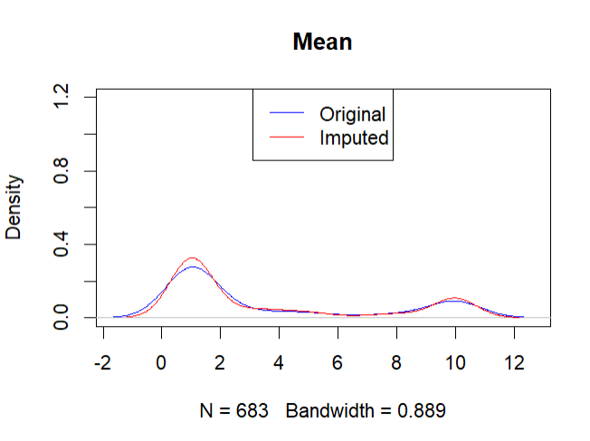 | 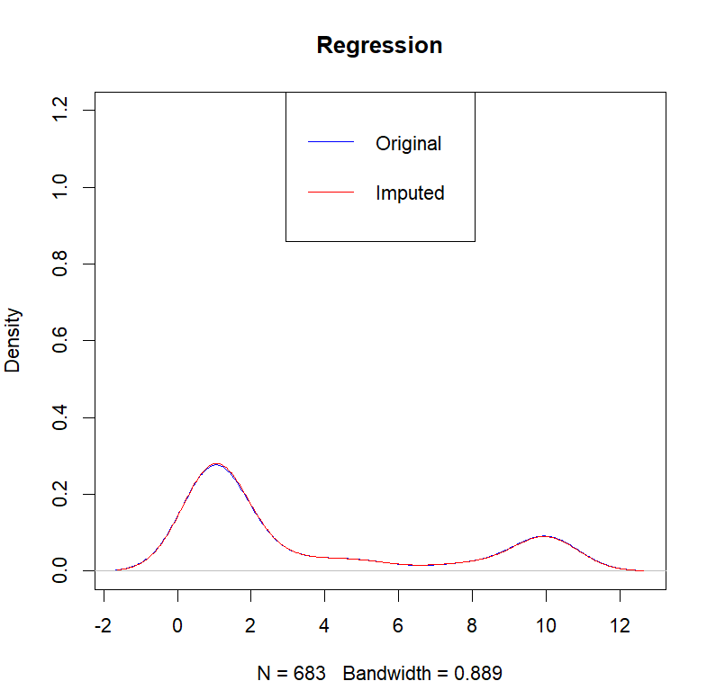
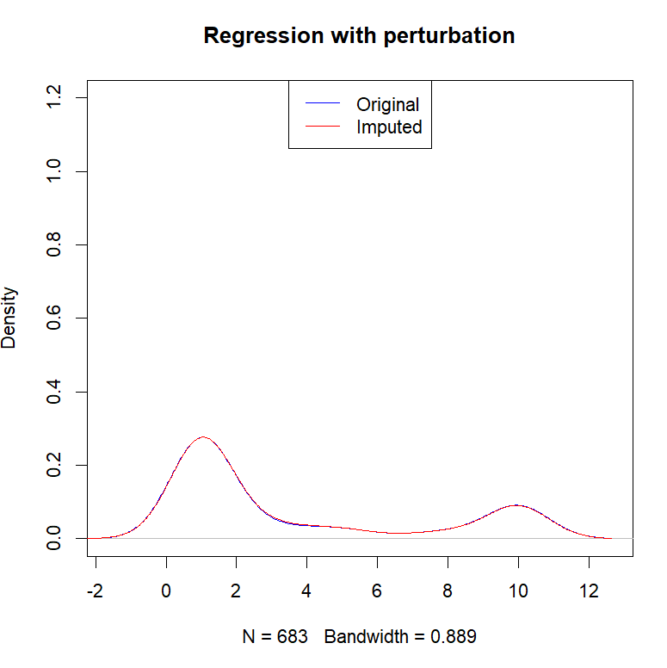

When interpreting the density plots, we are comparing the distribution of the original, observed data (the blue line) to the distribution of the data after it has been imputed (the red line). A good imputation method will produce an imputed distribution that closely resembles the original one.

The original distribution (blue line) line represents the distribution of the original data the bare_nuclei column, excluding any missing values. It's the benchmark against which we compare the results of each imputation method.
The imputed distribution (red line) line shows the distribution of the data after the imputation method has filled in the missing values.

The red line on Regression and Regression with Perturbation plots is much smoother and more closely aligned with the blue line than in the mean imputation plot.

The spikes on the Mean plot indicate that all missing values were replaced with a single number—the mean. This is a form of "data fabrication" that doesn't account for the natural variation in the data. While it's a simple fix, it distorts the true distribution by artificially lowering the variance and creating an unrealistic peak. This can be problematic for downstream modeling.

Standard regression imputation results in imputed values that lie perfectly on a line, which can artificially decrease the overall variance of the dataset. The addition of a random error term in perturbation imputation restores this variance, leading to a more realistic distribution.

Data imputed with perturbation is less likely to bias subsequent analyses, especially those that depend on variance and correlations, making it a more robust method for many statistical applications.

------------------------------------------------------------------------------------------------------------------------------------------

Question 15.1

Describe a situation or problem from your job, everyday life, current events, etc., for which optimization would be appropriate. What data would you need?

------------------------------------------------------------------------------------------------------------------------------------------
Answer - Question 15.1

I am in the construction field and could use optimization technique to create a project schedule that
smooths out the demand for key resources like skilled laborers and specialized equipment to avoid periods of over- and under-utilization. The goal is to finish the project on time while minimizing costs related to hiring temporary staff, paying overtime, or renting additional equipment.
An optimization model would be used to create an optimal schedule that meets the constraints while minimizing costs and maximizing efficiency.

Constraints:
Resource availability (fixed number of key personnel and equipment); project deadline (project must be completed by a specific date, which is contractually mandated); material and construction activities dependencies (resources as concrete for a foundation, have specific delivery timelines that must be factored into the schedule, and certain construction activities cannot begin until others are complete).

Data:
Project schedule data (list of every task required to complete the project and the required time to complete each task); resource data (the number of internal staff available for each specialized trade e.g., electricians, plumbers, crane operators, and list of all owned and available equipment); cost data (e.g., standard wages, overtime rates, and the cost of hiring temporary workers, cost of renting additional equipment); budget data; supplier data and delivery timelines; supply chain risks that could cause material delays.

