Question 11.1

Using the crime data set uscrime.txt from Questions 8.2, 9.1, and 10.1, build a regression model using:

Stepwise regression
- Lasso
- Elastic net
For Parts 2 and 3, remember to scale the data first – otherwise, the regression coefficients will be on different scales and the constraint won’t have the desired effect.

For Parts 2 and 3, use the glmnet function in R.

Notes on R:
- For the elastic net model, what we called λ in the videos, glmnet calls “alpha”; you can get a range of results by varying alpha from 1 (lasso) to 0 (ridge regression) [and, of course, other values of alpha in between].
- In a function call like glmnet(x,y,family=”mgaussian”,alpha=1) the predictors x need to be in R’s matrix format, rather than data frame format. You can convert a data frame to a matrix using as.matrix – for example, x <- as.matrix(data[,1:n-1])
- Rather than specifying a value of T, glmnet returns models for a variety of values of T.
------------------------------------------------------------------------------------------------------------------------------------------
Solution - Question 11.1

Methodology

      - Loaded and inspected the dataset:

data <- read.table('uscrime.txt', header=TRUE)
head(data)

      - Built a simple linear regression model including all the predictors:

lm <- lm(Crime~., data=data)
summary(lm)
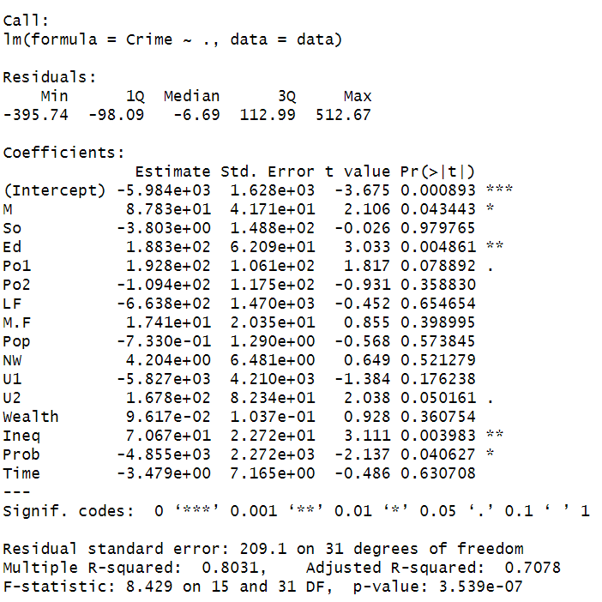
      - Performed stepwise regression in both directions (forward and backward):

stepwise <-stepAIC(lm, direction="both", trace=FALSE)

summary(stepwise)
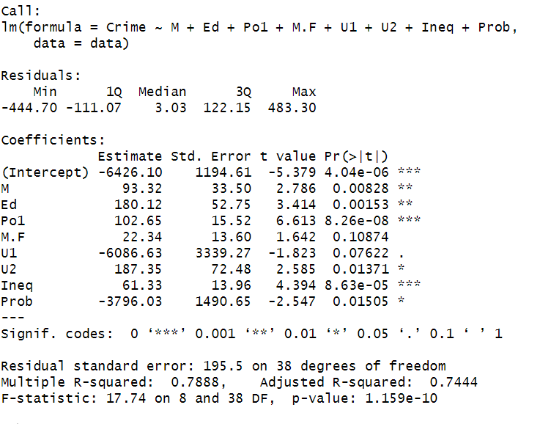
      - Scaled the data, performed k-fold cross-validation to find the best lambda, and applied lasso method:

#Lasso is a regression method that performs both variable selection and regularization by penalizing the absolute size of the regression coefficients.

#In a function call like glmnet(x,y,family=”mgaussian”,alpha=1) the predictors x need to be in R’s matrix format, rather than data frame format.
#I can convert a data frame to a matrix using as.matrix – for example, x <- as.matrix(data[,1:n-1]) family=”gaussian” for a single response $Crime

x <- as.matrix(data[,-ncol(data)])
y <- data$Crime

#Scaled the data first (predictor) – otherwise, the regression coefficients will be on different scales and the constraint won’t have the desired effect.

x_scaled <- scale(x)

#Performed k-fold cross-validation to find the best lambda (tuning parameter)
# alpha = 1 for Lasso

set.seed(123)

lasso_cv <- cv.glmnet(x_scaled, y, family='gaussian', alpha=1)
lasso_cv
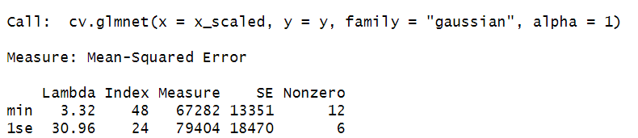

#Got the optimal lambda value
#lambda.min represents the best-performing model in terms of predictive accuracy. This is the value of λ that results in the absolute minimum mean cross-validated error.

lasso_lambda <- lasso_cv$lambda.min
lasso_lambda
[1] 3.319887

#Applied lasso method

lasso <- glmnet(x_scaled, y, family='gaussian',alpha=1, lambda=lasso_lambda)

coef(lasso)
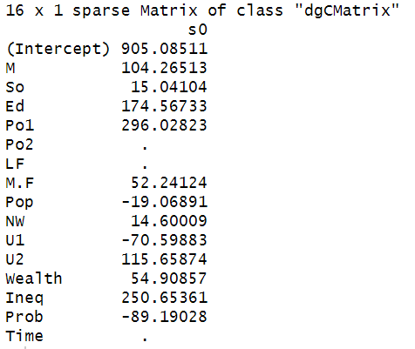
#The output shows which variables have non-zero coefficients, indicating their selection by the Lasso model

#Elastic net is a hybrid of Lasso and Ridge regression that combines their penalties.
#It is also performed using glmnet and cross-validation, but the alpha parameter is between 0 and 1. An alpha of 0.5 is a common choice.

      - Run cross validation for Ridge regression alpha = 0:

ridge_cv <- cv.glmnet(x_scaled, y, family='gaussian', alpha=0)

      - Got the optimal lambda value:

ridge_lambda <- ridge_cv$lambda.min
ridge_lambda
66.70427

      - Fit the Ridge model:

ridge <- glmnet(x_scaled, y, family='gaussian', alpha=0, lambda = ridge_lambda)

coef(ridge)

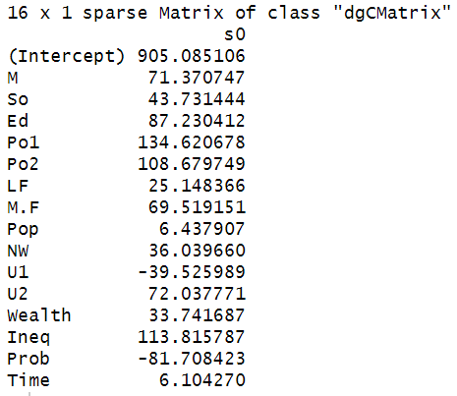
      - Run cross validation for elastic net with alpha = 0.5:

elastic_net_cv <- cv.glmnet(x_scaled, y, family="gaussian", alpha=0.5)

      - Got the optimal lambda value:

elastic_net_lambda <- elastic_net_cv$lambda.min
elastic_net_lambda
[1] 13.97609

      - Fit the elastic net model:

elastic_net <- glmnet(x_scaled, y, family="gaussian", alpha=0.5, lambda = elastic_net_lambda)

coef(elastic_net)
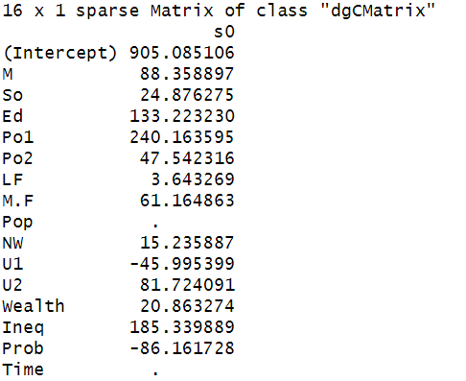
Results, discussion of the results:
Stepwise | Lasso
Ridge | Elastic Net

The Stepwise regression selected the following variables: M (percentage of males aged 14–24 in total state population), Ed (mean years of schooling of the population aged 25 years or over), Po1 ( per capita expenditure on police protection in 1960), M.F (number of males per 100 females), U1 (unemployment rate of urban males 14–24), U2 (unemployment rate of urban males 35–39), Ineq (income inequality: percentage of families earning below half the median income), Prob (probability of imprisonment: ratio of number of commitments to number of offenses).

The Lasso performed variable selection by setting some coefficients exactly to zero. The predictors that have a coefficient of ., mean that the lasso model has set them to exactly zero. The model has identified these features as not being important for predicting the crime rate. Po1 with a coefficient of 296.02, this is one of the strongest positive predictors. A one standard deviation increase in 1960 police expenditure is associated with a predicted increase of over 296 units in the crime rate. Ineq and Ed are also associated with higher crime rate.

The Ridge didn’t perform variable selection, all coefficients remained in the model.

The Elastic net performed variable selection and kept more variables than Lasso.
The predictors with a coefficient of ., mean that the elastic net model has set them to exactly zero. The model has identified these features as not being important for predicting the crime rate.

Po1 with a coefficient of 240.16, this is one of the strongest positive predictors. A one standard deviation increase in 1960 police expenditure is associated with a predicted increase of over 240 units in the crime rate.
Ed with coefficient of 133.22 suggests that higher average education is associated with a higher crime rate. Like the police expenditure, this may reflect other underlying socioeconomic factors.
Ineq with a coefficient of 185.34 indicates that greater income inequality is strongly associated with a higher crime rate. This aligns with standard sociological hypotheses.
Other positive coefficients: M, So, Po2, LF, M.F, NW, and U2 are all positively associated with the crime rate, to varying degrees based on the magnitude of their coefficients.

Negative coefficients:
Prob (probability of imprisonment): The coefficient of -86.16 suggests that a higher probability of imprisonment is associated with a lower crime rate.
U1 (unemployment rate of urban males 14–24): The negative coefficient -45.99 indicates that a higher unemployment rate among this age group is associated with a lower crime rate. This is a complex and potentially counterintuitive result, which can arise due to confounding factors in the dataset.

The elastic net model, with its mixture of Lasso and Ridge penalties, has correctly identified and removed the Pop and Time variables, indicating they have little predictive power when other variables are considered.

In terms of relative importance (magnitude), Po1 is the strongest predictor across all the regression models, followed by Ineq, Ed, and Prob. These variables have the most influence on the predicted crime rate based on the models.

