Question 10.1

Using the same crime data set uscrime.txt as in Questions 8.2 and 9.1, find the best model you can using
(a) a regression tree model, and
(b) a random forest model.
In R, you can use the tree package or the rpart package, and the randomForest package. For each model, describe one or two qualitative takeaways you get from analyzing the results (i.e., don’t just stop when you have a good model, but interpret it too).
------------------------------------------------------------------------------------------------------------------------------------------
Answer - Question 10.1

Methodology:

- Loaded and inspected the dataset:

data <-read.table('uscrime.txt', header=TRUE)
head(data)

library(tree)
library(randomForest)

- Set a seed for reproducibility:
set.seed(123)

- Built tree model:

tree_model <- tree(Crime~., data=data)

- Inspected and ploted the tree_model results:
summary(tree_model)

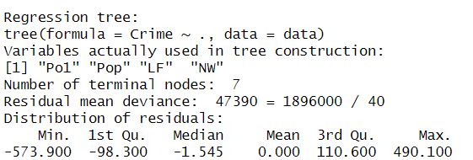

plot(tree_model)
text(tree_model)

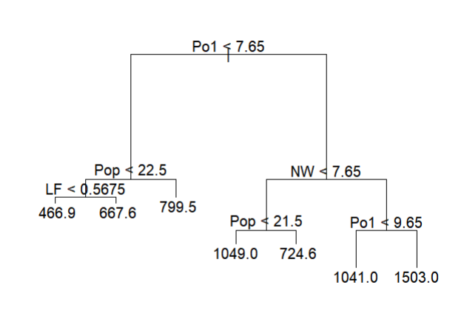

tree_model$frame

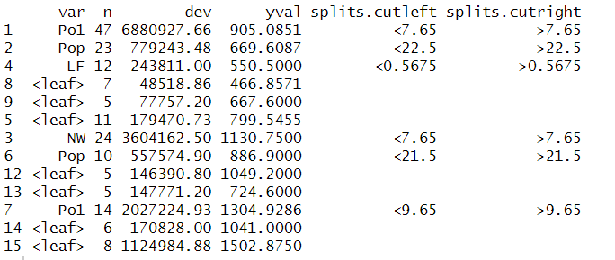

plot(tree_model_cv$size, tree_model_cv$dev, type='b')

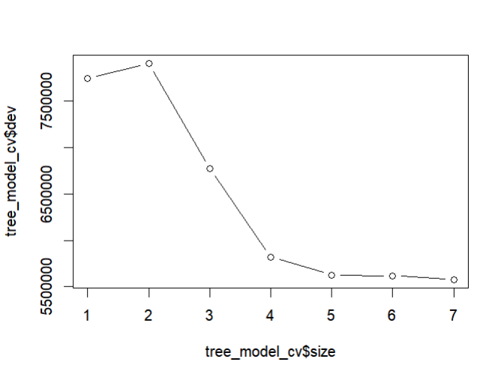

The error curve is flat at the end, it indicates that further pruning does not improve the model's performance on unseen data.

5. Performed cross-validation:cv.tree() to find the best tree size:

#The function evaluates different sized subtrees using cross-validation.

tree_model_cv <- cv.tree(tree_model)

print(tree_model_cv)
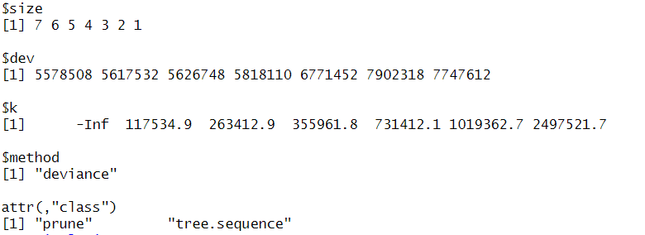

- Pruned the tree to find the size that minimizes the cross-validation error:

optimal_size <- tree_model_cv$size[which.min(tree_model_cv$dev)]
optimal_size
[1] 7 #the optimal number of terminal nodes for the tree

pruned_tree <- prune.tree(tree_model, best = optimal_size)

- Plotted the results:

plot(pruned_tree)
text(pruned_tree)

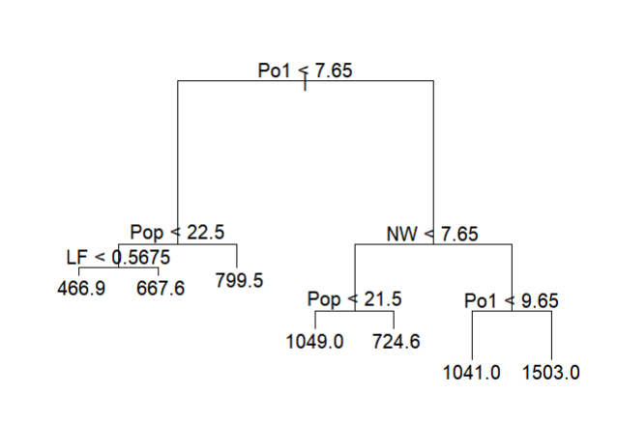

The minimum error corresponds to the largest tree size, and prune.tree() returned the full tree.
This indicates that the model isn't overfitting the training data, and the full tree provides the best generalization to new data, based on the cross-validation analysis.

- Used the pruned tree to make predictions on new data:

# created test dataset using given factors

test_data <- data.frame(M = 14.0, So = 0, Ed = 10.0, Po1 = 12.0, Po2 = 15.5, LF = 0.640, M.F = 94.0, Pop = 150, NW = 1.1, U1 = 0.120, U2 = 3.6, Wealth = 3200, Ineq = 20.1, Prob = 0.04, Time = 39.0)

pred <- predict(pruned_tree, data=test_data)

Pred

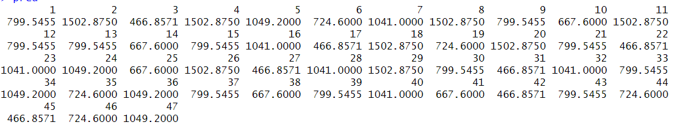

The predicted crime rates for each observation in the dataset, based on the regression tree model.
The fact that the predictions are repeated indicates that the tree has grouped observations into a small number of distinct categories based on the predictor variables.

A group of observations (like numbers 2, 4, 8, and others) consistently has a very high predicted crime rate of 1502.8750. By examining the tree, we could identify the specific set of conditions (e.g., high population density and low median income) that lead to this high predicted value.
Other observations (like 3, 17, and 42) have a very low predicted crime rate of 466.8571. This implies they share a different set of characteristics that lead to a lower crime rate.

- Calculated the Sum of Squared Residuals (SSE). It finds the difference between the predicted values (pred) and the actual values (data$Crime), squares each difference, and sums them up:

sse <- sum((pred - data$Crime)^2)
#The SSE represents the variation that is not explained by the model

- Calculated the Total Sum of Squares (SST). It finds the difference between each actual value and the mean of all actual values, squares each difference, and sums them up:

#The SST represents the total variation in the dependent variable.

sst <- sum((data$Crime - mean(data$Crime))^2)

- Calculated the R-squared value:
r_squared <- 1-(sse/sst)

r_squared
[1] 0.7244962

#The R-squared value tells the proportion of the total variance in the dependent variable (crime rate) that is explained by the regression tree model.
#A value of 1.0 means the model perfectly explains all the variance, while a value of 0.0 means the model explains none of it.
#72% of variability in the pruned_tree decision tree is explained by the model.

Built the random forest model and plotted the results:

# ntree: number of trees to grow (default is 500)
# mtry: number of variables to randomly sample at each split
# For regression, the default value for mtry is the number of predictor variables divided by three.
# importance = TRUE: tells R to calculate variable importance

random_forest <- randomForest(Crime~.,data=data)

random_forest

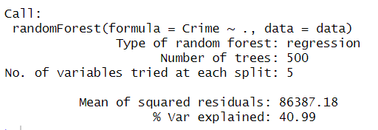

plot(random_forest)

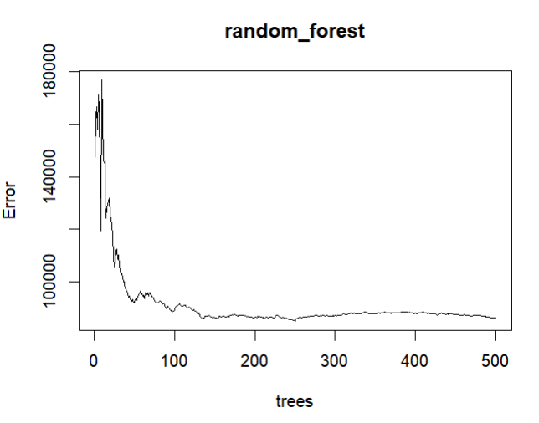

After approximately 130 trees, a horizontal, flat portion of the curve indicates that adding more trees to the model does not significantly improve its performance. This suggests that the model has stabilized and is no longer benefiting from additional trees.

- Tuned the model: Random forests have hyperparameters to improve performance:

#The tuneRF() function can help find the optimal mtry value.
#stepFactor = 1.5: Using a value of 1.5 means the function will increase the mtry value by 50% in each step (e.g., from 5 to 7 or 8)
#improve = 0.01: Using a value of 0.01 means tuneRF() will stop when the model's error doesn't improve by at least 1% for a certain number of iterations
#stepFactor controls the speed and granularity of the search for the optimal mtry value, while improve controls the stopping condition by setting a minimum threshold for improvement [1]

optimal_mtry <-tuneRF(data[,1:15], data$Crime, ntreeTry = 500, stepFactor = 1.5, improve = 0.01)

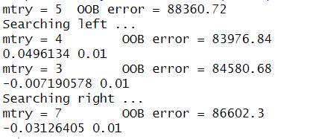

#the tuneRF() function concluded that mtry = 4 is the best choice because it yielded the minimum OOB error among the values tested.

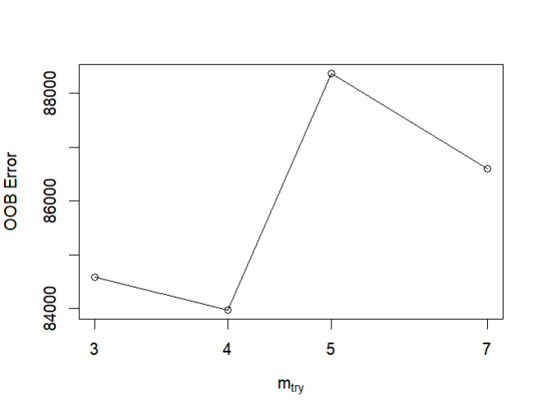

Improved the random forest model using mtry = 4 and plotted the results:

random_forest_improved <- randomForest(Crime~.,data=data, mtry = 4)

random_forest_improved
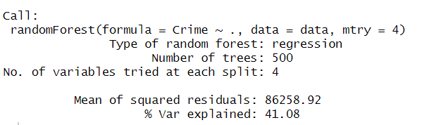

plot(random_forest_improved)
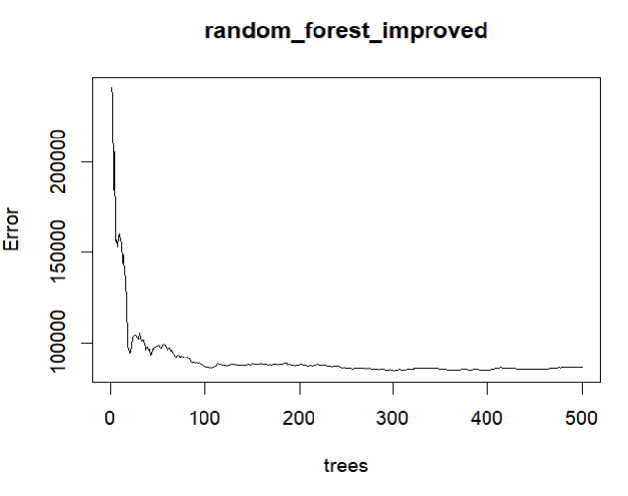

- Plotted the variable importance:

varImpPlot(random_forest_improved)

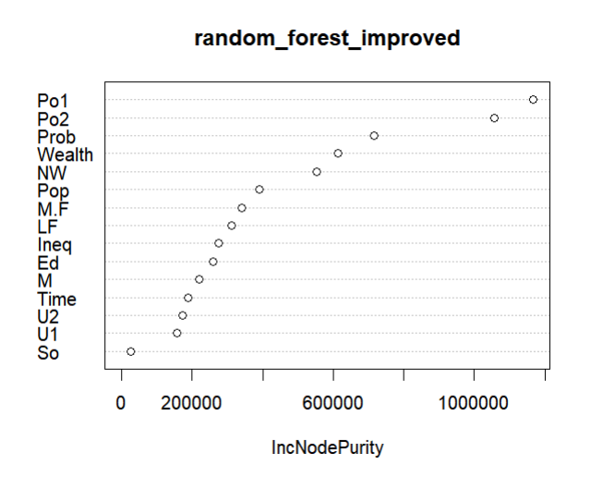

The Po2, Po1, Prob, Wealth, and NW factors are the most important in the randomForest model here.

- Made a prediction:

pred_random_forest <- predict(random_forest_improved, data=test_data)

pred_random_forest

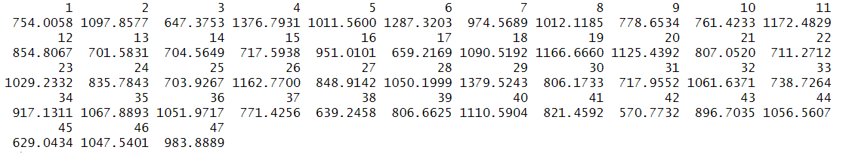

- Calculated the Sum of Squared Residuals (SSE). It finds the difference between the predicted values (pred) and the actual values (data$Crime):

#squares each difference and sums them up.

sse_rf <- sum((pred_random_forest - data$Crime)^2)

#The SSE represents the variation that is not explained by the model

- Calculated the Total Sum of Squares (SST). It finds the difference between each actual value and the mean of all actual values, squares each difference, and sums them up:

#The SST represents the total variation in the dependent variable.

sst_rf <- sum((data$Crime - mean(data$Crime))^2)

- Calculated the R-squared value:
r_squared_rf <- 1-(sse_rf/sst_rf)

r_squared_rf
[1] 0.4108106
------------------------------------------------------------------------------------------------------------------------------------------
Results, discussion of the results:

The Po1, Pop, LF, NW are the most important factors in the regression tree model.
The prune.tree() returned the full tree and the minimum error corresponds to the largest tree size.
This indicates that the model isn't overfitting the training data, and the full tree provides the best generalization to new data, based on the cross-validation analysis. By examining the tree, we could identify the specific set of conditions (e.g., high population density and low median income) that lead to this high predicted value of 1502.8750. The R-squared value of 0.72 signifies a better fit and that the regression tree model's predictions are relatively close to the actual data points

The Po2, Po1, Prob, Wealth, and NW factors are the most important in the random forest model.
The R-squared value of 0.41 means the model's inputs explain less than half of the variation in the output and doesn’t effectively capture the variations in the dependent variable.
------------------------------------------------------------------------------------------------------------------------------------------
Question 10.2

Describe a situation or problem from your job, everyday life, current events, etc., for which a logistic regression model would be appropriate. List some (up to 5) predictors that you might use.

------------------------------------------------------------------------------------------------------------------------------------------

I work in the construction field, and a logistic regression model would be appropriate for predicting project outcomes, particularly binary results like whether a project will be completed on time or be subject to a significant delay. I would use the following predictors: project size and complexity, weather conditions, tariff/regulatory changes, project manager’s experience, subcontractor’s reliability.

------------------------------------------------------------------------------------------------------------------------------------------Question 10.3

Using the GermanCredit data set germancredit.txt from https://archive.ics.uci.edu/static/public/144/statlog+german+credit+data.zip/ (description at https://archive.ics.uci.edu/dataset/144/statlog+german+credit+data ), use logistic regression to find a good predictive model for whether credit applicants are good credit risks or not. Show your model (factors used and their coefficients), the software output, and the quality of fit. You can use the glm function in R. To get a logistic regression (logit) model on data where the response is either zero or one, use family=binomial(link=”logit”) in your glm function call.

- Because the model gives a result between 0 and 1, it requires setting a threshold probability to separate between “good” and “bad” answers. In this data set, they estimate that incorrectly identifying a bad customer as good, is 5 times worse than incorrectly classifying a good customer as bad. Determine a good threshold probability based on your model.
-------------------------------------------------------------------------------------------------------------------------------------

Answer - Question 10.3

Methodology:

Loaded and inspected the dataset:

data <-read.table('germancredit.txt', header=FALSE)

head(data)

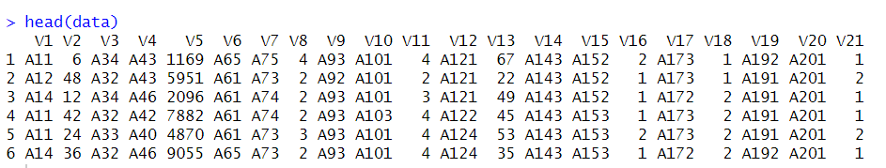

Created binary response for the logistic regression:

data$V21[data$V21==1] <- 0 #good
data$V21[data$V21==2] <- 1 #bad

- Split data into training set 70% and test set 30%:

set.seed(123)

training <- sample(nrow(data), 0.70*nrow(data), replace = FALSE)

train_set <- data[training,]
test_set <- data[-training,]

Built the logistic regression:

glm_model <- glm(V21~ .,family=binomial(link='logit'), data=train_set)

Inspected the results:

summary(glm_model)
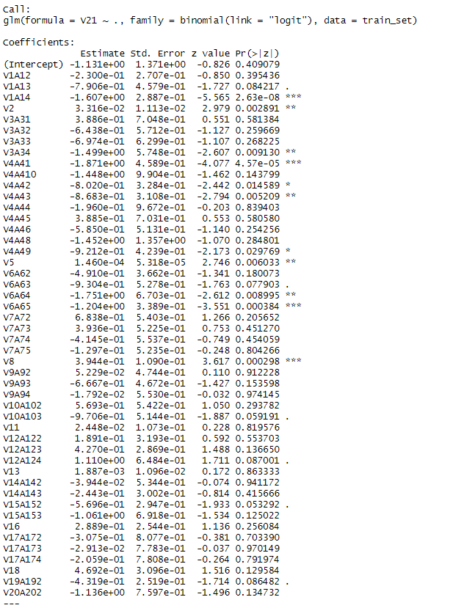
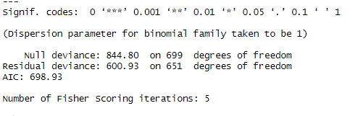
"Null deviance" and "Residual deviance". A larger difference between the two suggests that the model (with predictors) provides a better fit than a model with just an intercept.
AIC: The Akaike Information Criterion (AIC) is a measure of the model's quality, penalizing complexity. When comparing multiple models, a lower AIC value indicates a better-fitting model.

- Used the predict() function to see how your model performs on the test data it has not seen before:
#This will give an unbiased estimate of the model's performance.
#Predict probabilities on the test set
#type = "response" gives probabilities (0 to 1)

pred1 <- predict(glm_model, newdata=test_set, type="response")
head(pred1)

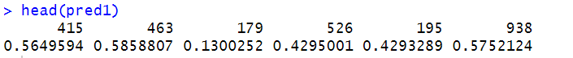

- Used ROC curve to calculate AUC values to determine fit of the model:

install.packages("pROC")
library(pROC)

#Calculated ROC curve

roc <- roc(response=test_set$V21, predictor=pred1)

#Calculated AUC value
auc <- auc(roc)
auc
Area under the curve: 0.7737

- Plotted the ROC curve:
plot(roc)
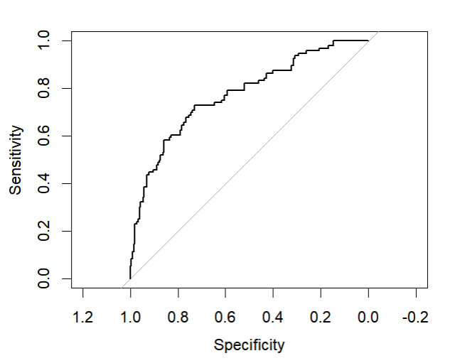

The Area Under the Curve (AUC) provides a single, summary metric of the model's performance. It represents the probability that the model will rank a randomly chosen positive observation higher than a randomly chosen negative observation.
AUC = 1.0: This indicates a perfect model. The classifier can perfectly distinguish between the two classes at some threshold.
AUC = 0.5: This indicates that the model's performance is no better than random guessing. The ROC curve will follow the diagonal.
An AUC (Area Under the Curve) value of 0.7737 indicates that your logistic regression model has moderately good performance. It is significantly better than random guessing (AUC = 0.5) but not a perfect classifier (AUC = 1.0).

AUC suggests that the model is generally good at assigning higher probabilities to the "bad" customers and lower probabilities to the "good" ones.

The problem states that the cost of a False Negative (classifying a bad customer as good) is 5 times greater than the cost of a False Positive (classifying a good customer as bad).
False Negative (FN): The model predicts "Good," but the customer is actually "Bad."
False Positive (FP): The model predicts "Bad," but the customer is actually "Good.

The standard threshold for a binary classifier is 0.5. This threshold treats False Positives and False Negatives equally. However, when the costs are unequal, we need to adjust the threshold.
To minimize the total cost, we should set the threshold probability to the point where the cost ratio is balanced against the model's error rates. A good heuristic is to set the threshold such that the misclassification cost is equal at the margin. The cost ration is 5:1.
The new threshold should be set at a lower probability than 0.5. This makes the model more conservative, requiring a higher probability before it predicts "Good".

Threshold = cost(FP)/cost(FN) + cost(FP)
1/1+5 = 0.167

Set new threshold: 0.167 (1/6):

new_threshold <- 1/6

- Converted predicted probabilities to class labels using the new threshold:

#The levels are 0 (good) and 1 (bad).

pred_classes <- ifelse(pred1 > new_threshold, 1, 0)

Created confusion matrix:

conf_matrix <- table(Predicted = pred_classes, Actual = test_set$V21)

print(conf_matrix)

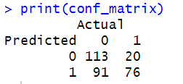

True Negatives (TN) = 113: The model correctly predicted that 113 customers were "Good" (and they were actually good).
False Negatives (FN) = 20: The model incorrectly predicted that 20 customers were "Good" when they were actually "Bad." This is the most expensive type of error.
False Positives (FP) = 91: The model incorrectly predicted that 91 customers were "Bad" when they were actually "Good."
True Positives (TP) = 76: The model correctly predicted that 76 customers were "Bad" (and they were actually bad).

Using the cost ratio you specified (a False Negative is 5 times more costly than a False Positive), we can calculate the total cost for this model and threshold.
Cost of a False Negative (FN): 5
Cost of a False Positive (FP): 1
Total Cost = (Number of False Negatives * Cost of FN) + (Number of False Positives * Cost of FP)
Total Cost = (20 * 5) + (91 * 1)
Total Cost = 100 + 91 = 191

------------------------------------------------------------------------------------------------------------------------------------------Results, discussion of the results:

The AUC (Area Under the Curve) value of 0.7737 indicates that your logistic regression model has moderately good performance. It is significantly better than random guessing (AUC = 0.5) but not a perfect classifier (AUC = 1.0). The AUC suggests that the model is generally good at assigning higher probabilities to the "bad" customers and lower probabilities to the "good" ones.

By setting a lower threshold of 0.167, the model successfully reduced the number of False Negatives to 20, at the expense of increasing the number of False Positives to 91. The total cost of 191 is the result of this trade-off, prioritizing the minimization of the more costly error.

