Question 9.1

Using the same crime data set uscrime.txt as in Question 8.2, apply Principal Component Analysis and then create a regression model using the first few principal components. Specify your new model in terms of the original variables (not the principal components), and compare its quality to that of your solution to Question 8.2. You can use the R function prcomp for PCA. (Note that to first scale the data, you can include scale. = TRUE to scale as part of the PCA function. Don’t forget that, to make a prediction for the new city, you’ll need to unscale the coefficients (i.e., do the scaling calculation in reverse)!)
------------------------------------------------------------------------------------------------------------------------------------------

Solution - Question 9.1

Methodology:

- Loaded and inspected the dataset:

data <-read.table('uscrime.txt', header=TRUE)
head(data)

- Created a test dataset using given factors:

test_data <- data.frame(M = 14.0, So = 0, Ed = 10.0, Po1 = 12.0, Po2 = 15.5, LF = 0.640, M.F = 94.0, Pop = 150, NW = 1.1, U1 = 0.120, U2 = 3.6, Wealth = 3200, Ineq = 20.1, Prob = 0.04, Time = 39.0)

- Applied Principal Component Analysis using R function prcomp; crime column is not included:

pca <- prcomp(data[,1:15], center = TRUE, scale = TRUE)

- Inspected PCA analysis results:

summary(pca)

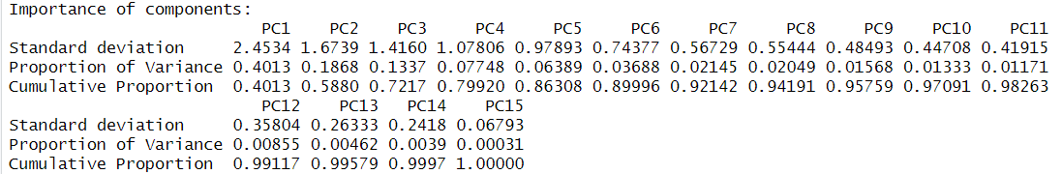

- Plotted the pca results:

plot(pca, type="l")

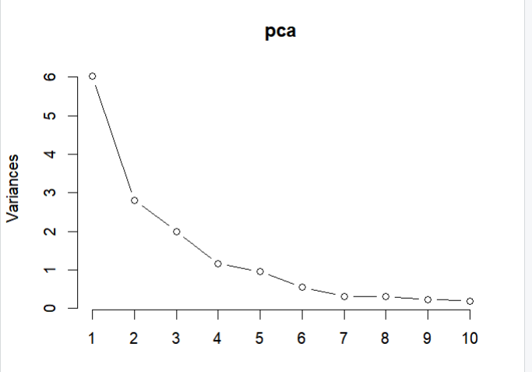

The first component explains close to 60% of the variance, the second component explains about 30% of the variance. Making use of the elbow diagram it is clearly visible that less and less of the variance is being explained beyond the 6th principal component.

- Determined the optimal number of principal components considering the elbow diagram above and using Kaiser's rule (eigenvalues > 1):

The elbow diagram shows that there is less variance beyond 6th principal component.

Applied Kaiser's rule (eigenvalues > 1) and got the eigenvalues(the square root of std):

eigenvalues <- pca$sdev^2

eigenvalues_selected <- sum(eigenvalues >1)
4

- Checked the cumulative variance using Cumulative Proportion values and calculate how much total variance is captured by 4 components versus 6 components:

summary_pca <- summary(pca)
# 6 components
pca_importance <- summary_pca$importance

pca_importance <- pca_importance["Cumulative Proportion", ]

pca_importance_6 <-pca_importance[6]

pca_importance_6
PC6 0.89996

#4 components

pca_importance_4 <-pca_importance[4]
pca_importance_4
PC4 0.7992

#calculated diff

diff <- (pca_importance_6 - pca_importance_4)*100
> diff
PC6
10.076

The difference in cumulative variance explained between the first 6 components and the first 4 components is approximately 10.076 percentage points, which means adding components 5 and 6 increases the total explained variance by an additional 10.076%. Based on this number, keeping the first 6 components is a very reasonable choice.

- Expected the 5th and 6th components using pca rotation values:

rotation_results <- pca$rotation

rotation_results_5_6 <- rotation_results[,5:6]

rotation_results_5_6

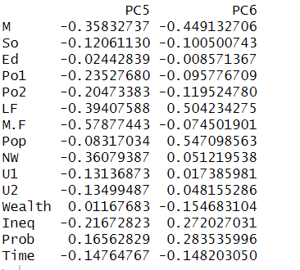
PC5 appears to be dominated by M.F (number of males per 100 females) followed by LF (labour force participation rate of civilian urban males in the age-group 14-24), M (percentage of males aged 14–24 in total state population), and Po1 (per capita expenditure on police protection in 1960). The fact that these are all negative loadings suggests that PC5 captures a dimension where a higher score on this component corresponds to lower values for these variables. Based on this, PC5 could represent a dimension related to workforce demographics and potential economic factors.

PC6 is most heavily influenced by Pop (state population in 1960 in hundred thousands) and LF (labour force participation rate of civilian urban males in the age-group 14-24), both with strong positive loadings. This suggests that PC6 represents population size and labor force participation.

- Selected original 6 principal components; used x values that stand for scores:

primary_components <- pca$x[,1:6]

summary(primary_components)

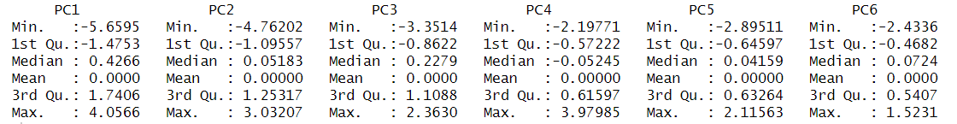

- Prepared a dataset for regression, where the selected PC scores are combined with the target variable, which came from the original dataset.

The PC scores are the new, transformed predictors. To run a regression, we need to combine these new predictors with the dependent (target) variable from the original dataset. The target variable is the crime variable from original dataset.

pca_target_combine <- cbind(primary_components, data[,16])

pca_target_combined <- as.data.frame(pca_target_combine)

head(pca_target_combined)

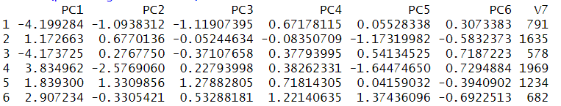

- Built lm model using pca_target_combined dataset:

pca_model <- lm(V7~., data=pca_target_combined)

summary(pca_model)
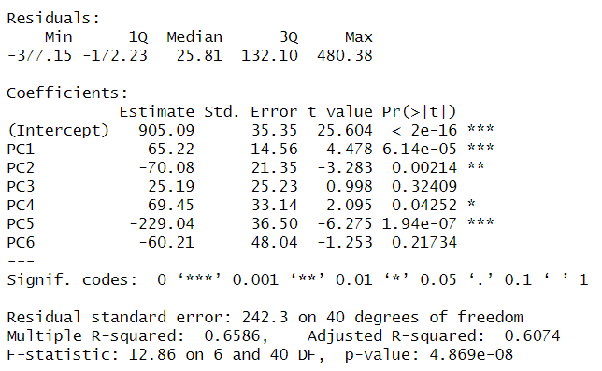

- Plotted the model:

plot(pca_model)

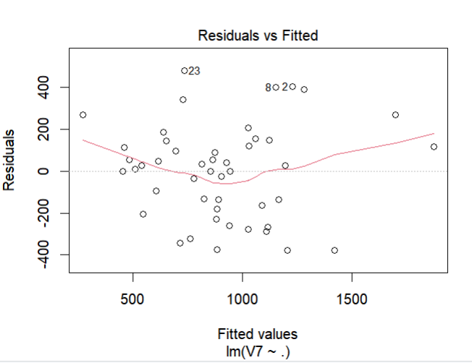 | 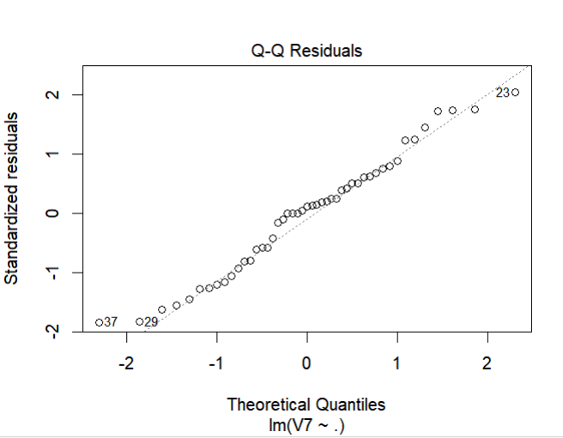

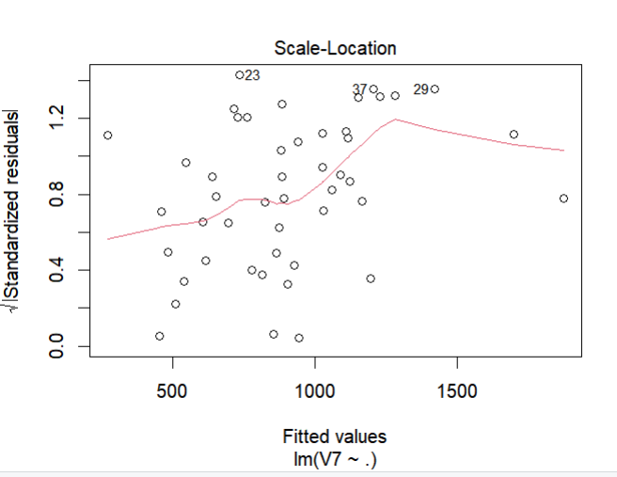 | 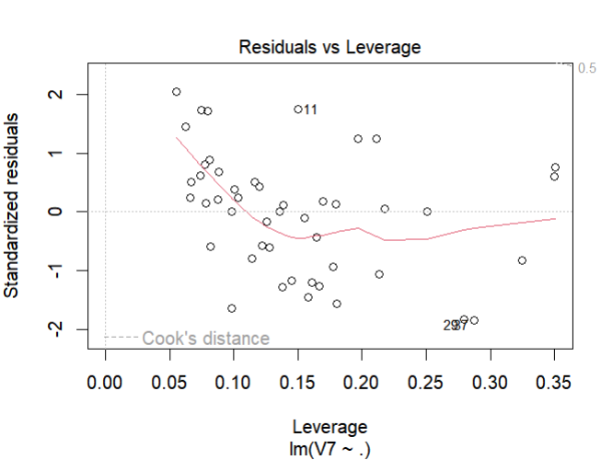

- Unscaled coefficients as an exercise. To get the final unscaled coefficients and intercept for the model, the following components needed to be calculated:

#PCA_model(PCR)
pcr_beta0_scaled <- coef(pca_model)['Intercept']

pcr_betas_scaled <- coef(pca_model)[-1]

#PCA results
#extracted pca rotation/loadings for 6 principal components, used rotation_results calculated above

rotation_results_6 <- rotation_results[,1:6]

#PCA original means
pca_orig_means <- pca$center

#PCA original standard deviation
pca_orig_stds <-pca$scale

#Calculated the unscaled coefficients for the original variables using components found above

betas_unscaled <- (rotation_results_6 %*% pcr_betas_scaled) / pca_orig_stds

# Calculated the final unscaled intercept

beta0_unscaled <- pcr_beta0_scaled - sum(betas_unscaled * pca_orig_means)

- Compared this week’s predictions to last week’s prediction:

Transformed the test data into PC scores using the pca object using first 6 components
test_data_transformed <- data.frame(predict(pca,test_data))

- Predicted the crime rate using the `pca_model` that was trained on the PC scores:

predicted_crime_rate <- predict(pca_model, newdata=test_data_transformed)

> predicted_crime_rate
1
1248.427
------------------------------------------------------------------------------------------------------------------------------------------
Results, discussion of the results:

Last week’s model reported RSE value of 200.7 and R-squared value of 0.76, and adjusted R-squared value of 0.73 and used predictors - M, Ed, Po1, U2, Ineq, Prob, with p-values <=0.05. The model produced a prediction for the crime rate of 1304.245.

model1 <- lm(Crime ~ M + Ed + Po1 + U2 + Ineq + Prob, data=data)
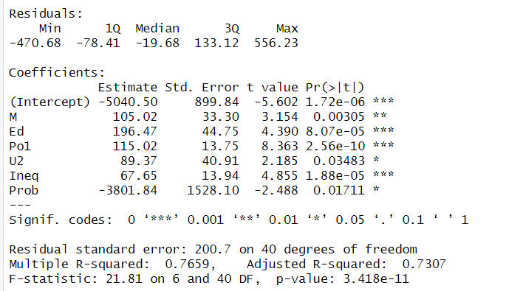

The PCA model reported RSE value of 242.3 and R-squared value of 0.65, and adjusted R-squared value of 0.60. The model produced a prediction for the crime rate of 1248.427.

pca_model <- lm(V7~., data=pca_target_combined)

Comparing both models, PCA model returned relatively close results. However, the last week’s model is still considered better as it demonstrated a stronger fit of the model to the data due to higher R-squared value and crime prediction result.
Looking at the p-values in PCA model for PC1 through PC6, PC3 and PC6 may not be statistically significant, which suggest that corresponding principal components do not have a meaningful relationship with the crime rate, and the model could be potentially simplified further by dropping these components.

