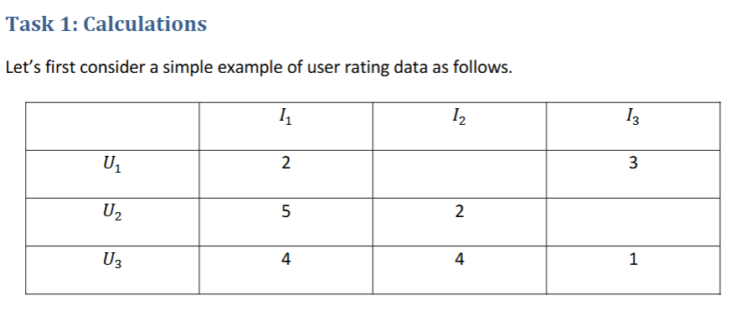

1. Applying the algorithm of User-based Collaborative Filtering (UBCF) as we learned in class,
manually calculate the predicted rating of User 1 (𝑈1) on Item 2 (𝐼2).
Hints: here are the steps you should follow:
i) Normalize the table by subtracting user-mean;
user means:
U1 – 2.5
U2 – 3.5
U3 – 3
 | I1 | I2 | I3
U1 | -0.5 |  | 0.5
U2 | 1.5 | -1.5
U3 | 1 | 1 | -2

ii) Calculate the similarities between 𝑈1 and 𝑈2 (𝑠12) and between 𝑈1 and 𝑈3 (𝑠13);
S12 = $\frac{−0.5 X 1.5}{\sqrt{{−0.5}^{2}∗{ 1.5}^{2 } }}$= -0.75 /0.75 = -1

S13 = = $\frac{−0.5∗ 1 +0.5∗ −2}{\sqrt{{−0.5}^{2}∗{ 0.5}^{2 }+ { { 1}^{2 }+−2}^{2 } }}$= -1.5 / 1.5811 = - 0.9487

iii) Calculate the predicted rating as the weighted average of 𝑈2’s and 𝑈3’s ratings on 𝐼2,
using 𝑠12 and 𝑠13 as the weights.
#normalized deviation
R12 = ((-1.5) * (-1) + 1 * (-0.9487)) / (1 + 0.9487) = (1.5 - 0.9487) / 1.9487 = 0.5513 / 1.9487 = 0.2829
#predicted rating
Pred = U1 mean + normalized deviation
Pred = 2.5 + 0.2829
Pred = 2.783

