# Computer Architecture and Technology Convergence Assignment

Computer Architecture and Technology Convergence Assignment 1

Q1: Binary Arithmetic: 1

Q1.1. 1

Q1.2. 1

Q1.3. 2

Q1.5 2

Q2: Linux Assignment 3

Q2.1: 3

Q2.2: 5

Q2.3 29

Q2.3.1: 29

Q2.3.2: 29

Q2.4: 30

## Q1: Binary Arithmetic:

#### Q1.1.

|  |  |  |  |  |  |  |
| --- | --- | --- | --- | --- | --- | --- |
|  | 1 | 1 | 0 | 1 | 1 |  |
|  |  | 1 | 1 | 0 | 1 | 1 |
| + |  | 0 | 1 | 0 | 1 | 1 |
|  | 1 | 0 | 0 | 1 | 1 | 0 |

**Answer**: 100110

#### Q1.2.

1. -31

* The equivalent binary number:

31/2= 15(1), 15/2=7(1), 7/2=3(1), 3/2=1(1), 1/2=0(1)

00011111

* As the number is negative, inverting all the bits (11100000) and adding 1: 11100001

**Answer**: 11100001

1. -59

* The equivalent binary number:

59/2=29(1), 29/2=14(1), 14/2=7(0), 7/2=3(1), 3/2=1(1), 1/2=0(1)

00111011

* As the number is negative, inverting all the bits (11000100) and adding 1: 11000101

**Answer:** 11000101

#### *Q1.3*.

The bit pattern 11101001 represents a negative integer in an 8-bit two's complement as it has the most significant bit as '1'.

As it is negative, subtracting 1 (11101000) and inverting all the bits (00010111):

00010111 = 064 + 032 + 016 + 28 + 04 + 22 + 21 + 20 = 16 + 4 + 2 + 1 = 23

It is a negative integer -23 in base-10.

*Q1.4.*

1. Truth Table

|  |  |  |  |
| --- | --- | --- | --- |
| X | Y | D | B |
| 0 | 0 | 0 | 0 |
| 0 | 1 | 1 | 0 |
| 1 | 0 | 1 | 1 |
| 1 | 1 | 0 | 0 |

1. Function: Half Subtractor

#### 

#### Q1.5

(AB + C)D

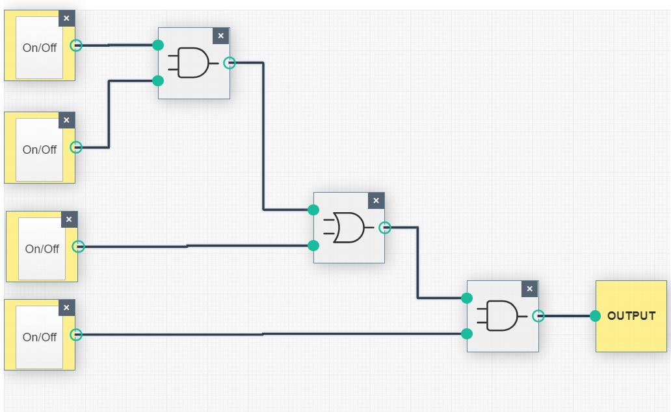

## Q2: Linux Assignment

#### Q2.1:

* **echo** **hello world** command prints out the string “hello world”.
* **passwd** command offers a user to change a password of his/her account or a superuser to change another user’s account password. It also gives suggestions in case a new password is bad.
* **date** command displays the current date and time of the operating system (in the time zone it is configured by default, however, the root can reset it)
* **hostname** commandoutputs a name given to a computer over the network (ip address in my case). It has a few options available, one of them is changing the name (*sudo hostname [new_host_name])*
* **arch** command displays computers architecture.
* **uname -a** command provides system information (of VM in this case)on OS kernel name, hostname, data on the last compiling of the kernel, computer architecture, type of operating system.
* **dmesg** command prints out kernel related messages produced by device drivers (very useful in troubleshooting as it outputs errors and warnings).
* **uptime** command outputs time for which the current system has been up running, how many users are logged in at the moment of input of the command and the system load average.
* **whoami** command outputs user’s username
* **who** command prints out the information on who logged on to the system last (username, terminal line number, time and hostname)
* **last** command offers a list of users logged in and out since the wtmp (in this case) was created. The number of lines displayed can be specified through an *option last –[number]*, for example, *last -10,* or by specifying the time period through *last -s* (since) and *-t* (to) command
* **finger** command offers information about the system users (such as username, login time, idle, hostname etc)
* **w** command provides data on who is logged on to the system and what they are doing at the moment of request (in the header it specifies the uptime)
* **top** command shows real-time processes running on the Linux system
* **echo $SHELL** command displays user’s preferred shell
* **echo {con,pre}{sent,fer}{s,ed}** command concatenates morphemes in the curly brackets text as follows “consents consented confers confered presents presented prefers preferred”
* **man ls** command outputs the manual information about the *ls* command
* **man who** command prints out information about the *who* command
* **clear** command clears up the screen
* **cal 2000** command outputs the calendar of 2000
* **cal 9 1752** command outputs September of 1752, however it misses 11 days from 3rd September to 13th September as a result of the Gregorian Reformation in Britain (as the country was 11 days behind all other European countries that have already adopted the Gregorian Calendar)
* **yes please** command prints out *please* until it is aborted
* **time sleep 5** command pauses the execution of a command for 5 seconds
* **history** command produces the history of commands used by the user

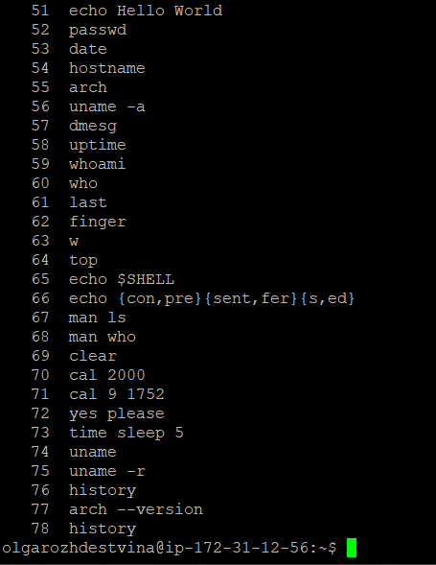

#### Q2.2:

************

date COMMAND

************

Fri Apr 3 03:03:20 UTC 2020

****************

hostname COMMAND

****************

ip-172-31-12-56

************

arch COMMAND

************

x86_64

****************

uname -a COMMAND

****************

Linux ip-172-31-12-56 4.4.0-1102-aws #113-Ubuntu SMP Wed Jan 29 14:54:54 UTC 2020 x86_64 x86_64 x86_64 GNU/Linux

**************

uptime COMMAND

**************

03:03:20 up 25 days, 5:33, 2 users, load average: 0.00, 0.00, 0.00

**************

whoami COMMAND

**************

olgarozhdestvina

***********

who COMMAND

***********

olgarozhdestvina pts/0 2020-04-03 01:42 (64.119.23.128)

olgarozhdestvina pts/1 2020-04-03 02:19 (64.119.23.128)

**************

finger COMMAND

**************

Login Name Tty Idle Login Time Office Office Phone

olgarozhdestvina pts/0 1:03 Apr 3 01:42 (64.119.23.128)

olgarozhdestvina pts/1 Apr 3 02:19 (64.119.23.128)

*********

w COMMAND

*********

03:03:20 up 25 days, 5:33, 2 users, load average: 0.00, 0.00, 0.00

USER TTY FROM LOGIN@ IDLE JCPU PCPU WHAT

olgarozh pts/0 64.119.23.128 01:42 1:03m 0.14s 0.07s vim olgaRozhdestvinaScript.txt

olgarozh pts/1 64.119.23.128 02:19 0.00s 0.10s 0.00s w

***********

top COMMAND

***********

top - 03:03:20 up 25 days, 5:33, 2 users, load average: 0.00, 0.00, 0.00

Tasks: 130 total, 1 running, 129 sleeping, 0 stopped, 0 zombie

%Cpu(s): 0.1 us, 0.1 sy, 0.0 ni, 99.7 id, 0.0 wa, 0.0 hi, 0.0 si, 0.0 st

KiB Mem : 1014424 total, 153588 free, 88692 used, 772144 buff/cache

KiB Swap: 0 total, 0 free, 0 used. 694704 avail Mem

PID USER PR NI VIRT RES SHR S %CPU %MEM TIME+ COMMAND

1 root 20 0 37720 5720 4024 S 0.0 0.6 0:42.06 systemd

2 root 20 0 0 0 0 S 0.0 0.0 0:00.01 kthreadd

3 root 20 0 0 0 0 S 0.0 0.0 0:26.62 ksoftirqd/0

5 root 0 -20 0 0 0 S 0.0 0.0 0:00.00 kworker/0:0H

7 root 20 0 0 0 0 S 0.0 0.0 0:35.53 rcu_sched

8 root 20 0 0 0 0 S 0.0 0.0 0:00.00 rcu_bh

9 root rt 0 0 0 0 S 0.0 0.0 0:00.00 migration/0

10 root rt 0 0 0 0 S 0.0 0.0 0:10.30 watchdog/0

11 root 20 0 0 0 0 S 0.0 0.0 0:00.00 kdevtmpfs

12 root 0 -20 0 0 0 S 0.0 0.0 0:00.00 netns

13 root 0 -20 0 0 0 S 0.0 0.0 0:00.00 perf

14 root 20 0 0 0 0 S 0.0 0.0 0:00.01 xenwatch

15 root 20 0 0 0 0 S 0.0 0.0 0:00.00 xenbus

17 root 20 0 0 0 0 S 0.0 0.0 0:00.54 khungtaskd

18 root 0 -20 0 0 0 S 0.0 0.0 0:00.00 writeback

19 root 25 5 0 0 0 S 0.0 0.0 0:00.00 ksmd

20 root 39 19 0 0 0 S 0.0 0.0 0:03.59 khugepaged

21 root 0 -20 0 0 0 S 0.0 0.0 0:00.00 crypto

22 root 0 -20 0 0 0 S 0.0 0.0 0:00.00 kintegrityd

23 root 0 -20 0 0 0 S 0.0 0.0 0:00.00 bioset

24 root 0 -20 0 0 0 S 0.0 0.0 0:00.00 kblockd

25 root 0 -20 0 0 0 S 0.0 0.0 0:00.00 ata_sff

26 root 0 -20 0 0 0 S 0.0 0.0 0:00.00 md

27 root 0 -20 0 0 0 S 0.0 0.0 0:00.00 devfreq_wq

30 root 20 0 0 0 0 S 0.0 0.0 0:00.71 kswapd0

31 root 0 -20 0 0 0 S 0.0 0.0 0:00.00 vmstat

32 root 20 0 0 0 0 S 0.0 0.0 0:00.00 fsnotify_mark

33 root 20 0 0 0 0 S 0.0 0.0 0:00.00 ecryptfs-kthrea

49 root 0 -20 0 0 0 S 0.0 0.0 0:00.00 kthrotld

50 root 0 -20 0 0 0 S 0.0 0.0 0:00.00 bioset

51 root 0 -20 0 0 0 S 0.0 0.0 0:00.00 bioset

52 root 0 -20 0 0 0 S 0.0 0.0 0:00.00 bioset

53 root 0 -20 0 0 0 S 0.0 0.0 0:00.00 bioset

54 root 0 -20 0 0 0 S 0.0 0.0 0:00.00 bioset

55 root 0 -20 0 0 0 S 0.0 0.0 0:00.00 bioset

56 root 0 -20 0 0 0 S 0.0 0.0 0:00.00 bioset

57 root 0 -20 0 0 0 S 0.0 0.0 0:00.00 bioset

58 root 0 -20 0 0 0 S 0.0 0.0 0:00.00 bioset

59 root 0 -20 0 0 0 S 0.0 0.0 0:00.00 bioset

60 root 0 -20 0 0 0 S 0.0 0.0 0:00.00 bioset

61 root 0 -20 0 0 0 S 0.0 0.0 0:00.00 bioset

62 root 0 -20 0 0 0 S 0.0 0.0 0:00.00 bioset

63 root 0 -20 0 0 0 S 0.0 0.0 0:00.00 bioset

64 root 0 -20 0 0 0 S 0.0 0.0 0:00.00 bioset

65 root 0 -20 0 0 0 S 0.0 0.0 0:00.00 bioset

66 root 0 -20 0 0 0 S 0.0 0.0 0:00.00 bioset

67 root 0 -20 0 0 0 S 0.0 0.0 0:00.00 bioset

68 root 0 -20 0 0 0 S 0.0 0.0 0:00.00 bioset

69 root 0 -20 0 0 0 S 0.0 0.0 0:00.00 bioset

70 root 0 -20 0 0 0 S 0.0 0.0 0:00.00 bioset

71 root 0 -20 0 0 0 S 0.0 0.0 0:00.00 bioset

72 root 0 -20 0 0 0 S 0.0 0.0 0:00.00 bioset

73 root 0 -20 0 0 0 S 0.0 0.0 0:00.00 bioset

74 root 0 -20 0 0 0 S 0.0 0.0 0:00.00 nvme

75 root 20 0 0 0 0 S 0.0 0.0 0:00.00 scsi_eh_0

76 root 0 -20 0 0 0 S 0.0 0.0 0:00.00 scsi_tmf_0

77 root 20 0 0 0 0 S 0.0 0.0 0:00.00 scsi_eh_1

78 root 0 -20 0 0 0 S 0.0 0.0 0:00.00 scsi_tmf_1

83 root 0 -20 0 0 0 S 0.0 0.0 0:00.00 ipv6_addrconf

94 root 0 -20 0 0 0 S 0.0 0.0 0:00.00 bioset

97 root 0 -20 0 0 0 S 0.0 0.0 0:00.00 deferwq

249 root 0 -20 0 0 0 S 0.0 0.0 0:00.00 raid5wq

280 root 0 -20 0 0 0 S 0.0 0.0 0:00.00 bioset

302 root 20 0 0 0 0 S 0.0 0.0 0:07.30 jbd2/xvda1-8

303 root 0 -20 0 0 0 S 0.0 0.0 0:00.00 ext4-rsv-conver

368 root 0 -20 0 0 0 S 0.0 0.0 0:00.57 kworker/0:1H

369 root 20 0 28436 2664 2300 S 0.0 0.3 6:32.80 systemd-journal

383 root 0 -20 0 0 0 S 0.0 0.0 0:00.00 iscsi_eh

390 root 0 -20 0 0 0 S 0.0 0.0 0:00.00 ib_addr

392 root 0 -20 0 0 0 S 0.0 0.0 0:00.00 ib_mcast

396 root 0 -20 0 0 0 S 0.0 0.0 0:00.00 ib_nl_sa_wq

398 root 0 -20 0 0 0 S 0.0 0.0 0:00.00 ib_cm

399 root 0 -20 0 0 0 S 0.0 0.0 0:00.00 iw_cm_wq

402 root 0 -20 0 0 0 S 0.0 0.0 0:00.00 rdma_cm

407 root 20 0 0 0 0 S 0.0 0.0 0:00.00 kauditd

422 root 20 0 102964 952 772 S 0.0 0.1 0:00.00 lvmetad

459 root 20 0 42440 3468 2584 S 0.0 0.3 0:01.22 systemd-udevd

528 root 0 -20 0 0 0 S 0.0 0.0 0:00.05 loop0

532 root 0 -20 0 0 0 S 0.0 0.0 0:00.04 loop1

541 root 0 -20 0 0 0 S 0.0 0.0 0:00.00 loop2

747 systemd+ 20 0 100320 2320 2116 S 0.0 0.2 0:01.40 systemd-timesyn

979 root 20 0 16120 2484 1632 S 0.0 0.2 0:00.71 dhclient

1135 root 20 0 275376 5272 3740 S 0.0 0.5 3:08.09 accounts-daemon

1138 root 20 0 5216 112 0 S 0.0 0.0 0:59.58 iscsid

1139 root 10 -10 5716 3508 2428 S 0.0 0.3 4:32.70 iscsid

1140 root 20 0 27724 2532 2252 S 0.0 0.2 0:02.68 cron

1147 root 20 0 637304 3656 1320 S 0.0 0.4 0:09.66 lxcfs

1149 root 20 0 218560 5072 3304 S 0.0 0.5 0:14.96 amazon-ssm-agen

1153 daemon 20 0 26040 1924 1728 S 0.0 0.2 0:00.02 atd

1154 message+ 20 0 42896 3380 2888 S 0.0 0.3 0:04.53 dbus-daemon

1181 syslog 20 0 260624 3716 2192 S 0.0 0.4 1:54.18 rsyslogd

1188 root 20 0 28612 2896 2536 S 0.0 0.3 0:02.76 systemd-logind

1198 root 20 0 4392 1272 1188 S 0.0 0.1 0:00.00 acpid

1219 root 20 0 279236 5464 4268 S 0.0 0.5 0:00.76 polkitd

1239 root 20 0 13368 140 0 S 0.0 0.0 0:00.12 mdadm

1245 root 20 0 173336 14616 6548 S 0.0 1.4 0:00.11 unattended-upgr

1300 root 20 0 14468 1608 1472 S 0.0 0.2 0:00.02 agetty

1309 root 20 0 14652 1460 1332 S 0.0 0.1 0:00.04 agetty

1510 root 20 0 65508 3984 3268 S 0.0 0.4 1:55.89 sshd

1744 root 20 0 0 0 0 S 0.0 0.0 0:00.06 kworker/0:1

2486 root 20 0 92908 6756 5724 S 0.0 0.7 0:00.02 sshd

2494 olgaroz+ 20 0 45164 4584 3872 S 0.0 0.5 0:00.00 systemd

2495 olgaroz+ 20 0 61172 1808 0 S 0.0 0.2 0:00.00 (sd-pam)

2562 olgaroz+ 20 0 92908 4332 3300 S 0.0 0.4 0:00.16 sshd

2563 olgaroz+ 20 0 21384 5216 3280 S 0.0 0.5 0:00.07 bash

3025 olgaroz+ 20 0 52912 8744 5528 S 0.0 0.9 0:00.07 vim

3653 root 20 0 0 0 0 S 0.0 0.0 0:00.04 kworker/0:0

3656 root 20 0 92828 6836 5908 S 0.0 0.7 0:00.01 sshd

3701 olgaroz+ 20 0 92828 4280 3312 S 0.0 0.4 0:00.56 sshd

3703 olgaroz+ 20 0 21384 5216 3280 S 0.0 0.5 0:00.10 bash

4539 root 0 -20 0 0 0 S 0.0 0.0 0:00.00 loop4

4555 root 20 0 302004 25036 13644 S 0.0 2.5 0:07.21 snapd

5036 root 20 0 65508 6088 5384 S 0.0 0.6 0:00.00 sshd

5039 sshd 20 0 65508 728 12 S 0.0 0.1 0:00.00 sshd

5089 root 20 0 92676 6712 5804 S 0.0 0.7 0:00.00 sshd

5090 sshd 20 0 65508 3284 2564 S 0.0 0.3 0:00.00 sshd

5093 root 20 0 92676 6468 5572 S 0.0 0.6 0:00.00 sshd

5094 root 20 0 65508 5904 5196 S 0.0 0.6 0:00.00 sshd

5095 sshd 20 0 65508 3236 2512 S 0.0 0.3 0:00.00 sshd

5096 sshd 20 0 65508 732 12 S 0.0 0.1 0:00.00 sshd

5097 root 20 0 65508 6040 5332 S 0.0 0.6 0:00.00 sshd

5098 sshd 20 0 65508 732 12 S 0.0 0.1 0:00.00 sshd

5099 olgaroz+ 20 0 21384 4244 2304 S 0.0 0.4 0:00.00 bash

5109 olgaroz+ 20 0 40384 3692 3176 R 0.0 0.4 0:00.00 top

5110 root 20 0 65508 5980 5272 S 0.0 0.6 0:00.00 sshd

5111 sshd 20 0 65508 728 12 S 0.0 0.1 0:00.00 sshd

11409 root 20 0 0 0 0 S 0.0 0.0 0:01.80 kworker/u30:0

26286 root 0 -20 0 0 0 S 0.0 0.0 0:00.00 xfsalloc

26287 root 0 -20 0 0 0 S 0.0 0.0 0:00.00 xfs_mru_cache

28143 root 20 0 0 0 0 S 0.0 0.0 0:00.36 kworker/u30:1

***************

history COMMAND

***************

325 arch

326 echo "****************"

327 echo "uname -a COMMAND"

328 echo "****************"

329 echo ""

330 uname -a

331 echo "**************"

332 echo "uptime COMMAND"

333 echo "**************"

334 echo ""

335 uptime

336 echo "**************"

337 echo "whoami COMMAND"

338 echo "**************"

339 echo ""

340 whoami

341 echo "***********"

342 echo "who COMMAND"

343 echo "***********"

344 echo ""

345 who

346 echo "**************"

347 echo "finger COMMAND"

348 echo "**************"

349 echo ""

350 finger

351 echo "*********"

352 echo "w COMMAND"

353 echo "*********"

354 echo ""

355 w

356 echo "***********"

357 echo "top COMMAND"

358 echo "***********"

359 echo ""

360 top

361 echo "***************"

362 echo "history COMMAND"

363 echo "***************"

364 echo ""

365 # turning the history command on as it is disabled in noninteractive shells

366 # taken from here https://unix.stackexchange.com/questions/5684/history-command-inside-bash-script

367 HISTFILE=~/.bash_history

368 set -o history

369 history

370 history >> olgaRozhdestvina.txt

371 history >> olgaRozhdestvina.txt

372 ./olgaRozhdestvina.txt

373 ls

374 ./olgaRozhdestvinaScript.txt

375 vim olgaRozhdestvinaScript.txt

376 ./olgaRozhdestvinaScript.txt

377 vim olgaRozhdestvinaScript.txt

378 ./olgaRozhdestvinaScript.txt

379 ls

380 ./ olgaRozhdestvinaScript.txt

381 ./olgaRozhdestvinaScript.txt

382 vim olgaRozhdestvinaScript.txt

383 ./olgaRozhdestvinaScript.txt

384 vim olgaRozhdestvinaScript.txt

385 ./olgaRozhdestvinaScript.txt

386 ls

387 ./olgaRozhdestvinaScript.txt

388 vim olgaRozhdestvina.txt

389 vim olgaRozhdestvinaScript.txt

390 ./olgaRozhdestvinaScript.txt

391 vim olgaRozhdestvina.txt

392 rm -R file

393 ls

394 rm -R file.txt

395 ls

396 rm -R listings

397 rm -R olgaRozhdestvina.txt

398 ls

399 vim olgaRozhdestvinaScript.txt

400 .\olgaRozhdestvinaScript.txt

401 ./olgaRozhdestvinaScript.txt

402 ls

403 vim olgaRozhdestvina.txt

404 vim olgaRozhdestvinaScript.txt

405 ./olgaRozhdestvinaScript.txt

406 top man

407 man top

408 vim olgaRozhdestvinaScript.txt

409 ./olgaRozhdestvinaScript.txt

410 vim olgaRozhdestvinaScript.txt

411 ./olgaRozhdestvinaScript.txt

412 vim olgaRozhdestvina.txt

413 finger

414 vim olgaRozhdestvina.txt

415 vim olgaRozhdestvinaScript.txt

416 ./olgaRozhdestvinaScript.txt

417 vim olgaRozhdestvinaScript.txt

418 ./olgaRozhdestvinaScript.txt

419 vim olgaRozhdestvina.txt

420 vim olgaRozhdestvinaScript.txt

421 ./olgaRozhdestvinaScript.txt

422 vim olgaRozhdestvina.txt

423 vim olgaRozhdestvinaScript.txt

424 ./olgaRozhdestvinaScript.txt

425 vim olgaRozhdestvinaScript.txt

426 ./olgaRozhdestvinaScript.txt

427 vim olgaRozhdestvina.txt

428 vim olgaRozhdestvinaScript.txt

429 ./olgaRozhdestvinaScript.txt

430 ls

431 mkdir Music

432 ls

433 cd Music/

434 mkdir Rammstein

435 ls

436 cd ..

437 ls

438 mkdir Tom Waits

439 ls

440 rm Tom Waits

441 rm -rf*

442 rm *

443 cd ,,

444 cd ..

445 rm *

446 cd Music

447 cd Music/

448 ls

449 cd Music/

450 mkdir Tom_Waits

451 ls

452 mkdir Soapkills

453 ls

454 cd Rammstein

455 mkdir Mutter Rammstein

456 ls

457 cd ..

458 cd Soapkills/

459 mkdir Bater Cheftak

460 ls

461 cd ..

462 cd Tom_Waits/

463 mkdir The_Black_Rider Alice

464 ls

465 cd ..

466 ls

467 rm -Tom

468 rm Tom

469 tree

470 cd Tom

471 rm *

472 rm -R Tom

473 cd ..

474 rm -R Tom

475 ls

476 rm -R Waits

477 ls

478 tree

479 ls

480 ls

481 cd music

482 cd Music

483 ..

484 ls

485 cd Rammstein/

486 cd ..

487 ls

488 echo hello world

489 ls

490 passwd

491 ls

492 date

493 passwd

494 hostname

495 arch

496 uname -a

497 dmesg

498 more

499 quit

500 q

501 dmesg

502 more

503 q

504 uptime

505 whoami

506 who

507 last

508 fingr

509 finger

510 w

511 top

512 echo $SHELL

513 echo

514 echo {con,pre}

515 echo {con,pre}{sent,fer}{s,ed}

516 man ls

517 man who

518 clear

519 cal 2000

520 cal 9 1752

521 yea please

522 yes please

523 clear

524 yes please

525 clear

526 time sleep

527 time sleep 5

528 history

529 do-release-upgrade

530 arch -version

531 arch --version

532 history

533 echo Hello World

534 passwd

535 date

536 hostname

537 arch

538 uname -a

539 dmesg

540 uptime

541 whoami

542 who

543 last

544 finger

545 w

546 top

547 echo $SHELL

548 echo {con,pre}{sent,fer}{s,ed}

549 man ls

550 man who

551 clear

552 cal 2000

553 cal 9 1752

554 yes please

555 time sleep 5

556 uname

557 uname -r

558 history

559 arch --version

560 history

561 uptime

562 history

563 uptime -p

564 uptime

565 uptime -s

566 hostname -a

567 hostname -h

568 hostname -s

569 hostname olga

570 hostname d

571 hostname -d

572 hostname -A

573 sudo hostname olga

574 uname -r

575 uname

576 uname -a

577 dmesg -h

578 dmesg -f=daemon

579 dmesg -f=ram

580 dmesg -f=kern

581 dmesg -f = news

582 dmesg -f =news

583 dmesg

584 dmesg -f =warn

585 dmesg --facility=warn

586 dmesg -l=err,warn

587 whoami - un

588 whoami -un

589 un

590 who

591 last

592 finger

593 w

594 history

595 echo hello world

596 passwd

597 date

598 hostname

599 sudo hostname [olga]

600 arch

601 uname -a

602 dmesg

603 q

604 uptime

605 whoami

606 who

607 last

608 last -10

609 last -s March 29 -t March 30

610 last -s 29.03.2020 -t 30.03.2020

611 vim

612 vim tutor

613 vimtutor

614 vim file

615 vim file.txt

616 history

617 echo {con,pre}{sent,fer}{s,ed}

618 consents consented confers confered presents presented prefers prefered

619 history

620 history

621 vim olgaRozhdestvina.txt

622 ./olgaRozhdestvina.txt

623 vim olgaRozhdestvina

624 vim olgaRozhdestvina.txt

625 ./olgaRozhdestvina.txt

626 vim olgaRozhdestvina.txt

627 ./olgaRozhdestvina.txt

628 vim olgaRozhdestvina.txt

629 ./olgaRozhdestvina.txt

630 vim olgaRozhdestvina.txt

631 history

632 history

633 history

634 history

635 history

636 echo "THE END!"

637 ls

638 vim olgaRozhdestvina.txt

639 ./olgaRozhdestvina.txt

640 vim olgaRozhdestvina.txt

641 ./olgaRozhdestvina.txt

642 vim olgaRozhdestvina.txt

643 owd

644 pwd

645 /home/olgarozhdestvina/olgaRozhdestvina.txt > olgaRozhdestvina.txt

646 ./olgaRozhdestvina.txt > olgaRozhdestvina.txt

647 ./olgaRozhdestvina.txt >> olgaRozhdestvina.txt

648 lsof

649 cd

650 ls

651 /tmp

652 ls

653 cd temp

654 vim olgaRozhdestvina.txt

655 ./olgaRozhdestvina.txt

656 chmod 755 olgaRozhdestvina

657 ls

658 chmod 755 olgaRozhdestvina.txt

659 ./olgaRozhdestvina.txt

660 ls

661 ./olgaRozhdestvina.txt > olgaRozhdestvina.txt

662 ./olgaRozhdestvina.txt

663 .\olgaRozhdestvina.txt

664 ./olgaRozhdestvina.txt

665 vim olgaRozhdestvina.txt

666 vim olgaRozhdestvina.txt.swap

667 vim olgaRozhdestvina.txt

668 ./olgaRozhdestvina.txt > olgaRozhdestvina.txt

669 ./olgaRozhdestvina.txt

670 vim olgaRozhdestvina.txt

671 history

672 history

673 history

674 # saving save stdout to a file olgaRozhdestvina.txt

675 exec > olgaRozhdestvina.txt

676 ./olgaRozhdestvina.txt

677 vim olgaRozhdestvina.txt

678 ./olgaRozhdestvina.txt

679 vim olgaRozhdestvina.txt

680 ./olgaRozhdestvina.txt

681 history

682 # saving save stdout to a file olgaRozhdestvina.txt

683 exec > olgaRozhdestvina.txt

684 history

685 # saving save stdout to a file olgaRozhdestvina.txt

686 exec >> olgaRozhdestvina.txt

687 ls -al > listings

688 ls

689 ./olgaRozhdestvina.txt

690 ls >> ./listings/olgaRozhdestvina.txt

691 pwd

692 ls >> /home/olgarozhdestvina/listings/olgarozhdestvina.txt

693 ls >> /home/olgarozhdestvina/olgaRozhdestvina.txt

694 ls

695 vim olgaRozhdestvina

696 olgaRozhdestvina.txt

697 olgaRozhdestvina.txt >> /home/olgarozhdestvina/olgaRozhdestvina.txt

698 cat olgaRozhdestvina.txt >> /home/olgarozhdestvina/olgaRozhdestvina.txt

699 vim olgaRozhdestvina.txt

700 vim olgaRozhdestvinaScript.txt

701 cat olgaRozhdestvinaScript.txt >> /home/olgarozhdestvina/olgaRozhdestvina.txt

702 vim olgaRozhdestvina.txt

703 rm olgaRozhdestvina.txt

704 ls

705 cat olgaRozhdestvinaScript.txt >> /home/olgarozhdestvina/olgaRozhdestvina.txt

706 ls

707 vim olgaRozhdestvina.txt

708 command >> olgaRozhdestvina.txt

709 vim olgaRozhdestvina.txt

710 vim olgaRozhdestvinaScript.txt

711 ./olgaRozhdestvinaScript.txt

712 chmod 755 olgaRozhdestvinaScript.txt

713 ./olgaRozhdestvinaScript.txt

714 vim olgaRozhdestvina.txt

715 vim olgaRozhdestvinaScript.txt

716 ./olgaRozhdestvinaScript.txt

717 vim olgaRozhdestvina.txt

718 vim olgaRozhdestvinaScript.txt

719 vim olgaRozhdestvina.txt

720 ./olgaRozhdestvinaScript.txt

721 vim olgaRozhdestvina.txt

722 history

723 exec >> olgaRozhdestvina.txt

724 history

725 exec >> olgaRozhdestvina.txt

726 vim olgaRozhdestvinaScript.txt

727 ./olgaRozhdestvinaScript.txt

728 vim olgaRozhdestvinaScript.txt

729 ./olgaRozhdestvinaScript.txt

730 vim olgaRozhdestvinaScript.txt

731 ./olgaRozhdestvina.txt

732 history

733 exec >> olgaRozhdestvina.txt

734 history

735 history

736 history

737 history >> olgaRozhdestvina.txt

738 # A shell script that automates execution of below commands

739 echo "" > olgaRozhdestvina.txt

740 echo "************" >> olgaRozhdestvina.txt

741 echo "date COMMAND"

742 echo "************"

743 echo ""

744 date > olgaRozhdestvina.txt

745 echo "****************"

746 echo "hostname COMMAND"

747 echo "****************"

748 echo ""

749 hostname >> olgaRozhdestvina.txt

750 echo "************"

751 echo "arch COMMAND"

752 echo "************"

753 echo ""

754 arch

755 echo "****************"

756 echo "uname -a COMMAND"

757 echo "****************"

758 echo ""

759 uname -a

760 echo "**************"

761 echo "uptime COMMAND"

762 echo "**************"

763 echo ""

764 uptime

765 echo "**************"

766 echo "whoami COMMAND"

767 echo "**************"

768 echo ""

769 whoami

770 echo "***********"

771 echo "who COMMAND"

772 echo "***********"

773 echo ""

774 who

775 echo "**************"

776 echo "finger COMMAND"

777 echo "**************"

778 echo ""

779 finger

780 echo "*********"

781 echo "w COMMAND"

782 echo "*********"

783 echo ""

784 w

785 echo "***********"

786 echo "top COMMAND"

787 echo "***********"

788 echo ""

789 top

790 echo "***************"

791 echo "history COMMAND"

792 echo "***************"

793 echo ""

794 # turning the history command on as it is disabled in noninteractive shells

795 # taken from here https://unix.stackexchange.com/questions/5684/history-command-inside-bash-script

796 HISTFILE=~/.bash_history

797 set -o history

798 history

799 history >> olgaRozhdestvina.txt

800 history >> olgaRozhdestvina.txt

801 ./olgaRozhdestvina.txt

802 ls

803 ./olgaRozhdestvinaScript.txt

804 vim olgaRozhdestvinaScript.txt

805 ./olgaRozhdestvinaScript.txt

806 vim olgaRozhdestvinaScript.txt

807 ./olgaRozhdestvinaScript.txt

808 history >> olgaRozhdestvina.txt

809 history >> olgaRozhdestvina.txt

810 history >> olgaRozhdestvina.txt

811 history >> olgaRozhdestvina.txt

812 history >> olgaRozhdestvina.txt

813 history >> olgaRozhdestvina.txt

814 history >> olgaRozhdestvina.txt

815 history >> olgaRozhdestvina.txt

816 history >> olgaRozhdestvina.txt

817 history >> olgaRozhdestvina.txt

818 history >> olgaRozhdestvina.txt

819 echo "" >> olgaRozhdestvina.txt

820 echo "End of the script"

821 history >> olgaRozhdestvina.txt

822 echo "" >> olgaRozhdestvina.txt

823 echo "End of the script" >> olgaRozhdestvina.txt

824 history >> olgaRozhdestvina.txt

End of the script

#### Q2.3

##### Q2.3.1:

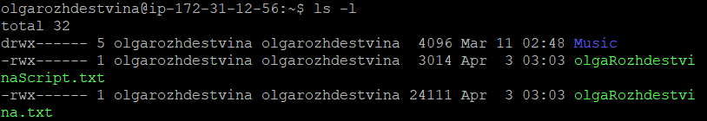

##### Q2.3.2:

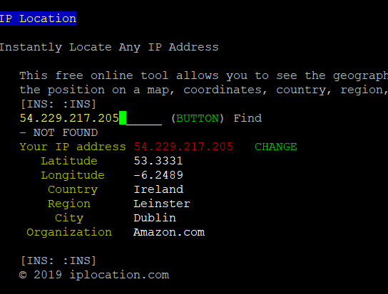

#### Q2.4:

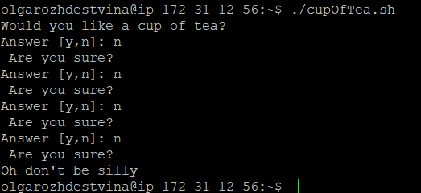

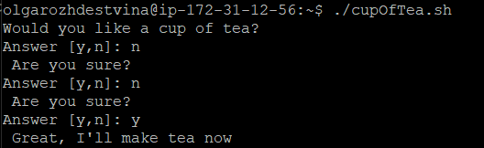

##### Shell Script:

#!/bin/bash

#Olga Rozhdestvina

# a shell script program that behaves

# like an Irish person offering a cup of tea.

echo "Would you like a cup of tea?"

i=0

while [ $i -lt 4 ]; do

read -n1 -p "Answer [y,n]: " ans

case $ans in

y|Y) echo ""

echo " Great, I'll make tea now"

exit;;

n|N) echo ""

echo " Are you sure?"

let i++;;

esac

done

echo "Oh don't be silly"