

review on sorting algorithms

Computational Thinking with Algorithms

Lecturer: Dominic Carr



May 3, 2021

Higher diploma in science – computing (data analytics)

Olga Rozhdestvina

G00387844

# Introduction

Sorting is a process of organising a list of elements in a particular order. It increases efficiency of subsequent operations performed on the elements since it is easier to handle sorted elements than randomize data (S. Paira et al., 2014). While sorting is a simple concept, it is frequently used as an intermediate step by complex computer programs such as data compression, path finding, data search, media recovery etc. This makes sorting a fundamental operation in computer science.

Sorting algorithm is an algorithm that takes an array as input and outputs a permutation of that array that is sorted (Sorting Algorithms, n.d.). Enhancing the existing sorting algorithms or producing new algorithms can greatly optimize other algorithms. Thus, a large number of algorithms has been developed to improve sorting, each approaching the reordering of elements differently in order to increase the performance and efficiency of the practical applications (K. S. Al-Kharabsheh et al., 2013).

When comparing various sorting algorithms, there are several factors that must be taken in consideration.

1. Time complexity.

Time complexity of an algorithm signifies the amount of time that required by an algorithm to run till its completion. The time complexity of an algorithm is generally written in form big O(n) notation, where the O represents the complexity of the algorithm and a value n represent the number of elementary operations performed by the algorithm. For example, a sorting algorithm has *O*(1), or constant time complexity if it needs to operate on one element of input list (regardless of the size). Time complexity of *O*(*n*) means an algorithm operates on each of the *n* elements of input list only once, etc. There are three types of time complexity: *best, average,* and *worst-case* complexity.

1. Space complexity

Space complexity describes the amount of memory (or space) necessary to perform the task that the algorithm is expected to solve. For example, space complexity of *O(1)* means that the algorithm doesn't require extra memory allocation to sort the input list. The sorting in this case is done *in-place*. A sorting algorithm has a *O(n)* space complexity when it needs the allocation of new space in memory like creating a new array (or list). Sorting algorithms that use recursive techniques require more copies of sorting data which increases their space complexity (K. S. Al-Kharabsheh et al., 2013; Space Complexity, n.d.).

1. Stability

algorithm keeps elements with equal values in the same relative order in the output as they were in the input. [2][3][9]. Some sorting algorithms are stable by its nature such as insertion sort, merge sort, bubble sort, while some sorting algorithms are not, such as quick sort, any given sorting algorithm which is not stable can be modified to be stable [3].

performance, comparator functions, comparison-based and non-comparison-based sorts, etc.

# Five Sorting Algorithms

In this report I examined five sorting algorithms: Insertion Sort, Quicksort, Heap Sort, Bucket Sort and Introsort.

## Insertion Sort

Insertion sort is a simple comparison-based sort that builds a final list one element at a time. Consider the example below where an array [4, 1, 20, 3, 11, 5, 9] needs to be sorted.

|  |  |  |  |  |  |  |  |  |  |  |
| --- | --- | --- | --- | --- | --- | --- | --- | --- | --- | --- |
| *Step 1* | |  |  |  |  |  |  |  | | --- | --- | --- | --- | --- | --- | --- | | 4 | 1 | 20 | 3 | 11 | 5 | 9 | |  | No element on the left of 4, so no change to its position. |
| *Step 2* | |  |  |  |  |  |  |  | | --- | --- | --- | --- | --- | --- | --- | | 4 | 1 | 20 | 3 | 11 | 5 | 9 | | |  |  |  |  |  |  |  | | --- | --- | --- | --- | --- | --- | --- | | 4 | 1 | 20 | 3 | 11 | 5 | 9 | | 1< 4, so we swap their positions. |
| *Step 3* | |  |  |  |  |  |  |  | | --- | --- | --- | --- | --- | --- | --- | | 1 | 4 | 20 | 3 | 11 | 5 | 9 | |  | 4 < 20, so no charge to its position. |
| *Step 4* | |  |  |  |  |  |  |  | | --- | --- | --- | --- | --- | --- | --- | | 1 | 4 | 20 | 3 | 11 | 5 | 9 | | |  |  |  |  |  |  |  | | --- | --- | --- | --- | --- | --- | --- | | 1 | 4 | 20 | 3 | 11 | 5 | 9 | | 3 < 20 and 3 < 4, so 3 is moved to the where number 4 is, and 4 and 20 are shifted one position to the right. |
| *Step 5* | |  |  |  |  |  |  |  | | --- | --- | --- | --- | --- | --- | --- | | 1 | 3 | 4 | 20 | 11 | 5 | 9 | | |  |  |  |  |  |  |  | | --- | --- | --- | --- | --- | --- | --- | | 1 | 3 | 4 | 20 | 11 | 5 | 9 | | 11 < 20, so we swap their positions. |
| *Step 6* | |  |  |  |  |  |  |  | | --- | --- | --- | --- | --- | --- | --- | | 1 | 3 | 4 | 11 | 20 | 5 | 9 | | |  |  |  |  |  |  |  | | --- | --- | --- | --- | --- | --- | --- | | 1 | 3 | 4 | 11 | 20 | 5 | 9 | | 5 < 20 and 5 < 11, so 5 is moved to the where number 11 is, and 11 and 20 are shifted one position to the right. |
| *Step 7* | |  |  |  |  |  |  |  | | --- | --- | --- | --- | --- | --- | --- | | 1 | 3 | 4 | 5 | 11 | 20 | 9 | | |  |  |  |  |  |  |  | | --- | --- | --- | --- | --- | --- | --- | | 1 | 3 | 4 | 5 | 11 | 20 | 9 | | 9 < 20 and 9 < 11, so 9 is moved to the where number 11 is, and 11 and 20 are shifted one position to the right. |
| *Sorted* | |  |  |  |  |  |  |  | | --- | --- | --- | --- | --- | --- | --- | | 1 | 3 | 4 | 5 | 9 | 11 | 20 | |  |  |

Insertion sort is a stable sort with *O(1)* space complexity. As for time complexity, in the best case, it is *O(n),* in the worst and average cases - *O(n2).* The best case occurs when the data is already sorted, so insertion sort only compares *O(n)* elements without performing any swaps. The insertion sort runs in its worst when the elements in the list are sorted in decreasing order when for the last element insertion at most *n−1* comparisons and *n−1* swaps are needed, for the second to last element insertion – at most *n−2* comparisons and *n−2* swaps, etc. Hence the number of steps required come to *2 × (1+2 + ⋯ + n−2 + n−1)* (Insertion Sort, n.d.)*.*

Among the advantages of insertion sort are simple implementation and efficiency when sorting small and nearly sorted data. However, it is much less efficient for sorting large and more unordered lists.

1. Quicksort
2. Heap Sort
3. Bucket Sort
4. Introsort

# Implementation & Benchmarking

This section will describe the process followed when implementing the application above, and will present the results of your benchmarking. Discuss how the measured performance of the algorithms differed – were the results similar to what you would expect, given the time complexity of each chosen algorithm?

All five sorting algorithms (Insertion Sort, Quicksort, Heap Sort, Bucket Sort and Introsort) were implemented in Python and tested for the random sequence input of length from 100 to 10000. All five sorting algorithms were executed on machine Operating System having Intel(R) Core(TM) i7-7700HQ CPU @ 2.80 GHz and installed memory (RAM) 8.00 GB. The Plot of length of input and CPU time taken (in milliseconds) is shown in Figure 1. The result shows that for small input the performance for the five algorithms is almost nearest, but for the large input Quicksort and Introsort are the fastest and the Insertion sort the slowest.

and measure the execution time of all programs with the same input data using the same computer. The built-in function (clock ()) in C++ is used to get the elapsed time of the implementing algorithms, execution time of a program is measured in milliseconds [6].The performances of GCS algorithm and a set of conventional sort algorithms are comparatively tested under average cases by using random test data from size 10000 to 30000. The result obtained is given in Table 1 to Table 6 for each Algorithm and the curves are shown in figure 1.

|  |  |  |  |  |  |  |  |  |  |  |  |  |  |
| --- | --- | --- | --- | --- | --- | --- | --- | --- | --- | --- | --- | --- | --- |
| *Sizes* | *100* | *250* | *500* | *750* | *1000* | *1250* | *2500* | *3750* | *5000* | *6250* | *7500* | *8750* | *10000* |
| *Insertion Sort* | 8.615 | 44.187 | 145.094 | 330.76 | 584.569 | 1038.718 | 3940.958 | 8683.307 | 16853.674 | 26118.586 | 36798.18 | 51102.482 | 68049.178 |
| *Quicksort* | 2.132 | 3.994 | 8.788 | 14.288 | 18.977 | 23.661 | 52.62 | 91.082 | 131.531 | 148.987 | 185.526 | 240.117 | 270.273 |
| *Heap Sort* | 3.938 | 14.024 | 29.678 | 49.135 | 71.095 | 83.327 | 174.13 | 309.035 | 428.624 | 495.514 | 612.139 | 708.832 | 836.248 |
| *Bucket Sort* | 1.598 | 4.179 | 10.328 | 16.611 | 22.959 | 47.141 | 76.723 | 150.642 | 242.875 | 371.101 | 519.634 | 703.357 | 1007.795 |
| *Introsort* | 1.674 | 5.043 | 11.098 | 20.134 | 23.068 | 33.364 | 67.835 | 103.779 | 136.952 | 166.592 | 203.662 | 233.689 | 279.067 |

Figure 1 Running time benchmark (the average of 10 repeated runs)

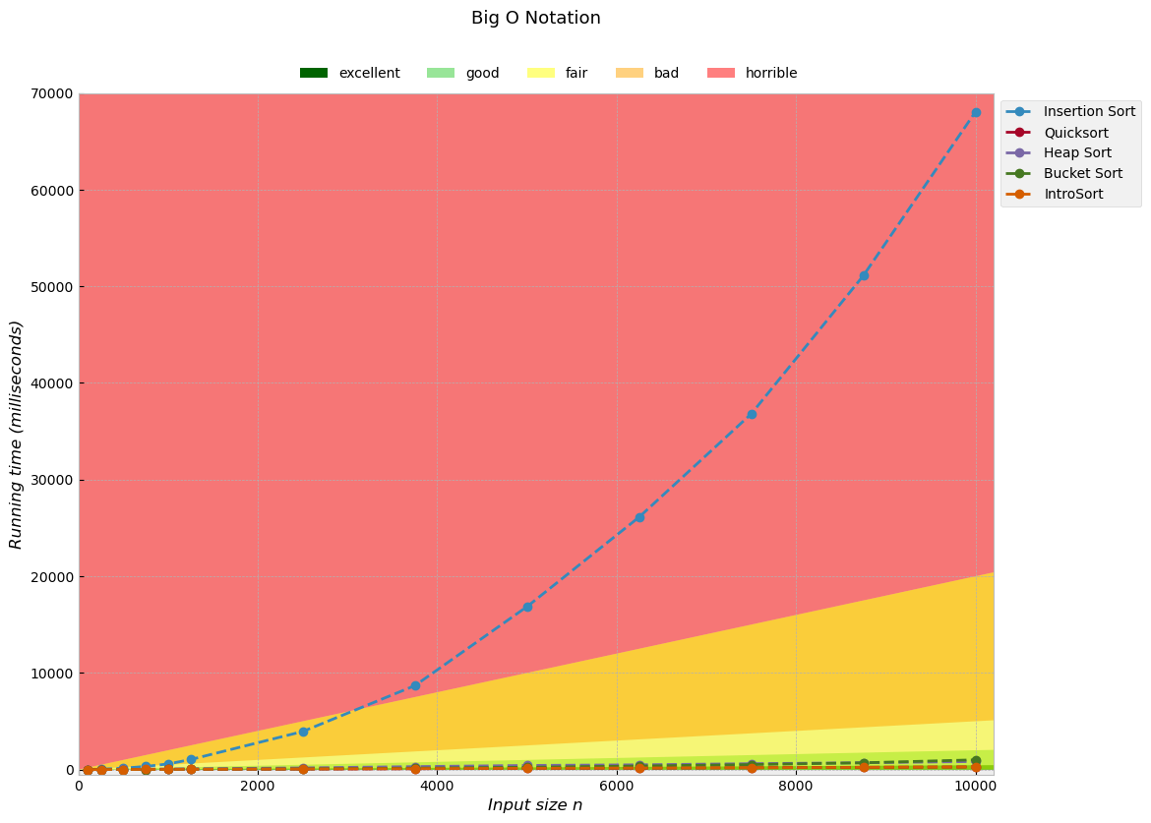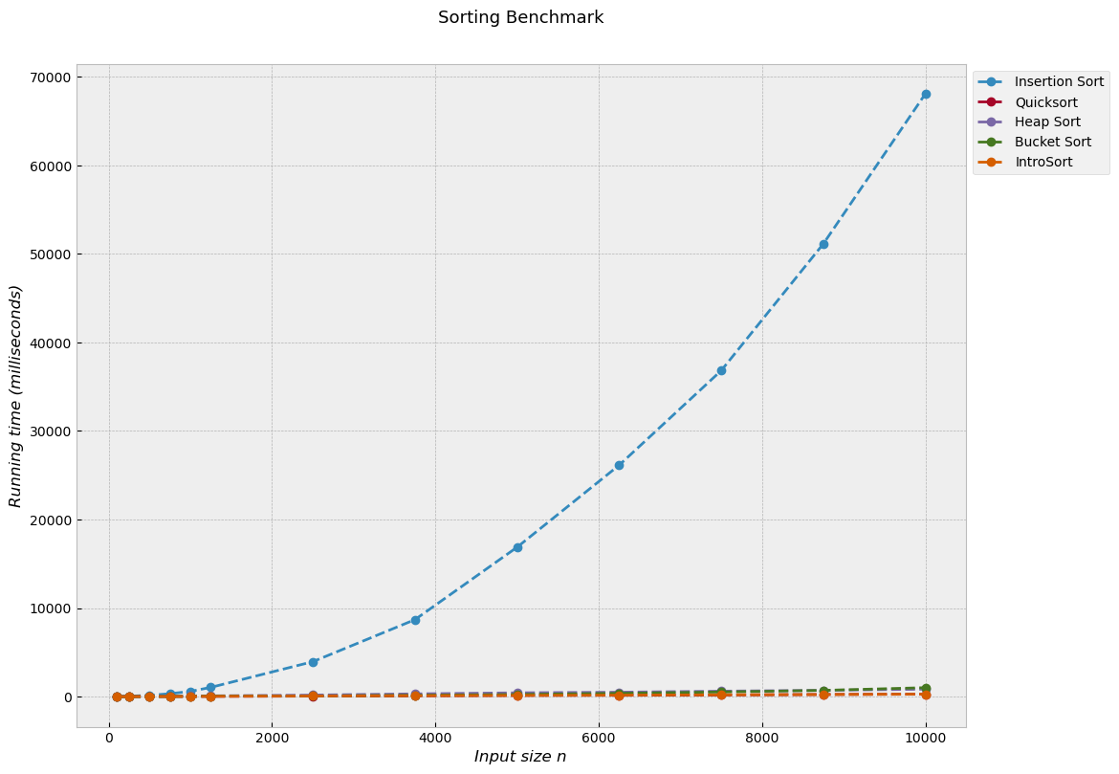

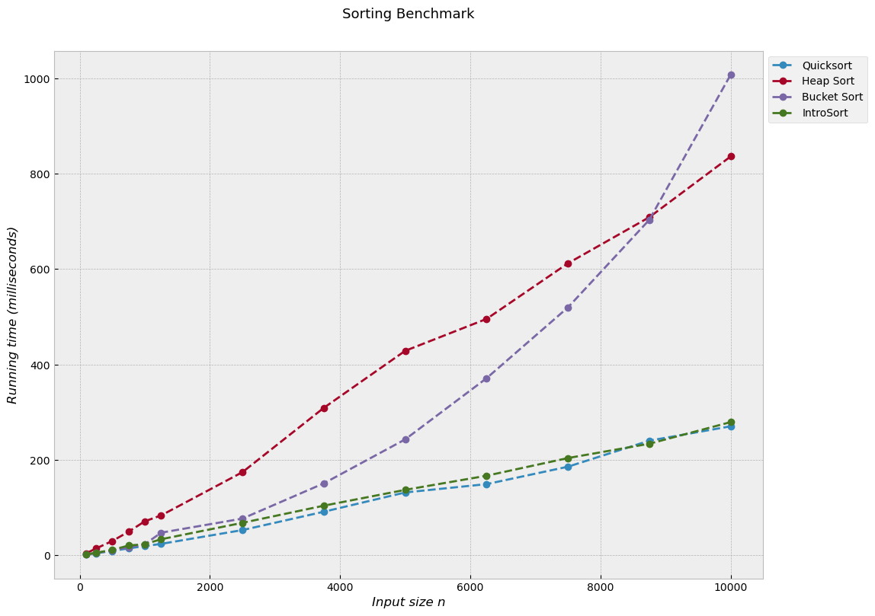

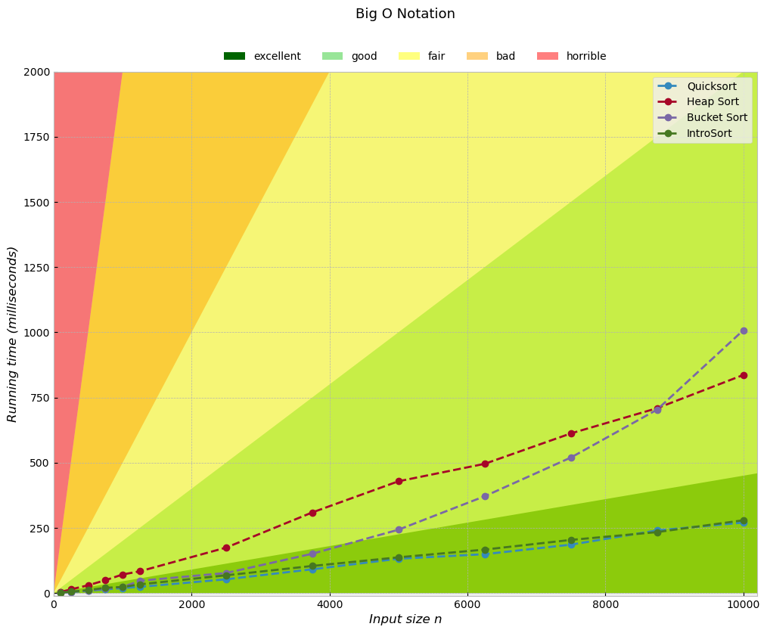

# References

1. S. Paira, S. Chnadra, A. Sk Safikul, D.S. Partha (2014) ‘A Review Report on Divide and Conquer Sorting Algorithm’. Available at: <https://www.researchgate.net/publication/276847633_A_Review_Report_on_Divide_and_Conquer_Sorting_Algorithm> (Accessed: May 3, 2021)
2. ‘Sorting Algorithms’. Brilliant.org. Available at: <https://brilliant.org/wiki/sorting-algorithms/> (Accessed: May 3, 2021)
3. K. S. Al-Kharabsheh, I. M. AlTurani, A. M. I. AlTurani, N. I. Zanoon (2013) ‘Review on Sorting Algorithms A Comparative Study’. Available at: <https://www.researchgate.net/publication/259911982_Review_on_Sorting_Algorithms_A_Comparative_Study> (Accessed: May 3, 2021)
4. ‘Space Complexity’. Brilliant.org. Available at: <https://brilliant.org/wiki/space-complexity/> (Accessed: May 4, 2021)
5. ‘Insertion Sort’. Brilliant.org. Available at: <https://brilliant.org/wiki/insertion/> (Accessed: May 4, 2021)