**Контроль версий углублённо (GIT). Обучение в записи**

**Урок 4. Семинар: Работа с изменениями**



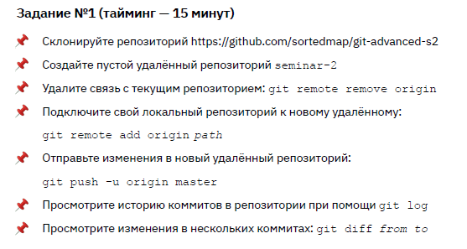

**Ход выполнения задания 1.**

*user@DESKTOP-929P2AG MINGW64 /*

*$ cd ~/Desktop/*

*user@DESKTOP-929P2AG MINGW64 ~/Desktop*

*$ git clone git@github.com:sortedmap/git-advanced-s2.git*

*Cloning into 'git-advanced-s2'...*

*remote: Enumerating objects: 54, done.*

*remote: Counting objects: 100% (54/54), done.*

*remote: Compressing objects: 100% (38/38), done.*

*remote: Total 54 (delta 18), reused 49 (delta 13), pack-reused 0 (from 0)*

*Receiving objects: 100% (54/54), 12.10 KiB | 6.05 MiB/s, done.*

*Resolving deltas: 100% (18/18), done.*

*user@DESKTOP-929P2AG MINGW64 ~/Desktop*

*$ cd git-advanced-s2/*

*user@DESKTOP-929P2AG MINGW64 ~/Desktop/git-advanced-s2 (master)*

*$ git remote -v*

*origin git@github.com:sortedmap/git-advanced-s2.git (fetch)*

*origin git@github.com:sortedmap/git-advanced-s2.git (push)*

*user@DESKTOP-929P2AG MINGW64 ~/Desktop/git-advanced-s2 (master)*

*$ git remote remove origin*

*user@DESKTOP-929P2AG MINGW64 ~/Desktop/git-advanced-s2 (master)*

*$ git remote -v*

*user@DESKTOP-929P2AG MINGW64 ~/Desktop/git-advanced-s2 (master)*

*$ git remote add origin git@github.com:olgashenkel/seminar-2.git*

*user@DESKTOP-929P2AG MINGW64 ~/Desktop/git-advanced-s2 (master)*

*$ git remote -v*

*origin git@github.com:olgashenkel/seminar-2.git (fetch)*

*origin git@github.com:olgashenkel/seminar-2.git (push)*

*user@DESKTOP-929P2AG MINGW64 ~/Desktop/git-advanced-s2 (master)*

*$ git branch -M main*

*user@DESKTOP-929P2AG MINGW64 ~/Desktop/git-advanced-s2 (main)*

*$ git push -u origin main*

*Enumerating objects: 54, done.*

*Counting objects: 100% (54/54), done.*

*Delta compression using up to 20 threads*

*Compressing objects: 100% (33/33), done.*

*Writing objects: 100% (54/54), 12.10 KiB | 1.01 MiB/s, done.*

*Total 54 (delta 18), reused 54 (delta 18), pack-reused 0*

*remote: Resolving deltas: 100% (18/18), done.*

*To github.com:olgashenkel/seminar-2.git*

*\* [new branch] main -> main*

*branch 'main' set up to track 'origin/main'.*

*user@DESKTOP-929P2AG MINGW64 ~/Desktop/git-advanced-s2 (main)*

*$ git log*

*commit 8897d25c3fd2a037185a5e518b32e931b2a3161b (HEAD -> main, origin/main)*

*Author: Daniil Pilipenko <sortedmap@gmail.com>*

*Date: Tue Nov 1 10:42:31 2022 +0300*

*refactoring*

*commit daaa3d32ff98ffad7321c14815438b28a7583529*

*Author: Daniil Pilipenko <sortedmap@gmail.com>*

*Date: Tue Nov 1 10:37:58 2022 +0300*

*reset button enabling/disabling added*

*commit bbf1b69d61ce9ebadb0ecfe9563a50bf0a88b3d5*

*Author: Daniil Pilipenko <sortedmap@gmail.com>*

*Date: Tue Nov 1 10:36:46 2022 +0300*

*reset button added*

*commit fe4e2639663f50c652dc7dfcae7c715bba3e87f8*

*Author: Daniil Pilipenko <sortedmap@gmail.com>*

*Date: Tue Nov 1 10:29:18 2022 +0300*

*button inactivation added*

*commit d014a17ca049ad5389484b1cf29e695ab7d36dcf*

*Author: Daniil Pilipenko <sortedmap@gmail.com>*

*Date: Tue Nov 1 09:20:36 2022 +0300*

*text styles changed*

*commit 13a902e43c6ffbf36ee553e3d24377bb11e1575c*

*user@DESKTOP-929P2AG MINGW64 ~/Desktop/git-advanced-s2 (main)*

*$ git diff 13a902e43c6ffbf36ee553e3d24377bb11e1575c*

***diff --git a/index.html b/index.html***

***index 2853512..f1a3173 100644***

***--- a/index.html***

***+++ b/index.html***

*@@ -21,6 +21,9 @@*

*#result {*

*margin-top: 20px;*

*}*

*+ #reset-button {*

*+ margin-left: 20px;*

*+ }*

*</style>*

*<link href="https://cdn.jsdelivr.net/npm/bootstrap@5.2.2/dist/css/bootstrap.min.css" rel="stylesheet" integrity="sha384-Zenh87qX5JnK2Jl0vWa8Ck2rdkQ2Bzep5IDxbcnCeuOxjzrPF/et3URy9Bv1WTRi" crossorigin="anonymous">*

*<script src="https://cdn.jsdelivr.net/npm/bootstrap@5.2.2/dist/js/bootstrap.bundle.min.js" integrity="sha384-OERcA2EqjJCMA+/3y+gxIOqMEjwtxJY7qPCqsdltbNJuaOe923+mo//f6V8Qbsw3" crossorigin="anonymous"></script>*

*@@ -28,9 +31,10 @@*

*</head>*

*<body>*

*<h1>Измеритель длины текста</h1>*

*- <p>Введите текст в поле ниже, и система измерит и покажет его длину.</p>*

*+ <p class="fw-lighter">Введите текст в поле ниже, и система измерит и покажет его длину.</p>*

*<textarea class="form-control" id="text"></textarea>*

*- <button class="btn btn-info" id="count-button">Посчитать</button>*

*+ <button class="btn btn-success" id="count-button" disabled="disabled">Посчитать</button>*

*+ <button class="btn btn-danger" id="reset-button" disabled="disabled">Очистить</button>*

*<div id="result"></div>*

*</body>*

*</html>*

*\ No newline at end of file*

***diff --git a/logs/access.log b/logs/access.log***

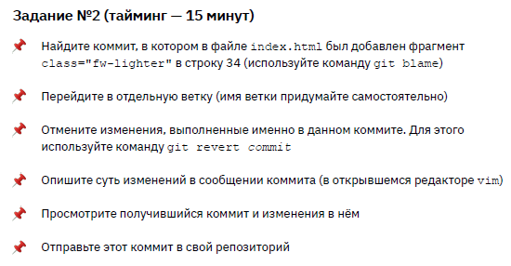

**Ход выполнения задания 2.**

*user@DESKTOP-929P2AG MINGW64 ~/Desktop/git-advanced-s2 (main)*

*$ git blame index.html*

*...*

*d014a17c (Daniil Pilipenko 2022-11-01 09:20:36 +0300 34) <p class="fw-lighter">Введите текст в поле ниже, и система измерит и покажет его длину.</p>*

*13a902e4 (Daniil Pilipenko 2022-11-01 09:14:44 +0300 35) <textarea class="form-control" id="text"></textarea>*

*user@DESKTOP-929P2AG MINGW64 ~/Desktop/git-advanced-s2 (main)*

*$ git branch seminar-2*

*user@DESKTOP-929P2AG MINGW64 ~/Desktop/git-advanced-s2 (main)*

*$ git branch*

*\* main*

*seminar-2*

*user@DESKTOP-929P2AG MINGW64 ~/Desktop/git-advanced-s2 (main)*

*$ git checkout seminar-2*

*Switched to branch 'seminar-2'*

*user@DESKTOP-929P2AG MINGW64 ~/Desktop/git-advanced-s2 (seminar-2)*

*$ git diff d014a17c*

***diff --git a/index.html b/index.html***

***index 8210c7f..f1a3173 100644***

***--- a/index.html***

***+++ b/index.html***

*@@ -21,6 +21,9 @@*

*#result {*

*margin-top: 20px;*

*}*

*+ #reset-button {*

*+ margin-left: 20px;*

*+ }*

*</style>*

*<link href="https://cdn.jsdelivr.net/npm/bootstrap@5.2.2/dist/css/bootstrap.min.css" rel="stylesheet" integrity="sha384-Zenh87qX5JnK2Jl0vWa8Ck2rdkQ2Bzep5IDxbcnCeuOxjzrPF/et3URy9Bv1WTRi" crossorigin="anonymous">*

*<script src="https://cdn.jsdelivr.net/npm/bootstrap@5.2.2/dist/js/bootstrap.bundle.min.js" integrity="sha384-OERcA2EqjJCMA+/3y+gxIOqMEjwtxJY7qPCqsdltbNJuaOe923+mo//f6V8Qbsw3" crossorigin="anonymous"></script>*

*@@ -30,7 +33,8 @@*

*<h1>Измеритель длины текста</h1>*

*<p class="fw-lighter">Введите текст в поле ниже, и система измерит и покажет его длину.</p>*

*<textarea class="form-control" id="text"></textarea>*

*- <button class="btn btn-info" id="count-button">Посчитать</button>*

*+ <button class="btn btn-success" id="count-button" disabled="disabled">Посчитать</button>*

*+ <button class="btn btn-danger" id="reset-button" disabled="disabled">Очистить</button>*

*<div id="result"></div>*

*</body>*

*</html>*

*\ No newline at end of file*

***diff --git a/logs/access.log b/logs/access.log***

***new file mode 100644***

***index 0000000..3e80617***

***--- /dev/null***

*user@DESKTOP-929P2AG MINGW64 ~/Desktop/git-advanced-s2 (seminar-2)*

*$ git revert d014a17c*

*Auto-merging index.html*

*[seminar-2 be0cebd] Revert "text styles changed"*

*1 file changed, 1 insertion(+), 1 deletion(-)*

*user@DESKTOP-929P2AG MINGW64 ~/Desktop/git-advanced-s2 (seminar-2)*

*$ git log*

*commit be0cebd8d3c879aa37dd0d025b5409a660e6e7ba (HEAD -> seminar-2)*

*Author: olgashenkel <olga_shenkel@mail.ru>*

*Date: Tue Jan 7 00:15:46 2025 +0200*

*Revert "text styles changed"*

*This reverts commit d014a17ca049ad5389484b1cf29e695ab7d36dcf.*

*commit 8897d25c3fd2a037185a5e518b32e931b2a3161b (origin/main, main)*

*Author: Daniil Pilipenko <sortedmap@gmail.com>*

*Date: Tue Nov 1 10:42:31 2022 +0300*

*refactoring*

*commit daaa3d32ff98ffad7321c14815438b28a7583529*

*Author: Daniil Pilipenko <sortedmap@gmail.com>*

*Date: Tue Nov 1 10:37:58 2022 +0300*

*reset button enabling/disabling added*

*commit bbf1b69d61ce9ebadb0ecfe9563a50bf0a88b3d5*

*Author: Daniil Pilipenko <sortedmap@gmail.com>*

*Date: Tue Nov 1 10:36:46 2022 +0300*

*reset button added*

*commit fe4e2639663f50c652dc7dfcae7c715bba3e87f8*

*Author: Daniil Pilipenko <sortedmap@gmail.com>*

*Date: Tue Nov 1 10:29:18 2022 +0300*

*button inactivation added*

*user@DESKTOP-929P2AG MINGW64 ~/Desktop/git-advanced-s2 (seminar-2)*

*$ git diff be0cebd8d3c879aa37dd0d025b5409a660e6e7ba*

*user@DESKTOP-929P2AG MINGW64 ~/Desktop/git-advanced-s2 (seminar-2)*

*$ git diff 8897d25c3fd2a037185a5e518b32e931b2a3161b*

***diff --git a/index.html b/index.html***

***index f1a3173..23bc8f6 100644***

***--- a/index.html***

***+++ b/index.html***

*@@ -31,7 +31,7 @@*

*</head>*

*<body>*

*<h1>Измеритель длины текста</h1>*

*- <p class="fw-lighter">Введите текст в поле ниже, и система измерит и покажет его длину.</p>*

*+ <p>Введите текст в поле ниже, и система измерит и покажет его длину.</p>*

*<textarea class="form-control" id="text"></textarea>*

*<button class="btn btn-success" id="count-button" disabled="disabled">Посчитать</button>*

*<button class="btn btn-danger" id="reset-button" disabled="disabled">Очистить</button>*

*user@DESKTOP-929P2AG MINGW64 ~/Desktop/git-advanced-s2 (seminar-2)*

*$ git push -u origin/seminar-2*

*fatal: 'origin/seminar-2' does not appear to be a git repository*

*fatal: Could not read from remote repository.*

*Please make sure you have the correct access rights*

*and the repository exists.*

*user@DESKTOP-929P2AG MINGW64 ~/Desktop/git-advanced-s2 (seminar-2)*

*$ git push -u origin seminar-2*

*Enumerating objects: 5, done.*

*Counting objects: 100% (5/5), done.*

*Delta compression using up to 20 threads*

*Compressing objects: 100% (3/3), done.*

*Writing objects: 100% (3/3), 393 bytes | 393.00 KiB/s, done.*

*Total 3 (delta 1), reused 0 (delta 0), pack-reused 0*

*remote: Resolving deltas: 100% (1/1), completed with 1 local object.*

*remote:*

*remote: Create a pull request for 'seminar-2' on GitHub by visiting:*

*remote: https://github.com/olgashenkel/seminar-2/pull/new/seminar-2*

*remote:*

*To github.com:olgashenkel/seminar-2.git*

*\* [new branch] seminar-2 -> seminar-2*

*branch 'seminar-2' set up to track 'origin/seminar-2'.*

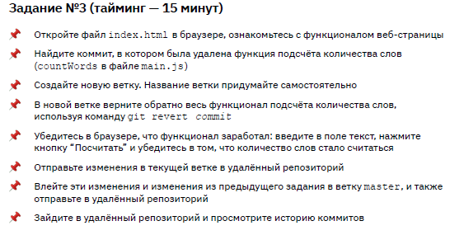

**Ход выполнения задания 3.**

*user@DESKTOP-929P2AG MINGW64 ~/Desktop/git-advanced-s2 (main)*

*$ git checkout -b seminar-2v1*

*Switched to a new branch 'seminar-2v1'*

*user@DESKTOP-929P2AG MINGW64 ~/Desktop/git-advanced-s2 (seminar-2v1)*

*$ git branch*

*main*

*seminar-2*

*\* seminar-2v1*

*user@DESKTOP-929P2AG MINGW64 ~/Desktop/git-advanced-s2 (seminar-2v1)*

*$ git log*

*commit 8897d25c3fd2a037185a5e518b32e931b2a3161b (HEAD -> seminar-2v1, origin/main, main)*

*Author: Daniil Pilipenko <sortedmap@gmail.com>*

*Date: Tue Nov 1 10:42:31 2022 +0300*

*refactoring*

*commit daaa3d32ff98ffad7321c14815438b28a7583529*

*Author: Daniil Pilipenko <sortedmap@gmail.com>*

*Date: Tue Nov 1 10:37:58 2022 +0300*

*reset button enabling/disabling added*

*commit bbf1b69d61ce9ebadb0ecfe9563a50bf0a88b3d5*

*Author: Daniil Pilipenko <sortedmap@gmail.com>*

*Date: Tue Nov 1 10:36:46 2022 +0300*

*reset button added*

*commit fe4e2639663f50c652dc7dfcae7c715bba3e87f8*

*Author: Daniil Pilipenko <sortedmap@gmail.com>*

*Date: Tue Nov 1 10:29:18 2022 +0300*

*button inactivation added*

*commit d014a17ca049ad5389484b1cf29e695ab7d36dcf*

*Author: Daniil Pilipenko <sortedmap@gmail.com>*

*Date: Tue Nov 1 09:20:36 2022 +0300*

*text styles changed*

*commit 13a902e43c6ffbf36ee553e3d24377bb11e1575c*

*Author: Daniil Pilipenko <sortedmap@gmail.com>*

*Date: Tue Nov 1 09:14:44 2022 +0300*

*changed styles of form elements*

*commit 69ee940cde148081fd3cc1ad44324279b4e9ac0c*

*Author: Daniil Pilipenko <sortedmap@gmail.com>*

*Date: Tue Nov 1 09:03:47 2022 +0300*

*added logs folder*

*commit c7e2f247eee7e5bca2113524d475f305dc603ca3*

*Author: Daniil Pilipenko <sortedmap@gmail.com>*

*Date: Tue Nov 1 08:51:42 2022 +0300*

*removed word counting function*

*commit 560a30066a37aff0f5d5badcf11304744dde74b5*

*Author: Daniil Pilipenko <sortedmap@gmail.com>*

*Date: Tue Nov 1 08:51:05 2022 +0300*

*removed word counting*

*commit 62d35c31cb58870aacc8d0a1ee031b2b5d3c5ab0*

*Author: Daniil Pilipenko <sortedmap@gmail.com>*

*Date: Tue Nov 1 00:35:24 2022 +0300*

*Bootstrap styles added*

*commit 464f0deee311b4bdbf88e8b6406a3c1196624865*

*Author: Daniil Pilipenko <sortedmap@gmail.com>*

*Date: Mon Oct 31 23:22:31 2022 +0300*

*length without spaces counting added*

*commit b4a1840199304f92954d5a956463129e9f442ccd*

*Author: Daniil Pilipenko <sortedmap@gmail.com>*

*Date: Mon Oct 31 22:59:14 2022 +0300*

*word count added*

*commit 1c9f8b890cdd43c31c44647f34f1497de3c5edbd*

*Author: Daniil Pilipenko <sortedmap@gmail.com>*

*Date: Mon Oct 31 22:48:16 2022 +0300*

*adding result field instead of alert*

*commit 7185cc102bf721004875a3f78151300be8584d9c*

*Author: Daniil Pilipenko <sortedmap@gmail.com>*

*Date: Mon Oct 31 22:03:06 2022 +0300*

*added textarea, button and counting script*

*commit 3473752e84494f4b7f23839800694bb4bab94c6c*

*Author: Daniil Pilipenko <sortedmap@gmail.com>*

*Date: Sun Oct 30 14:54:01 2022 +0300*

*initial*

*user@DESKTOP-929P2AG MINGW64 ~/Desktop/git-advanced-s2 (seminar-2v1)*

*$ git revert c7e2f247eee7e5bca2113524d475f305dc603ca3*

*Auto-merging main.js*

*[seminar-2v1 f0e058d] Revert "removed word counting function"*

*1 file changed, 12 insertions(+)*

*user@DESKTOP-929P2AG MINGW64 ~/Desktop/git-advanced-s2 (seminar-2v1)*

*$ git revert 560a30066a37aff0f5d5badcf11304744dde74b5*

*Auto-merging main.js*

*[seminar-2v1 aab7979] Revert "removed word counting"*

*1 file changed, 3 insertions(+), 1 deletion(-)*

*user@DESKTOP-929P2AG MINGW64 ~/Desktop/git-advanced-s2 (seminar-2v1)*

*$ git status*

*On branch seminar-2v1*

*nothing to commit, working tree clean*

*user@DESKTOP-929P2AG MINGW64 ~/Desktop/git-advanced-s2 (seminar-2v1)*

*$ git push origin seminar-2v1*

*Enumerating objects: 8, done.*

*Counting objects: 100% (8/8), done.*

*Delta compression using up to 20 threads*

*Compressing objects: 100% (6/6), done.*

*Writing objects: 100% (6/6), 847 bytes | 847.00 KiB/s, done.*

*Total 6 (delta 4), reused 0 (delta 0), pack-reused 0*

*remote: Resolving deltas: 100% (4/4), completed with 2 local objects.*

*remote:*

*remote: Create a pull request for 'seminar-2v1' on GitHub by visiting:*

*remote: https://github.com/olgashenkel/seminar-2/pull/new/seminar-2v1*

*remote:*

*To github.com:olgashenkel/seminar-2.git*

*\* [new branch] seminar-2v1 -> seminar-2v1*

*user@DESKTOP-929P2AG MINGW64 ~/Desktop/git-advanced-s2 (main)*

*$ git branch*

*\* main*

*seminar-2*

*seminar-2v1*

*user@DESKTOP-929P2AG MINGW64 ~/Desktop/git-advanced-s2 (main)*

*$ git merge seminar-2*

*Updating 8897d25..be0cebd*

*Fast-forward*

*index.html | 2 +-*

*1 file changed, 1 insertion(+), 1 deletion(-)*

*user@DESKTOP-929P2AG MINGW64 ~/Desktop/git-advanced-s2 (main)*

*$ git merge seminar-2v1*

*Merge made by the 'ort' strategy.*

*main.js | 16 +++++++++++++++-*

*1 file changed, 15 insertions(+), 1 deletion(-)*

*user@DESKTOP-929P2AG MINGW64 ~/Desktop/git-advanced-s2 (main)*

*$ git push*

*Enumerating objects: 4, done.*

*Counting objects: 100% (4/4), done.*

*Delta compression using up to 20 threads*

*Compressing objects: 100% (2/2), done.*

*Writing objects: 100% (2/2), 281 bytes | 281.00 KiB/s, done.*

*Total 2 (delta 1), reused 0 (delta 0), pack-reused 0*

*remote: Resolving deltas: 100% (1/1), completed with 1 local object.*

*To github.com:olgashenkel/seminar-2.git*

*8897d25..de9314a main -> main*

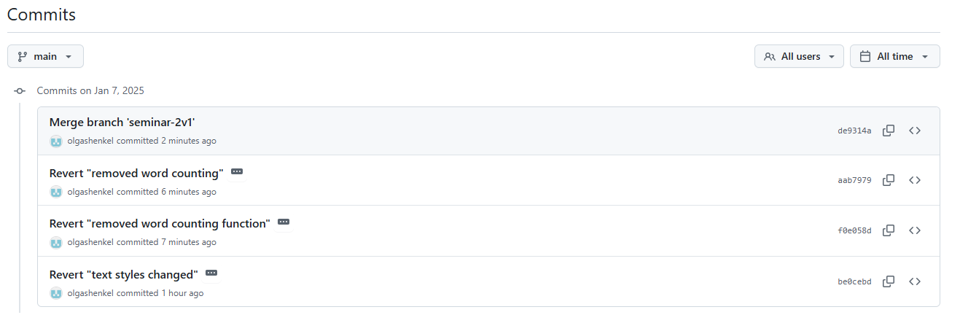

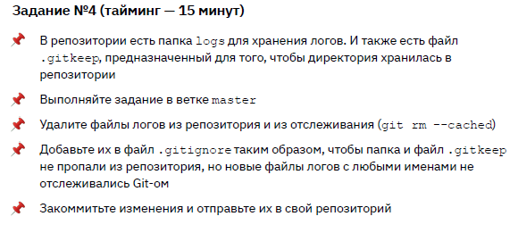

**Ход выполнения задания 4.**

user@DESKTOP-929P2AG MINGW64 ~/Desktop/git-advanced-s2 (main)

$ ls

index.html logs/ main.js

user@DESKTOP-929P2AG MINGW64 ~/Desktop/git-advanced-s2 (main)

$ cd logs/

user@DESKTOP-929P2AG MINGW64 ~/Desktop/git-advanced-s2/logs (main)

$ ls

access.log error.log

user@DESKTOP-929P2AG MINGW64 ~/Desktop/git-advanced-s2/logs (main)

$ git status

On branch main

Your branch is up to date with 'origin/main'.

nothing to commit, working tree clean

user@DESKTOP-929P2AG MINGW64 ~/Desktop/git-advanced-s2/logs (main)

$ git rm --cached access.log

rm 'logs/access.log'

user@DESKTOP-929P2AG MINGW64 ~/Desktop/git-advanced-s2/logs (main)

$ git status

On branch main

Your branch is up to date with 'origin/main'.

Changes to be committed:

(use "git restore --staged <file>..." to unstage)

deleted: access.log

Untracked files:

(use "git add <file>..." to include in what will be committed)

access.log

user@DESKTOP-929P2AG MINGW64 ~/Desktop/git-advanced-s2/logs (main)

$ git rm --cached error.log

rm 'logs/error.log'

user@DESKTOP-929P2AG MINGW64 ~/Desktop/git-advanced-s2/logs (main)

$ git status

On branch main

Your branch is up to date with 'origin/main'.

Changes to be committed:

(use "git restore --staged <file>..." to unstage)

deleted: access.log

deleted: error.log

Untracked files:

(use "git add <file>..." to include in what will be committed)

access.log

error.log

user@DESKTOP-929P2AG MINGW64 ~/Desktop/git-advanced-s2/logs (main)

$ cd ..

user@DESKTOP-929P2AG MINGW64 ~/Desktop/git-advanced-s2 (main)

$ git status

On branch main

Your branch is up to date with 'origin/main'.

Changes to be committed:

(use "git restore --staged <file>..." to unstage)

deleted: logs/access.log

deleted: logs/error.log

Untracked files:

(use "git add <file>..." to include in what will be committed)

.gitignore

user@DESKTOP-929P2AG MINGW64 ~/Desktop/git-advanced-s2 (main)

$ git add .gitignore

user@DESKTOP-929P2AG MINGW64 ~/Desktop/git-advanced-s2 (main)

$ git status

On branch main

Your branch is up to date with 'origin/main'.

Changes to be committed:

(use "git restore --staged <file>..." to unstage)

new file: .gitignore

deleted: logs/access.log

deleted: logs/error.log

user@DESKTOP-929P2AG MINGW64 ~/Desktop/git-advanced-s2 (main)

$ git commit -m "add .gitigore"

[main 422efc2] add .gitigore

3 files changed, 1 insertion(+), 343 deletions(-)

create mode 100644 .gitignore

delete mode 100644 logs/access.log

delete mode 100644 logs/error.log

user@DESKTOP-929P2AG MINGW64 ~/Desktop/git-advanced-s2 (main)

$ git status

On branch main

Your branch is ahead of 'origin/main' by 1 commit.

(use "git push" to publish your local commits)

nothing to commit, working tree clean

user@DESKTOP-929P2AG MINGW64 ~/Desktop/git-advanced-s2 (main)

$ git push

Enumerating objects: 6, done.

Counting objects: 100% (6/6), done.

Delta compression using up to 20 threads

Compressing objects: 100% (2/2), done.

Writing objects: 100% (4/4), 397 bytes | 397.00 KiB/s, done.

Total 4 (delta 0), reused 1 (delta 0), pack-reused 0

To github.com:olgashenkel/seminar-2.git

de9314a..422efc2 main -> main

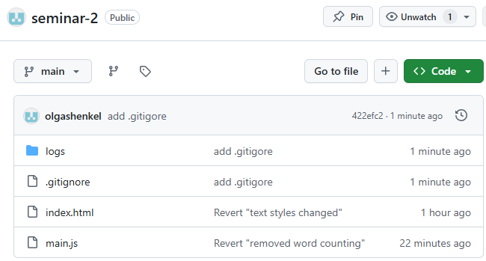 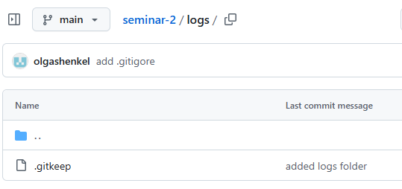

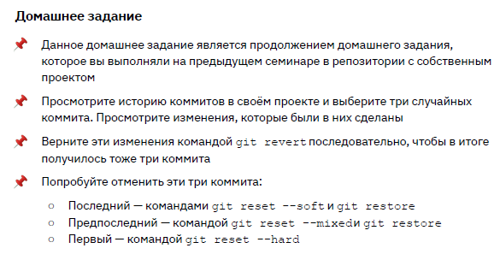

***Ссылка на репозиторий GitHub:***

[***https://github.com/olgashenkel/remote-test-2/tree/main***](https://github.com/olgashenkel/remote-test-2/tree/main)

user@DESKTOP-929P2AG MINGW64 ~/Desktop/git-advanced-s2 (main)

$ cd ~/Desktop/remote-test-1/

user@DESKTOP-929P2AG MINGW64 ~/Desktop/remote-test-1 (main)

$ git status

On branch main

nothing to commit, working tree clean

user@DESKTOP-929P2AG MINGW64 ~/Desktop/remote-test-1 (main)

$ git log

commit 3a3f24e9f3be913edf891cbf3d8ac642b63e5f4a (HEAD -> main, origin/main)

Author: olgashenkel <olga_shenkel@mail.ru>

Date: Tue Jan 7 02:25:18 2025 +0200

update file

commit a8259cc398d4a5de297a12164f6118942beb69b2

Author: olgashenkel <olga_shenkel@mail.ru>

Date: Tue Jan 7 02:14:17 2025 +0200

update test-1

commit e10f9152315ecf93caccc49d557e9019360894c2

Author: olgashenkel <olga_shenkel@mail.ru>

Date: Tue Jan 7 02:13:26 2025 +0200

rename test-1

commit 40b9713068ac8735e96a727363b0133100d530b2

Author: olgashenkel <olga_shenkel@mail.ru>

Date: Tue Jan 7 01:54:40 2025 +0200

Revert "Update test-2"

This reverts commit 9024f00f2f8fdfd257cc774a992488aafbf15ad3.

commit 52bed68e80950b8f06876dd6612c40cb123239ba

Merge: bc6b5f8 6722abc

Author: olgashenkel <olga_shenkel@mail.ru>

Date: Sun Jan 5 21:58:19 2025 +0200

Merge remote-tracking branch 'source/main'

commit bc6b5f87326134363a9997e31cce3d36aede1fb4

Merge: fcda8b8 7ee4dbe

Author: olgashenkel <olga_shenkel@mail.ru>

Date: Sun Jan 5 21:57:04 2025 +0200

Merge remote-tracking branch 'origin/main'

commit 7ee4dbe2ef3e36f078ce233a9a9bfbf66e8a4e56

Author: olgashenkel <158843723+olgashenkel@users.noreply.github.com>

Date: Sun Jan 5 21:55:55 2025 +0200

Rename test-2.txt to test-2.md

commit 2dcd21d8a39c3d876f3364218e8a3b91d427e4e4

Author: olgashenkel <158843723+olgashenkel@users.noreply.github.com>

Date: Sun Jan 5 21:55:35 2025 +0200

Rename test-2 to test-2.txt

commit 9024f00f2f8fdfd257cc774a992488aafbf15ad3

Author: olgashenkel <158843723+olgashenkel@users.noreply.github.com>

Date: Sun Jan 5 21:54:59 2025 +0200

Update test-2

commit 6722abc4628bb87d94bf3298d92d12e5d77da6db

Author: olgashenkel <158843723+olgashenkel@users.noreply.github.com>

Date: Sun Jan 5 21:54:27 2025 +0200

Update README.md

commit 30ce0233049ce803f67eae6fe4d20ee4f2d03493

Author: olgashenkel <158843723+olgashenkel@users.noreply.github.com>

Date: Sun Jan 5 21:54:08 2025 +0200

Update README.md

commit fcda8b8335cbf19a57f842b4b81e890724675ece

Author: olgashenkel <158843723+olgashenkel@users.noreply.github.com>

Date: Sun Jan 5 21:50:59 2025 +0200

Update README.md

commit 948a889bb39b64cffc3850440c6c8557e9fc0b8a

Author: olgashenkel <158843723+olgashenkel@users.noreply.github.com>

Date: Sun Jan 5 21:50:50 2025 +0200

Update README.md

commit c70e638b2beacbddd10c2f22f9423179cf891261

Author: olgashenkel <158843723+olgashenkel@users.noreply.github.com>

Date: Sun Jan 5 11:05:56 2025 +0200

Update README.md

commit 669862c134ef190dc6c294c2c76afcad3db708ab

Author: olgashenkel <158843723+olgashenkel@users.noreply.github.com>

Date: Sun Jan 5 11:05:35 2025 +0200

Create test-2

commit 1f49f39bd7f575b6d5a07e53ecfcd83868b176ab

Merge: e35eda4 6071fdc

Author: olgashenkel <olga_shenkel@mail.ru>

Date: Sun Jan 5 10:56:38 2025 +0200

fatal: Exiting because of an unresolved conflict

commit e35eda4a0e5f26160e2fb9f578b905d0c6c220b5

Author: olgashenkel <158843723+olgashenkel@users.noreply.github.com>

Date: Sun Jan 5 10:48:13 2025 +0200

Update README.md

commit 6071fdc6b4c4be502ed899e53b4acdf7d8d48430

Author: olgashenkel <158843723+olgashenkel@users.noreply.github.com>

Date: Sun Jan 5 10:48:00 2025 +0200

Update README.md

commit a248c0629fa05440fc12a1124af6fe7b119590f5

Author: olgashenkel <158843723+olgashenkel@users.noreply.github.com>

Date: Sun Jan 5 10:47:48 2025 +0200

Update README.md

commit e786c05a2f07605a0635dcbb1f6d2536fa824b78

Author: olgashenkel <olga_shenkel@mail.ru>

Date: Sun Jan 5 10:42:08 2025 +0200

update README.md

commit efa0c36d90775564e503f99060083565233d04b5

Author: olgashenkel <158843723+olgashenkel@users.noreply.github.com>

Date: Sun Jan 5 02:17:39 2025 +0200

Initial commit

***Commit*** a8259cc398d4a5de297a12164f6118942beb69b2

user@DESKTOP-929P2AG MINGW64 ~/Desktop/remote-test-1 (main)

$ git diff a8259cc398d4a5de297a12164f6118942beb69b2

**diff --git a/test-1.md b/test-1.md**

**index f18c2e9..709eaae 100644**

**--- a/test-1.md**

**+++ b/test-1.md**

@@ -1,5 +1,3 @@

Задание № 2. Внесение изменений в файл удаленно (в репозитории remote-test-2)

Домашняя работа № 2. Внесение изменений в файл локально

-

-test test test

\ No newline at end of file

***Commit*** 9024f00f2f8fdfd257cc774a992488aafbf15ad3

user@DESKTOP-929P2AG MINGW64 ~/Desktop/remote-test-1 (main)

$ git diff 9024f00f2f8fdfd257cc774a992488aafbf15ad3

**diff --git a/README.md b/README.md**

**index 243574a..ae74d2f 100644**

**--- a/README.md**

**+++ b/README.md**

@@ -1,4 +1,5 @@

# remote-test-1

Задание № 2. Внесение изменений в файл локально (на ПК)

-Задание № 2. Внесение изменений в файл удаленно (в репозитории remote-test-2)

+

+***Задание № 2. Внесение изменений в файл удаленно (в репозитории remote-test-1)***

**diff --git a/test-2 b/test-2.md**

**similarity index 100%**

**rename from test-2**

**rename to test-2.md**

user@DESKTOP-929P2AG MINGW64 ~/Desktop/remote-test-1 (main|REVERTING)

$ git revert a8259cc398d4a5de297a12164f6118942beb69b2

[main f03dd6b] Revert "update test-1"

1 file changed, 2 deletions(-)

user@DESKTOP-929P2AG MINGW64 ~/Desktop/remote-test-1 (main)

$ git revert 9024f00f2f8fdfd257cc774a992488aafbf15ad3

[main 40b9713] Revert "Update test-2"

1 file changed, 1 insertion(+), 1 deletion(-)

user@DESKTOP-929P2AG MINGW64 ~/Desktop/remote-test-1 (main)

$ git reset --mixed 3a3f24e9f3be913edf891cbf3d8ac642b63e5f4a

Unstaged changes after reset:

M test-1.md

user@DESKTOP-929P2AG MINGW64 ~/Desktop/remote-test-1 (main)

$ git status

On branch main

Changes not staged for commit:

(use "git add <file>..." to update what will be committed)

(use "git restore <file>..." to discard changes in working directory)

modified: test-1.md

no changes added to commit (use "git add" and/or "git commit -a")

user@DESKTOP-929P2AG MINGW64 ~/Desktop/remote-test-1 (main)

$ git add .

user@DESKTOP-929P2AG MINGW64 ~/Desktop/remote-test-1 (main)

$ git status

On branch main

Changes to be committed:

(use "git restore --staged <file>..." to unstage)

modified: test-1.md

user@DESKTOP-929P2AG MINGW64 ~/Desktop/remote-test-1 (main)

$ git commit -m "update test"

[main 5996b6a] update test

1 file changed, 1 insertion(+), 1 deletion(-)

user@DESKTOP-929P2AG MINGW64 ~/Desktop/remote-test-1 (main)

$ git push origin main

Enumerating objects: 5, done.

Counting objects: 100% (5/5), done.

Delta compression using up to 20 threads

Compressing objects: 100% (3/3), done.

Writing objects: 100% (3/3), 333 bytes | 333.00 KiB/s, done.

Total 3 (delta 1), reused 0 (delta 0), pack-reused 0

remote: Resolving deltas: 100% (1/1), completed with 1 local object.

To github.com:olgashenkel/remote-test-2.git

3a3f24e..5996b6a main -> main

user@DESKTOP-929P2AG MINGW64 ~/Desktop/remote-test-1 (main)

$ git remote -v

origin git@github.com:olgashenkel/remote-test-2.git (fetch)

origin git@github.com:olgashenkel/remote-test-2.git (push)