**Task 1**[**¶**](https://jupyterlab-6-labs-prod-jupyterlab-us-east-0.labs.cognitiveclass.ai/user/olgavovka/lab/tree/labs/module_2#Task-1)

**Display the names of the unique launch sites in the space mission**

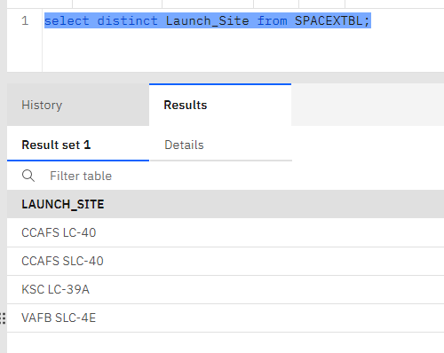

### Task 2[¶](https://jupyterlab-6-labs-prod-jupyterlab-us-east-0.labs.cognitiveclass.ai/user/olgavovka/lab/tree/labs/module_2#Task-2)

##### Display 5 records where launch sites begin with the string 'CCA'

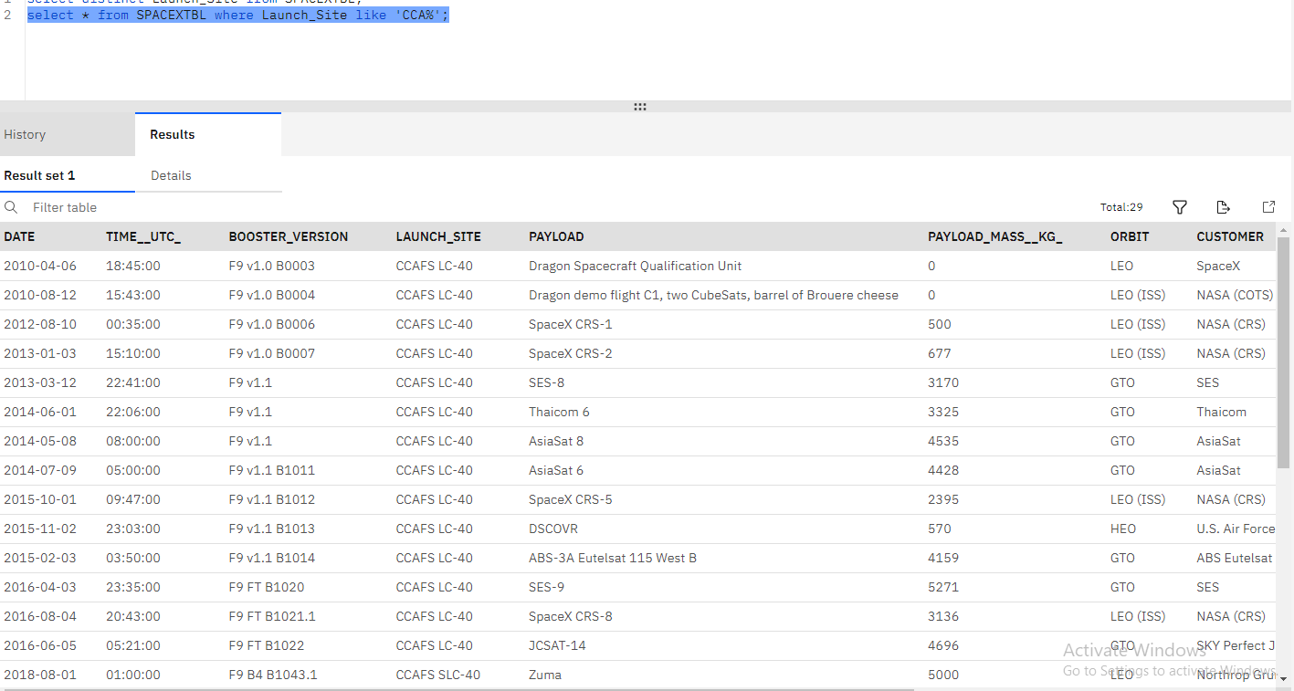

### Task 3[¶](https://jupyterlab-6-labs-prod-jupyterlab-us-east-0.labs.cognitiveclass.ai/user/olgavovka/lab/tree/labs/module_2#Task-3)

##### Display the total payload mass carried by boosters launched by NASA (CRS)

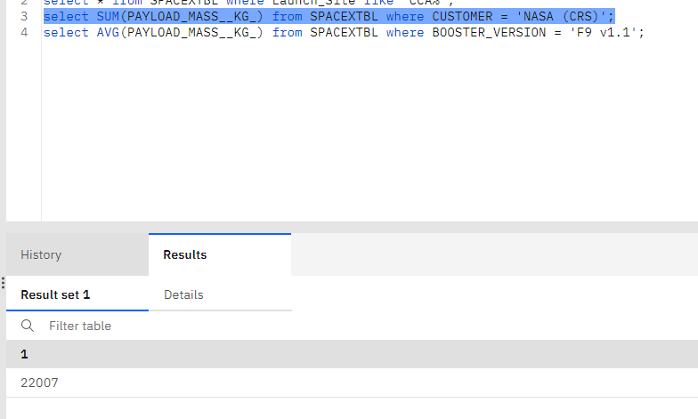

### Task 4

##### Display average payload mass carried by booster version F9 v1.1

##### 

### Task 5

##### List the date when the first succesful landing outcome in ground pad was acheived.

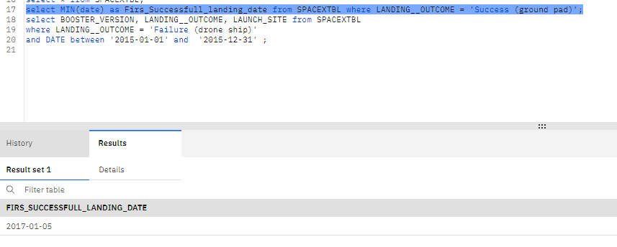

### Task 6

##### List the names of the boosters which have success in drone ship and have payload mass greater than 4000 but less than 6000

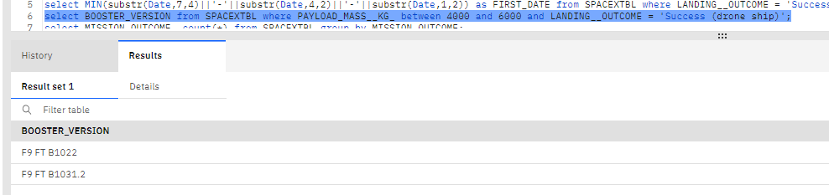

### Task 7

##### List the total number of successful and failure mission outcome

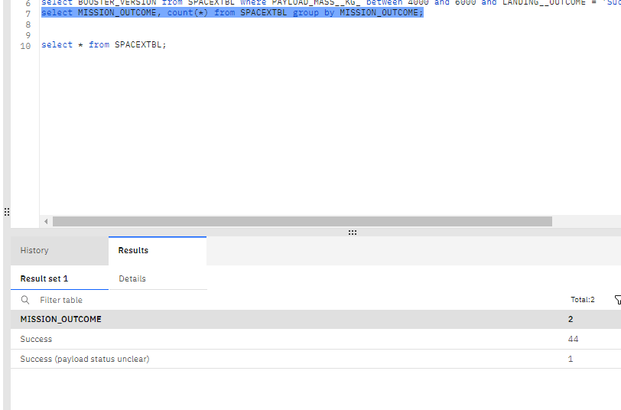

### Task 8

##### List the names of the booster_versions which have carried the maximum payload mass. Use a subquery

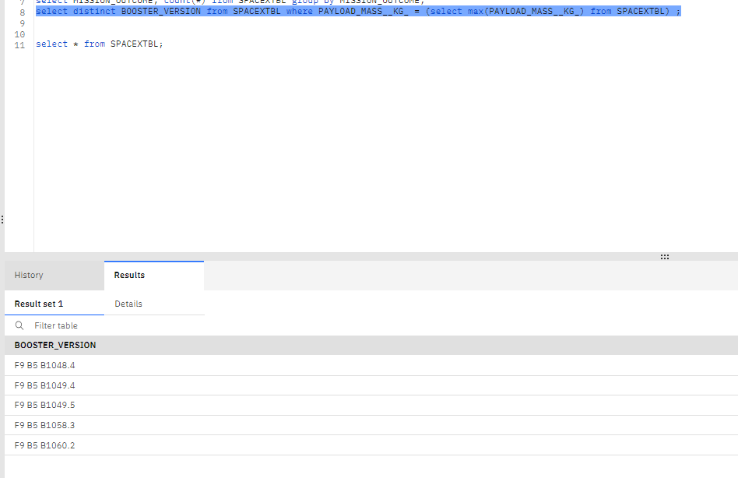

### Task 9

##### List the records which will display the month names, failure landing_outcomes in drone ship ,booster versions, launch_site for the months in year 2015.

**Note: SQLLite does not support monthnames. So you need to use substr(Date, 4, 2) as month to get the months and substr(Date,7,4)='2015' for year.**

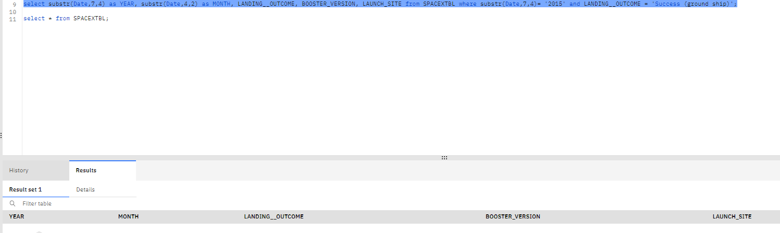



### Task 10[¶](https://jupyterlab-6-labs-prod-jupyterlab-us-east-0.labs.cognitiveclass.ai/user/olgavovka/lab/tree/labs/module_2#Task-10)

##### Rank the count of successful landing_outcomes between the date 04-06-2010 and 20-03-2017 in descending order.

