**Домашнее задание №3**

a.

SELECT name from student

UNION ALL

SELECT name from course

ORDER BY name DESC

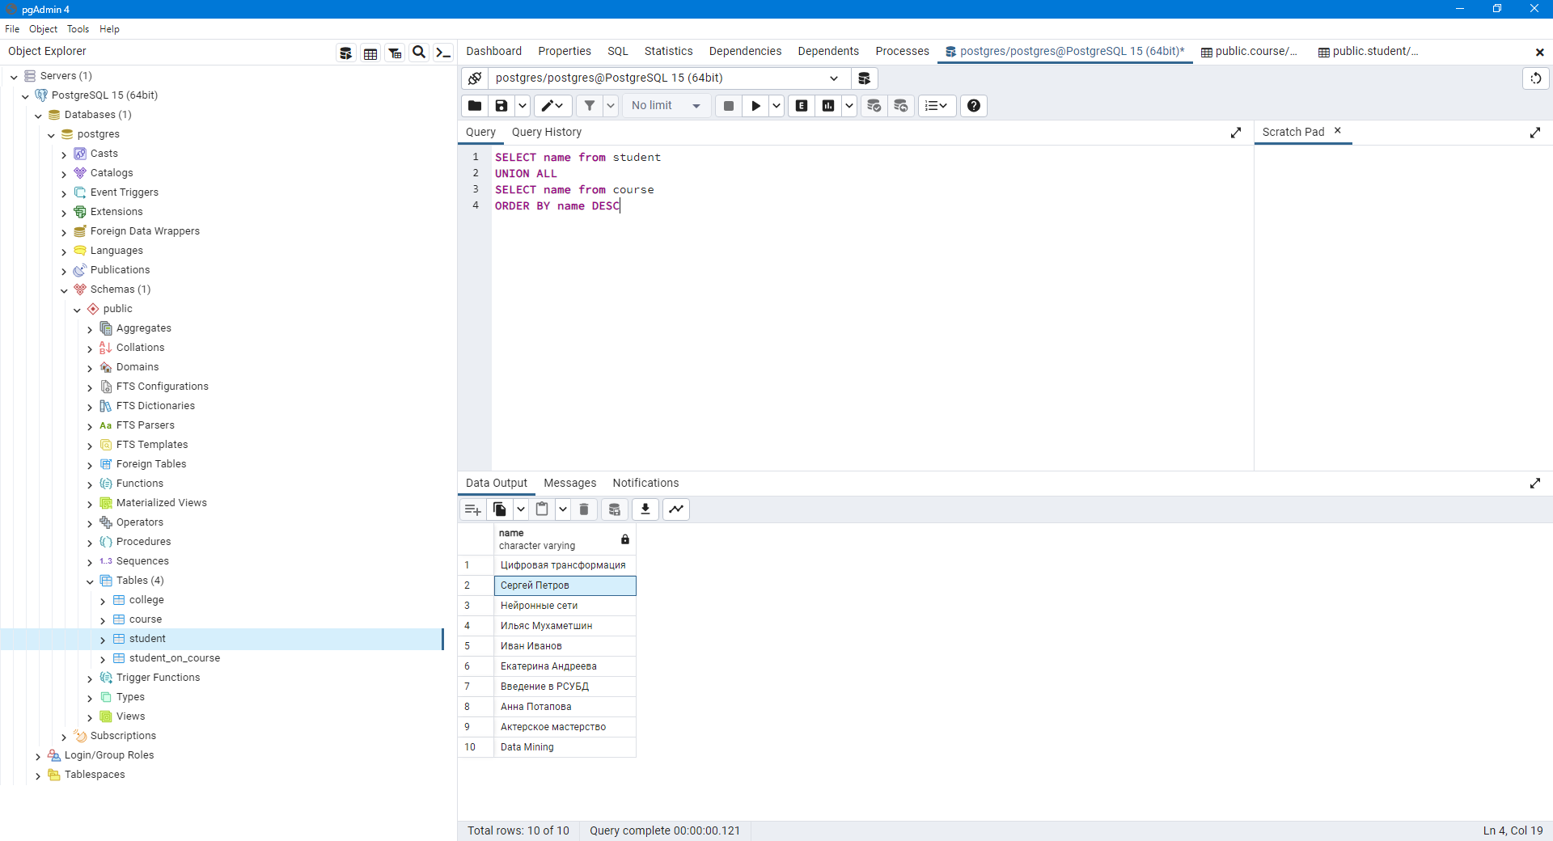

b.

SELECT name, 'университет' AS object_type

from college

UNION

SELECT name, 'курс' AS object_type

from course

ORDER BY object_type DESC,name ASC

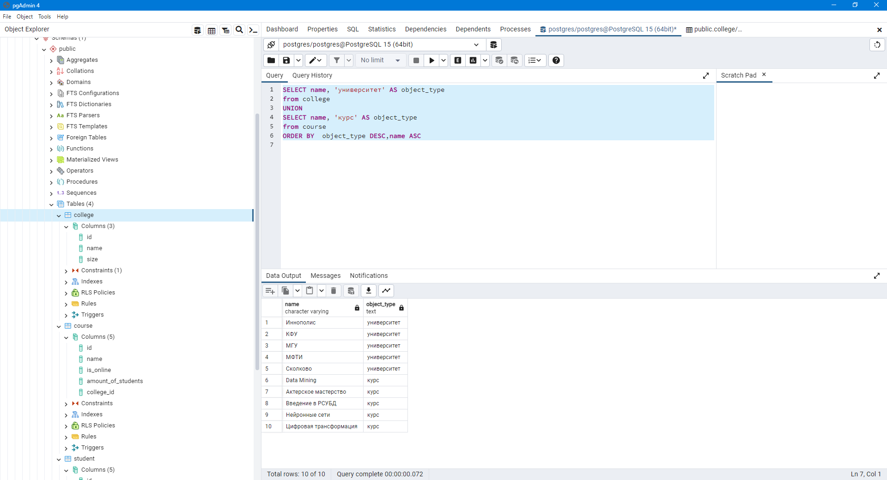

c.

SELECT name, amount_of_students FROM public.course

ORDER BY CASE

when amount_of_students = ‘300’ then 0

ELSE 1

END, amount_of_students

LIMIT 3

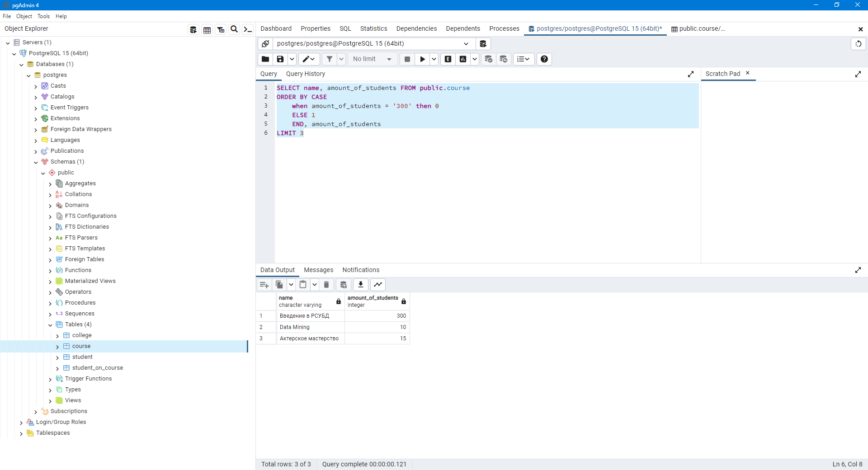

d.

INSERT into public.course

VALUES (60, 'Machine Learning', false, 17, 20)

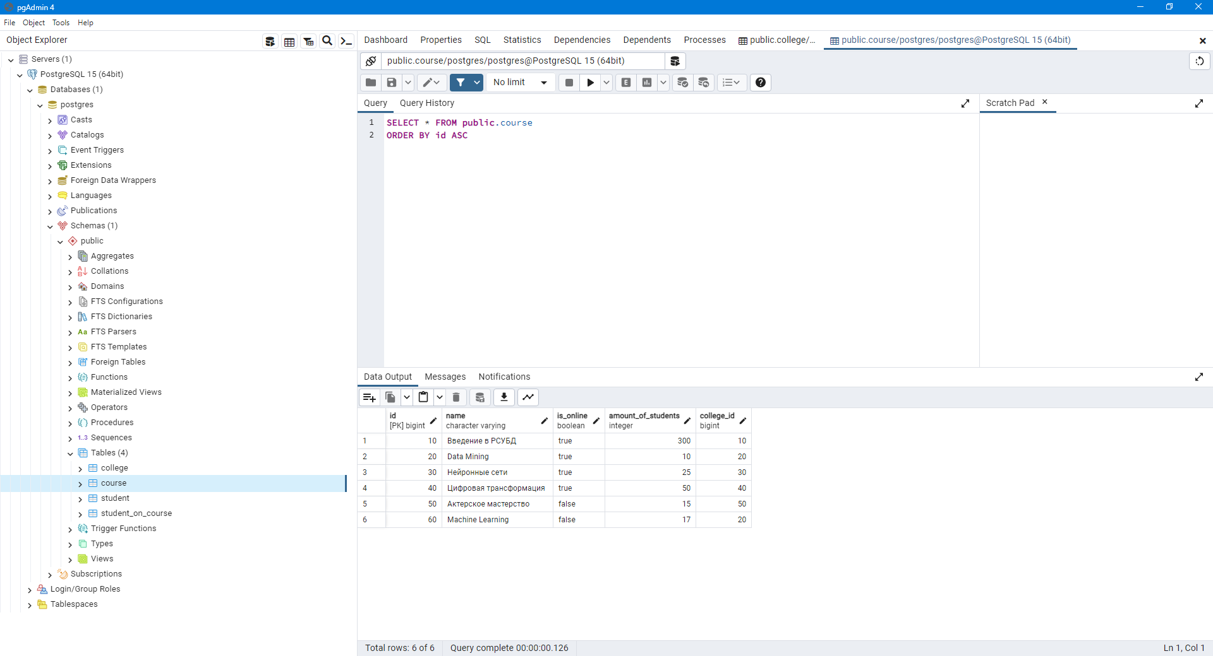

e.

SELECT id FROM public.course

EXCEPT

SELECT id FROM public.student_on_course

UNION

SELECT id FROM public.student_on_course

EXCEPT

SELECT id FROM public.course

ORDER BY id ASC

