**Домашнее задание №4**

a.

create table student_on_course_kn as

select t1.id, t1.student_id, t1.course_id, t1.student_rating, t1.finished_date from student_on_course t1

join student t2 on t1.id = t2.id

where t2.city in ('Казань', 'Новосибирск')

SELECT * FROM student_on_course_kn ORDER BY id;

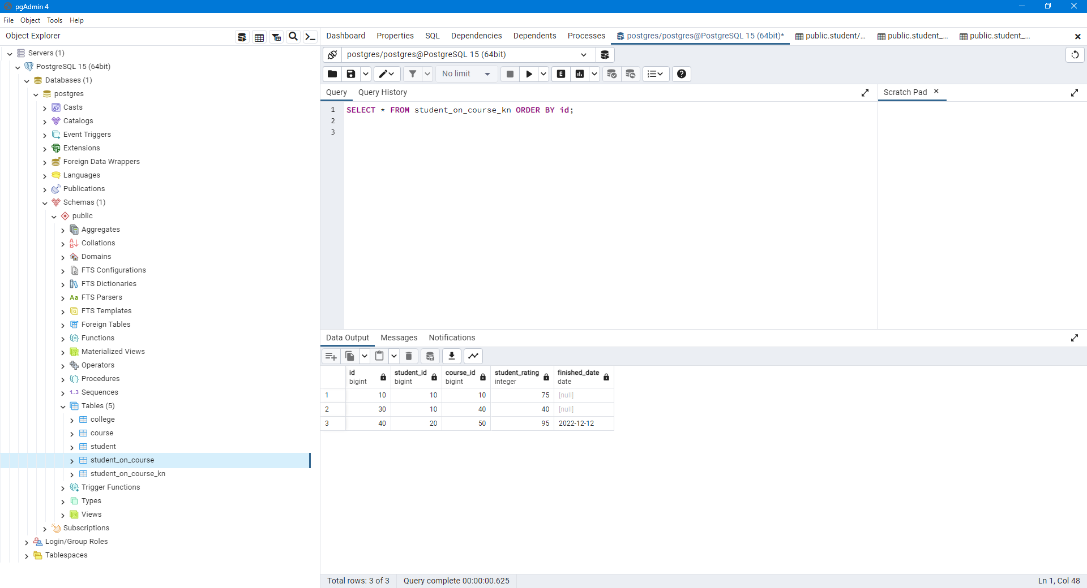

b.

UPDATE student_on_course_kn

SET student_rating = CASE

WHEN student_rating between 0 and 60

THEN student_rating - 5

WHEN student_rating between 61 and 80

THEN student_rating - 10

WHEN student_rating between 81 and 90

THEN student_rating - 15

else student_rating - 20

END;

SELECT * FROM student_on_course_kn ORDER BY id;

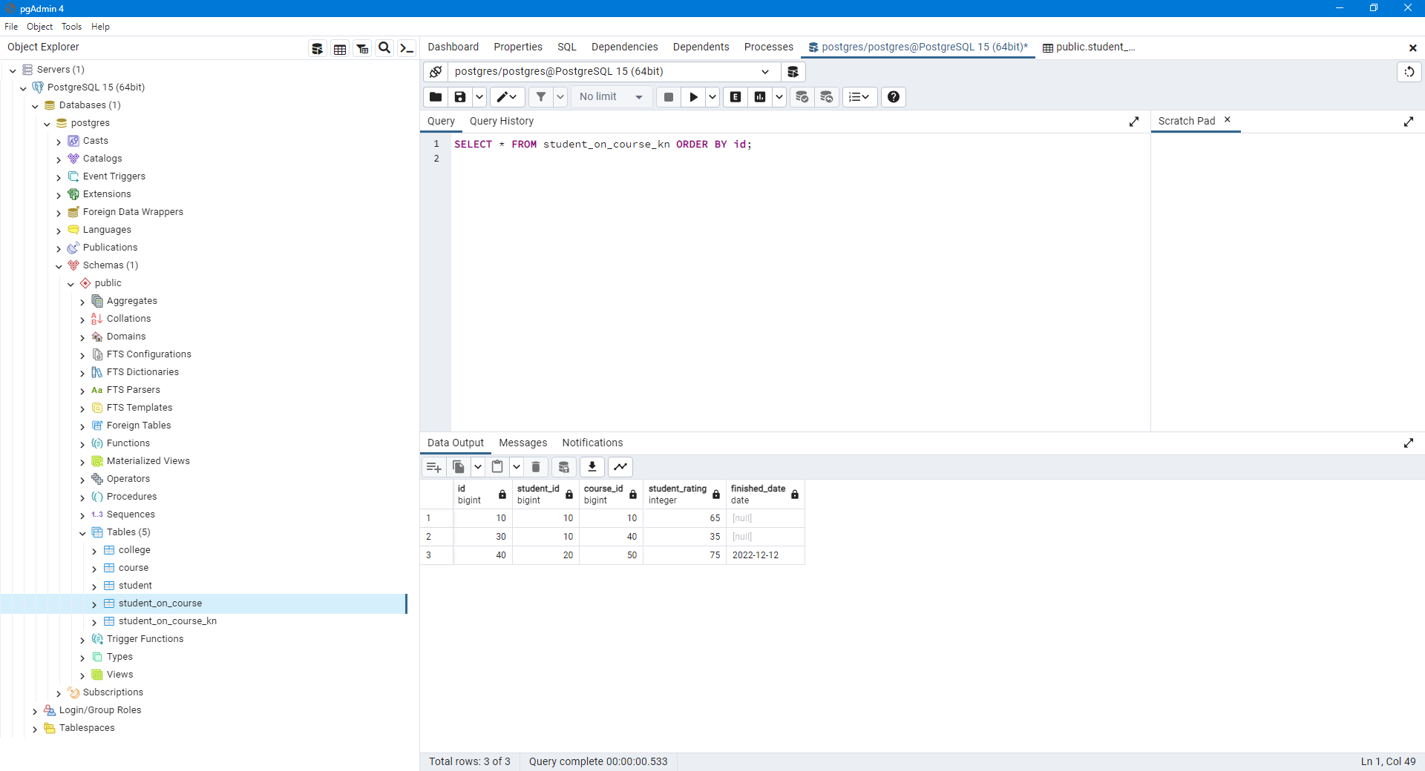

c.

delete from student_on_course_kn

where id in (select id from course where name = 'Цифровая трансформация')

and id in (select id from student where city = 'Новосибирск')

SELECT * FROM student_on_course_kn ORDER BY id;

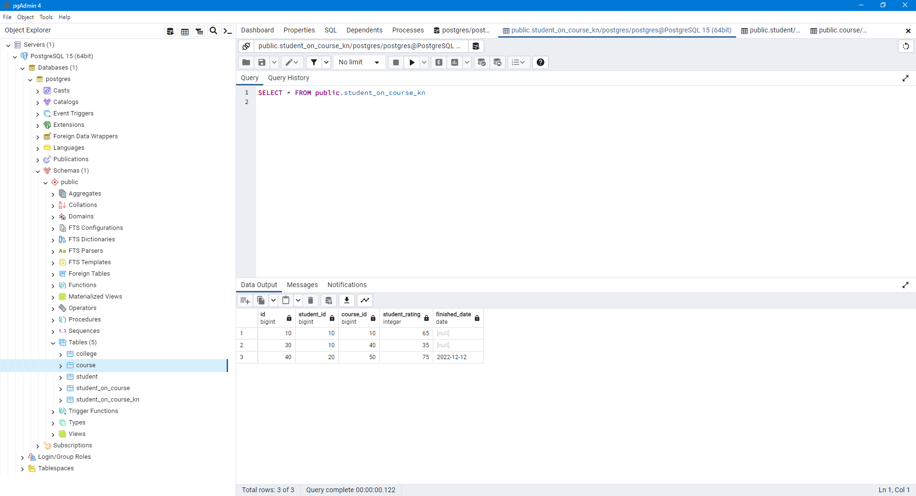

d.

INSERT INTO student_on_course_kn

SELECT *

FROM student_on_course

WHERE id in (select id from student where city = 'Москва');

UPDATE student_on_course_kn

SET student_rating = CASE

WHEN student_on_course_kn.student_rating between 0 and 60

THEN student_on_course_kn.student_rating - 5

WHEN student_on_course_kn.student_rating between 61 and 80

THEN student_on_course_kn.student_rating - 10

WHEN student_on_course_kn.student_rating between 81 and 90

THEN student_on_course_kn.student_rating - 15

else student_on_course_kn.student_rating - 20

END

FROM student_on_course

WHERE student_on_course_kn.id in (select id from student where city = 'Москва');

SELECT * FROM student_on_course_kn ORDER BY id;

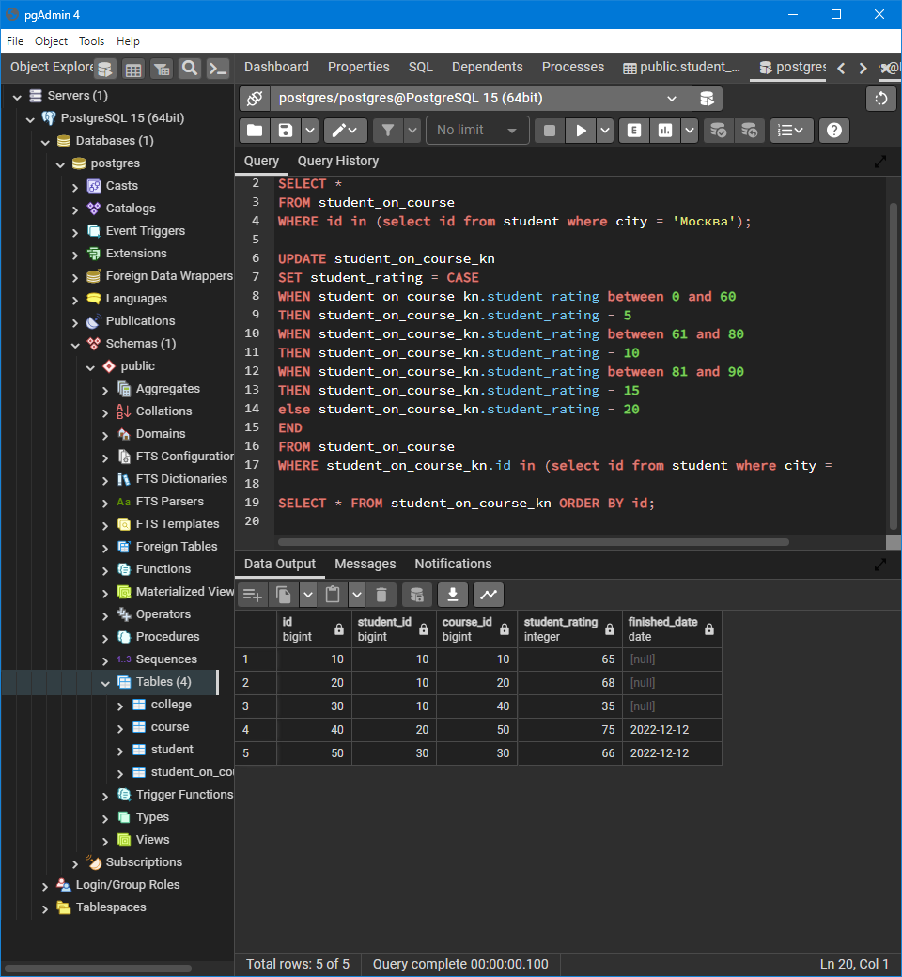

e. В таблице, показанной как пример кажется ошибка – курсы актерского мастерства проводятся не в МГУ

select t2.name as student_name, t1.student_rating as student_rating,

t3.name as student_college_name, t4.name as course_name, t3.name as course_college_name

from student_on_course_kn t1

join student t2 on t1.student_id = t2.id

join college t3 on t1.course_id = t3.id

join course t4 on t1.course_id = t4.id

order by student_name, course_name asc

