**Домашнее задание №6**

a.

select

case

when student_rating < 30

then 'неудовлетворительно'

when student_rating >= 30 and student_rating < 60

then 'удовлетворительно'

when student_rating >= 60 and student_rating < 85

then 'хорошо'

else 'отлично'

end as "оценка",

count(student_id) as "колличество студентов"

from student_on_course

group by "оценка"

order by "оценка"

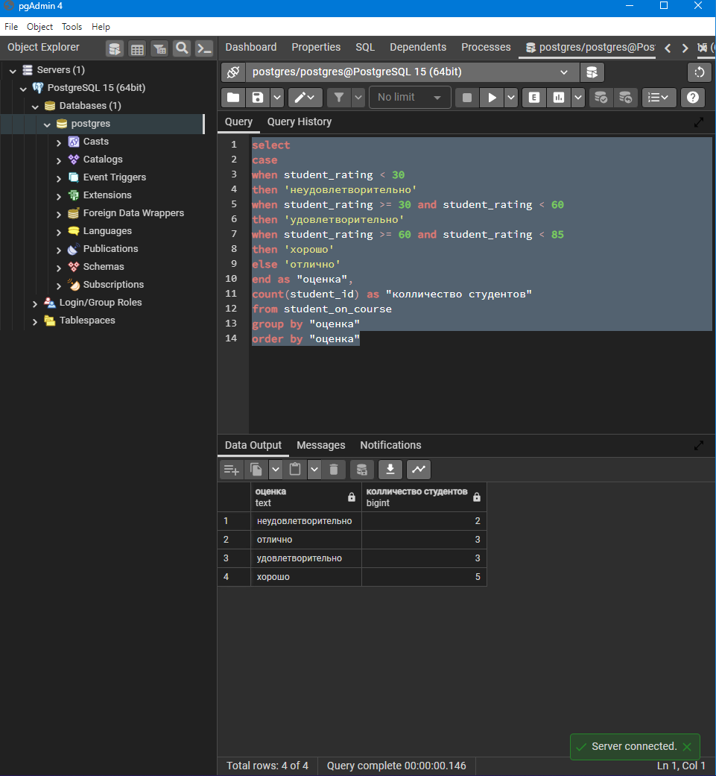

b.

select t1.name as "курс",

case

when student_rating < 30

then 'неудовлетворительно'

when student_rating >= 30 and student_rating < 60

then 'удовлетворительно'

when student_rating >= 60 and student_rating < 85

then 'хорошо'

else 'отлично'

end as "оценка",

count(student_id) as "колличество студентов"

from student_on_course

left join course t1 on student_on_course.course_id = t1.id

group by "оценка", "курс"

order by "курс", "оценка"

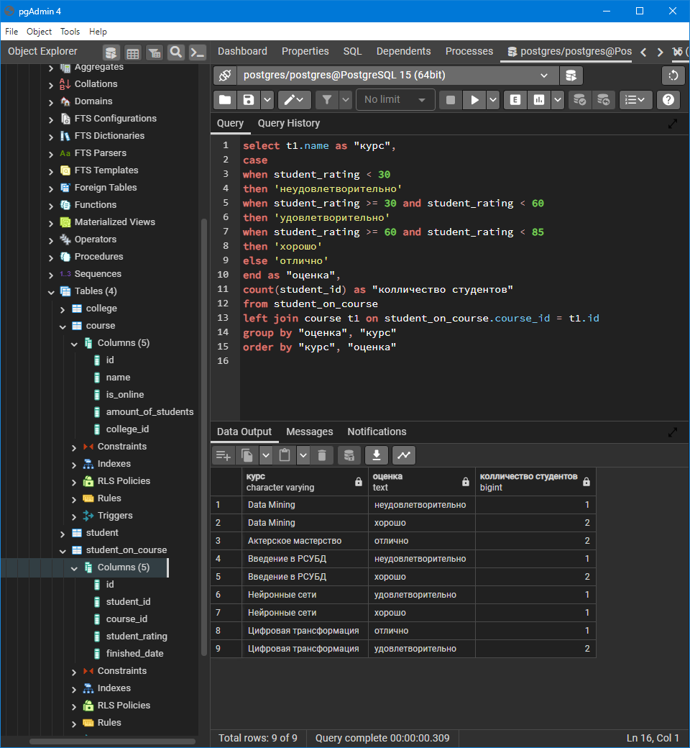

c.

select row_number() over(order by (select null) ) as "#строки",

row_number() over(partition by "курс" order by (select null))as "#строки в группе",

sub."курс",

sub."оценка",

sub."колличество студентов"

from(

select

t1.name as "курс",

case

when student_rating < 30

then 'неудовлетворительно'

when student_rating >= 30 and student_rating < 60

then 'удовлетворительно'

when student_rating >= 60 and student_rating < 85

then 'хорошо'

else 'отлично'

end as "оценка",

count(student_id) as "колличество студентов"

from student_on_course

left join course t1 on student_on_course.course_id = t1.id

group by grouping sets(("курс", "оценка"), ("курс"), ("оценка"), ())

order by "курс", "оценка"

) as sub

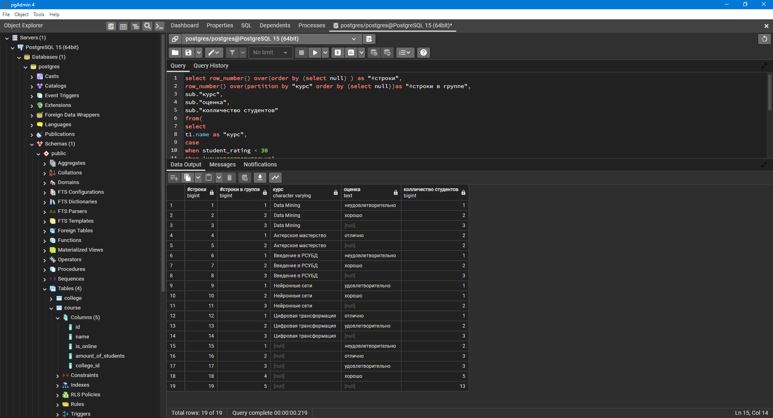

d.

select DENSE_RANK() over(order by "оценка" ) as "ранг курса и оценки",

sub."курс",

sub."оценка"

from(

select

t1.name as "курс",

case

when student_rating < 30

then 'неудовлетворительно'

when student_rating >= 30 and student_rating < 60

then 'удовлетворительно'

when student_rating >= 60 and student_rating < 85

then 'хорошо'

else 'отлично'

end as "оценка"

from student_on_course

left join course t1 on student_on_course.course_id = t1.id

group by "курс", "оценка", student_rating

) as sub

order by "ранг курса и оценки"

