**Домашнее задание №8**

a.

create or replace function getStudentHierarchy(p_manager_id integer)

returns table ("студент" character varying, "роль" character varying,

"уровень" integer, "путь от лидера" text) as $$

begin

------------------------------------

return query WITH RECURSIVE _manager AS

(

SELECT manager.id,

manager_id,

student.name,

1 AS level,

array [student.name] AS path,

student_id

FROM manager

join student on manager.student_id = student.id

WHERE manager_id = p_manager_id or (manager_id is null and p_manager_id is null)

UNION

SELECT m1.id,

m1.manager_id,

student.name,

level + 1 AS level,

path || student.name AS path,

m1.student_id

FROM manager AS m1

join student on m1.student_id = student.id

INNER JOIN _manager AS m2 ON m1.manager_id = m2.id

)

SELECT student.name as "студент",

role as "роль",

level as "уровень",

array_to_string (path, '->') as "путь от лидера"

FROM _manager

join student_role on student_role.svyaz_manager_id = _manager.id

join student on _manager.student_id = student.id

order by student.id desc;

--------------------------------------

end;

$$

language plpgsql;

SELECT * FROM getStudentHierarchy(p_manager_id := 100);

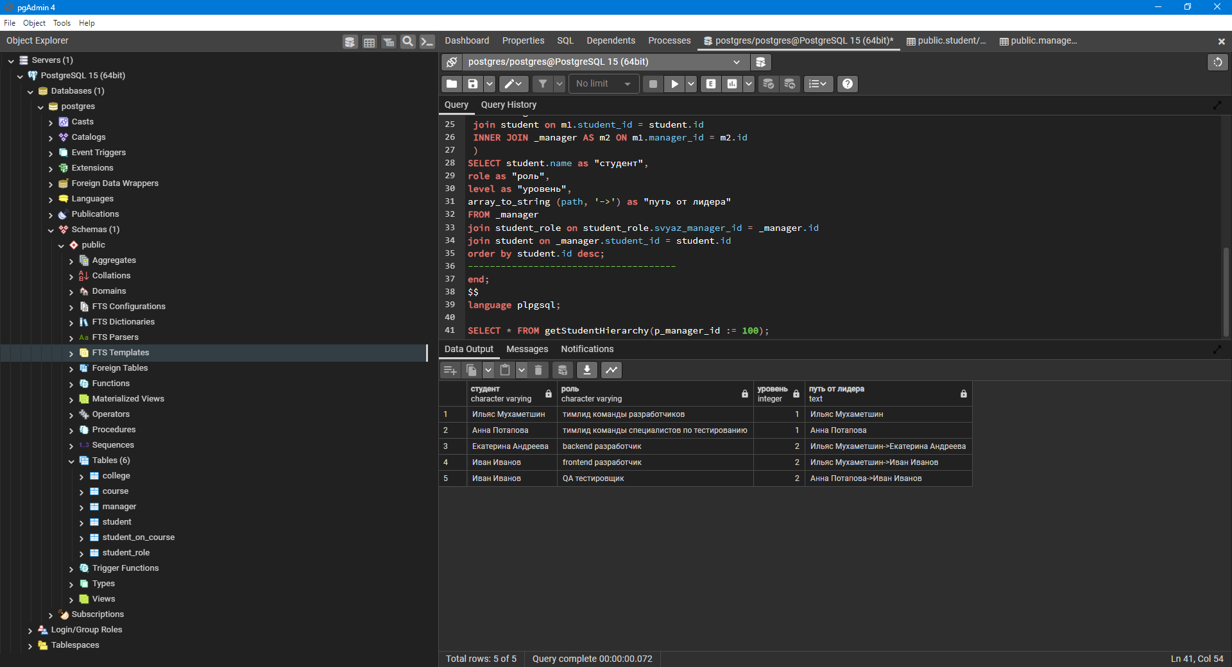

SELECT * FROM getStudentHierarchy(p_manager_id := null);

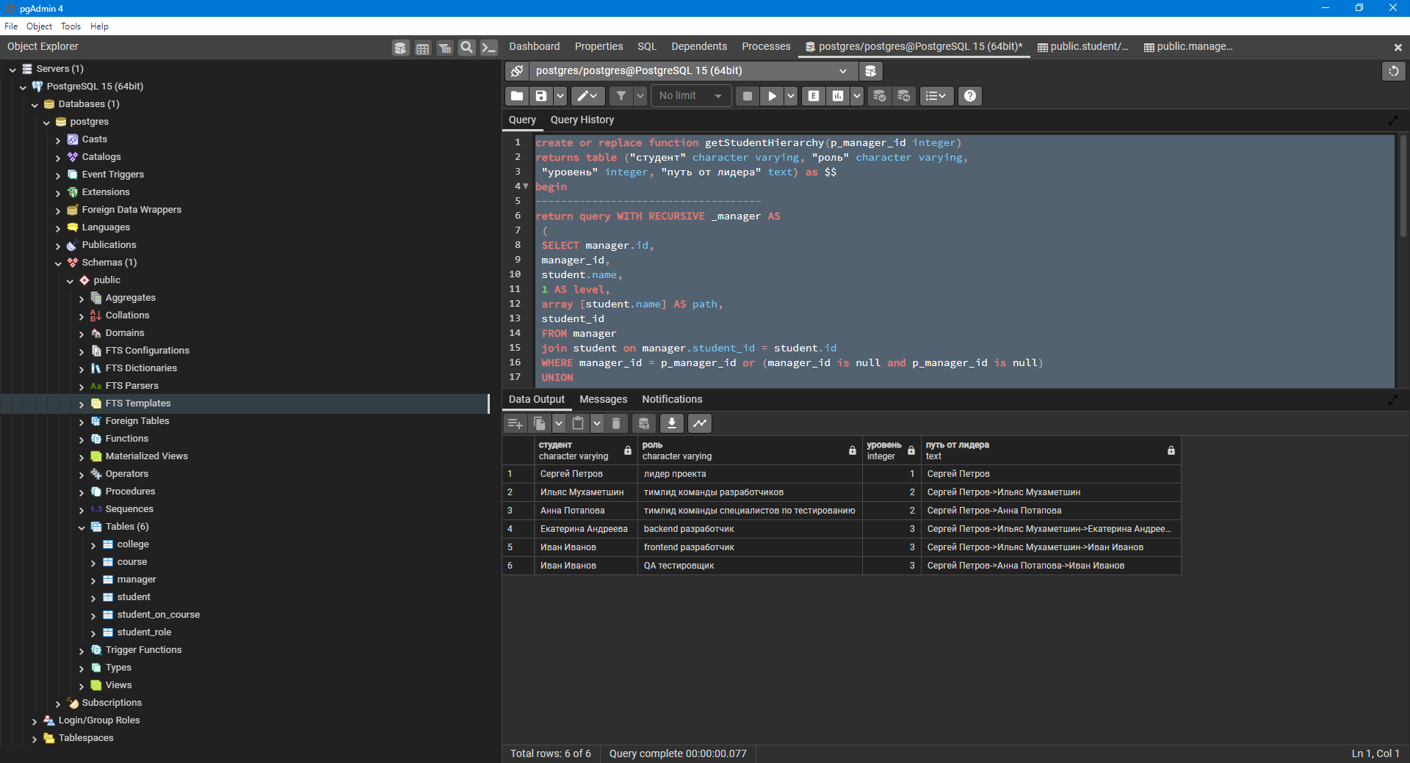

SELECT * FROM getStudentHierarchy();



b.

create or replace function getStudentHierarchyByLevel(p_manager_id integer default null, p_level integer default null)

returns table ("студент" character varying, "роль" character varying,

"уровень" integer, "путь от лидера" text) as $$

begin

------------------------------------

return query WITH RECURSIVE _manager AS

(

SELECT manager.id,

manager_id,

student.name,

1 AS level,

array [student.name] AS path,

student_id

FROM manager

join student on manager.student_id = student.id

WHERE manager_id = p_manager_id or (manager_id is null and p_manager_id is null)

UNION

SELECT m1.id,

m1.manager_id,

student.name,

level + 1 AS level,

path || student.name AS path,

m1.student_id

FROM manager AS m1

join student on m1.student_id = student.id

INNER JOIN _manager AS m2 ON m1.manager_id = m2.id

)

SELECT student.name as "студент",

role as "роль",

level as "уровень",

array_to_string (path, '->') as "путь от лидера"

FROM _manager

join student_role on student_role.svyaz_manager_id = _manager.id

join student on _manager.student_id = student.id

where level = p_level

order by student.id desc;

--------------------------------------

end;

$$

language plpgsql;

SELECT * FROM getStudentHierarchyByLevel(p_manager_id := null, p_level := 3);

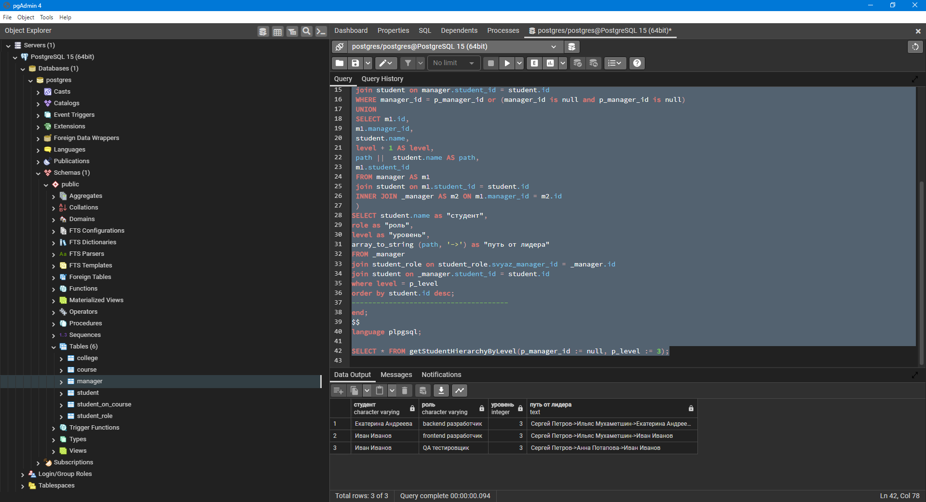

SELECT * FROM getStudentHierarchyByLevel(p_manager_id := 100, p_level := 1);

