**Домашнее задание №9**

a.

create or replace function fnc_trg_check_permissions()

returns trigger as $$

begin

declare

some_date timestamp := timestamp '2001-02-16 20:38:40';

current_day_of_week int := extract(dow from some_date);

current_hour int := extract(hour from some_date);

begin

if current_day_of_week >= 1 and current_day_of_week <= 5

and current_hour >= 9 and current_hour <= 18 then

return new;

else

raise exception 'Вы не можете выполнить изменение данных в нерабочее время';

end if;

end;

end; $$

language plpgsql;

create trigger trg_check_permissions

before insert or update or delete on course

for each statement execute function fnc_trg_check_permissions();

INSERT INTO course(id, name, is_online, amount_of_students, college_id)

VALUES (70, 'Линейная алгебра', false, 25, 20);

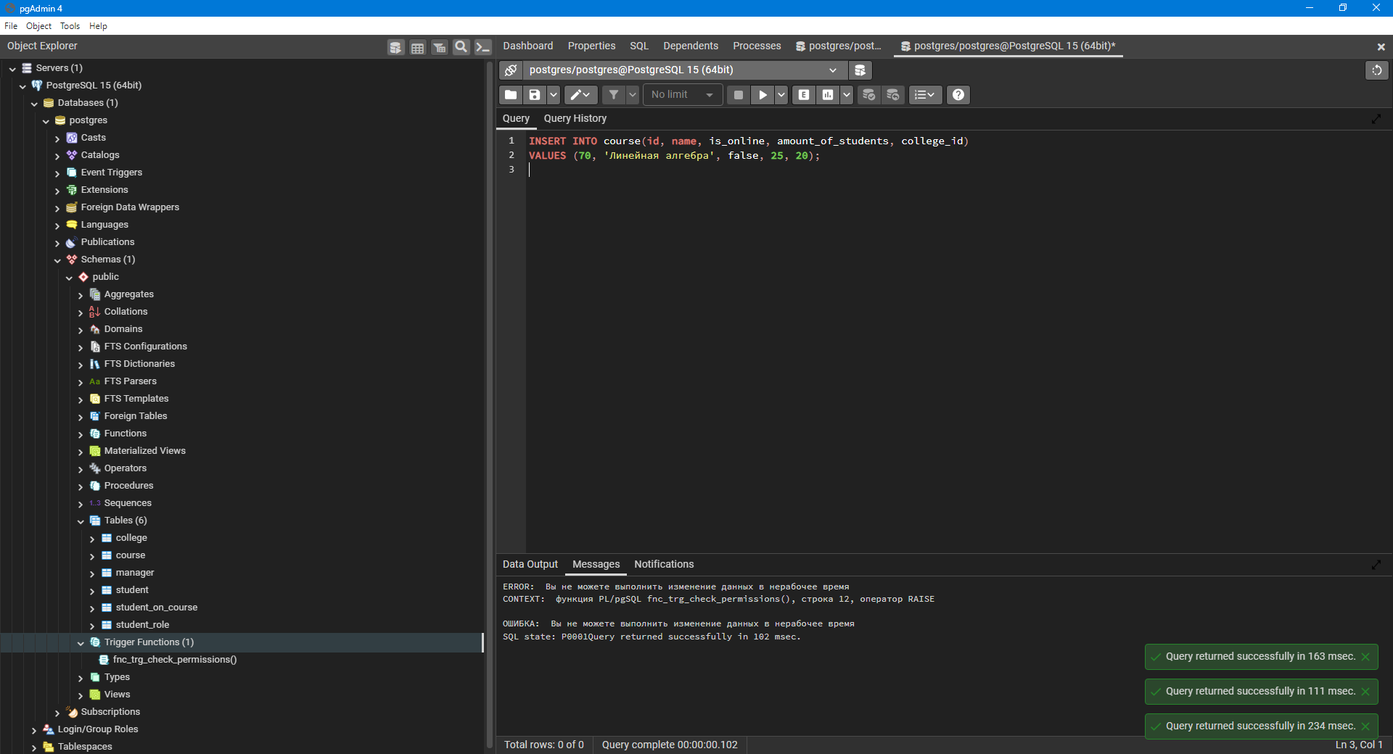

b.

create or replace function fnc_trg_check_contact ()

returns trigger as $$

begin

if new.telegram_contact is NULL then

new.telegram_contact = '@default_contact';

end if;

return new;

end; $$

language plpgsql;

create trigger trg_check_contact

before insert or update on student

for EACH ROW execute function fnc_trg_check_contact();

UPDATE student

SET telegram_contact = NULL

WHERE id = 10;

INSERT INTO student (id, city, name, telegram_contact,

college_id)

VALUES (70, 'Казань', 'Петр Емельянов', NULL, 20);

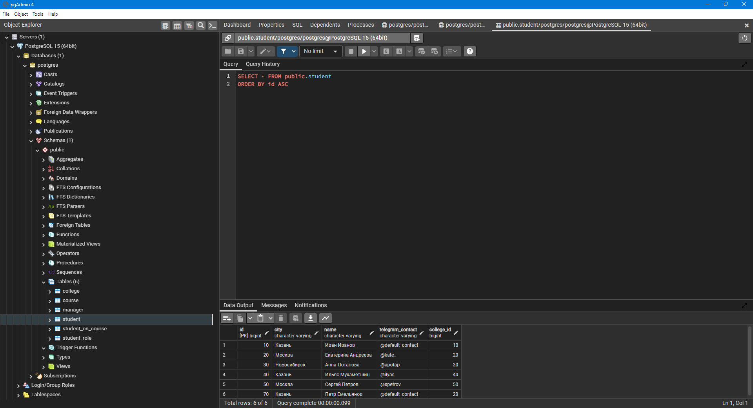

c.

CREATE TABLE college_audit

(

audit_id serial primary key,

"DS DATE" timestamp,

CHANGE_TYPE character varying,

ROW_ID INTEGER,

NAME character varying,

SIZE bigint

)

create or replace function fnc_trg_audit_college()

returns trigger as $$

begin

if (TG_OP = 'INSERT') then

insert into college_audit ("DS DATE", CHANGE_TYPE, ROW_ID, NAME, SIZE)

values (current_timestamp, 'insert', new.id, new.name, new.size);

elsif (TG_OP = 'DELETE') then

insert into college_audit ("DS DATE", CHANGE_TYPE, ROW_ID, NAME, SIZE)

values (current_timestamp, 'delete', old.id, old.name, old.size);

elsif (TG_OP = 'UPDATE') then

insert into college_audit ("DS DATE", CHANGE_TYPE, ROW_ID, NAME, SIZE)

values (current_timestamp, 'update', new.id, new.name, new.size);

insert into college_audit ("DS DATE", CHANGE_TYPE, ROW_ID, NAME, SIZE)

values (current_timestamp, 'old_value_update', old.id, old.name, old.size);

end if;

return new;

end; $$

language plpgsql;

create trigger trg_audit_college

after insert or update or delete on college

for EACH ROW execute function fnc_trg_audit_college();

INSERT INTO college(id, name,size)

VALUES (60,'КАИ',12000);

UPDATE college

SET size = 12500

WHERE id = 60;

UPDATE college

SET size = 12800

WHERE id = 60;

DELETE FROM college

WHERE id = 60;

