**Домашнее задание №10**

a.

create view v_student_college as

(select student.name as student_name, college.name as college_name

from student

join college on student.college_id = college.id);

SELECT *

FROM v_student_college

ORDER BY student_name;

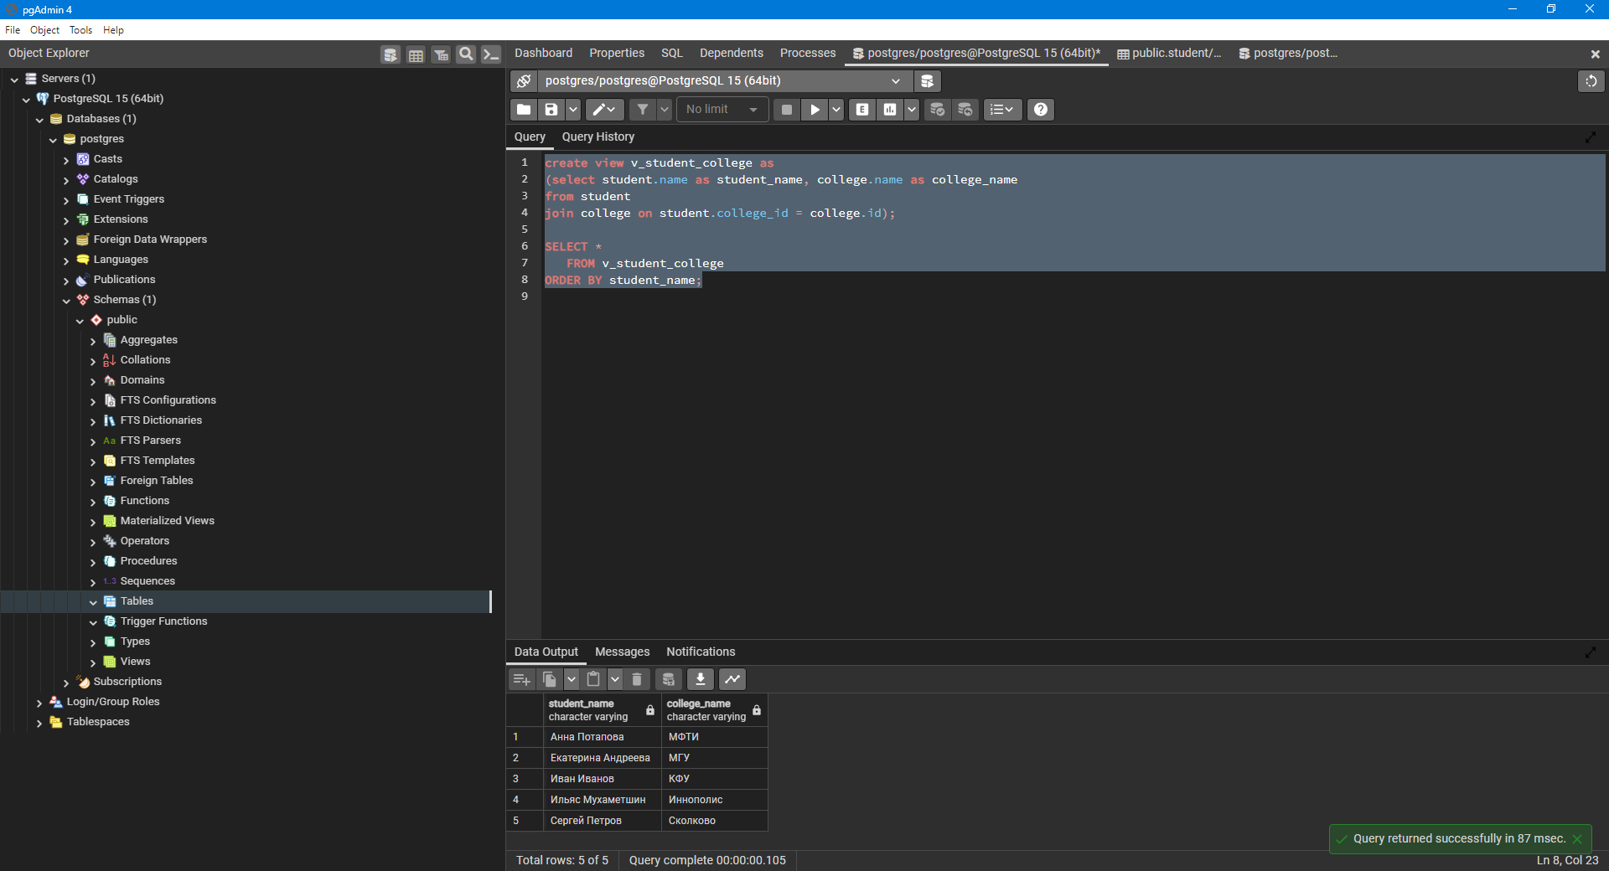

b.

create view v_student_course_rating as

select student.name as student_name, course.name as course_name,

college.name as student_college, student_rating

from student_on_course t1

join student on student.id = t1.student_id

join course on course.id = t1.course_id

join college on student.college_id = college.id

order by student_name, course_name;

SELECT *

FROM v_student_course_rating;

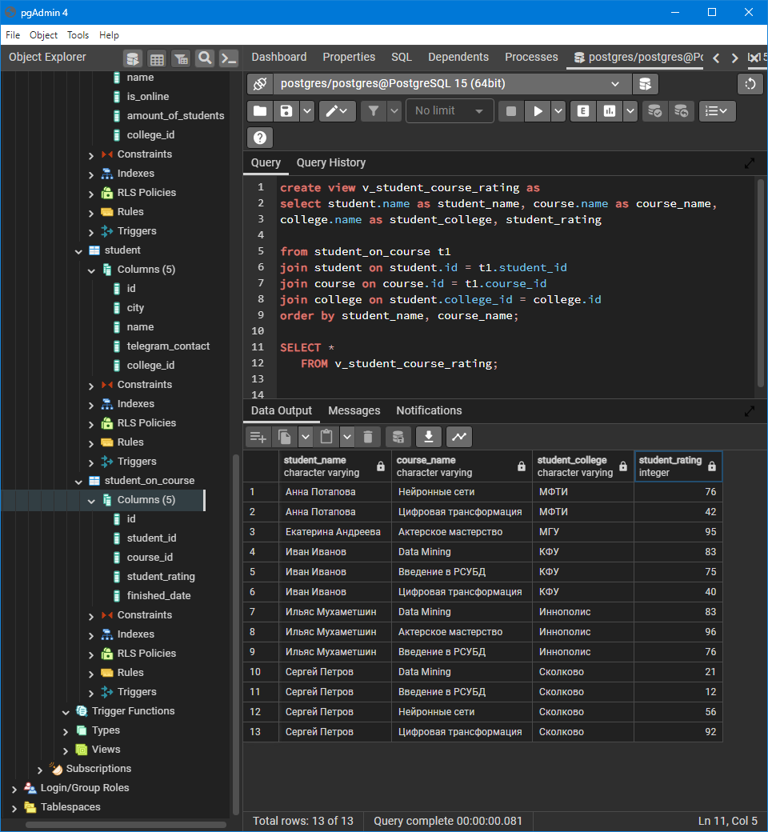

c.

create materialized view mv_student_course_rating as

select student.name as student_name, course.name as course_name,

college.name as student_college, student_rating

from student_on_course t1

join student on student.id = t1.student_id

join course on course.id = t1.course_id

join college on student.college_id = college.id

order by student_name, course_name;

SELECT *

FROM mv_student_course_rating;

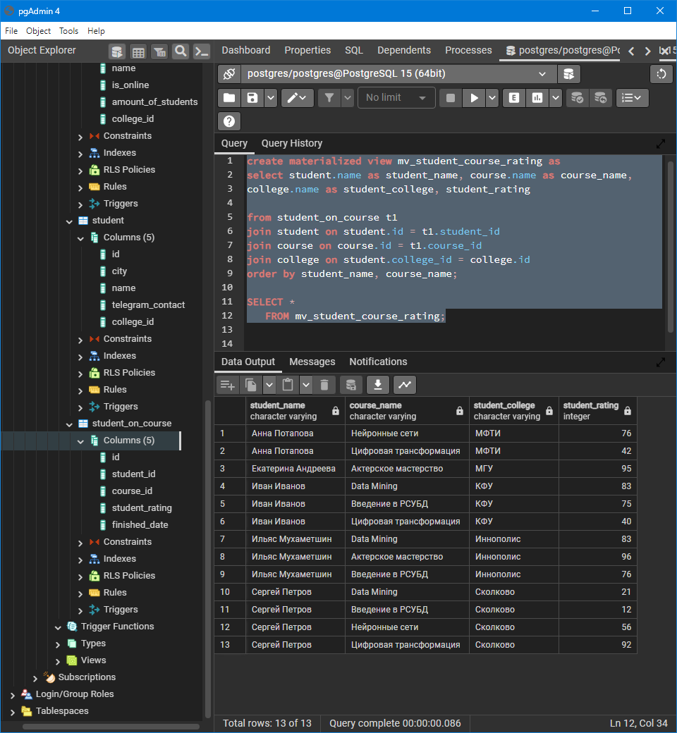

insert into student_on_course(id, student_id, course_id, student_rating, finished_date) VALUES (140,30,20,53, '2023-01-15');

refresh materialized view mv_student_course_rating

SELECT *

FROM mv_student_course_rating

WHERE student_name = 'Анна Потапова' AND

course_name = 'Data Mining';

