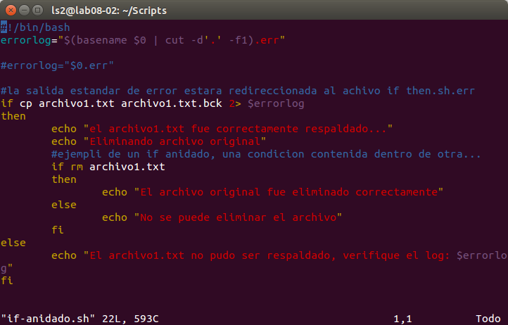
ls2@lab08-02:~/Scripts$ vim if-anidado.sh
ls2@lab08-02:~/Scripts$ chmod +x if-anidado.sh
ls2@lab08-02:~/Scripts$ ./if-anidado.sh

git clone
clonar un repositorio.
Git status
ls2@lab08-02:~$ git clone git@github.com:olgerpv/LS2G1SC-VI2015.git

ls2@lab08-02:~/LS2G1SC-VI2015/Scripts$ git config --global user.email "critsol.sa@gmail.com"
ls2@lab08-02:~/LS2G1SC-VI2015/Scripts$ git config --global user.name "Olger Parra"

ls2@lab08-02:~/LS2G1SC-VI2015/Scripts$ git --global user.email "critsol.sa@gmail.com"
Unknown option: --global
usage: git [--version] [--help] [-C <path>] [-c name=value]
[--exec-path[=<path>]] [--html-path] [--man-path] [--info-path]
[-p|--paginate|--no-pager] [--no-replace-objects] [--bare]
[--git-dir=<path>] [--work-tree=<path>] [--namespace=<name>]
<command> [<args>]
ls2@lab08-02:~/LS2G1SC-VI2015/Scripts$ git config --global user.email "critsol.sa@gmail.com"
ls2@lab08-02:~/LS2G1SC-VI2015/Scripts$ git config --global user.name "Olger Parra"
ls2@lab08-02:~/LS2G1SC-VI2015/Scripts$ touc mi_primer_script.sh
No se ha encontrado la orden «touc», quizás quiso decir:
La orden «touch» del paquete «coreutils» (main)
touc: no se encontró la orden
ls2@lab08-02:~/LS2G1SC-VI2015/Scripts$ touch mi_primer_script.sh
ls2@lab08-02:~/LS2G1SC-VI2015/Scripts$ git add *
ls2@lab08-02:~/LS2G1SC-VI2015/Scripts$ git commit -m "Mi primer Script.sh"
[master 29743a7] Mi primer Script.sh
1 file changed, 0 insertions(+), 0 deletions(-)
create mode 100644 Scripts/mi_primer_script.sh
ls2@lab08-02:~/LS2G1SC-VI2015/Scripts$ git push
warning: push.default is unset; its implicit value is changing in
Git 2.0 from 'matching' to 'simple'. To squelch this message
and maintain the current behavior after the default changes, use:

git config --global push.default matching

To squelch this message and adopt the new behavior now, use:

git config --global push.default simple

When push.default is set to 'matching', git will push local branches
to the remote branches that already exist with the same name.

In Git 2.0, Git will default to the more conservative 'simple'
behavior, which only pushes the current branch to the corresponding
remote branch that 'git pull' uses to update the current branch.

See 'git help config' and search for 'push.default' for further information.
(the 'simple' mode was introduced in Git 1.7.11. Use the similar mode
'current' instead of 'simple' if you sometimes use older versions of Git)

Warning: Permanently added the RSA host key for IP address '192.30.252.130' to the list of known hosts.
Counting objects: 5, done.
Delta compression using up to 4 threads.
Compressing objects: 100% (2/2), done.
Writing objects: 100% (4/4), 341 bytes | 0 bytes/s, done.
Total 4 (delta 0), reused 0 (delta 0)
To git@github.com:olgerpv/LS2G1SC-VI2015.git
2addcd2..29743a7 master -> master
ls2@lab08-02:~/LS2G1SC-VI2015/Scripts$
cisco TCL scripting
set -n muestra errores

ls2@lab08-02:~/LS2G1SC-VI2015/Scripts$ history
1 ps
2 ps aux | grep
3 ps aux | grep yes
4 ps aux | grep y
5 ps aux | grep ssh
6 ps aux | grep
7 ps aux | grep yes
8 ps aux | wc -l
9 ps aux | grep yes
10 ps aux | grep -v grep
11 pgrep yes
12 kill
13 kill 15644
14 sudo -u
15 ps aux | grep -v grep
16 ps aux | grep yes
17 job
18 jobs
19 kill -8 15644
20 echo $BASH_VERSION
21 echo $BASH_VERSION | CUT -D'.' -F1
22 echo $BASH_VERSION | cut -D'.' -F1
23 echo $BASH_VERSION | cut -D`.` -F1
24 echo $BASH_VERSION | cut -d'.' -F1
25 echo $BASH_VERSION | cut -d'.' -f1
26 echo $BASH_VERSION | cut -d'.' -f2
27 echo $BASH_VERSION | cut -d'.' -f3
28 echo $BASH_VERSION | cut -d'.' -f4
29 echo $BASH_VERSION | cut -d'(' -f1
30 echo $BASH_VERSION | cut -d'(' -f2
31 echo $BASH_VERSION | cut -d'(' -f1
32 var ="value uS$5"
33 var ='value uS$'
34 var='value uS$'
35 clear
36 pgrep yes
37 jobs
38 pgrep yes
39 clear
40 .
41 ls -l
42 cd scripts
43 cd Scripts
44 sudo iptables -l
45 sudo iptables -L
46 whoami
47 sudo su -
48 pwd
49 ls
50 cd Scripts
51 vim if-anidado.sh
52 ls
53 vim if-anidado.sh
54 chmod +x if-anidado.sh
55 ./if-anidado.sh
56 vim archivo1.txt
57 los
58 ls
59 ./if-anidado.sh archivo1.txt
60 ls
61 vim archivo1.txt
62 vim if-anidado.sh
63 ssh-keygen -t rsa -b 4096
64 cat /home/ls2/.ssh/id_rsa.pub
65 cd.
66 cd \
67 sudo apt-get install git -y -qq
68 git clone git@github.com:olgerpv/LS2G1SC-VI2015.git
69 ls
70 cd LS2G1SC-VI2015
71 git status
72 ls
73 ls -l
74 mkdir Scripts
75 cd Scripts
76 cd..
77 cd'

78 git --global user.email "critsol.sa@gmail.com"
79 git config --global user.email "critsol.sa@gmail.com"
80 git config --global user.name "Olger Parra"
81 touc mi_primer_script.sh
82 touch mi_primer_script.sh
83 git add *
84 git commit -m "Mi primer Script.sh"
85 git push
86 ls
87 vim mi_primer_script.sh
88 git status
89 vim mi_primer_script.sh
90 git status
91 git add mi_primer_script.sh
92 git commit -m "Hola mundo"
93 git push -u origin master
94 chmod +x mi_primer_script.sh
95 git status
96 git add mi_primer_script.sh
97 git commit -m "permisos agregados"
98 git push -u origin master
99 clear
100 history

