**To read documentation about Maven**: maven tutorial <https://www.tutorialspoint.com/maven/>

**Central repo**: <https://search.maven.org/> > search for artifacts!

1. Maven > jdk (chose from c:program files\java > new project (dbdc.upskilling)
2. Import Maven
3. <dependencies>  
    <dependency>  
    <groupId>org.junit.jupiter</groupId>  
    <artifactId>junit-jupiter-api</artifactId>  
    <version>5.2.0</version>  
    <scope>test</scope>  
    </dependency>  
    <dependency>  
    <groupId>org.junit.jupiter</groupId>  
    <artifactId>junit-jupiter-engine</artifactId>  
    <version>5.2.0</version>  
    <scope>test</scope>  
    </dependency>  
    </dependencies>  
    <build>  
    <plugins>  
    <plugin>  
    <groupId>org.apache.maven.plugins</groupId>  
    <artifactId>maven-compiler-plugin</artifactId>  
    <version>3.7.0</version>  
    <configuration>  
    <source>1.8</source>  
    <target>1.8</target>  
    </configuration>  
    </plugin>  
    <plugin>  
    <groupId>org.apache.maven.plugins</groupId>  
    <artifactId>maven-surefire-plugin</artifactId>  
    <version>2.19.1</version>  
    </plugin>  
    </plugins>  
    </build>
4. Terminal > mvn clean test

Test должен быть такой (always true) and pass!!!

**package** com.luxoft.dbdc.upskilling;  
  
**import** org.junit.jupiter.api.Assertions;  
**import** org.junit.jupiter.api.Test;  
  
**public class** SimpleTest {  
 @Test  
 **public void** alwaysPass(){  
 Assertions.*assertTrue*(**true**);  
 }  
}

1. Потом в Terminal > mvn clean install (to build Maven and get sources). Then in C:\Users\ptc-hp-20\.m2\repository\com\luxoft\dbdc.upskilling

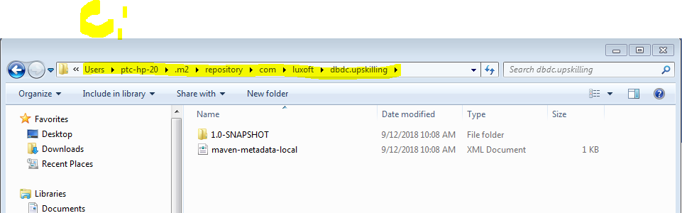

And in Idea sources:

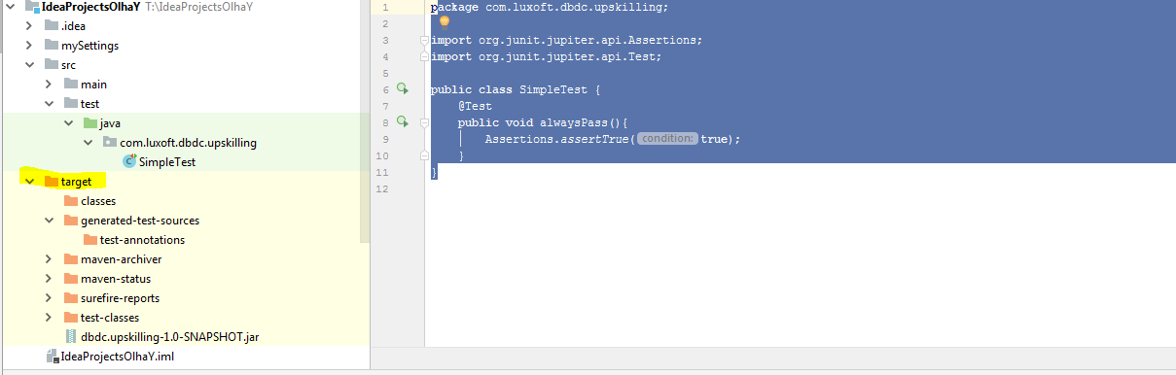

1. **Central Repository**: Go to pom.xml file > change:

<repositories> … </repositories>

1. Maven Plugins (to change something in Maven) – для каждой цели исп-ся свой плагин
2. Mocking Files in Java - Mock Contents - **Mockito**