Government of the People’s Republic of Bangladesh
Public Works Department (PWD)
National Science and Technology Council Premises, Dhaka

GUIDELINES FOR THE PLANNING, DESIGN,
CONSTRUCTION AND MAINTENANCE OF A
FORENSIC DNA TESTING LABORATORY

From the Perspective of Construction and Maintenance
For Forensic Case Work: Rape, Women Torture, Parentage Determination, Accidental Victim Identification
Prepared by: Public Works Department (PWD)
For: National Science and Technology Council, Bangladesh
Version: Draft for Review | April 2026
Classification: RESTRICTED — Government Use Only

Abbreviations & Key Terms
Abbreviation | Full Form
BNBC | Bangladesh National Building Code 2020
BSL-2 | Biosafety Level 2
CCTV | Closed Circuit Television
CODIS | Combined DNA Index System (US FBI)
DNA | Deoxyribonucleic Acid
HEPA | High Efficiency Particulate Air (filter)
HVAC | Heating, Ventilation and Air Conditioning
ISO/IEC 17025 | International Standard for Testing Laboratory Competence
LIMS | Laboratory Information Management System
NFDPL | National Forensic DNA Profiling Laboratory, Dhaka
NIJ | National Institute of Justice, USA
PCR | Polymerase Chain Reaction
PWD | Public Works Department, Bangladesh
QA/QC | Quality Assurance / Quality Control
SWGDAM | Scientific Working Group on DNA Analysis Methods (FBI)
TWGDAM | Technical Working Group on DNA Analysis Methods (FBI)
UPS | Uninterruptible Power Supply

1. Introduction

1.1 Purpose and Scope
This guideline document has been prepared by the Public Works Department (PWD) of the Government of the People’s Republic of Bangladesh to provide a comprehensive reference for the planning, design, construction, and maintenance of a Forensic DNA Testing Laboratory at the National Science and Technology Council premises. The document addresses the physical infrastructure, architectural layout, construction standards, and maintenance requirements of the facility from a civil/architectural perspective. [Ref-1]
Scientific equipment and analytical procedures are outside the direct scope of this document; however, where they impose specific construction requirements (such as vibration isolation, HVAC segregation, or dedicated power supply), they are addressed here.

1.2 Legal Basis
The establishment of this laboratory is mandated and governed by the following legislation and regulatory framework:
- The Deoxyribonucleic Acid (DNA) Act, 2014 (Act No. X of 2014): Section 14 authorises the Government to establish forensic DNA laboratories. Section 15 imposes a statutory obligation on every DNA laboratory to ensure physical infrastructure facilities, follow appropriate procedures to maintain safety and confidentiality, and ensure the highest quality of DNA analysis.
- Section 15(2)(c) of the DNA Act, 2014 explicitly mandates: "ensure the physical infrastructural facilities" — making construction standards a legal requirement, not merely a best practice. [Ref-2]
- The DNA Rules (Deoxyribonucleic Acid Bidhimala) — currently being enacted — will prescribe detailed operational and infrastructural requirements under delegated legislation power of Section 39 of the DNA Act, 2014. [Ref-3]
- Bangladesh National Building Code (BNBC) 2020: Part 3 (Special Occupancy) governs the construction of specialised laboratory buildings, and Part 8 (Building Services) governs mechanical, electrical and plumbing systems. [Ref-4]
- Guidelines of the National Forensic DNA Profiling Laboratory (NFDPL), Dhaka, which is the apex reference laboratory in Bangladesh under Section 14(3) of the DNA Act, 2014. [Ref-5]
- NIJ/NIST Forensic Laboratories: Handbook for Facility Planning, Design, Construction, and Moving (NCJ 168106) — the primary international construction reference for forensic laboratories, developed jointly by the National Institute of Justice and NIST. [Ref-1]

1.3 Purpose of the DNA Testing Laboratory
The primary function of this laboratory is to assist the courts and law enforcement agencies of Bangladesh in resolving legal matters requiring DNA analysis, including:
- Rape and sexual assault investigations (processing of forensic biological evidence)
- Women torture and violence cases requiring victim DNA analysis
- Parentage determination (paternity/maternity testing for court proceedings)
- Identification of accidental and disaster victims
- DNA profiling for the National DNA Database (established under Section 24 of the DNA Act, 2014) [Ref-2]
- Missing persons identification

2. Guiding Design Principles
The following five principles must drive all design and construction decisions for this facility. Failure to uphold any of these principles may compromise the legal admissibility of DNA evidence produced by the laboratory.
Principle | Explanation | Authority
1. Unidirectional Workflow | Evidence must flow in one direction only — from receipt through processing to storage — and never backtrack. Equipment, PPE and personnel must NEVER return from post-PCR zones to pre-PCR zones. | NIJ Handbook [Ref-1]; FBI QAS Standard 6.1
2. Physical Separation of PCR Zones | The PCR Amplification Room must be physically separated from all evidence examination, extraction, and PCR setup areas by floor-to-ceiling walls and self-closing doors. | FBI QAS 6.1.3 [Ref-1]; DNA Act S.15 [Ref-2]
3. Security of Evidence | All evidence must be secured against unauthorised access at all times. Chain of custody must be physically supported by the design (access control, CCTV, locked storage). | ISO/IEC 17025; DNA Act S.25-26 [Ref-2]
4. Flexibility & Future-Proofing | The facility must be designed to accommodate evolving DNA technologies and increasing caseload without full reconstruction. Modular casework and adaptable HVAC systems are essential. | NIJ Handbook [Ref-1] Executive Summary
5. Regulatory Compliance | All construction must comply with BNBC 2020 (Parts 3 & 8) for special occupancy, structural, mechanical, electrical and plumbing requirements. | BNBC 2020 [Ref-4]; DNA Act S.15 [Ref-2]

3. Architectural Layout and Zone Planning

3.1 Zone-Based Spatial Organisation
The laboratory must be organised into eight discrete functional zones arranged to ensure unidirectional evidence flow and graduated security access. [Ref-1, Ref-2] The zones should be arranged in a linear or L-shaped plan so that evidence enters at one end, is processed sequentially, and is stored securely at the other end without any backtracking.
The recommended gross floor area per staff member is 65–93 m², resulting in an overall building size that must be calculated based on approved staffing levels. [Ref-1]

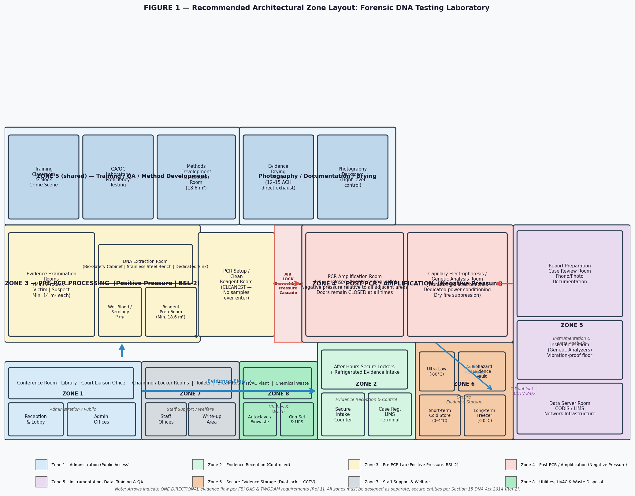
Figure 1: Recommended Zone-Based Architectural Layout for a Forensic DNA Testing Laboratory[Ref-1: NIJ Handbook; Ref-2: DNA Act 2014, Section 15]

3.2 Zone Descriptions

Zone 1 — Administrative / Public Zone
This is the outermost zone with no restriction on access for official visitors. It includes the main reception/lobby, administrative offices, conference rooms, library, court liaison office, and visitor toilets. It must be separated from all laboratory zones by a clearly defined security perimeter with sign-in/badging facilities at the transition point. [Ref-1]

Zone 2 — Evidence Reception and Control
This is the first secured zone. The NIJ Handbook recommends a minimum of four levels of secured parking, with evidence delivery occurring in a partially secured, fenced Level 2 area. [Ref-1] The zone must include:
- A dedicated, secure evidence intake counter with CCTV coverage
- After-hours secure evidence lockers for submissions outside working hours
- LIMS (Laboratory Information Management System) terminal for case registration and chain-of-custody initiation [Ref-2]
- Refrigerated/frozen intake units for biological evidence requiring cold storage
- An evidence workroom with layout counter, sink, and packaging facilities
Section 26 of the DNA Act, 2014 requires that access to DNA profiles and evidence be restricted to authorised persons only. This must be physically enforced at Zone 2. [Ref-2]

Zone 3 — Pre-PCR Processing Zone (Positive Pressure)
This is the most critical zone for contamination prevention. The NIJ Handbook mandates that general contamination prevention is critical and that the zone be designed as a biologically hazardous space (BSL-2) with a biovestibule at entry. [Ref-1]
The zone must contain at minimum the following separate rooms:
- Evidence Examination Room(s): Minimum two rooms to separate victim and suspect evidence, each with a minimum floor area of 13.9 m² (150 ft²). Each room must have a mobile stainless-steel examination table with all-around access, an evidence hanging apparatus, bench space with sink (minimum 2.4 m linear), and light-level control. [Ref-1]
- DNA Extraction Room: Fitted with a Class II Biological Safety Cabinet, stainless-steel bench surfaces, dedicated sink, and negative-pressure ventilation.
- PCR Setup / Reagent Preparation Room: The cleanest room in the entire laboratory. No evidence samples or amplified DNA products may ever be brought into this room. Fitted with a biological hood and refrigerator. [Ref-1]
- Wet Blood / Serology Preparation: Minimum 9.3 m² (100 ft²) with biological hood and sink. [Ref-1]

Zone 4 — Post-PCR / Amplification Zone (Negative Pressure)
Physical separation of the PCR amplification room from all pre-PCR areas is a non-negotiable requirement of the FBI Quality Assurance Standards and the NIJ Handbook. [Ref-1] The amplification room must be:
- Enclosed with walls extending from floor to ceiling (no false ceiling breaks)
- Maintained under negative pressure relative to all adjacent areas
- Entered only through a biovestibule/airlock, with doors remaining closed at all times [Ref-1]
- Allocated minimum 9.3 m² (100 ft²) per analyst [Ref-1]
- Connected to a separate HVAC exhaust system with HEPA filtration [Ref-4]

Zone 5 — Instrumentation, Data Analysis, Training and QA Zone
This zone houses the genetic analysis instruments, the CODIS/LIMS computer infrastructure, the quality assurance office, and training facilities. Instrument rooms require: [Ref-1]
- Vibration-proof flooring and vibration-isolated benches for sensitive instruments
- Dry fire-suppression systems in all computer and instrument rooms (NOT wet sprinklers) [Ref-1]
- Dedicated stable electrical supply with UPS protection
- Supplemental cooling (beyond standard HVAC) for heat-generating instruments
- Dedicated data lines and telephone connections for each CODIS/LIMS workstation [Ref-1]
Section 15(2)(g) of the DNA Act, 2014 requires the laboratory to use appropriate technology to ensure the highest technical standards. [Ref-2] This mandates purpose-designed instrument accommodation.

Zone 6 — Secure Evidence Storage Zone
The evidence storage zone must provide short-term, long-term, and ultra-low temperature storage for biological evidence. The NIJ Handbook specifies walk-in refrigerators, freezers, and ultra-low temperature freezer units. [Ref-1] Construction requirements include:
- Dual-lock access control with all access devices uniquely identified and logged
- 24/7 CCTV surveillance with recording retained for the prescribed case retention period
- Continuous temperature monitoring with automatic alarm for deviations [Ref-4]
- Emergency backup power for all refrigeration units [Ref-1]
- Motion detection in evidence storage spaces [Ref-1]

Zone 7 — Staff Support Zone
Staff support spaces must be provided within the building but separated from laboratory zones. The NIJ Handbook specifies: [Ref-1]
- Supervisor’s office: minimum 11.5 m² (120 ft²)
- Individual analyst’s administrative workstation: minimum 5.95 m² (64 ft²) per analyst
- Locker rooms with showers, separate male/female facilities, for gowning transition
- Lunchroom, break room, and staff toilets
- Library with book stacks, periodicals shelving, study carrels, and computer terminals [Ref-1]

Zone 8 — Utility, Waste and Plant Zone
Mechanical and utility equipment that requires periodic maintenance must be located outside laboratory spaces and particularly outside evidence storage areas. [Ref-1] This zone includes the HVAC plant room, emergency generator, UPS equipment, autoclave room, biohazardous waste holding area, and chemical waste neutralisation system.

4. Important Components of the Laboratory

4.1 Building Fabric and Finishes

4.1.1 Exterior Walls and Openings
The NIJ Handbook recommends bullet-resistant construction for exterior walls (concrete or fully grouted masonry) for forensic laboratory buildings. [Ref-1] Windows exposed to public view must use reflective and/or bullet-resistant glazing, with window sills designed flush with the exterior or sloped to prevent the placement of objects. HVAC intakes must be located away from public access and positioned away from and upwind from fume hood exhaust. [Ref-1]
BNBC 2020 Part 3 (Special Occupancy) governs structural and fire performance requirements for this category of building. [Ref-4]

4.1.2 Internal Finishes
Location | Floor | Walls | Ceiling
Lab rooms (BSL-2 biohazard) | Seamless chemical-resistant sheet vinyl or epoxy resin (coved skirting) | Epoxy paint — smooth, non-porous, cleanable | Epoxy — sealed, no exposed fixtures [Ref-1]
PCR Amplification Room | Seamless anti-static sheet vinyl | Epoxy — coved at all joints | Epoxy — sealed [Ref-1]
Instrument rooms | Vibration-proof, seamless vinyl | Semi-gloss latex enamel | Suspended acoustic (for sound damping) [Ref-1]
Evidence storage | High-strength, chemical resistant vinyl | Epoxy or ceramic tile | Sealed/painted [Ref-1, Ref-4]
Admin / offices | Standard commercial carpet or tiles | Painted plasterboard | Suspended acoustic tiles [Ref-1]

4.1.3 Laboratory Casework and Benching
The NIJ Handbook specifies: [Ref-1]
- Steel or wood casework preferred; plastic laminate acceptable for non-hazardous areas
- Epoxy resin bench tops in all areas where a fume hood or biological hood is installed
- Stainless-steel bench surfaces wherever biologically contaminated evidence may contact the surface
- Standard bench depth 600–750 mm with utility access space behind all base cabinets
- Individual workstations: minimum 4.57 m (15 linear ft) bench space per analyst [Ref-1]
- Maximize use of flexible, modular casework systems to support future technology changes [Ref-1]

4.2 HVAC and Mechanical Systems
HVAC is the single most critical building system in a forensic DNA laboratory. [Ref-1, Ref-4] The pressure cascade illustrated in Figure 2 must be strictly maintained.

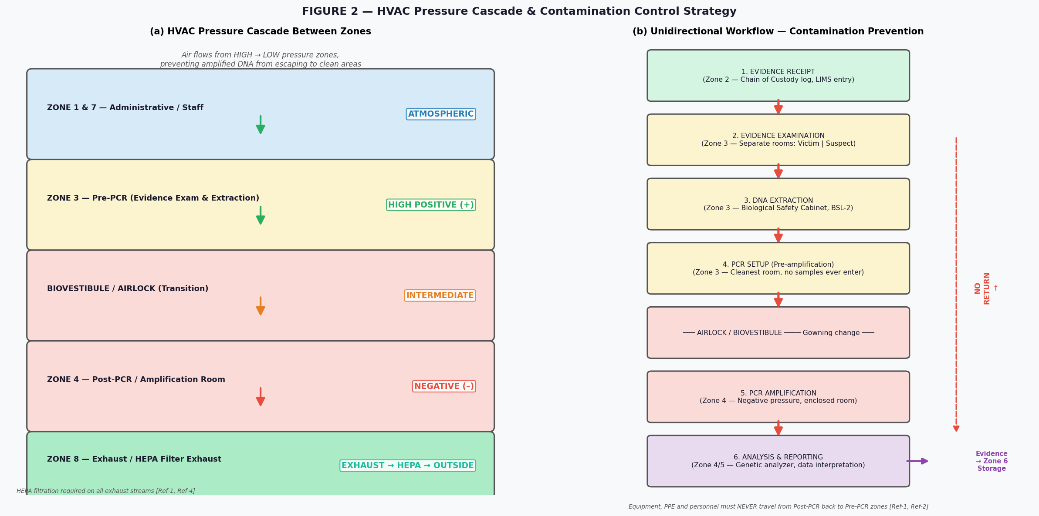
Figure 2: (a) HVAC Pressure Cascade Between Zones; (b) Unidirectional Evidence Workflow[Ref-1: NIJ Handbook; Ref-2: DNA Act 2014 Section 15; Ref-4: BNBC 2020 Part 8]

4.2.1 Pressure Requirements
The FBI Quality Assurance Standards and the NIJ Handbook require: [Ref-1]
- PCR Amplification Room (Zone 4): Negative pressure relative to all adjacent spaces — doors must remain closed at all times
- Pre-PCR Zones (Zone 3 extraction, evidence rooms): Positive pressure relative to corridors
- Biovestibule/Airlock: Intermediate pressure, functioning as a pressure buffer
- HEPA filtration on all exhaust streams from biologically hazardous spaces [Ref-1, Ref-4]
- Separate, dedicated HVAC systems for PCR amplification rooms and mitochondrial DNA rooms — NOT shared with any other space [Ref-1]

4.2.2 Air Change Rates
Space | Min. Air Changes/Hr | Reference
Evidence Drying Room | 12–15 ACH, direct exhaust to exterior | NIJ Handbook [Ref-1]
DNA Extraction (BSL-2 hood areas) | 10–12 ACH minimum | NIJ Handbook [Ref-1]
PCR Amplification Room | 8–10 ACH with HEPA-filtered exhaust | FBI QAS; NIJ [Ref-1]
General lab spaces | 6–8 ACH | BNBC 2020 Part 8 [Ref-4]
Evidence Storage (refrigerated) | Mechanical cooling, no natural ventilation | NIJ Handbook [Ref-1]

4.2.3 Temperature and Humidity Control
The NIJ Handbook requires the highest performance standards for temperature and humidity for forensic science environments. [Ref-1] Target conditions: 18–22°C and 40–60% relative humidity. Continuous monitoring with automatic alarms and backup controls is required.
BNBC 2020 Part 8 (Building Services) governs the design, installation, and testing of HVAC systems in Bangladesh. [Ref-4]

4.3 Plumbing Systems
Per the NIJ Handbook: [Ref-1]
- Deionised water: Recirculating deionised water system with point-of-use Type 1 water polisher at each laboratory bench
- Emergency eyewash stations and safety deluge showers in all laboratory spaces and areas of refuge
- Biohazardous liquid waste: Dedicated acid/alkali waste neutralisation system before discharge to main sewer
- Hands-free (foot or sensor operated) sinks at the exit of every laboratory section, with lab coat hooks and PPE storage [Ref-1]
- Fume hood plumbing: Dedicated cup sinks with caustic waste plumbing at all fume hood locations [Ref-1]
- BNBC 2020 Part 8 governs all plumbing installation and testing standards in Bangladesh [Ref-4]

4.4 Electrical Systems
The NIJ Handbook requires an emergency generator system and UPS protection for critical laboratory functions. [Ref-1] All of the following must be on emergency backup power:
- Entire evidence storage section including all refrigerators and freezers (including walk-in units) [Ref-1]
- All security systems including electronic access control, CCTV, and alarm systems [Ref-1]
- All laboratory technical, examination, and investigation spaces (minimum one duplex outlet per 93 m² and 25% lighting on emergency circuits) [Ref-1]
- CODIS/LIMS computer systems and all laboratory instrumentation (via UPS) [Ref-1]
BNBC 2020 Part 8 (Electrical Services) governs all electrical installation, testing and inspection requirements. [Ref-4]

4.5 Security Systems
The NIJ Handbook recommends a formal Security Strategy Meeting as the first step in security design, attended by building owner, users, security staff, architect, electrical engineer, and a security consultant. [Ref-1]

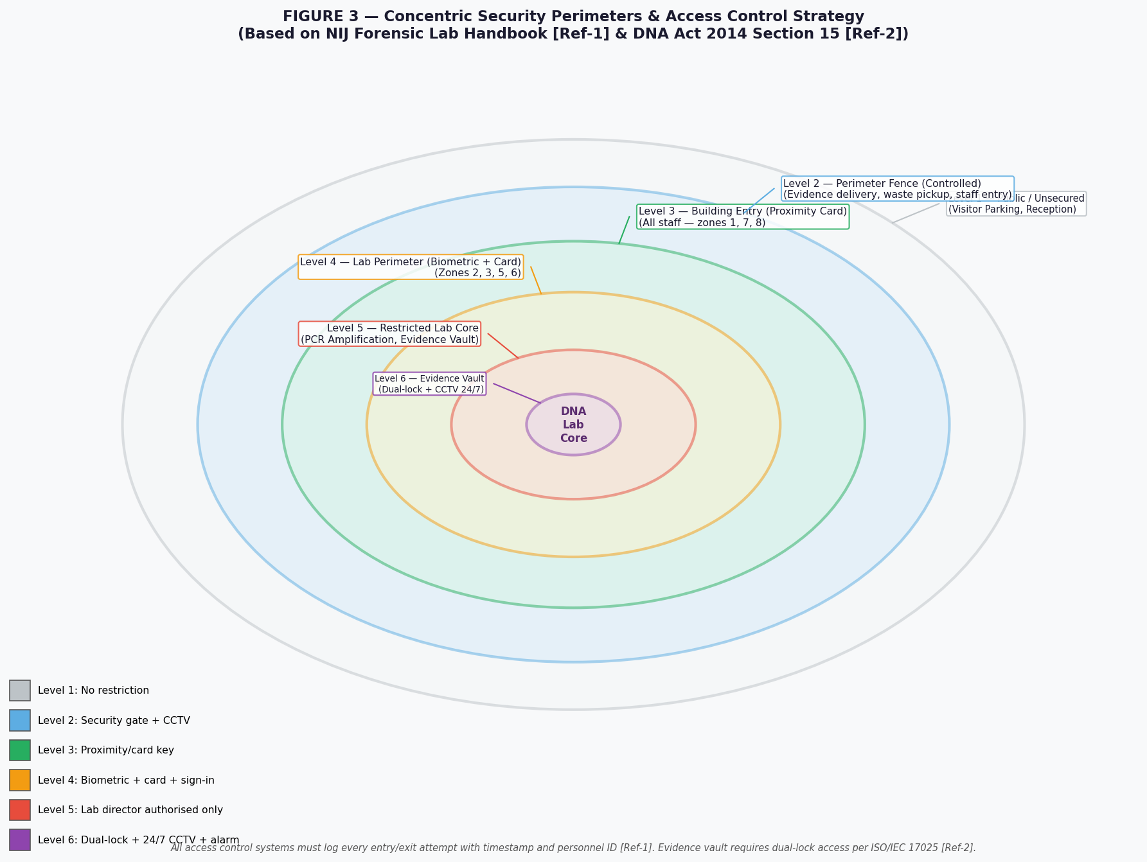
Figure 3: Concentric Security Perimeter Strategy for a Forensic DNA Laboratory[Ref-1: NIJ Handbook; Ref-2: DNA Act 2014 Sections 25–26]

Sections 25 and 26 of the DNA Act, 2014 require that the National DNA Database and all DNA evidence be secured and access restricted to authorised persons only. [Ref-2] The physical security infrastructure must include:
- Electronic proximity/card-key access control for all lab zone transitions, with programming capability for area-specific and time-specific access [Ref-1]
- Complete audit log of all access attempts (authorised and refused), retained for the case retention period [Ref-2]
- CCTV at all exterior doors, lobby/reception, evidence delivery areas, and evidence storage — with pan/zoom/tilt capability and 24/7 recording [Ref-1]
- Motion detection in evidence storage spaces and circulation corridors [Ref-1]
- Duress/panic alarms concealed at evidence intake counter, chemical storage spaces, and other key areas [Ref-1]
- Tour groups and visitors must NEVER be admitted into any laboratory space; viewing must be via strategically placed corridor windows [Ref-1]

5. Design and Maintenance Standards

5.1 International Accreditation Standard
The international benchmark for all forensic DNA laboratories is accreditation under ISO/IEC 17025:2017 (“General Requirements for the Competence of Testing and Calibration Laboratories”). This standard governs equipment calibration, method validation, staff competence, metrological traceability, and management systems. Section 15(2)(b) of the DNA Act, 2014 mandates the highest quality of DNA analysis, which requires ISO/IEC 17025 compliance as the minimum standard. [Ref-2, Ref-5]
Additionally, the FBI Quality Assurance Standards for Forensic DNA Testing Laboratories (FBI QAS) represent the most comprehensive operational and facility standard globally and should be adopted as a reference for both construction design requirements and ongoing laboratory operations. [Ref-1]

5.2 Chain of Custody — Physical Infrastructure Requirements
Section 13 of the DNA Act, 2014 requires DNA samples to be preserved by the laboratory in the prescribed manner. [Ref-2] A physically supportive chain-of-custody infrastructure must include:
- A barcode/RFID labelling system for every sample and exhibit, supported by LIMS terminals at each processing stage
- Tamper-evident packaging storage within a dedicated locked room
- A physical evidence log and transfer register at each zone transition point
- Dual signatures required for all evidence transfers in and out of the storage vault [Ref-2]

5.3 Construction Standards and Codes
Subject | Standard/Code | Applicability
Building Structure & Occupancy Classification | BNBC 2020 — Part 3 (Special Occupancy) | Structural, fire resistance, occupancy classification [Ref-4]
Mechanical (HVAC) | BNBC 2020 — Part 8, Chapter 2 | All ventilation, air conditioning, air quality systems [Ref-4]
Electrical Services | BNBC 2020 — Part 8, Chapter 3; Bangladesh Electricity Rules | All wiring, panels, emergency generation, UPS [Ref-4]
Plumbing & Drainage | BNBC 2020 — Part 8, Chapter 4 | Water supply, waste, chemical drainage [Ref-4]
Fire Safety | BNBC 2020 — Part 4; Bangladesh Fire Code | Suppression, detection, evacuation routes [Ref-4]
Laboratory Contamination Control | NIJ Handbook [Ref-1]; FBI QAS | PCR separation, HEPA exhaust, pressure differential
Evidence Integrity & Security | DNA Act 2014 S.15, 25, 26 [Ref-2] | Physical security, access control, storage conditions
Lab Quality Management | ISO/IEC 17025:2017; NFDPL Guidelines [Ref-5] | Overall QA/QC framework, audit, accreditation

5.4 Maintenance Programme
Section 15(2)(c) of the DNA Act, 2014 requires that physical infrastructure be maintained at a standard that ensures the highest quality of DNA analysis. [Ref-2] The following maintenance schedule is mandated by international standards: [Ref-1, Ref-5]
Frequency | Maintenance Activity | Reference
Daily | Temperature and humidity check for all storage units; alarm system test; CCTV check | DNA Act S.15 [Ref-2]; NFDPL [Ref-5]
Weekly | Clean and decontaminate all laboratory bench surfaces (bleach then ethanol or UV); inspect PPE stock; test emergency lighting | NIJ Handbook [Ref-1]
Monthly | LIMS backup; calibrate critical instruments; inspect HEPA pre-filters; test UPS/generator switchover; review access logs for anomalies | FBI QAS; NIJ [Ref-1]
Quarterly | HEPA filter inspection and replacement if required; full HVAC service; pressure differential verification between zones; fire alarm and suppression test | BNBC 2020 [Ref-4]; NIJ [Ref-1]
6-Monthly | External proficiency testing of laboratory (inter-lab comparison); full security audit; reagent review | DNA Act S.15 [Ref-2]; ISO 17025
Annually | Full ISO/IEC 17025 internal audit; Annual QAS audit per FBI standards; Comprehensive facility inspection against NFDPL standards; Structural inspection report | DNA Act S.15 [Ref-2]; NIJ [Ref-1]; NFDPL [Ref-5]

5.5 Waste Management
Biohazardous waste must be managed per BNBC 2020 and international biosafety standards: [Ref-4]
- All biohazardous solid waste must be autoclaved on-site before disposal — a dedicated autoclave room in Zone 8 is mandatory [Ref-1]
- Biohazardous liquid waste must pass through a chemical neutralisation/treatment system before entering the main sewer [Ref-1]
- Chemical waste: segregated storage with fire-rated, ventilated flammable storage cabinets and blowout panels [Ref-1, Ref-4]
- Sharps and biological material: dedicated labelled containers within each laboratory section, collected and autoclaved per protocol

6. Checklists for Planners, Designers and Facility Managers
These checklists are derived from the NIJ Forensic Laboratories Handbook [Ref-1], the DNA Act 2014 [Ref-2], BNBC 2020 [Ref-4], and NFDPL Guidelines [Ref-5]. They are intended as practical tools for each stage of the project lifecycle. Column “Ref” provides the applicable reference number. The checkbox (☐) should be ticked upon completion and verified by a signature.

6.1 — Checklist A: For Planners (Needs Assessment & Design Programming Stage)
Use this checklist during the Needs Assessment and Design Program preparation, before an architect is engaged. [Ref-1]

Checklist Item | Ref | Notes | ☐
▶ MISSION & LEGAL BASIS
Confirm legal authority: DNA Act 2014 Section 14 authorises establishment; Section 15 mandates infrastructure standards | [Ref-2] |  | ☐
Identify all applicable laws: DNA Act 2014, DNA Rules (Bidhimala), BNBC 2020 Parts 3 & 8 | [Ref-2,3,4] |  | ☐
Obtain mandate/gazette notification for establishment of this laboratory from Government | [Ref-2] |  | ☐
Consult NFDPL (National Forensic DNA Profiling Laboratory) for guidelines and technical advice | [Ref-5] |  | ☐
▶ NEEDS ASSESSMENT
Prepare a formal Needs Assessment/Design Program document per NIJ Handbook process | [Ref-1] |  | ☐
Define current and projected annual caseload (rape, parentage, accident, etc.) | [Ref-1] |  | ☐
Define staffing levels (Director, DNA Analysts, Technicians, Custodians) — space calculated at 65–93 m² per staff member | [Ref-1] |  | ☐
Identify all laboratory sections required: Biology/DNA, Evidence Storage, QA, Training | [Ref-1] |  | ☐
Confirm whether PCR and mitochondrial DNA analysis are both required (different room requirements) | [Ref-1] |  | ☐
▶ SITE SELECTION
Site accessible from at least two directions for emergency vehicle access | [Ref-1] |  | ☐
Site away from industrial emissions and adverse outdoor air quality sources | [Ref-1] |  | ☐
Landscape plan avoids dense shrubbery within 3 m of building perimeter | [Ref-1] |  | ☐
Secure fenced area designated for evidence delivery, waste pickup and staff entry | [Ref-1] |  | ☐
HVAC intake located in secured fenced area, away from public and upwind from fume hood exhaust | [Ref-1] |  | ☐
Four levels of parking security planned (visitor, controlled, staff, high-security impound) | [Ref-1] |  | ☐
▶ BUDGET & PROCUREMENT
Confirm whether project is needs-driven or budget-driven (NIJ Handbook warns: cost-cutting that jeopardises testing quality cannot be an option) | [Ref-1] |  | ☐
Prepare Request for Proposals (RFP) for Architectural/Engineering Needs Assessment | [Ref-1] |  | ☐
Include forensic laboratory experience as a mandatory prequalification criterion for contractors | [Ref-1] |  | ☐
Budget separately for: HVAC, security systems, LIMS, UPS/generator, casework, cold storage | [Ref-1] |  | ☐

6.2 — Checklist B: For Architects and Engineers (Design and Construction Stage)
Use this checklist during schematic design, design development, and construction documentation phases. [Ref-1, Ref-4]

Checklist Item | Ref | Notes | ☐
▶ SPATIAL LAYOUT & ZONES
All 8 zones present and arranged for unidirectional evidence flow (Zone 2 → 3 → 4 → 5/6) | [Ref-1] |  | ☐
Evidence examination rooms: minimum 2 rooms, each min. 13.9 m², for victim/suspect separation | [Ref-1] |  | ☐
PCR Amplification room: floor-to-ceiling enclosure, self-closing doors, negative pressure | [Ref-1] |  | ☐
Biovestibule/airlock between Pre-PCR (Zone 3) and Post-PCR (Zone 4), min. 5.95 m² | [Ref-1] |  | ☐
Reagent preparation room: physically cleanest area, no samples ever enter | [Ref-1] |  | ☐
Reagent prep room: min. 18.6 m², negative pressure ventilation, autoclave, fume hood | [Ref-1] |  | ☐
All DNA lab sections designed as biologically hazardous space (BSL-2) with biovestibule entry | [Ref-1] |  | ☐
Corridors: primary min. 1.83 m wide; secondary min. 1.37 m wide | [Ref-1] |  | ☐
Double doors (0.914 m + 0.457 m leaves) at all sections receiving oversized evidence/equipment | [Ref-1] |  | ☐
▶ BUILDING FABRIC
Exterior walls: bullet-resistant (concrete or fully grouted masonry) | [Ref-1, Ref-4] |  | ☐
Lab floor finishes: seamless chemical-resistant vinyl/epoxy with coved skirting — no joints | [Ref-1] |  | ☐
Lab wall finishes: epoxy paint in all BSL-2 and chemically hazardous spaces | [Ref-1] |  | ☐
Bench tops: epoxy resin at fume/bio hoods; stainless steel where biological evidence contacts | [Ref-1] |  | ☐
Clean hands-free sinks at entrance/exit of every lab section with lab coat hangers and PPE storage | [Ref-1] |  | ☐
▶ HVAC
Separate, dedicated HVAC for PCR amplification room(s) and mitochondrial DNA room(s) | [Ref-1, Ref-4] |  | ☐
HEPA-filtered exhaust on all biologically hazardous spaces (PCR rooms, extraction areas) | [Ref-1, Ref-4] |  | ☐
Pressure differential confirmed: PCR ampli. room = negative; pre-PCR rooms = positive | [Ref-1, Ref-4] |  | ☐
Evidence drying room: 12–15 air changes/hour, direct exhaust to exterior | [Ref-1] |  | ☐
Supplemental cooling provided for instrument rooms (genetic analyzers generate significant heat) | [Ref-1, Ref-4] |  | ☐
All HVAC controls and VAV boxes located outside of laboratory and evidence storage spaces | [Ref-1] |  | ☐
▶ PLUMBING
Emergency safety shower and eyewash in all laboratory spaces and areas of refuge | [Ref-1, Ref-4] |  | ☐
Acid/alkali (caustic) waste neutralisation system before discharge to main sewer | [Ref-1, Ref-4] |  | ☐
Type 1 deionised water point-of-use polisher at laboratory benches | [Ref-1] |  | ☐
Laboratory gas distribution: manifolded systems for N₂, H₂, He, argon, compressed air, vacuum | [Ref-1] |  | ☐
Floor drains in evidence examination rooms and extraction areas | [Ref-1] |  | ☐
▶ ELECTRICAL
Emergency generator: covers all evidence storage/refrigeration, security systems, CCTV, LIMS | [Ref-1, Ref-4] |  | ☐
UPS: covers all computer-driven instruments, CODIS/LIMS, sequencers, alarms | [Ref-1] |  | ☐
Dry fire-suppression systems in all instrument rooms, computer rooms, server rooms | [Ref-1] |  | ☐
Dedicated stable electrical circuits for each high-draw instrument (with voltage conditioning) | [Ref-1] |  | ☐
Bench power: duplex outlets at 0.91 m centres on all laboratory benches | [Ref-1] |  | ☐
▶ SECURITY
Formal Security Strategy Meeting held and documented prior to design development | [Ref-1] |  | ☐
Electronic proximity/card-key access at all zone transitions with full audit logging | [Ref-1, Ref-2] |  | ☐
CCTV at all exterior doors, lobby, evidence delivery, and evidence storage areas | [Ref-1, Ref-2] |  | ☐
Bullet-resistant glazing at administrative/security reception desk | [Ref-1] |  | ☐
Motion detection in evidence storage and circulation corridors | [Ref-1] |  | ☐
Duress/panic alarms concealed at intake counter, chemical storage, and key staff areas | [Ref-1] |  | ☐
Laboratory tours: only via corridor viewing windows — no public/visitor entry into lab spaces | [Ref-1] |  | ☐
▶ CONSTRUCTION CONTRACTS
Contractor prequalification includes forensic laboratory construction experience | [Ref-1] |  | ☐
Laboratory Technical Coordinating Officer (LTCO) appointed before construction begins | [Ref-1] |  | ☐
Mock-up panels/modules constructed for critical systems before bulk fabrication | [Ref-1] |  | ☐
Coordination drawings reviewed at pre-construction conference: HVAC, plumbing, electrical, casework | [Ref-1] |  | ☐
Systems commissioning: HVAC, UPS, generator, access control, CCTV all tested before occupancy | [Ref-1] |  | ☐

6.3 — Checklist C: For Facility Managers (Operation and Maintenance Stage)
Use this checklist for ongoing facility management after the laboratory is occupied. Section 15(2)(c) of the DNA Act, 2014 makes physical infrastructure maintenance a legal obligation. [Ref-2]

Checklist Item | Ref | Notes | ☐
▶ DAILY
Check and record temperature of all refrigerators, freezers and ultra-low temperature units | [Ref-2, Ref-5] |  | ☐
Verify CCTV systems are recording and all cameras are functional | [Ref-1] |  | ☐
Check alarm systems (intrusion, temperature deviation, fire) are active and tested | [Ref-1, Ref-4] |  | ☐
Confirm HVAC is operating and air supply/exhaust is functional in all laboratory zones | [Ref-1, Ref-4] |  | ☐
▶ WEEKLY
Decontaminate all bench surfaces (bleach solution then ethanol OR ethanol then UV irradiation) | [Ref-1] |  | ☐
Inspect and restock PPE (gloves, lab coats, shoe covers, eye protection) at each zone entry point | [Ref-1] |  | ☐
Test emergency lighting and safety shower/eyewash in each laboratory section | [Ref-1, Ref-4] |  | ☐
Inspect evidence drying room exhaust to confirm direct external exhaust is unobstructed | [Ref-1] |  | ☐
▶ MONTHLY
LIMS data backup and system integrity check | [Ref-2] |  | ☐
Review access control logs for anomalous entries or attempted breaches | [Ref-1, Ref-2] |  | ☐
Calibration check of critical instruments (genetic analyzers, centrifuges, thermocyclers) | [Ref-1, Ref-5] |  | ☐
Inspect HEPA pre-filters; replace if discoloured or pressure differential indicates blockage | [Ref-1, Ref-4] |  | ☐
Test UPS and generator automatic switchover under load | [Ref-1, Ref-4] |  | ☐
Inspect biohazardous waste autoclave: run biological indicator test (spore test) | [Ref-1] |  | ☐
▶ QUARTERLY
Full HEPA main filter inspection and replacement as required by manufacturer specification | [Ref-1, Ref-4] |  | ☐
Verify pressure differential between Zone 3 (pre-PCR) and Zone 4 (amplification room) by measurement | [Ref-1] |  | ☐
Comprehensive HVAC service: belts, coils, condensate trays, filter housings, ductwork inspection | [Ref-1, Ref-4] |  | ☐
Fire suppression and detection system test (dry fire suppression in instrument rooms) | [Ref-1, Ref-4] |  | ☐
Cold storage temperature chart review; calibrate temperature probes | [Ref-1] |  | ☐
Chemical waste disposal: arrange licensed disposal of accumulated hazardous chemical waste | [Ref-4] |  | ☐
▶ 6-MONTHLY
External proficiency testing: submit to inter-laboratory comparison programme | [Ref-2, Ref-5] |  | ☐
Full security system audit: access logs, CCTV retention, key card inventory, alarm response test | [Ref-1, Ref-2] |  | ☐
Review laboratory reagent quality and expiry; dispose of expired materials per protocol | [Ref-5] |  | ☐
Decontamination sweep of all laboratory zones: UV irradiation and deep clean | [Ref-1] |  | ☐
▶ ANNUALLY
Full ISO/IEC 17025 internal audit against accreditation requirements | [Ref-2, Ref-5] |  | ☐
Annual QAS Audit per FBI Quality Assurance Standards for Forensic DNA Testing Laboratories | [Ref-1] |  | ☐
Comprehensive facility inspection against NFDPL standards and DNA Rules (Bidhimala) | [Ref-3, Ref-5] |  | ☐
Structural inspection by licensed engineer: BNBC 2020 compliance review | [Ref-4] |  | ☐
Full inventory and reconciliation of all evidence in storage against LIMS records | [Ref-2] |  | ☐
Review and update Security Strategy and Laboratory Operations Manual | [Ref-1, Ref-2] |  | ☐
Train all new staff on building systems, emergency procedures, and chain-of-custody protocols | [Ref-1, Ref-2] |  | ☐

7. References

[Ref-1] National Institute of Justice (NIJ) & National Institute of Standards and Technology (NIST). Forensic Laboratories: Handbook for Facility Planning, Design, Construction, and Moving. NCJ 168106. U.S. Department of Justice, Office of Justice Programs. April 1998. Developed jointly with the American Society of Crime Laboratory Directors (ASCLD). Available at: https://www.ojp.gov/pdffiles/168106.pdf

[Ref-2] Government of the People’s Republic of Bangladesh. The Deoxyribonucleic Acid (DNA) Act, 2014 (Act No. X of 2014). Published as the Authentic English Text by the Ministry of Women and Children Affairs via S.R.O. No. 22-Law/2017, Bangladesh Gazette (Extraordinary), 26 January 2017. See especially: Section 14 (Establishment of DNA Laboratory), Section 15 (Quality Assurance), Sections 25–26 (Security of National DNA Database), and Section 30 (Penalty for contamination or destruction of DNA sample).

[Ref-3] Government of the People’s Republic of Bangladesh. The Deoxyribonucleic Acid Rules (Bidhimala) [Rules enacted under Section 39 of DNA Act 2014]. The Rules will prescribe detailed operational, staffing, infrastructure, sample handling, and retention requirements. Until formally enacted, the DNA Act, 2014 and NFDPL guidelines apply as the operative standards. This document should be revised to incorporate the Bidhimala requirements upon enactment.

[Ref-4] Housing and Building Research Institute (HBRI) & Bangladesh National Building Code (BNBC) Authority. Bangladesh National Building Code (BNBC) 2020. Ministry of Housing and Public Works, Government of the People’s Republic of Bangladesh. 2020. Specifically: Part 3 – Occupancy Classification and General Building Requirements (governing special occupancy buildings including laboratories); Part 8 – Building Services (governing HVAC, plumbing, electrical services, and fire protection in laboratory buildings). Compliance with BNBC 2020 is mandatory for all new construction in Bangladesh.

[Ref-5] National Forensic DNA Profiling Laboratory (NFDPL), Dhaka, Bangladesh. Operational Guidelines and Technical Standards for DNA Testing Laboratories in Bangladesh. NFDPL, Ministry of Women and Children Affairs. [Consult NFDPL directly for latest version]. Note: Section 14(3) of the DNA Act, 2014 deems the NFDPL as established under the Act, making it the apex reference laboratory. Its guidelines represent the national standard and must be consulted alongside international standards.

Additional Supporting References (for further study):
- FBI Quality Assurance Standards for Forensic DNA Testing Laboratories. FBI Director / SWGDAM. Effective July 1, 2025 edition. Available at: https://www.fbi.gov/services/laboratory/biometric-analysis/codis
- Scientific Working Group on DNA Analysis Methods (SWGDAM). Guidance Documents. Available at: https://www.swgdam.org/publications
- ISO/IEC 17025:2017 – General Requirements for the Competence of Testing and Calibration Laboratories. International Organisation for Standardisation. Geneva, Switzerland.
- ASCLD/LAB Accreditation Manual. American Society of Crime Laboratory Directors / Laboratory Accreditation Board.
- International Forensic Strategic Alliance (IFSA). Minimum Requirements for DNA Collection, Analysis and Interpretation – A document for Emerging Laboratories. Version 2, 2021. Available at: https://www.ifsa-forensics.org
- UK Forensic Science Regulator. DNA Contamination Controls: Laboratory (FSR-GUI-0018). UK Home Office. October 2023.

