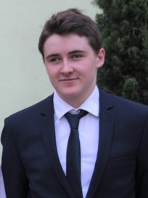
CV Oliver Hliddal
Gemeindestrasse 17
8032 Zürich
Switzerland
+41 76 515 37 43
oliver.hliddal@gmx.ch

Born in Zürich August 15th 1998
1999 - 2003
Daycare ABC Zürich
August 2003 - July 2005
Kindergarten Hohenbühl Zürich
August 2005 - July 2011
Primary School Ilgen A/B Zürich
August 2011 - November 2011
Canton School¹ Hohe Promenade Zürich
December 2011 - July 2012
Secondary School Münchhalde Zürich
August 2012 - July 2013
Free catholic secondary school (FKSZ) Kreuzbühl Zürich
August 2013 - July 2017
Mathematics and science Canton School Rämibühl Zürich
Graduation 2017
End of September 2017 - Middle of August 2018
Mandatory community service at Daycare
GFZ Kita 8, Zollikerstrasse 78, 8008 Zürich
Middle of September 2018 - expectedly Juni 2022
Bachelor in Psychology at University of Zürich
October 2019 - February 2020
Research internship at the institute of Psychology University of Zürich, Developmental psychology: Infancy and Childhood, Topic: “Early social cognition”
Since October 2018
Co-Organization of Events with up to 350 participants, over the duration of multiple days as (board-) member of the Gaming & Entertainment Committee (GECo) of the VSETH (Association of students at the ETH). Events include Boardgame & Roleplay Days, Social Gaming Events, Public Viewings of CSGO Majors and League of Legends World Championship Final and PolyLANs (LAN-Partys with up to 350 events)

¹ Canton School is swiss Highschool, although only around 20% of children manage to get into a Canton School.

