Zusammenfassung Human-Computer Interaction

Inhalt

Human-centered design & interviewing 2

Human-Centered Design 3

Interviewing 3

Contextual inquiry 3

Who to interview? 4

Problematic interview questions 4

Steps of an interview 5

Using video in an interview 5

Analyzing qualitative data 6

Transcription 6

Interpretation 6

Coding 6

Interpretation session 6

Summarizing 6

Ideation and prototyping 7

Testing 7

Design principles 7

Model human processing 7

Time 7

Errors 7

Visual perception 7

Interaction styles 7

Input devices and interaction techniques 7

Survey and experimental research 7

# Human-centered design & interviewing

**HCI…**

* **Saves lives**

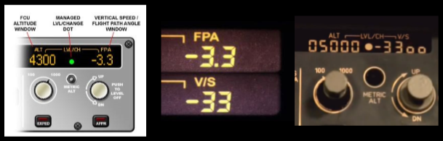

* **Saves time**

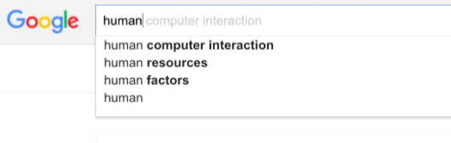

1 second improved per search * 3.5 Billion Searches per day = 110.915 man-years per day.

* **Sells**

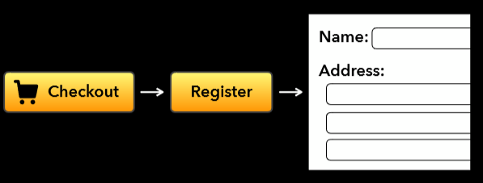

## Human-Centered Design

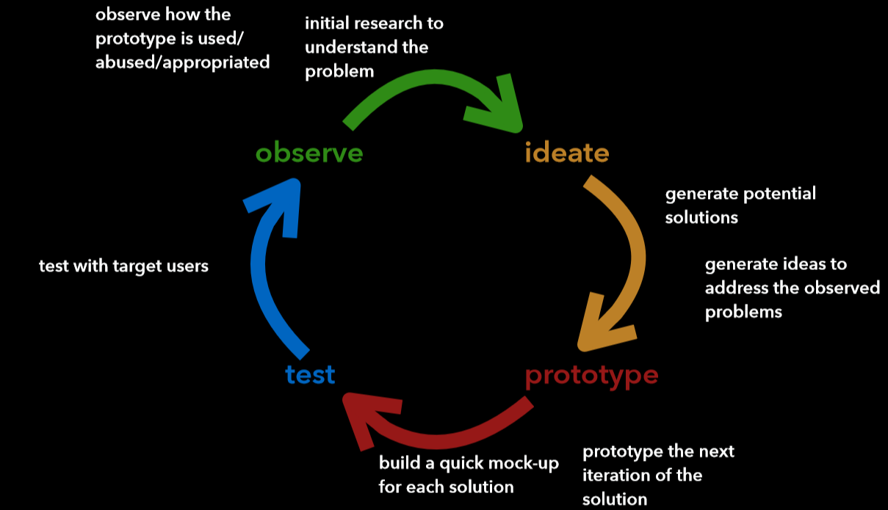

**Steps of Human-Centered Design**

1. Observe potential user groups to find a problem
2. Generate potential solutions to the problem
3. Prototype different solutions and build different mockups
4. Test the solutions with target users
5. Observe the use of the prototype by the test users and adjust it

**The HCD process ensures that…**

* People’s needs are met
* The resulting product is understandable and usable
* It accomplishes the desired task
* The experience of use is positive and enjoyable

## Interviewing

Interview can be used to discover real problems or to dig deeper into any issues that arise based on the responses from a previous round of interviews.

### Contextual inquiry

Interviews in HCD should be done with contextual inquiry. That means one should go to the user, watch them do the activities one cares about, and talk with them about what they’re doing right then.

The questions should be about what is happening right then and what the interviewer can see. The focus should be on what really happened. Contextual inquiry is grounded on real-life and not on the interviewer’s preconceived ideas.

**Principles of contextual inquiry**

1. **Context**

Gather concrete data about the ongoing experience.

1. **Partnership**

The Interviewer creates a partnership with the users to understand their work. While the user is engrossed in the activity, the interviewer watches the details, patterns and reasons of the user’s activity. This is important because the user might not notice the patterns while they are focusing on the activity. When the interviewer spots a pattern, they interrupt the user to talk about it.

1. **Interpretation**

A good product is built on the designer’s interpretation of the observed facts.

1. **Focus**

If one works in a team, the team’s shared focus and those of the individuals of the group must be defined.

### Who to interview?

1. **Users**: different types of users (current/potential users, novice/expert users)
2. **Stakeholders**: People who don’t use the system but are affected by it
3. **Key informants**: People who know how to do the necessary things. The key informants are repeatedly consulted and provide important insights.

### Problematic interview questions

* **Close-ended questions**: Yes-/No-questions. *i.e. “Do you like Google Search?”*
* **Leading questions**: A question that suggests the answer the interviewer expects or wants to get. *i.e. “Do you like our new design of Google Search?”*
* **Complex questions**: Multiple aspects that must be thought about and could be too complex for the interviewee. *i.e. “What are the strengths and weaknesses of Google Search vs. Bing Search?”*
* **Double barreled questions**: Two questions in one sentence. *i.e. “Should Google Search provide more results and more detailed results?”*
* **Negative questions**: *i.e. “Don’t you like Google search?”*
* **Asking the users to design**: *i.e. “What is a feature that you would like to have from Google Search?”*

### Steps of an interview

1. **Prepare**: Prepare the interview guideline, make sure the recording equipment works, test the interview guideline
2. **Build rapport**
3. **Introduction**: tell the high-level research goals to the interviewee, obtain recording permissions
4. **Have a conversation**
5. **Debrief**: Summarize what you learned, tell the detailed research goals, say thank you
6. **Brain dump**: type down everything one remembered

### Using video in an interview

* Explain how the video is used
* Ask for permission
* Shoot the title page
* Show example of recording
* Record the usage, not the user
* Offer to show the video + cuts

# Analyzing qualitative data

The process of analyzing the data consists of three steps: Transcription, Interpretation & Summarization.

## Transcription

**Purpose**: Providing a representation of data that is easy to navigate and analyze, exposing yourself with the responses with more distance

**Types of transcription**

* Full transcription: transcribe everything that is done and said during the interview
* Partial transcription: take field notes on when interesting parts took place and only transcribe these. Note that there is already a certain amount of judging taking place during the interview when deciding on what is important, which will influence the partial transcription.

**Data sources**: Audio, video, screen recording, …

**Transcription software**

There are a lot of software/ methods that can help when transcribing.

* A **foot pedal** with which the audio or video recording can be controlled. This saves a lot of time as you don’t have to switch key-bindings on the keyboard to switch between the media-player and the software used to transcribe.
* **Adding timestamps**: makes it easier to find additional context when looking at the transcript and wanting to find said passage in the recording
* **Playback speed control (0.5x-2x)**: Can be used if the interviewee talks too slow/fast to type down.
* **Support audio and video formats**: a good transcription software should be able to play different types of audio and video formats, so that the user is not limited in what he can use.

## Interpretation

The interpretation consists of coding and an interpretation session.

### Coding

**Purpose**: To reduce the complexity of free-form of the dataset into a finite set of codes for further analysis.

**Coding procedure**

1. Read through the transcript in one first pass (note down the first impression of the data)
2. For each chunk of the transcript
   1. Read it
   2. Assign one or multiple codes that represent that chunk
3. Iteratively refine the set of code and how they are assigned
   1. At the beginning you may need to go back and change the assigned codes in previous chunks
   2. After coding 20-30% of data, the code set usually stabilizes
   3. Discuss with other coders to refine the understanding of codes
   4. Take notes of ideas and questions that emerges

### Interpretation session

## Summarizing

# Ideation and prototyping

# Testing

# Design principles

# Model human processing

# Time

# Errors

# Visual perception

# Interaction styles

# Input devices and interaction techniques

# Survey and experimental research