Notes on Ray Tracer by Oliver Ford
Author: V. Perseo, version: June 2024
Full 3D geometric optics ray tracer:
- Polariastion aware (coherent/incoherent);
- Recursive mulitpath or fast sequential tracing;
- No GUI, but does output SVG, VRML (FreeCAD), WRL (CATIA) ﬁles of optics and rays;
- Written in Java with a simple architecture, all the work done is in modular components so very ﬂexible.
file: LightAssessnentW7X
Script to be run to perform ray tracing. The rays go from the object to the image plane, so it is used to assess the ability of a system to collect light. It calls the optics defined in a separate file (e.g. MantisAEE40Preliminary).
The optics are called as sys. The program also needs beams, i.e. a target that needs to be viewed. The beams are defined in a separate file (in this example HeliumBeamAEI31.java).
Different scripts are available:
- Fiber back trace normal tracing, so from the image plane towards the object (it needs a beam ‘plane’ to observe)
- Background targeting “back-tracing”, outcome: spots on walls covered by light cone (particularly useful for systems with fibers, less so with cameras)
To change the precision of the tracing:
- nAttempts: attempts of tracing for each target point (if bigger number, then better statistics). In the output, the codes returns also the number of attempts that make it to the image plane (the rays start from the targets points in a solid angle), i.e. more or less the amount of light that will get to the image plane. This number, together with SR (=radiance, representing the system transmission), can be used to assess the quality of the optical system.
- nRaysToDraw: influence how the output is visualised but not the calculation.
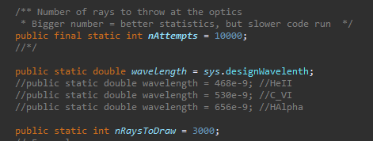
The rays are started from the beam in a discrete amount of points, defined as pointR. In this case, the function linSpace is used to generate an array of starting points (linSpace is defined as in python, so it returns evenly spaced numbers over a specified interval). Increasing number of rays will increase the computational time but give more information in terms of spatial resolution. A small number of rays can be useful as well to check for vignetting effects (e.g. linSpace(5.00, 5.64, 3)to check what happens to a point at the beginning of the beam, one in the center, one at the end).
The rays to be drawn are selected by:
In this example, only the rays that arrive at the image plane (called fibrePlane) will be drawn in the output. It can be useful to change the surface considered here to check for vignetting effects, i.e. checking for rays to diverge substantially from the optical path. For example, in a system looking inside the vessel through a mirror:
file: sys
Definition of all the optics in the system, the target location, the image plane, and the location of the output file input file that will be changed the most to run the script LightAssessnentW7X.
getDesignName: setting the output name. It is good practice to change it for each new design.
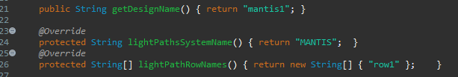
Definition of parameters describing the light collecting system.
- designWavelength: wavelength for which the ray tracing is performed.
- collectionF/collectionNA: F-number/Numerical Aperture of collecting object (i.e. of fibre, camera, image plane at the entrance of a cavity).
- pixelDiameter: diameter of collecting object (i.e. of fibre, camera pixel, or equivalent pixel on image plane at the entrance of a cavity)
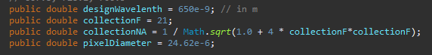
Definition of the coordinates to be used, described by vectors. The definition includes general coordinate system requirements (“up” direction) and reference points. In this example, the image place is a cylinder connecting two ports. The ray tracer needs a “target point” (=targetObsPos), in this example defined as the center of the distance between the two ports (the first run of light assessment goes from target to image plane).
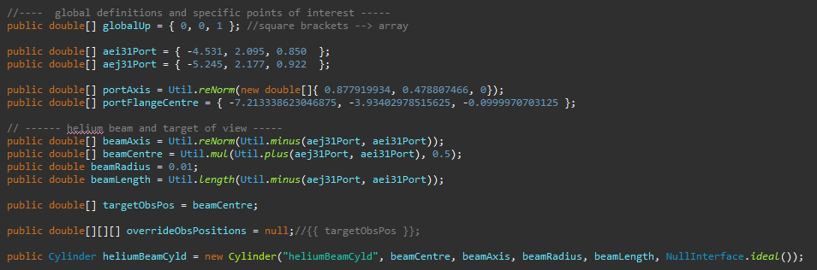
The definition of the single components need a spatial reference point (that can be a component, in this example: flange) and a normal vector.
Simple surfaces available (full list under FusionOpitcs -> src -> fusionOptics -> surfaces):
- Plane (Circular, Square, Triangular, Iris)
- Dish (spherical cap), and TruncatedDish
- Cylinder, and TruncatedCylinder
- Aspheric
- CylDish
- Disc
- Parapoloid
Lenses are constructed with simple surfaces. Available pre-made lenses (full list under FusionOpitcs -> src -> fusionOptics -> optics or FusionOpitcs -> src -> fusionOptics -> lenses for compound lenses):
- SimplePlanarConvexLens
- SimplePlanarAsphericLens
- SimpleDoubleConvexLens
- DoubleGaussLens
A material and an interface need to be specified for surfaces and lenses. Available materials (full list under FusionOpitcs -> src -> fusionOptics -> materials):
- BK7 (most common lens material)
- B270
- FusedSilica
- LAK9
- Several birefringent materials (AlphaBariumBorare, BetaBariumBorate, Calcite, YVO4, …)
Available interfaces (full list under FusionOpitcs -> src -> fusionOptics -> interfaces):
- Absorber (when rays hit the component, they stop)
- DiffractionGrating
- DualMediumInterface
- IsoIsoInterface (perfect ideal glass, non-reflective)
- IsoIsoStdFresnel (a bit more representative for realistic lenses, taking into account the effect on light polarisation)
- IsoIsoAntiReflective (even more representative for realistic lenses)
- IsoIsoPart
- IsoUniaxialInterface
- NullInterface
- Reflector (when rays hit the component, they get perfectly reflected)
- SimplePolariser
IsoIsoInterface will make the code run much faster. Despite its simplicity, it is representative for most cases, especially when the designed systems are not with many lenses (reflections are negligible, for example in the case of lenses with anti-reflection coatings, that substantially decrease the usual 5-10% reflections typical of glass) or changes in the light polarization do not matter.
Note that the surfaces/materials/interfaces need to be imported at the beginning of the file.
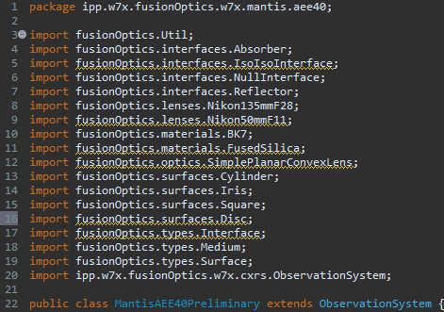
It’s easier to build a system with a spatial reference that never changes (e.g. port flanges), and add components one by one. In this example, the flange is the original reference, but the rest of the components are defined with respect to the center of a flat mirror, positioned close to the flange at 45 deg to have a toroidal view in the machine.
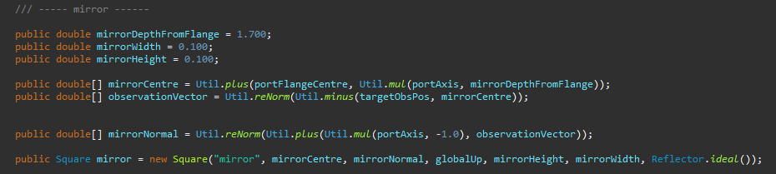
Definition of image plane, in this case defined with respect of a component center (mirror). The geometrical factors (width and height) depend on the sensor used for imaging. The image plane needs to be an Absorber.ideal() to block all the rays arriving at it.
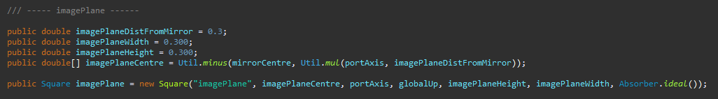
Definition of aperture (Iris surface) to mimic a window/obstructing elements to the light path.
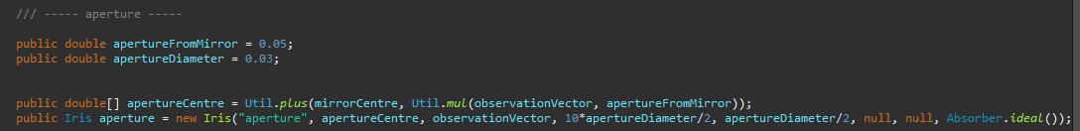
Example of simple lens generation:
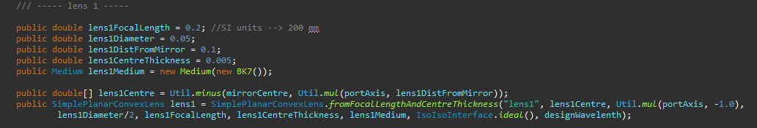
The variable names in the lens definition are self-explanatory. Note that the lens thickness can be specified at the center (.fromFocalLengthAndCenterThickness) or at the edge of the lens (.fromFocalLengthAndEdgeThickness).
The elements to be included in the system need to be listed in the following way:
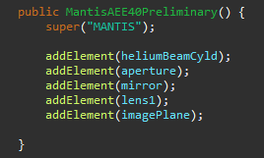
Last additional necessary entries: the rays are generated at the beam, tracingTarget is the target for the generated rays and it needs to be a big enough component that covers every ray that goes through the system (but not too big, otherwise the program becomes inefficient). In this example, the tracingTarget is the mirror. The fibrePlane is the final imaging surface. The beamIdx is based on the idea that the tracer can handle multiple beams at the same time. Note that the beams are defined in a separate file (in this example HeliumBeamAEI31.java, as mentioned before).
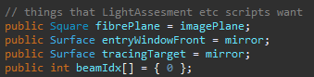
Output evaluation
Output of the code:
- .vrml file that can be opened in FreeCAD for visual inspection
- Text output on console:
  - Result divided by each point on the beam specified in pointR.
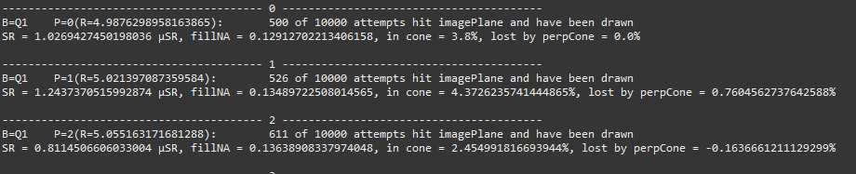
  - List of coordinates to generate freeCAD vectors (useful to give to designers to check lines of sight in CATIA). To generate the viewing cords, use create a group in FreeCAD and copy and paste the command below in the FreeCAD python console.
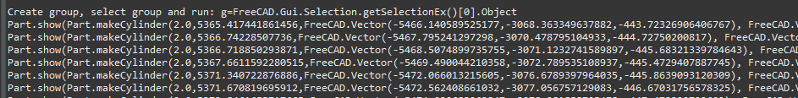
  - Recap of results for each point on the beam specified in pointR.
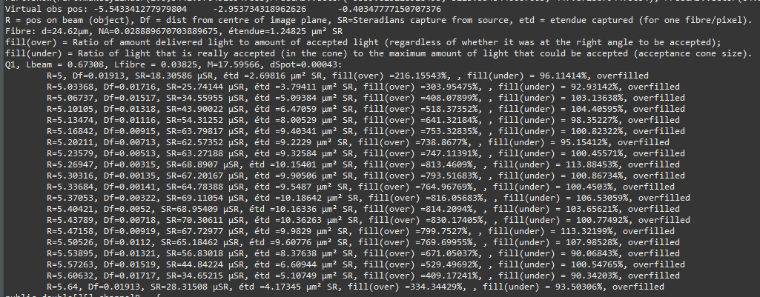
    - R = position on the beam
    - Df = distance from the centre of the image plane
    - SR = Steradian emitted by the source and captured by observation optics and delivered to the image plane
    - etd = etendue captured by one fibre/pixel
NOTE: reliable if fibre/pixel size is correct
    - fill(over) = ratio of light given by observation optics to pixels/fibres and total light that the pixel/fibre can accept in percentage. (This does not guarantee that the light would be at the right angle to be accepted!)
    - fill(under) = ratio of accepted light given by observation optics to pixels/fibres and total light that the pixel/fibre can accept in percentage. (This takes into account the angle, but if the system is overfilled, it doesn’t give a sense by how much)
    - overfilled/** UNDERFILLED ** = evaluation if collection optics are the limiting factor in light collection (** UNDERFILLED **, i.e. the etendue of the observation optics is smaller than the etendue that can be accepted by the fibre/pixel) or not (overfilled, i.e. the etendue of the observation optics is bigger than the etendue that can be accepted by the fibre/pixel)
NOTE: this is reliable only if the NA and the size of the fibre/pixel are correctly defined
  - Coordinates of the end points of the traced points on the image plane.
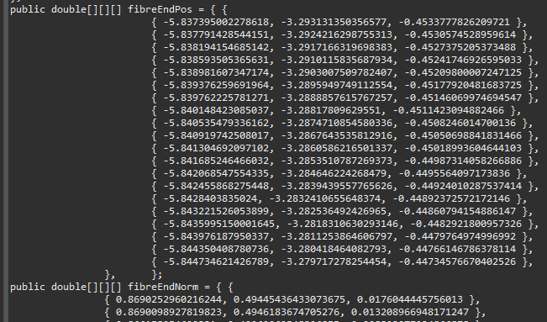
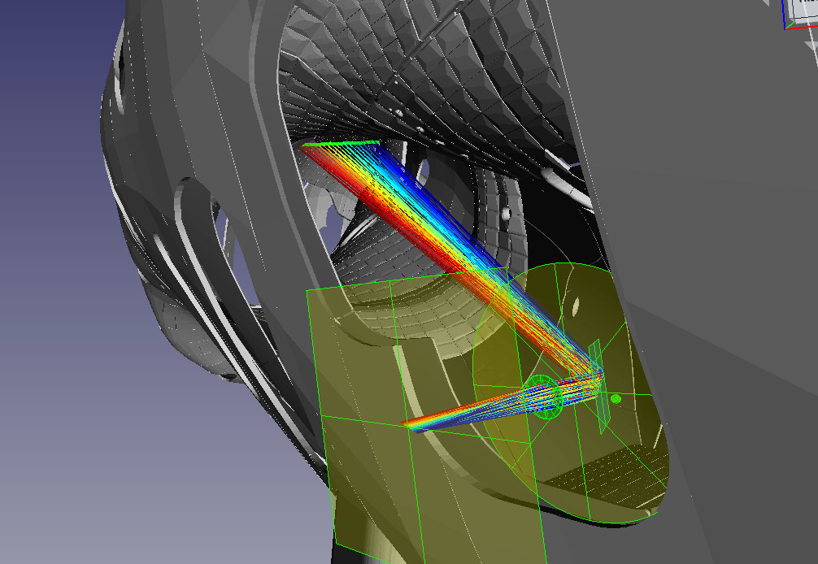
Visualization in FreeCAD: import .vrml file together with W7-X CAD model.

Useful shortcuts:
- shift+F to freeze the view
- ctrl+# frozen view to switch between them
- space to turn things on/off (if two objects are selected, one visible and one invisible, pressing space switches between the two)
Metrics to evaluate the result:
- SR in code output as high as possible, note that the value is reliable only if a number of attempts over a few hundreds hit the image plane, otherwise the calculation becomes too noisy
- Total size of the object on image plane magnification
- Single spot size on image plane (measureable in FreeCAD by zooming on rays of all the same colour) sense of spatial resolution, limited by aberrations caused by non-ideal optics
- Rays in focus or not
examples:
out of focus
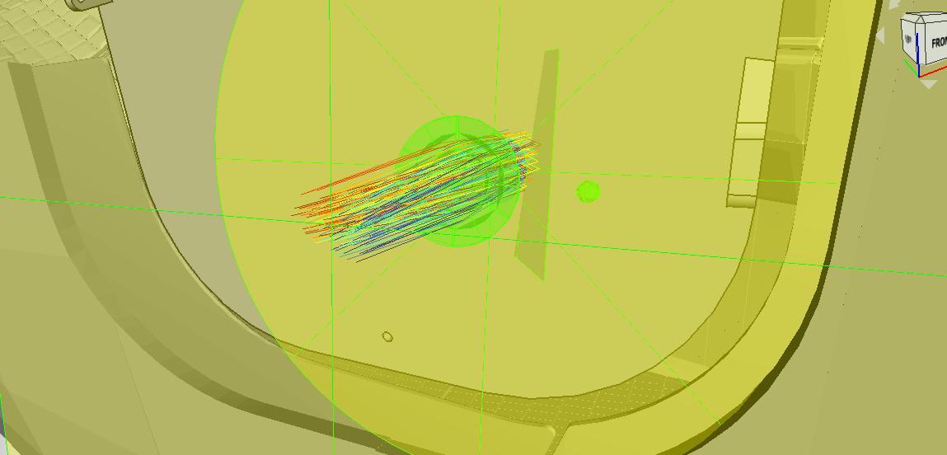
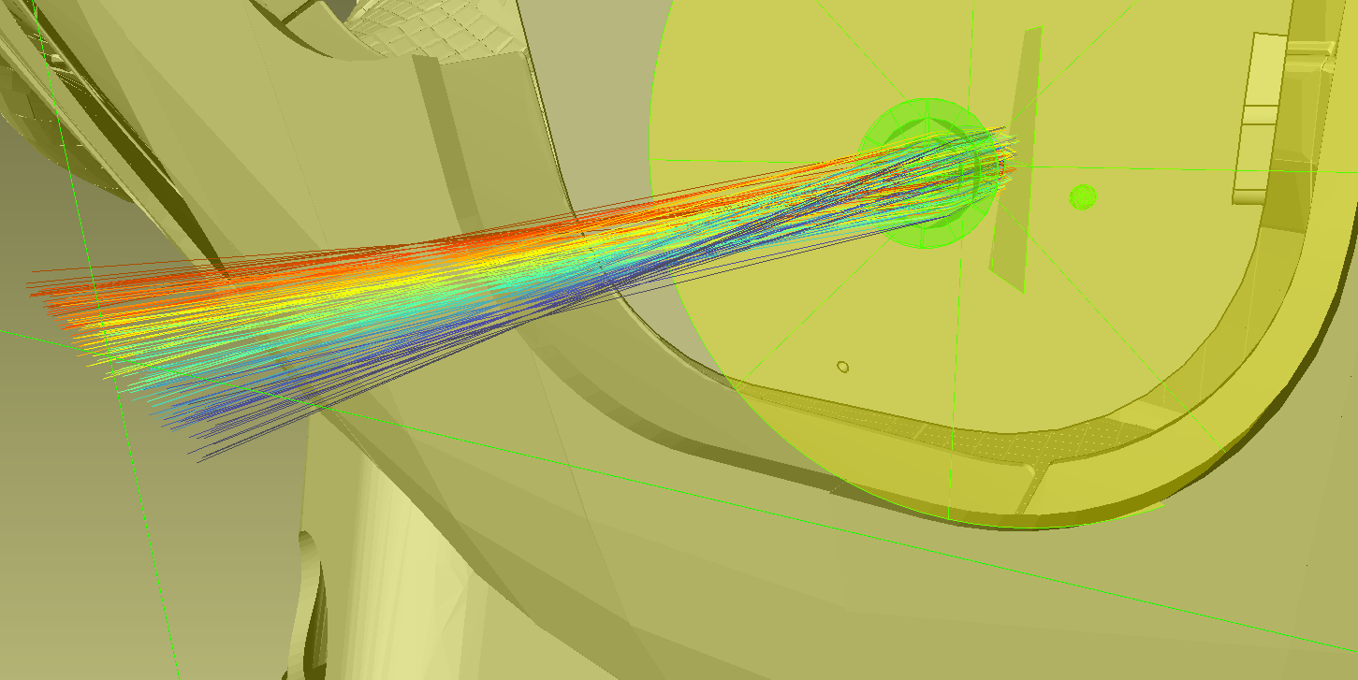
focused
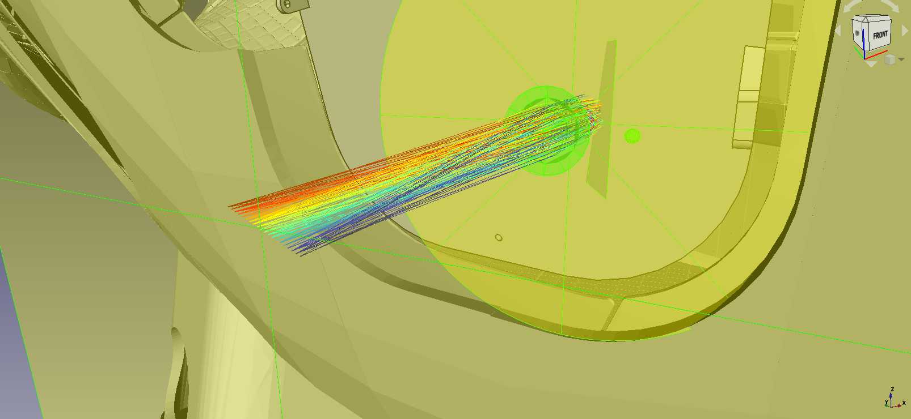
General notes
- Evaluation should be repeated at different wavelengths to check for chromatic aberration (rays could go massively out of focus at different wavelengths)
- If chromatic aberration too strong, consider achromatic doublet (still simpler than compound lenses)
- Spherical aberration gets worse with the increased curvature of the lens worse at shorter focal length and it starts to be evident (rays at the edge of the image plane cannot be focused) for simple lenses of focal length below 300 m. If the spherical aberration is too strong but the focal length cannot be changed, possible to substitute 2 lenses with longer focal length to get an equivalent (example: 2 200 mm focal length lenses in a row are equivalent to 1 100 mm focal length lens). Note that also very big lenses will have strong spherical aberration.
- In general, compound (objective) lenses will have less chromatic and spherical aberration

