REG NUMBER:22558/2023
# Student E-Commerce Website

## Project Overview
This project is a modern e-commerce website created using Wix platform as part of a No-Code/Low-Code development assignment.

## Features
- Responsive homepage
- Product showcase section
- Contact page
- User-friendly interface
- Modern website layout

## Technologies Used
- Wix
- Drag and Drop Design
- Basic UI/UX Principles

## Screenshots

### Homepage
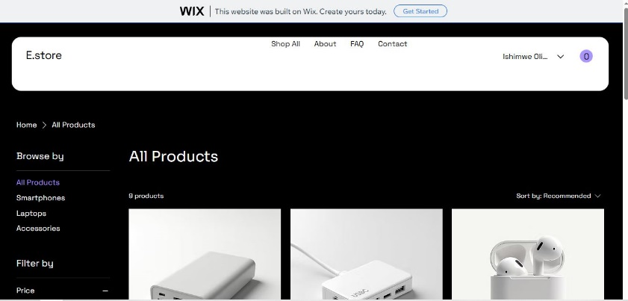
### Products Page
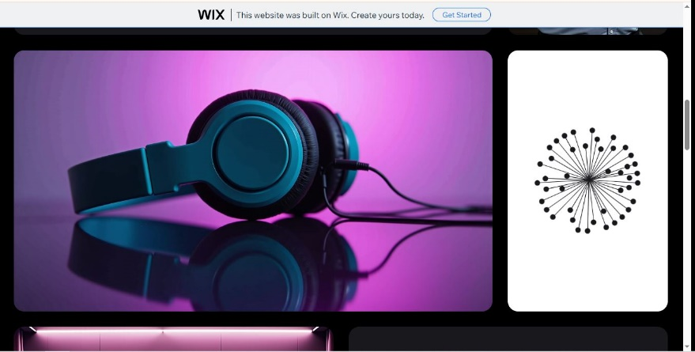

### help section
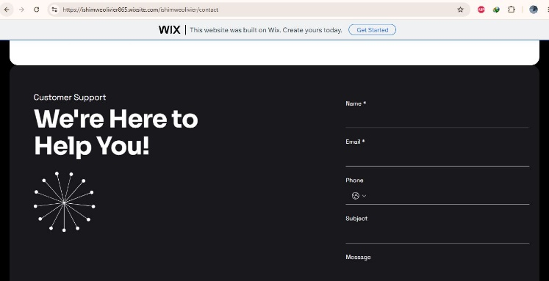

## Author
Ishimwe Olivier
## reg number
22558/2023

