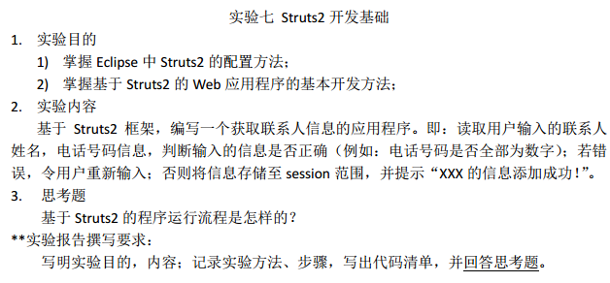
开始
<%@ page language="java" import="java.util.*" pageEncoding="utf-8"%>
<!DOCTYPE HTML PUBLIC "-//W3C//DTD HTML 4.01 Transitional//EN">
<html>
<head>
<title>添加联系人</title>
</head>

<body>
<form action="/J2e_week16_20170622/addContact.action" method="post">表单看到这个全改为绝对路径，尽管我不习惯，J2e_week16_20170622为工程名称
<form action="addContact.action" method="post">
<table align="center">
<tr>
<td>联系人姓名</td>
<td><input type="text" name="contactPerson" /></td>
</tr>
<tr>
<td>联系人电话</td>
<td><input type="text" name="phone" /></td>
</tr>
<tr>
<td colspan="2"><input type="submit" value="添加" /></td>
</tr>
</table>
</form>
</body>
</html>

Action
<?xml version="1.0" encoding="UTF-8"?>
<web-app xmlns:xsi="http://www.w3.org/2001/XMLSchema-instance"
xmlns="http://java.sun.com/xml/ns/javaee"
xsi:schemaLocation=
"http://java.sun.com/xml/ns/javaee http://java.sun.com/xml/ns/javaee/web-app_3_0.xsd"
id="WebApp_ID" version="3.0">
<display-name>J2e_week16_20170622</display-name>
<!-- 强调：不能忘记配置前端控制器 -->
<filter>
<filter-name>struts2</filter-name>
<filter-class>org.apache.struts2.dispatcher.ng.filter.StrutsPrepareAndExecuteFilter</filter-class>
</filter>
<filter-mapping>
<filter-name>struts2</filter-name>
<url-pattern>/*</url-pattern>
</filter-mapping>
<welcome-file-list>
<welcome-file>index.jsp</welcome-file>
</welcome-file-list>
</web-app>
<?xml version="1.0" encoding="UTF-8" ?>
<!DOCTYPE struts PUBLIC
"-//Apache Software Foundation//DTD Struts Configuration 2.3//EN"
"http://struts.apache.org/dtds/struts-2.3.dtd">
<struts>
<package name="addContactPerson" extends="struts-default">
<action name="addContact" class="com.huang.AddContactAction">
<result name="success">/success.jsp</result>
<result name="none">/add_contact.jsp</result>
</action>
</package>
</struts>
package com.huang;

import java.util.regex.Pattern;

import javax.servlet.http.HttpServletRequest;

import org.apache.struts2.ServletActionContext;

import com.opensymphony.xwork2.ActionSupport;

public class AddContactAction extends ActionSupport {

private static final long serialVersionUID = 1L;

@SuppressWarnings("null")
@Override
public String execute() throws Exception {
HttpServletRequest request = ServletActionContext.getRequest();
String name = request.getParameter("contactPerson");
String phone = request.getParameter("phone");
if (name != null && phone != null)
if (!name.equals("")) {
if (!phone.equals("")) {
String regex = "[0-9]*";
Pattern pattern = Pattern.compile(regex);
if (pattern.matcher(phone).matches()) {
request.getSession().setAttribute("addPerson", name);
return SUCCESS;
}
}
}
return NONE;
}

}

成功
<%@ page language="java" import="java.util.*" pageEncoding="utf-8"%>
<!DOCTYPE HTML PUBLIC "-//W3C//DTD HTML 4.01 Transitional//EN">
<html>
<head>
<title>添加成功</title>
</head>
<body>
${addPerson}的信息添加成功<br>
</body>
</html>

