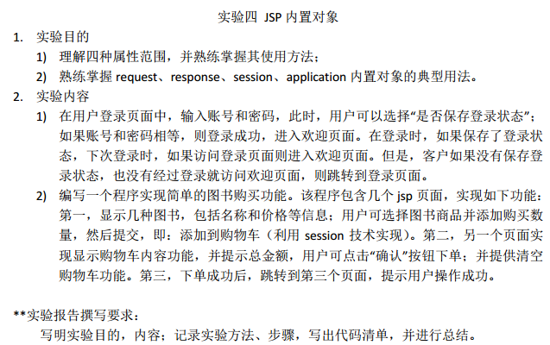
实验四
- 用户登录
http://localhost:8080/J2e_week12_20170525/login.jsp
<%@ page language="java" import="java.util.*" pageEncoding="utf-8"%>
<%
String path = request.getContextPath();
String basePath = request.getScheme()+"://"+request.getServerName()+":"+request.getServerPort()+path+"/";
%>

<!DOCTYPE HTML PUBLIC "-//W3C//DTD HTML 4.01 Transitional//EN">
<html>
<head>
<base href="<%=basePath%>">
</head>

<body>

<%
String saveOk = (String) session.getAttribute("saveOk");
if(saveOk==null || saveOk.equals("")){
System.out.println("登陆错误或者没保存");
}else{
System.out.println("先前用户已经保存");
request.setAttribute("user", saveOk);
%>
<jsp:forward page="success.jsp" />
<%
}
%>

<%
String msg=(String) request.getAttribute("msg");
if(msg != null){
out.println("<h6 align='center'>"+msg+"</h6>");
}
%>

<h3 align="center">用户登录</h3>
<form action="show.jsp" method="get">
<table align="center" >
<tr>
<td>用户名</td>
<td><input type="text" name="name" /></td>
</tr>
<tr>
<td>密码</td>
<td><input type="password" name="pwd" /></td>
</tr>
<tr>
<td><input type="submit" value="登录"/></td>
<td>是否保存登录<input type="checkbox" name="save" value="ok"/></td>
</tr>
</table>
</form>
</body>
</html>

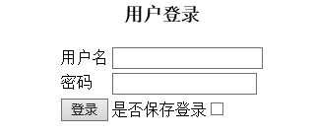
http://localhost:8080/J2e_week12_20170525/show.jsp中转处理
<%@page import="java.sql.PreparedStatement"%>
<%@page import="java.sql.ResultSet"%>
<%@page import="java.sql.Statement"%>
<%@page import="java.sql.DriverManager"%>
<%@page import="java.sql.Connection"%>
<%@ page language="java" import="java.util.*" pageEncoding="utf-8"%>
<!DOCTYPE HTML PUBLIC "-//W3C//DTD HTML 4.01 Transitional//EN">
<html>
<head>
</head>
<body>
<%
Class.forName("com.mysql.jdbc.Driver");
java.sql.Connection con = DriverManager.getConnection(
"jdbc:mysql://localhost:3306/j2e", "root", "root");
request.setCharacterEncoding("utf-8");
String name = request.getParameter("name");
String pwd = request.getParameter("pwd");
String sql = "SELECT * FROM USER WHERE NAME=? AND pwd=?";
PreparedStatement ps = con.prepareStatement(sql);
ps.setString(1, name);
ps.setString(2, pwd);
ResultSet s = ps.executeQuery();
if(s.next()){
request.setAttribute("user", name);
String ok = request.getParameter("save");
if(ok==null){
System.out.println("没有保存啊");
}else{
System.out.println("保存ok");
session.setAttribute("saveOk", name);
}
%>
<jsp:forward page="success.jsp" />
<%
} else{
request.setAttribute("msg", "登陆失败！用户名或者密码错误");
%>
<jsp:forward page="login.jsp"></jsp:forward>

<%}
%>

</body>
</html>

成功登陆时
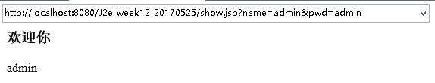
登陆失败时
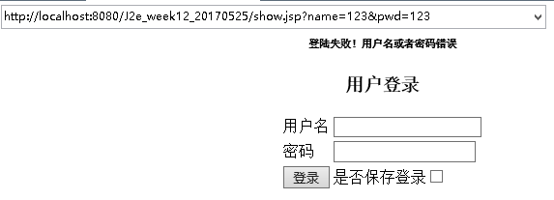
勾选保存  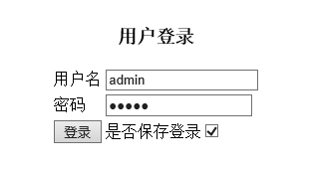 | 访问登陆页面显示如下  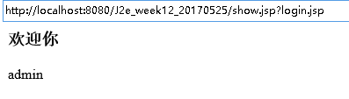

- 购买图书
图书展示
<%@page import="java.sql.PreparedStatement"%>
<%@page import="java.sql.ResultSet"%>
<%@page import="java.sql.Statement"%>
<%@page import="java.sql.DriverManager"%>
<%@page import="java.sql.Connection"%>
<%@ page language="java" import="java.util.*" pageEncoding="utf-8"%>
<!DOCTYPE HTML PUBLIC "-//W3C//DTD HTML 4.01 Transitional//EN">
<html>
<head>
</head>
<body>
<%
Class.forName("com.mysql.jdbc.Driver");
java.sql.Connection con = DriverManager.getConnection(
"jdbc:mysql://localhost:3306/j2e", "root", "root");
%>

<%
request.setCharacterEncoding("utf-8");
String name = request.getParameter("name");
String price = request.getParameter("price");
if (name != null && price != null) {
String sql = "INSERT INTO T_Book(BookName,BookPrice) VALUES(?,?)";
PreparedStatement ps = con.prepareStatement(sql);
ps.setString(1, name);
ps.setDouble(2, Double.parseDouble(price));
ps.execute();
}
%>
<h3 align="center">图书信息</h3>
<table align="center" cellpading="0" border="1">
<tr>
<td>书号</td>
<td>书名</td>
<td>价格</td>
<td>购买数量</td>
<td>加入购物车</td>
</tr>
<%
Statement st = con.createStatement();
ResultSet rs = st.executeQuery("select * from T_Book");
while (rs.next()) {
System.out.println(rs.getString("BookName"));
int id = rs.getInt("BookId");
request.setAttribute("id", id);
String bname=rs.getString("BookName");
double bprice = rs.getDouble("BookPrice");
%>
<tr>
<form action="car.jsp">
<td><input type="text" name="id" value="${id}"></td>
<td><%=bname%></td>
<td><%=bprice%></td>
<td><input type="text" name="amount"></td>
<td><input type="submit" value="加入购物车"></td>
</form>
</tr>
<%
}
%>
</table>
</body>
</html>

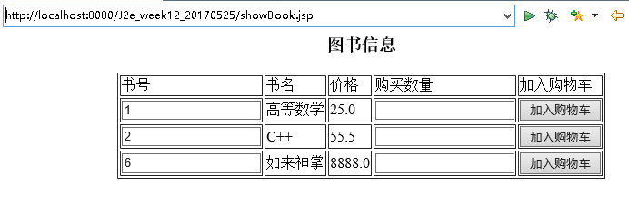
购物车界面
<%@ page language="java" import="java.util.*" pageEncoding="utf-8"%>

<%@page import="java.sql.PreparedStatement"%>
<%@page import="java.sql.ResultSet"%>
<%@page import="java.sql.Statement"%>
<%@page import="java.sql.DriverManager"%>
<%@page import="java.sql.Connection"%>
<!DOCTYPE HTML PUBLIC "-//W3C//DTD HTML 4.01 Transitional//EN">
<html>
<head>

</head>

<body>
<% double all = 0;
Class.forName("com.mysql.jdbc.Driver");
java.sql.Connection con = DriverManager.getConnection(
"jdbc:mysql://localhost:3306/j2e", "root", "root");
%>
<h3 align="center">购物车信息</h3>
<table align="center" cellpading="0" border="1">
<tr>
<td>订单号</td>
<td>书名</td>
<td>价格</td>
<td>数量</td>
<td>总价格</td>
</tr>
<%
//装入session
String id = request.getParameter("id");
String amount = request.getParameter("amount");
ArrayList<String> idlist = (ArrayList<String>) session.getAttribute("idlist");
ArrayList<String> amountlist =(ArrayList<String>) session.getAttribute("amountlist");
if(idlist==null){
idlist = new ArrayList<String>();
amountlist = new ArrayList<String>();
}
idlist.add(id);amountlist.add(amount);
session.setAttribute("idlist", idlist);
session.setAttribute("amountlist", amountlist);
%>

<%//数据显示
for(int i = 0;i<idlist.size();i++){
//out.print(idlist.get(i));
Statement st = con.createStatement();
ResultSet rs = st.executeQuery("select * from T_Book where BookId="+Integer.valueOf(idlist.get(i)));
if(rs.next()) {
double bprice = rs.getDouble("BookPrice");
double allNow=bprice*Integer.valueOf(amountlist.get(i));
all+=allNow;
%>
<tr>
<td><%= i%></td>
<td><%=rs.getString("BookName")%></td>
<td><%=bprice%></td>
<td><%=amountlist.get(i)%></td>
<td><%= allNow%></td>
</tr>
<%
}
}
%>
</table>
总价格：<%=all %>
<a href="buySuccess.jsp">确认下单</a>
</body>
</html>

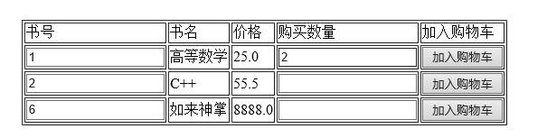
加入如上
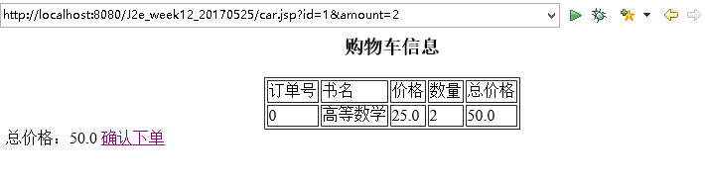

继续添加
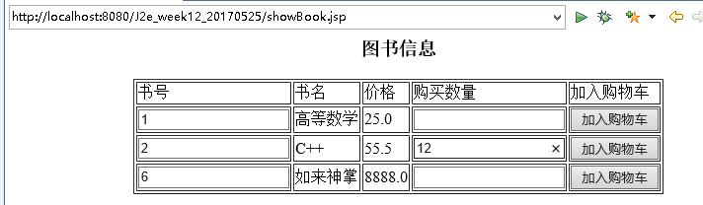
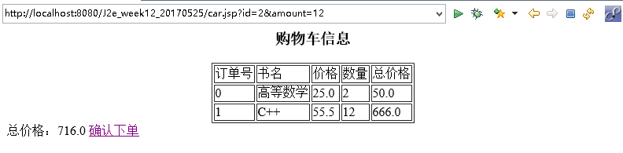

确认下单
<%@ page language="java" import="java.util.*" pageEncoding="utf-8"%>

<!DOCTYPE HTML PUBLIC "-//W3C//DTD HTML 4.01 Transitional//EN">
<html>
<head>
</head>

<body>
<% session.removeAttribute("idlist");
session.removeAttribute("amountlist"); %>
<!-- 清除session -->
亲，操作成功！订单已经生成！请确认收货<br>
</body>
</html>

