scFlow Studio Agent
V0.1.0
User Manual
Windows x64 | Installation | Data Import | 16-Step Analysis Workflow
Product: scFlow Studio Agent V0.1.0
Platform: Windows 10/11 x64
Document type: User Manual

Getting Started
scFlow Studio Agent is a desktop workflow for single-cell transcriptomics. It brings data import, quality control, doublet removal, clustering, annotation, downstream statistics, and file export into one interface.

Main capabilities
Imports 10X folders, text matrices, archives, H5AD or H5AD.GZ files, and compatible Seurat RDS objects.
Provides a continuous 01-16 workflow with parameters, progress, logs, and confirmation controls at each step.
Includes a portable R runtime, so a separate system R installation is normally unnecessary.
Supports UMAP and t-SNE, major and subcluster annotation, DEG, GSEA, gene analysis, communication, cell cycle, and trajectory analysis.
Exports figures, tables, objects, project packages, and optional AI-assisted manuscript content.

Standard run sequence
Order | Action
1 | Open the target step from the left sidebar and review its Parameters.
2 | Click Run Current Step and monitor the progress indicator and Log.
3 | Wait for completion. The Log must contain no Error or Task failed message, and Confirm and Continue must be enabled.
4 | Click Confirm and Continue to advance to the next step.

System requirements
Item | Recommendation
Operating system | Windows 10/11 x64
Memory | 16 GB or more; large H5AD files may require additional memory
Disk | About 5 GB for installation, plus space for project cache and exports
Project directory | Use a data drive and keep original data read-only
Network | Not required for routine analysis; required for AI providers and some online resources

Screenshot key The numbered red callouts in each screenshot correspond one-to-one with the numbered instructions immediately below it.

Contents
Getting Started 2
Contents 3
Install, Launch, and Uninstall 4
Launch, Activation, and Uninstall 6
Project and Task Management 7
01 Data Import 8
01 Supported Data Formats 9
01 Import a Matrix, Archive, or H5AD 10
01 Confirm H5AD Samples 11
01 Complete GSE250245 Import Example 12
02 Quality Control 13
03 Doublet Removal 14
04 Batch Correction 15
05 Merge and Clustering 16
06 Cell-Type Annotation 17
07 Subcluster Analysis 18
08 Differential Expression 19
09 GSEA Enrichment 20
10 Single-Gene Analysis 21
11 Gene Set Scoring 22
12 Cell–Cell Communication 23
13 Cell-Cycle Scoring 24
14 Trajectory Analysis 25
15 Export Report 26
16 AI Scientific Manuscript Agent 27
Common Parameter Reference 28
Troubleshooting 29

Install, Launch, and Uninstall
Run the scFlow Studio Agent installer. To avoid using the system drive, choose a data-drive destination in the setup wizard.

Choose the installation directory
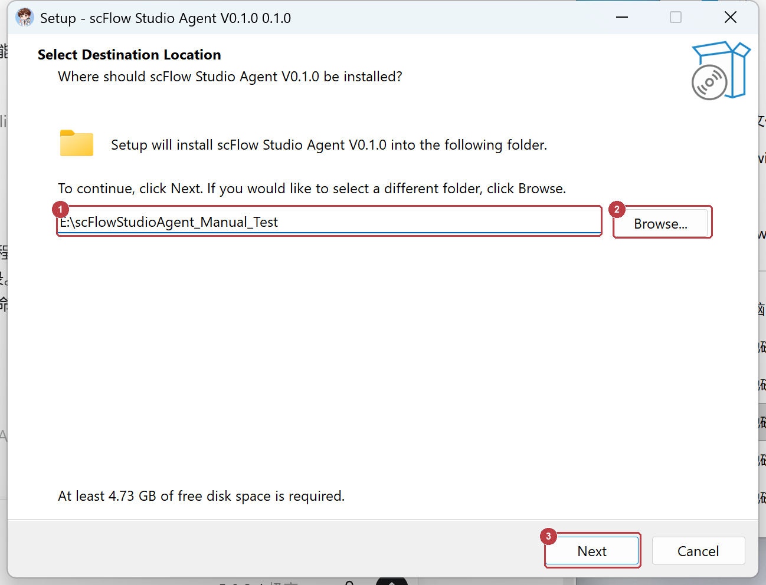
Figure 1 Choose the installation directory
1 | Review or enter the destination folder.
2 | Click Browse to select another folder.
3 | After confirming the path, click Next.

Continue installation
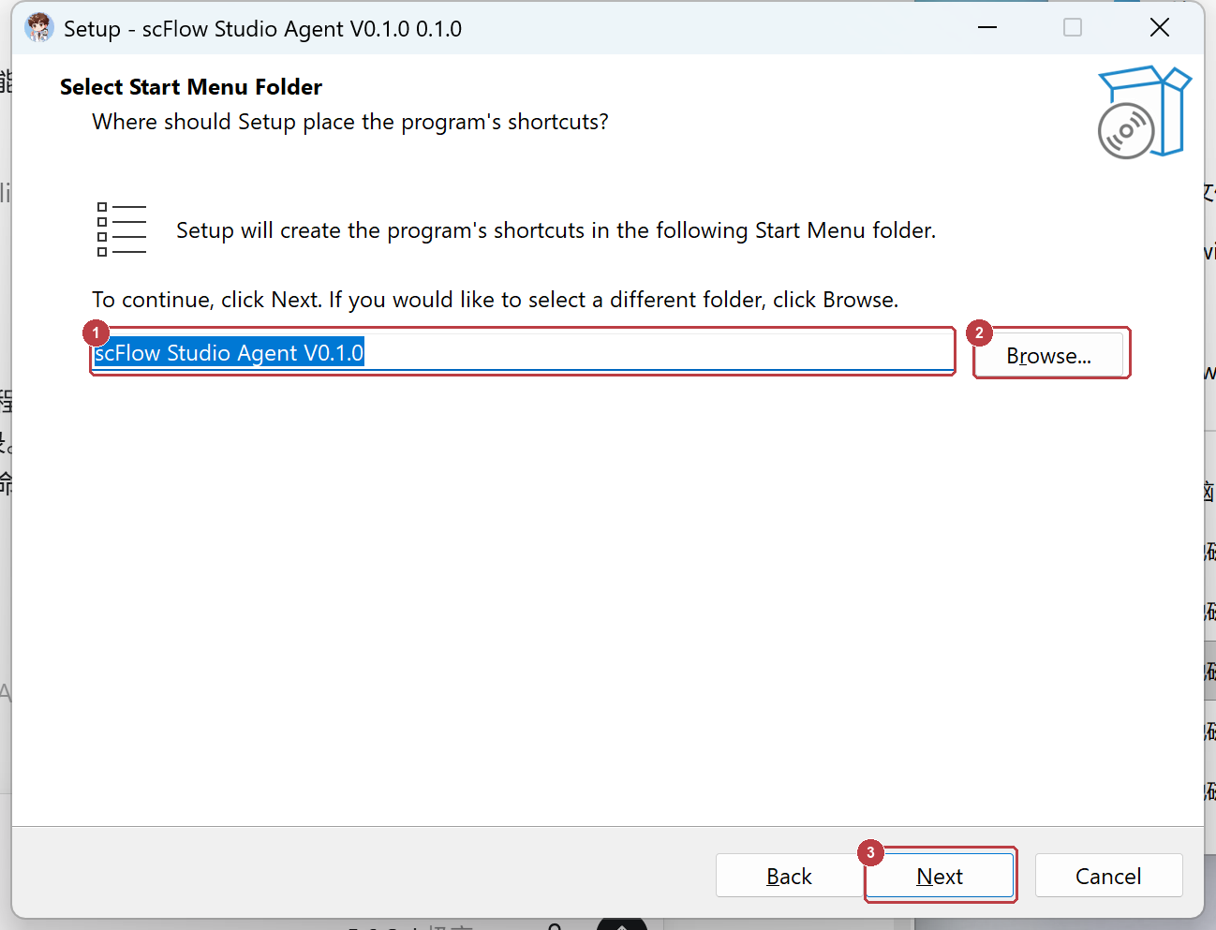
Figure 2 Choose the Start Menu folder
1 | Confirm the Start Menu folder name.
2 | Click Browse if you need to change it.
3 | Click Next and complete the setup wizard.

Launch, Activation, and Uninstall

First launch
Order | Action
1 | Double-click scFlow Studio Agent V0.1.0.exe.
2 | Open Environment Diagnostics and confirm that the bundled R runtime is selected.
3 | If an activation window appears, enter a valid license and continue.
4 | Create or open a project only after the main application window is available.

Uninstall
Order | Action
1 | Close scFlow Studio Agent and back up the project directory and original data.
2 | Run unins_scFlowStudioAgent.exe from the installation directory, or use Windows Installed apps.
3 | Confirm removal when Windows displays the uninstall prompt.

Important The project directory is separate from the installation directory. Back it up before uninstalling or upgrading the application.

Project and Task Management
The project directory stores analysis configuration, cache, and export references. It is separate from the application installation directory and should be placed on a data drive with sufficient free space.

Top toolbar
Control | When to use it
New Project | Start a project. Set Project Directory before adding samples.
Open Project | Continue an existing project. Verify the project name, sample count, and current step after opening.
Save Project | Save after changing samples, groups, or important parameters, and again before exiting.
Run Current Step | Run the selected sidebar step. Some pages also provide an internal button for the same main task.
Stop | Request that the running task stop, then wait for the background process to finish.
Environment Diagnostics | Check before the first QC run or when R fails; prefer the bundled R runtime.

Bottom controls
Control | Purpose
Restore Defaults | Restore the default parameters for the current step; this does not rerun the step.
Clear Step Result | Remove the current step result after confirming that its cache is no longer needed.
Confirm and Continue | Confirm a successful task and advance to the next step.

Recommendation Do not create projects inside the installation directory. Back up project directories and original data separately before uninstalling or upgrading.

01 Data Import
Purpose Create a project, register samples, groups, species, and data paths, and connect supported inputs to the existing QC workflow.
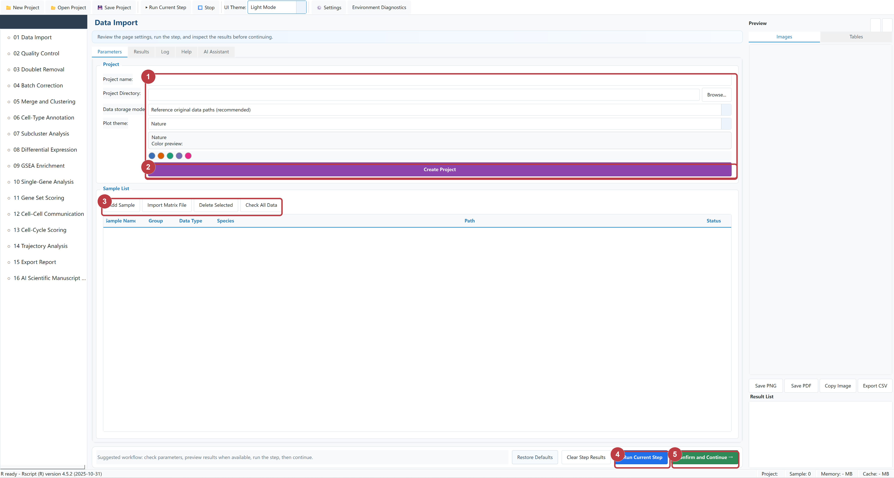
Figure 01-1 Data Import controls
1 | Enter Project name, Project Directory, data storage mode, and plot theme.
2 | Click Create Project.
3 | Click Add Sample or Import Matrix File; after adding data, click Check All Data.
4 | Click Run Current Step.
5 | When the Log reports success, click Confirm and Continue.

01 Supported Data Formats
Entry point | Format | Select
Add Sample | 10X Matrix Folder | One sample folder containing matrix.mtx, barcodes.tsv, and features.tsv
Import Matrix File | TXT / TSV / CSV / .gz | A gene-by-cell expression matrix
Import Matrix File | TAR / TAR.GZ / TGZ / RAR | An archive containing 10X data, a matrix, or H5AD
Import Matrix File | H5AD / H5AD.GZ | An AnnData file; confirm sample names and Group after detection
Add Sample | Seurat RDS | A compatible Seurat object

Add a 10X or RDS sample
Field | What to enter
Sample Name | A unique, readable sample identifier
Group | The biological condition used for comparison
Data Type | 10X Matrix Folder or Seurat RDS
Species | The organism represented by the data
Data Path | The single sample folder or RDS file; use Browse to select it

Complete the dialog After all five fields are correct, click OK. Repeat Add Sample for every independent sample.

01 Import a Matrix, Archive, or H5AD
Order | Action
1 | Click Import Matrix File on the Data Import page.
2 | In the Windows file picker, select the matrix, archive, H5AD, or H5AD.GZ file and click Open.
3 | Keep the progress window open while the application reads and identifies the input.
4 | For H5AD input, review the detected samples in the confirmation window shown on the next page.

What happens during H5AD import
The application reads AnnData counts from raw or X according to file contents.
It detects sample labels, splits data when needed, and writes project-managed 10X matrices.
The resulting samples enter the same Quality Control workflow as existing import methods.
Wait for completion Large H5AD files may take time to read, split, and write. Do not click Import again or force-close a responsive progress window.

01 Confirm H5AD Samples
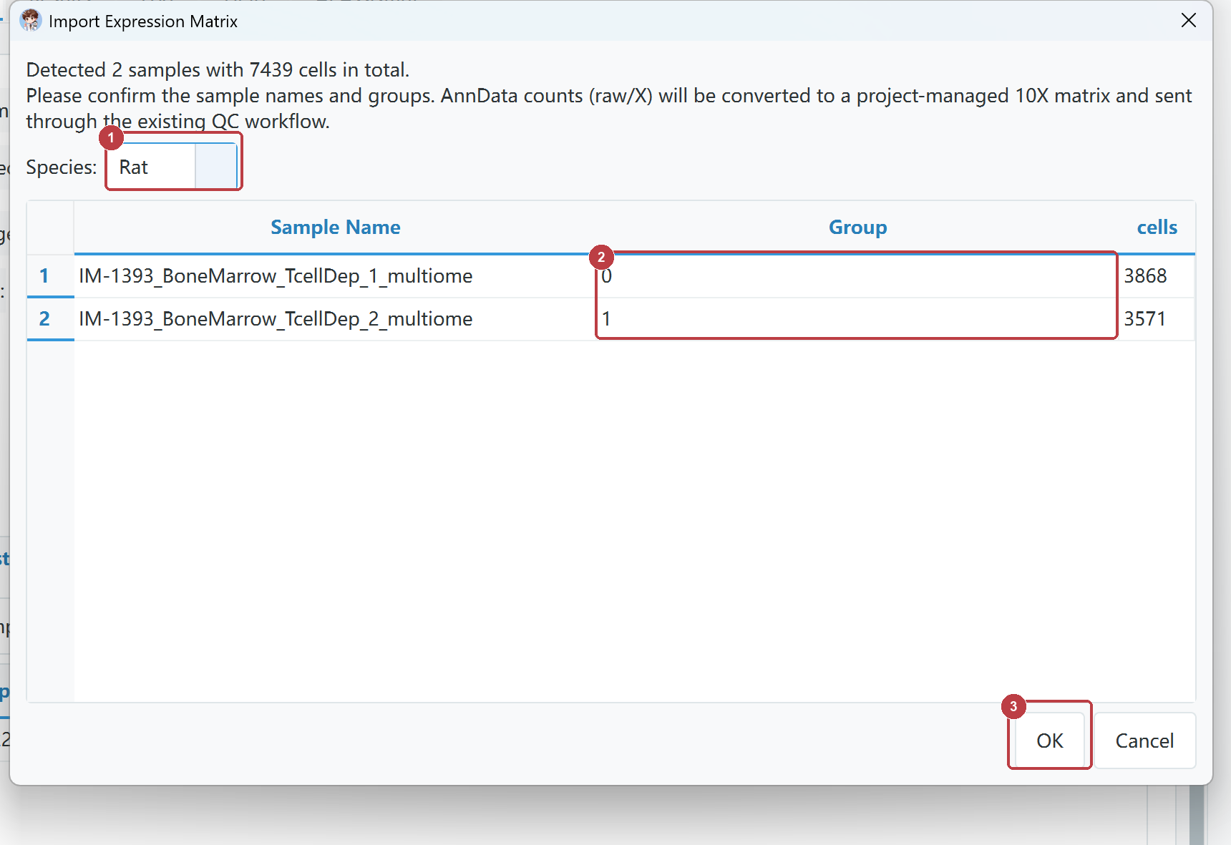
Figure 01-2 Confirm H5AD samples and groups
1 | Confirm that Species matches the organism in the dataset.
2 | Review Sample Name. Double-click each Group cell and replace technical codes such as 0 or 1 with meaningful experimental group names.
3 | After all values are correct, click OK and wait for conversion and writing to finish.

Group rule Keep 0 or 1 only when those values are intentionally used as the experimental group names. Otherwise use names such as Control and Treatment.

01 Complete GSE250245 Import Example
The example contains three 10X sample folders: Sham, mMCAO, and sMCAO. The mMCAO and sMCAO samples belong to the same MCAO experimental group.
Sample Name | Group | Data Type | Species | Folder
Sham | Sham | 10X Matrix Folder | Rat | GSE250245/Sham
mMCAO | MCAO | 10X Matrix Folder | Rat | GSE250245/mMCAO
sMCAO | MCAO | 10X Matrix Folder | Rat | GSE250245/sMCAO

Run in this order
Order | Action
1 | Click New Project, enter a Project name and data-drive Project Directory, then click Create Project.
2 | Click Add Sample, add Sham using the table above, verify all five fields, and click OK.
3 | Click Add Sample again, add mMCAO, and set Group to MCAO.
4 | Click Add Sample again, add sMCAO, and also set Group to MCAO.
5 | Click Check All Data and wait until all three sample rows show valid.
6 | Click Run Current Step. After the standard success checks pass, click Confirm and Continue to open Quality Control.

Check carefully Each Data Path must point to its matching sample folder. Do not assign all three samples to the same directory.

02 Quality Control
Purpose Filter low-quality cells by UMI count, detected genes, and mitochondrial percentage. Before you run it: Data Import is complete and every sample status is valid.
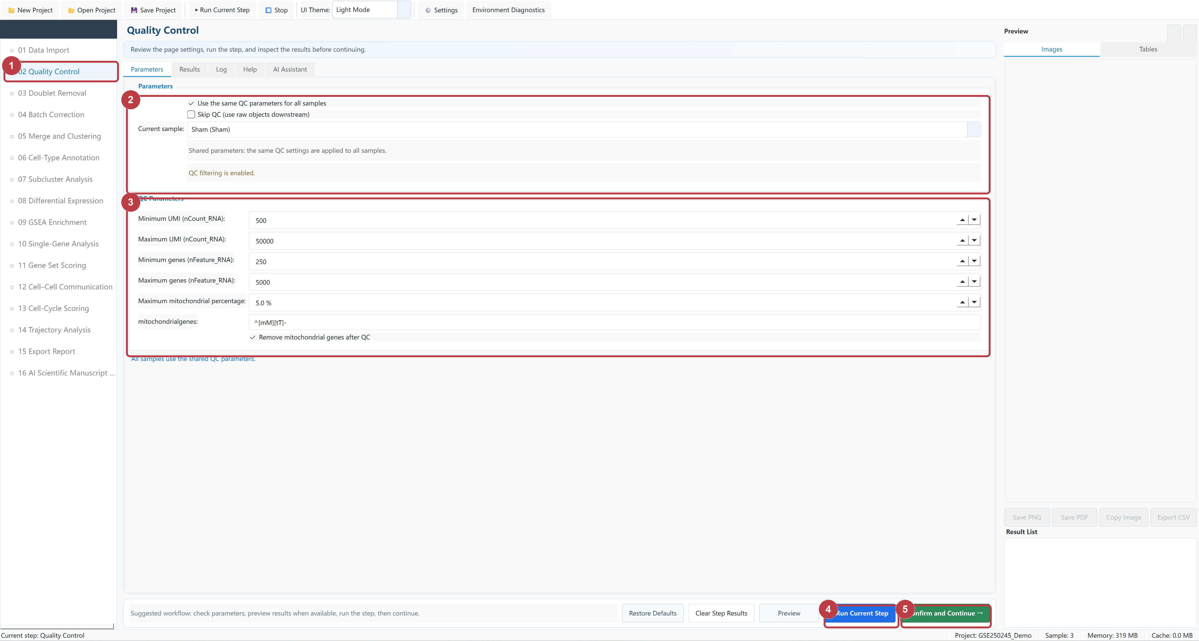
Figure 02-1 Quality Control controls
1 | Open Quality Control.
2 | Select shared parameters, per-sample parameters, or Skip QC.
3 | Confirm UMI, gene-count, mitochondrial-percentage, and mitochondrial-gene removal settings.
4 | Click Run Current Step.
5 | When the Log reports success, click Confirm and Continue.

Common settings Minimum UMI 500; Minimum genes 250; Maximum mitochondrial percentage 5%; Seed 1234.

03 Doublet Removal
Purpose Identify and remove likely doublets and create singlet objects for downstream analysis. Before you run it: Quality Control completed successfully, or Skip QC was intentionally selected.
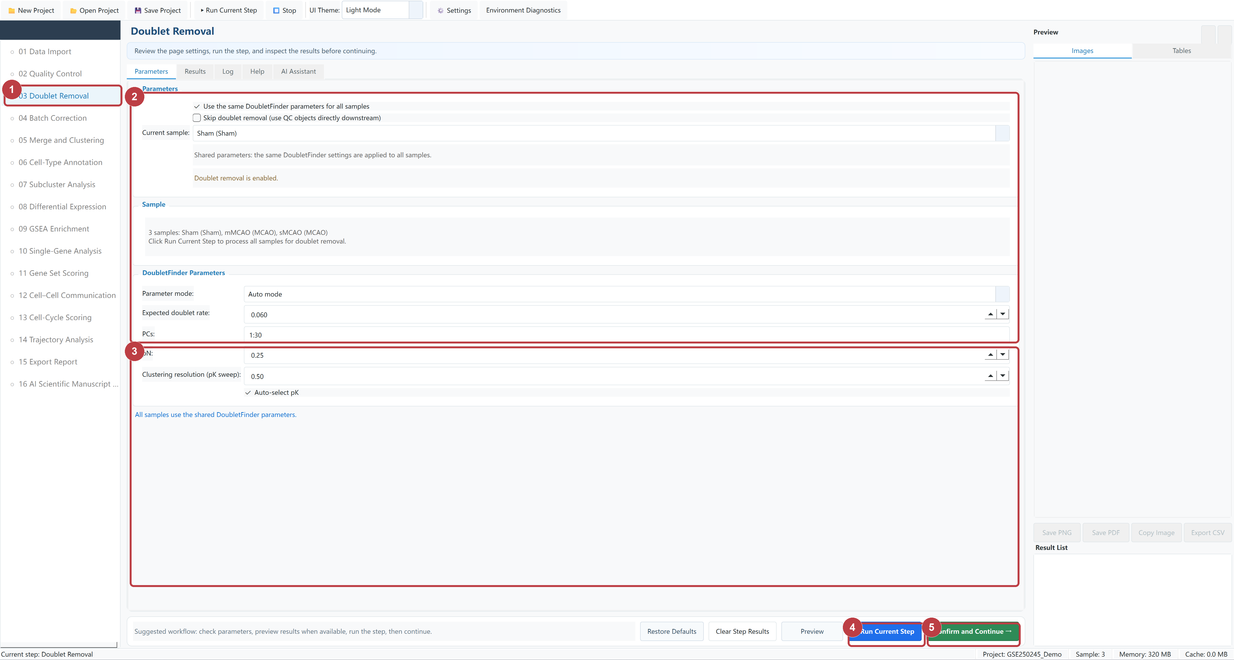
Figure 03-1 Doublet Removal controls
1 | Open Doublet Removal.
2 | Select Auto mode, shared parameters, or Skip.
3 | Confirm Expected rate, PCs, pN, Resolution, and Auto pK.
4 | Click Run Current Step.
5 | When the Log reports success, click Confirm and Continue.

Common settings Auto mode; Expected doublet rate 0.06; PCs 1:30; Seed 1234.

04 Batch Correction
Purpose Correct genuine technical batch effects, or continue without correction when it is not required. Before you run it: Doublet Removal is complete; enable correction only for a genuine technical batch effect.
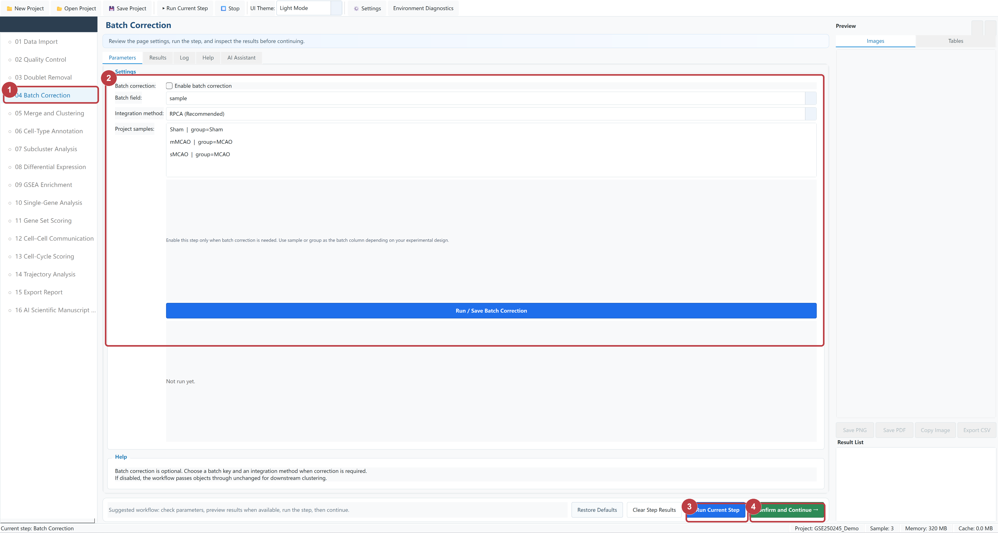
Figure 04-1 Batch Correction controls
1 | Open Batch Correction.
2 | Decide whether correction is needed, then select the Batch key and RPCA, Harmony, or CCA.
3 | Click Run Current Step.
4 | When the Log reports success, click Confirm and Continue.

Common settings Disabled by default; when correction is required, select a Batch key and RPCA, Harmony, or CCA.

05 Merge and Clustering
Purpose Merge samples, normalize data, run PCA, cluster cells, and calculate UMAP or t-SNE embeddings. Before you run it: Steps 01-04 are confirmed; use the corrected object if batch correction was enabled.
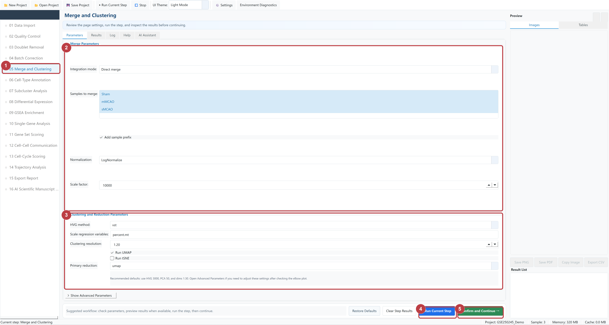
Figure 05-1 Merge and Clustering controls
1 | Open Merge and Clustering.
2 | Confirm Merge mode, samples, prefixes, Normalization, and Scale factor.
3 | Confirm HVG, regression variables, Resolution, UMAP or t-SNE, and Primary reduction.
4 | Click Run Current Step.
5 | When the Log reports success, click Confirm and Continue.

Common settings Direct merge; LogNormalize; HVG 3000; dims 1:30; resolution 1.20; Seed 1234.

06 Cell-Type Annotation
Purpose Calculate cluster markers and annotate major cell types with manual markers or SingleR. Before you run it: Merge and Clustering is complete and clusters are available.
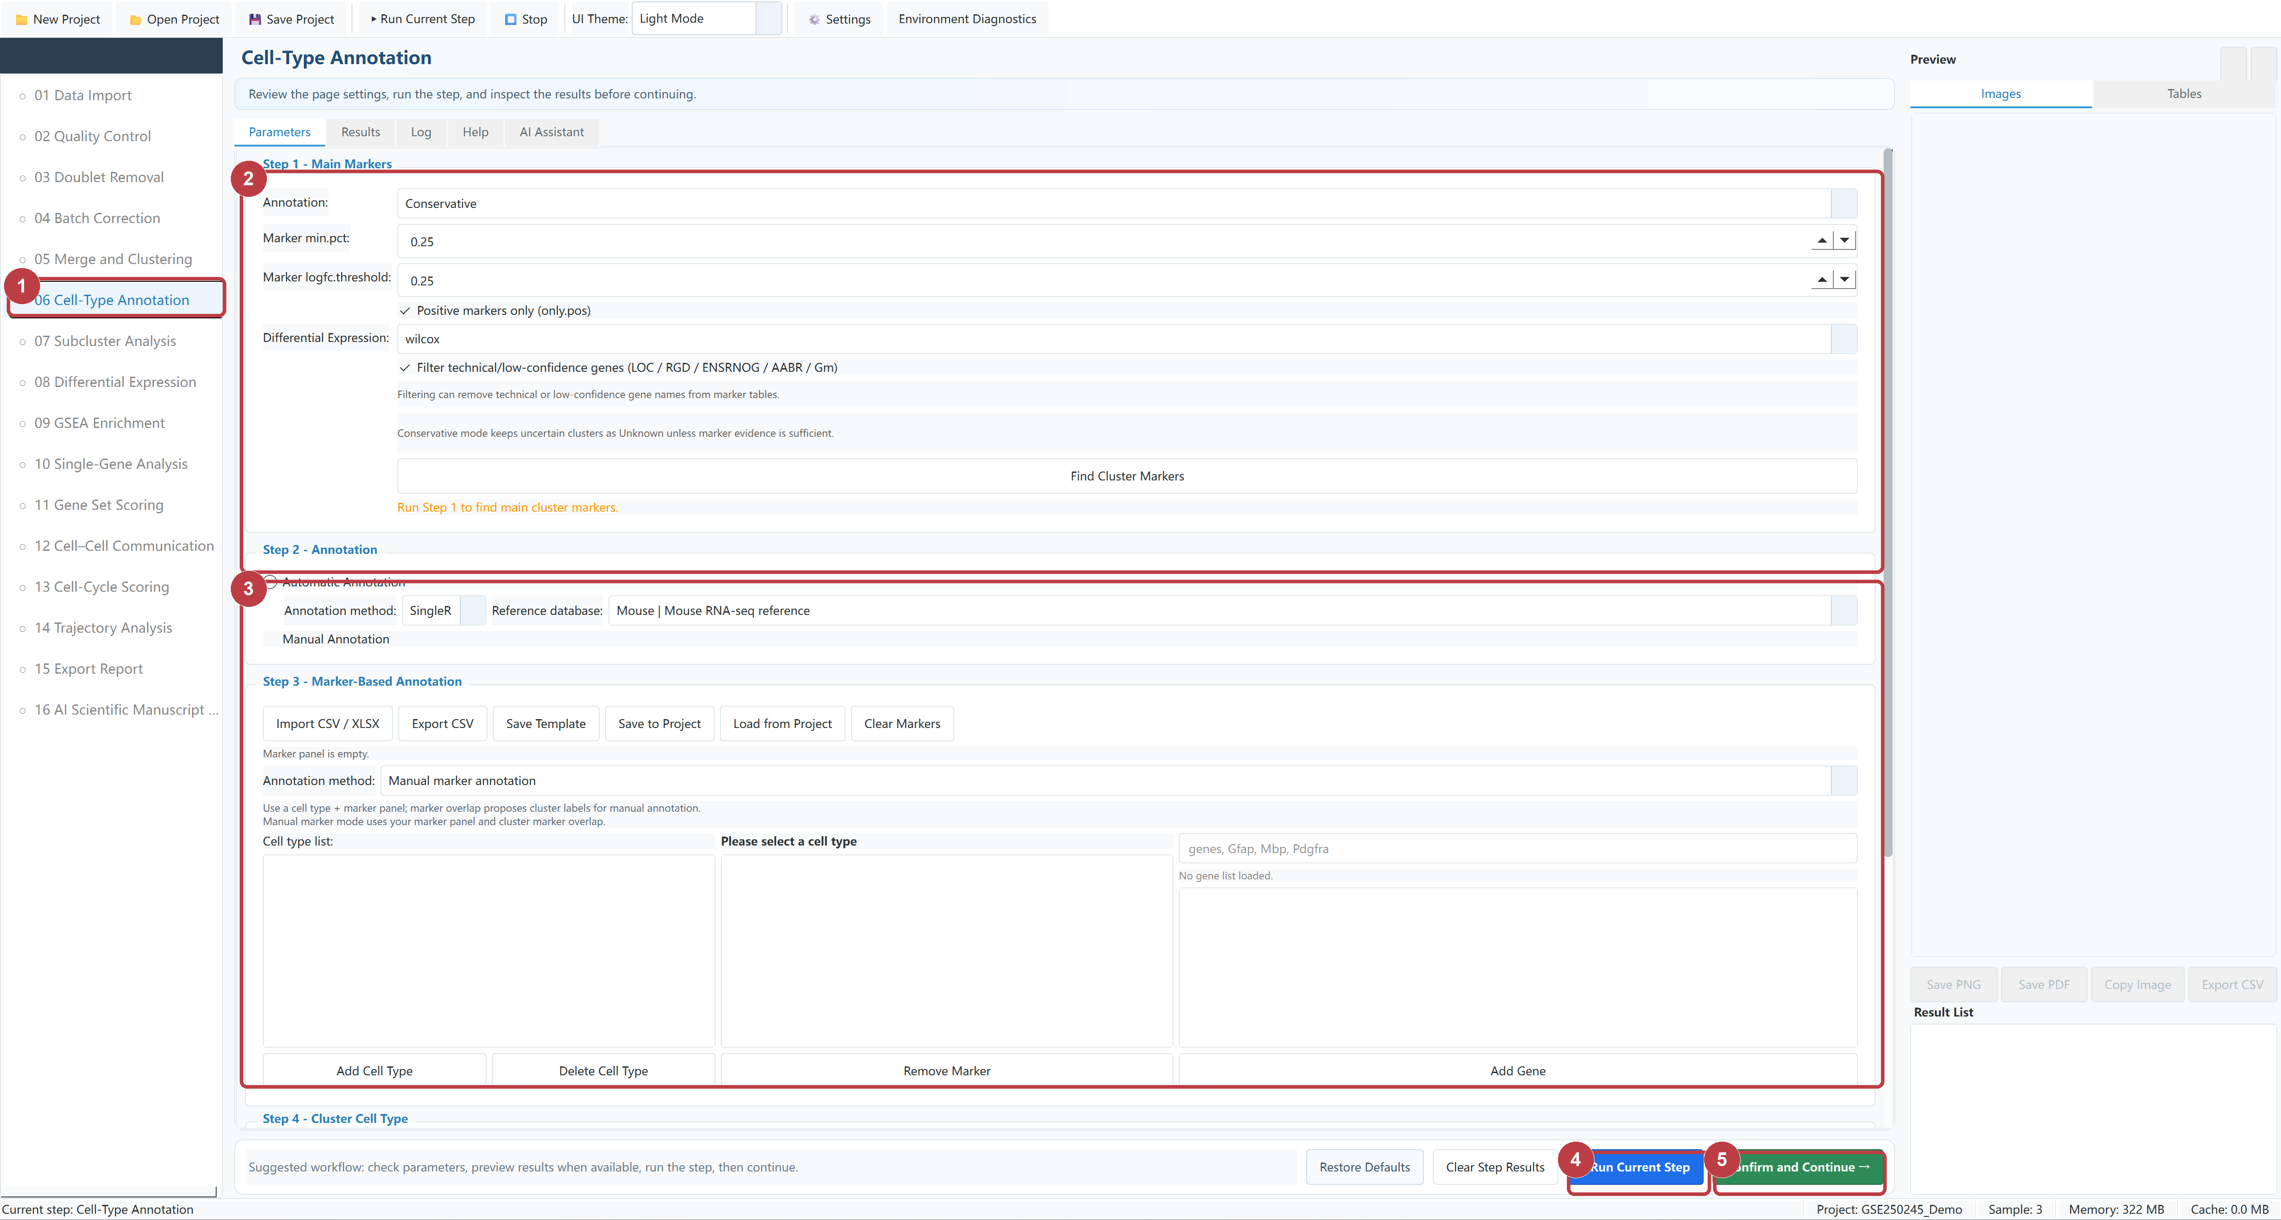
Figure 06-1 Cell-Type Annotation controls
1 | Open Cell-Type Annotation.
2 | Confirm the profile and thresholds, then click Find Cluster Markers.
3 | After markers finish, choose Automatic or Manual Annotation, enter markers or mapping, scroll down, click Run Annotation, review the result, and click Apply Annotation.
4 | Run Current Step performs the same marker task as Find Cluster Markers; do not run both consecutively.
5 | When annotation finishes without errors and Confirm is enabled, click Confirm and Continue.

Common settings Conservative; min.pct 0.25; logFC 0.25; Generate Annotation Plots is optional after Apply Annotation.

07 Subcluster Analysis
Purpose Extract a target cell type, recluster it, calculate an embedding, and annotate subclusters. Before you run it: Major-cell-type annotation is complete and the target cell type exists.
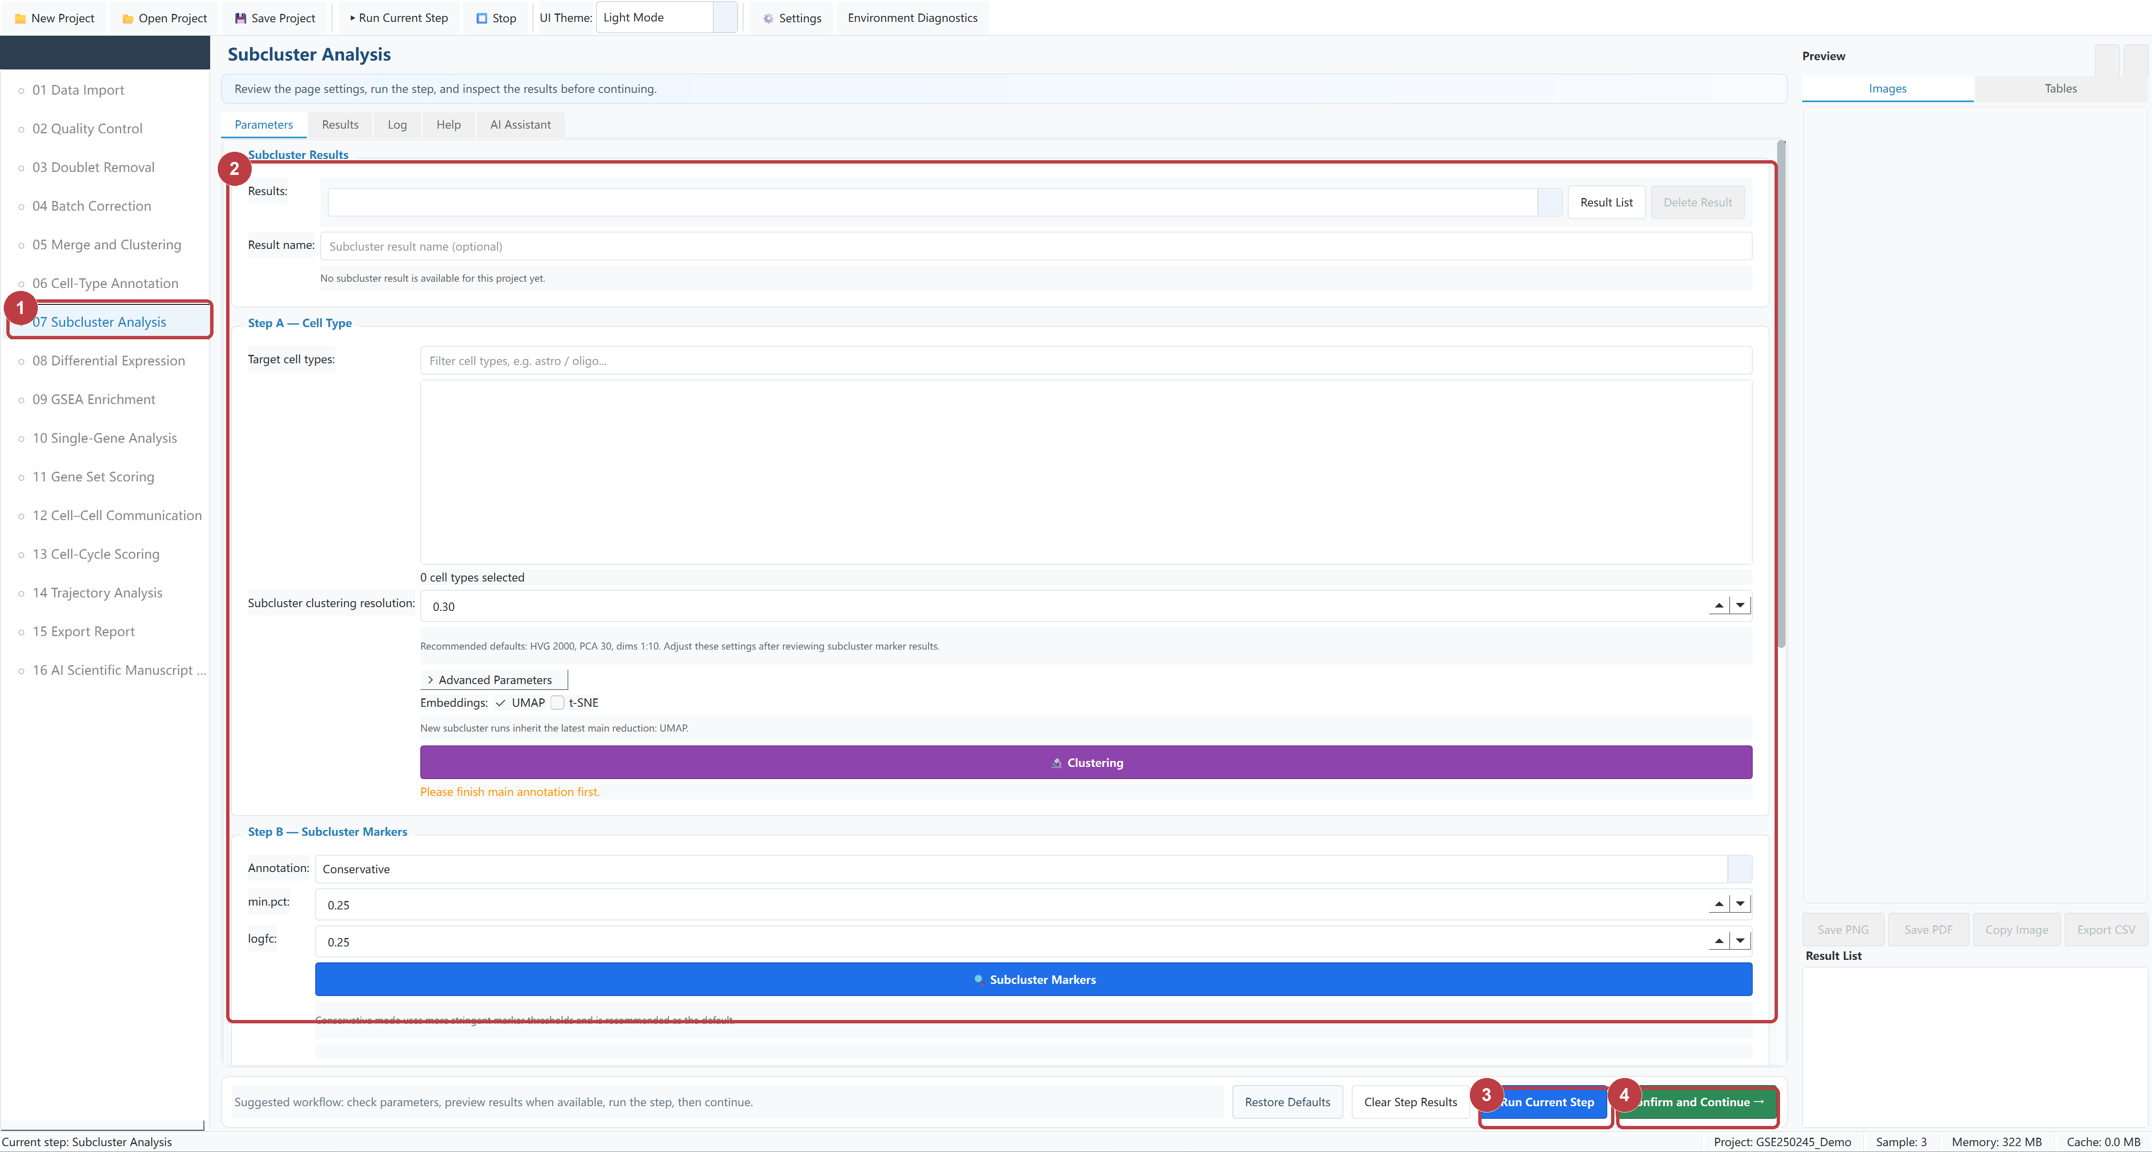
Figure 07-1 Subcluster Analysis controls
1 | Open Subcluster Analysis.
2 | Select the target cell type, embedding, clustering, and annotation method.
3 | Click Run Current Step.
4 | When the Log reports success, click Confirm and Continue.

Common settings Resolution 0.30; HVG 2000; dims 1:10; use the current major-cluster embedding type.

08 Differential Expression
Purpose Define a comparison in a major-cluster or subcluster object and run differential expression analysis. Before you run it: Major or subcluster annotation is complete and the groups or identities to compare exist.
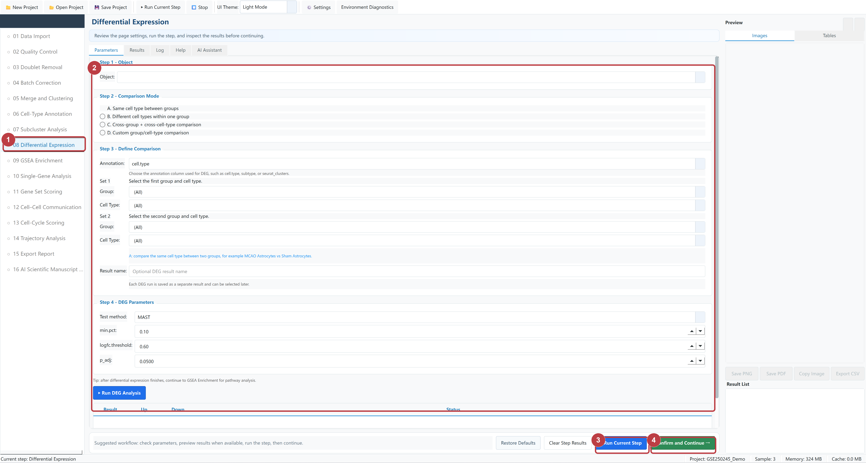
Figure 08-1 Differential Expression controls
1 | Open Differential Expression.
2 | Select the object, comparison mode, groups, test, and thresholds.
3 | Click Run Current Step.
4 | When the Log reports success, click Confirm and Continue.

Common settings MAST; min.pct 0.10; logFC 0.60; adjusted P cutoff 0.05.

09 GSEA Enrichment
Purpose Run GSEA with an existing ranked DEG result and a compatible GMT gene-set file. Before you run it: Differential Expression is complete and a species- and gene-ID-compatible GMT file is available.
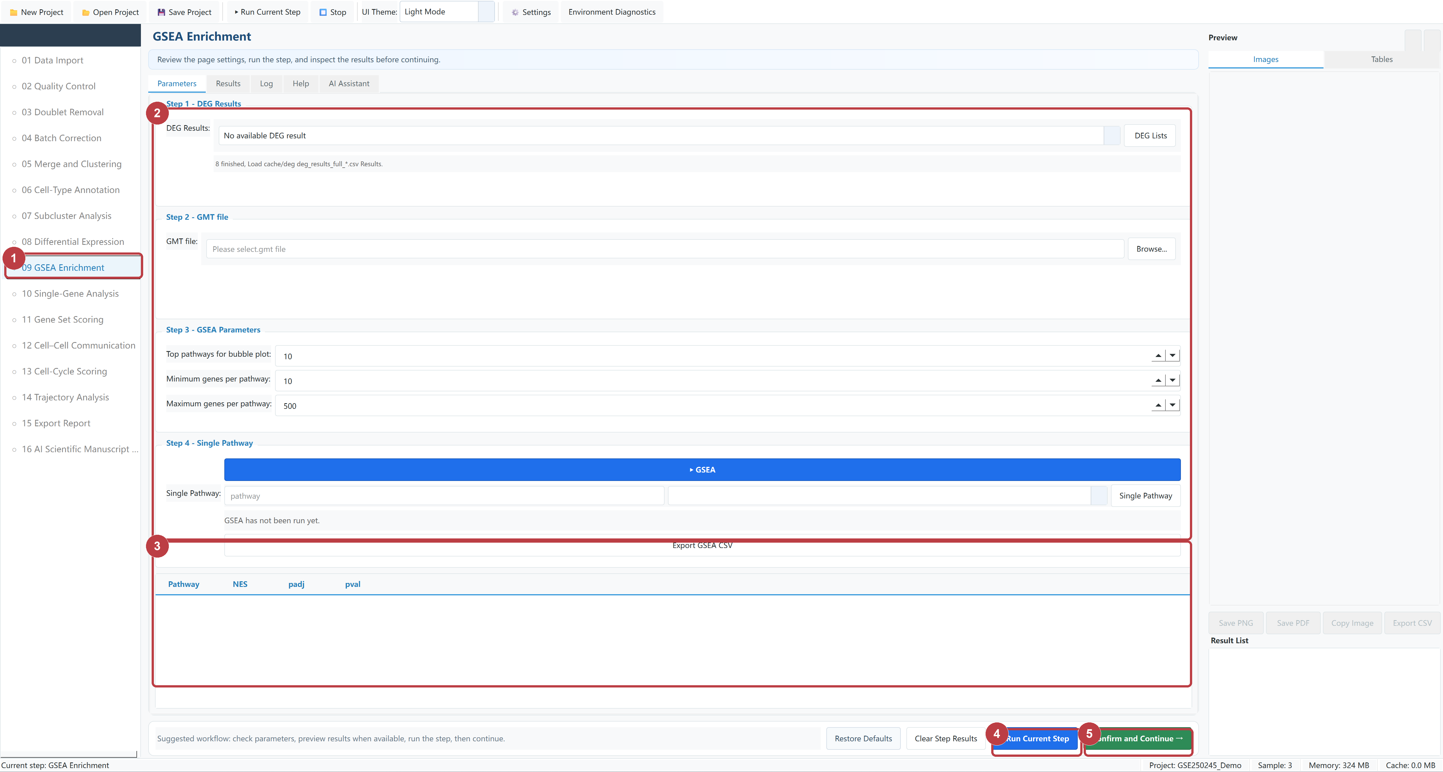
Figure 09-1 GSEA Enrichment controls
1 | Open GSEA Enrichment.
2 | Select the DEG result, GMT file, Top N, and gene-set size.
3 | Click GSEA to start the main analysis; after it finishes, optionally select a pathway and click Single Pathway.
4 | Run Current Step and GSEA start the same main task. Use one, not both.
5 | When the main analysis finishes without errors and Confirm is enabled, click Confirm and Continue.

Common settings Top pathways 10; gene-set size 10-500; Single Pathway is available after the main analysis.

10 Single-Gene Analysis
Purpose Inspect the expression of one or more genes across groups or cell types. Before you run it: A major or subcluster object exists and the requested gene symbols are present.
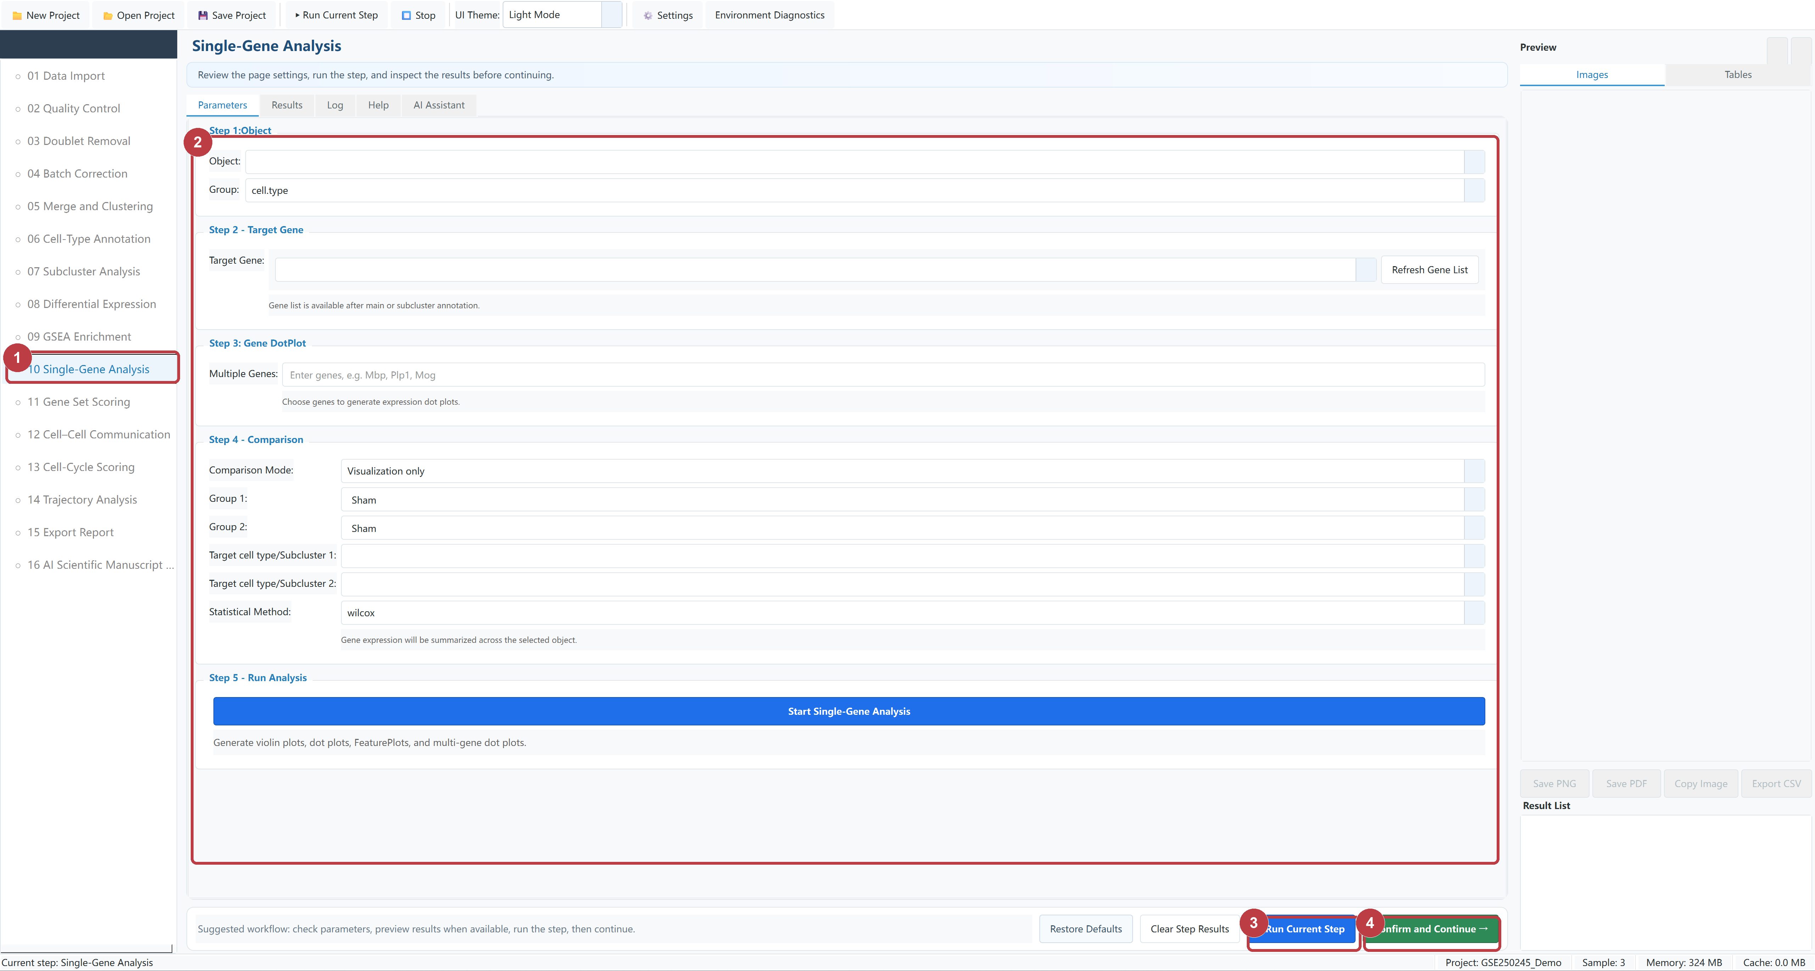
Figure 10-1 Single-Gene Analysis controls
1 | Open Single-Gene Analysis.
2 | Select the object, gene, comparison mode, groups, and statistical test.
3 | Click Run Current Step.
4 | When the Log reports success, click Confirm and Continue.

Common settings Visualization only by default; for comparison, select Grouping, group order, and a statistical test.

11 Gene Set Scoring
Purpose Calculate gene-set scores from a GMT pathway or a custom gene list. Before you run it: An analysis object exists and a GMT pathway or custom gene list is available.
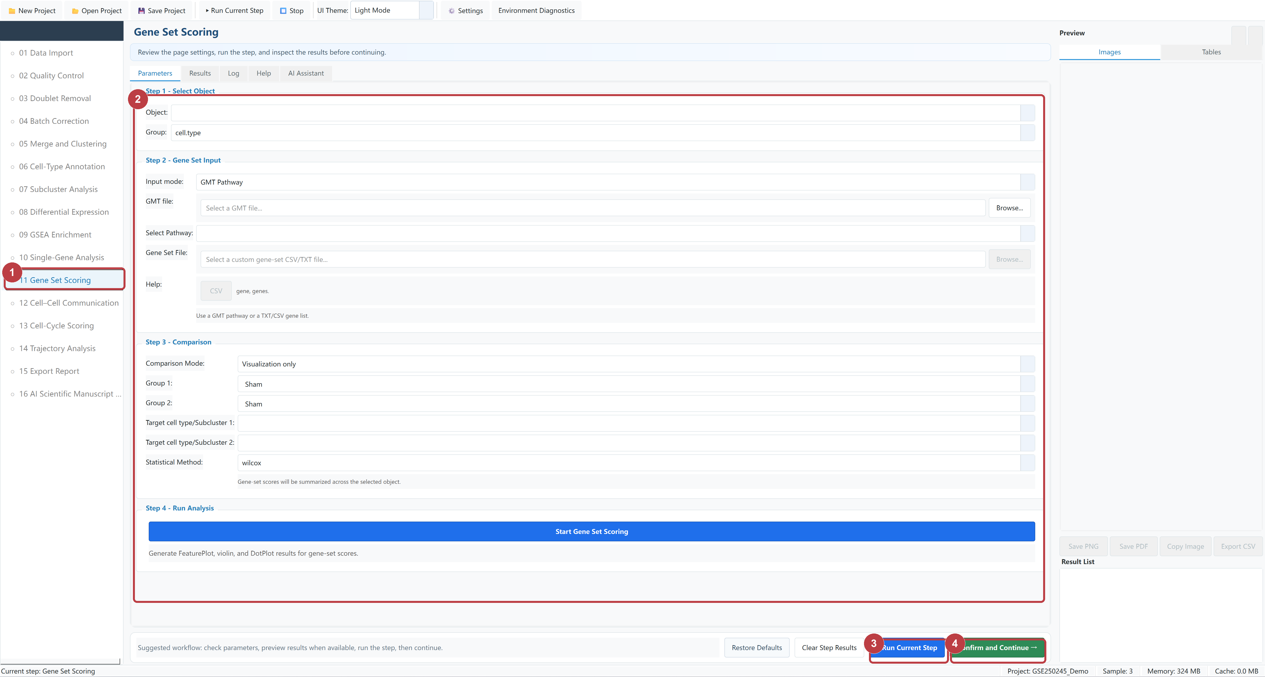
Figure 11-1 Gene Set Scoring controls
1 | Open Gene Set Scoring.
2 | Select GMT or Custom genes, the object, label column, and comparison settings.
3 | Click Run Current Step.
4 | When the Log reports success, click Confirm and Continue.

Common settings Select GMT Pathway or Custom genes, then confirm the object, label column, and comparison order.

12 Cell–Cell Communication
Purpose Run CellChat cell-cell communication analysis and optionally compare conditions. Before you run it: Cell-type annotation is complete; verify that the CellChat runtime is available first.
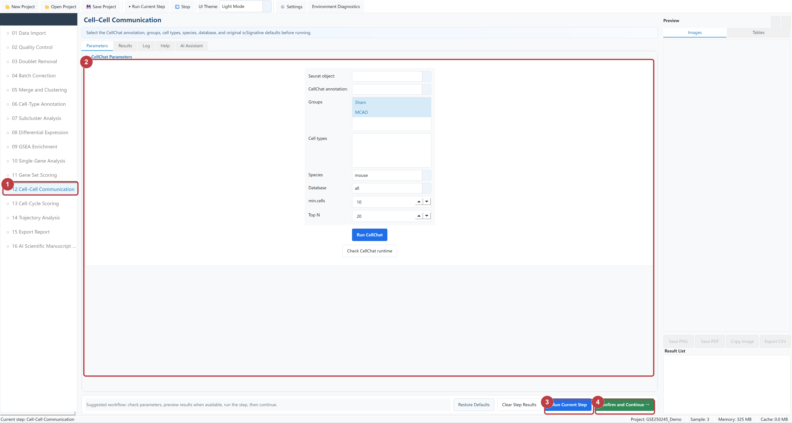
Figure 12-1 Cell–Cell Communication controls
1 | Open Cell-Cell Communication.
2 | Check the CellChat runtime, then select the object, identity, species, and database.
3 | Click Run Current Step.
4 | When the Log reports success, click Confirm and Continue.

Common settings Run Check CellChat runtime first, then select identity, species, database, and min cells.

13 Cell-Cycle Scoring
Purpose Calculate cell-cycle phases and scores from S/G2M markers. Before you run it: The object has a UMAP or t-SNE embedding and the correct species-specific S/G2M markers are selected.
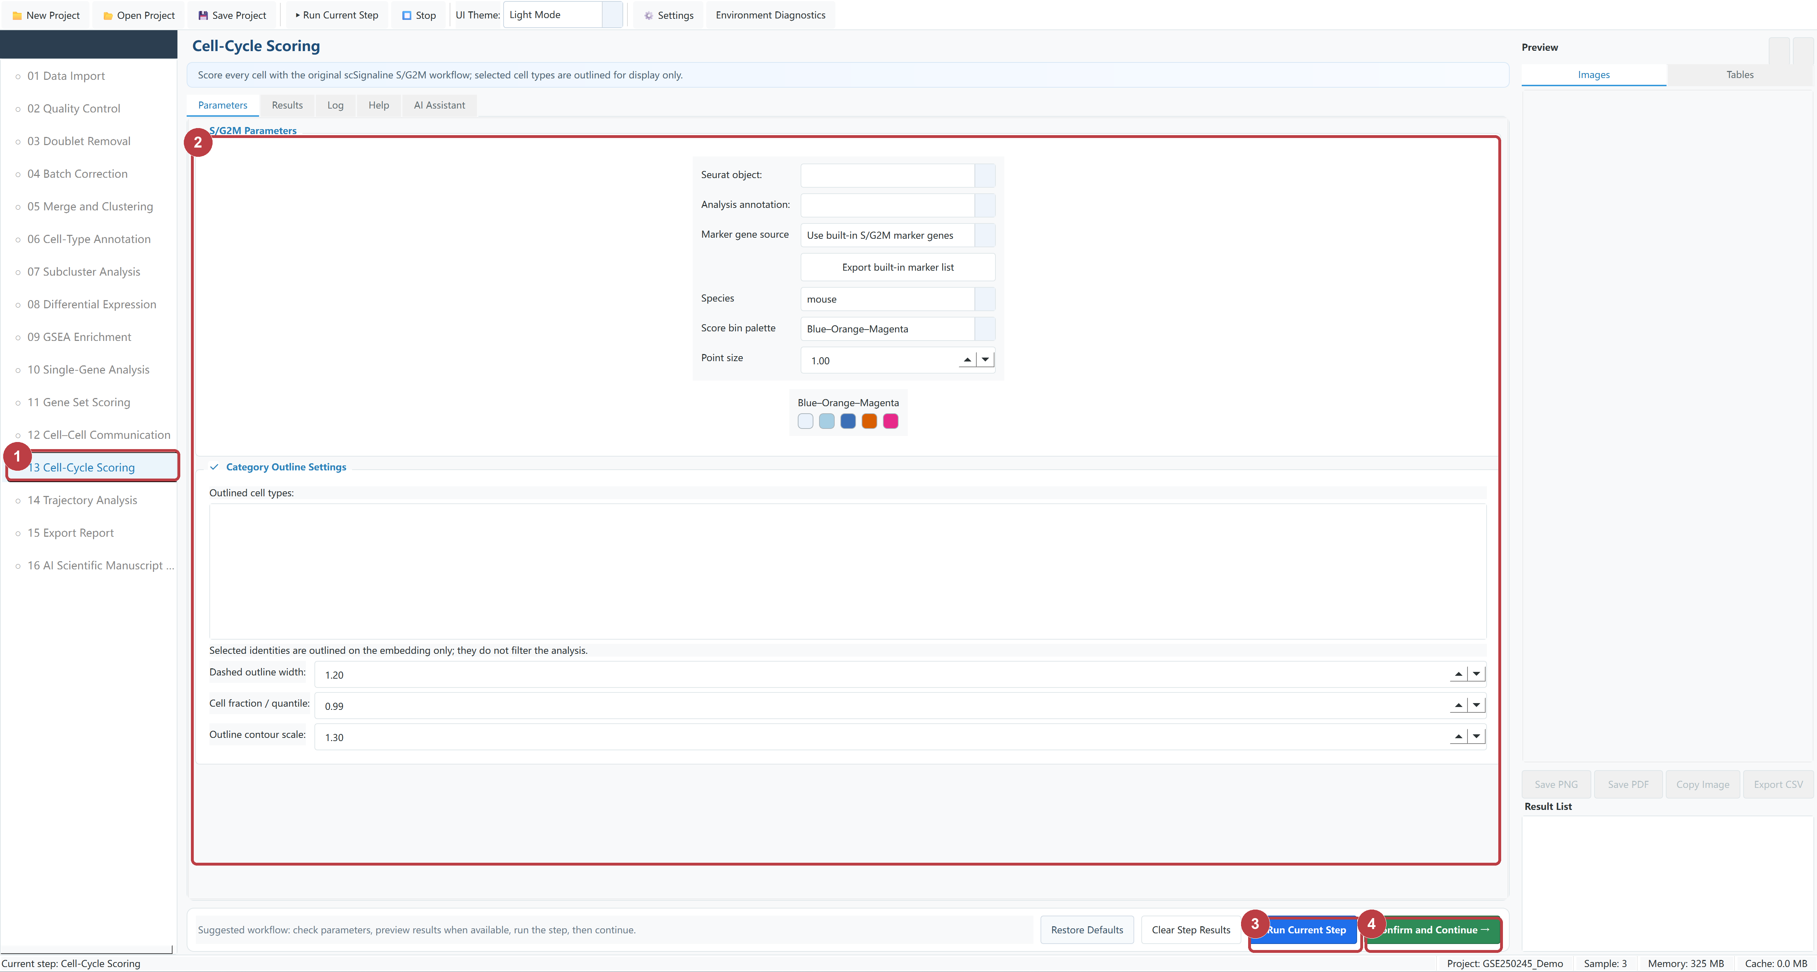
Figure 13-1 Cell-Cycle Scoring controls
1 | Open Cell-Cycle Scoring.
2 | Select the object, S/G2M markers, embedding, and display settings.
3 | Click Run Current Step.
4 | When the Log reports success, click Confirm and Continue.

Common settings Select built-in or custom S/G2M markers and an existing UMAP or t-SNE embedding.

14 Trajectory Analysis
Purpose Build a Monocle3 trajectory and pseudotime for selected cells. Before you run it: An annotated object and embedding exist, and the target cells plus root and terminal states are defined.
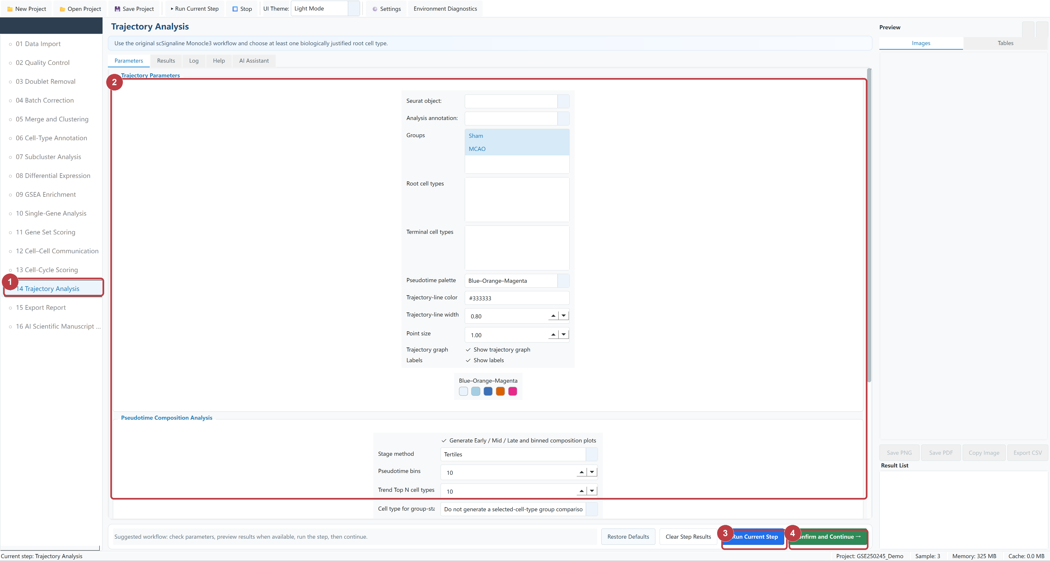
Figure 14-1 Trajectory Analysis controls
1 | Open Trajectory Analysis.
2 | Select the object, cell types, Monocle3, root and terminal states, and display settings.
3 | Click Run Current Step.
4 | When the Log reports success, click Confirm and Continue.

Common settings Monocle3; select target cells, root and terminal states, embedding, and trajectory display options.

15 Export Report
Purpose Export H5AD, Seurat objects, project packages, figures, tables, and report files. Before you run it: At least one exportable object or result exists and a writable output directory is available.

Choose what to export
Export | Use it for
H5AD | Exchange an analysis object with AnnData-compatible tools.
Project RDS | Save the project object for later use in scFlow Studio Agent.
Seurat RDS | Save a Seurat object for downstream work in R.
PNG / PDF / SVG | Export generated figures at the selected output resolution.
CSV / TSV / TXT | Export result tables.
Complete analysis | Collect the selected analysis files in a user-chosen output directory.

Run the export
Order | Action
1 | Open Export Report.
2 | Choose the object, format, and a writable output directory.
3 | Use the relevant export button, or Run Current Step for the configured main export.
4 | Check the Log and verify the generated files in the selected directory.

Common settings Preview DPI 150; Export DPI 300; ensure that the output drive has sufficient free space.

16 AI Scientific Manuscript Agent
Purpose Connect a compatible large-language-model service to organize completed analyses into a manuscript draft and exportable content. Before you run it: The target analyses are complete and recognized by Verify Report; online providers also require network access.
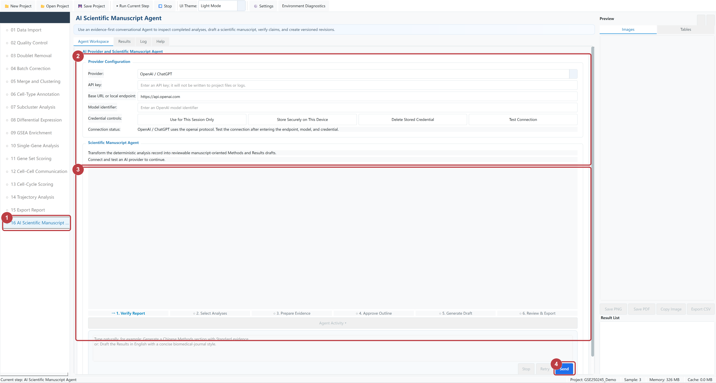
Figure 16-1 AI Scientific Manuscript Agent controls
1 | Open AI Scientific Manuscript Agent.
2 | Enter Provider, API key, Base URL, and Model, then click Test Connection.
3 | Proceed through Verify Report, Select Analyses, Prepare Evidence, Approve Outline, Generate Draft, and Review & Export.
4 | Enter an instruction in the message box and click Send.

Common settings Qwen example: select Alibaba Qwen (DashScope), keep the prefilled Base URL, enter the provider's model ID, choose Session Only for the API key, and click Test Connection.

Common Parameter Reference
This page summarizes the parameters most often encountered in the interface. First-time users can keep the listed defaults, then adjust them to match the experimental design.
Parameter | Meaning
UMI / genes / percent.mt | Total counts, detected genes, and mitochondrial percentage per cell; used for QC filtering.
HVG | Number of highly variable genes used for PCA, clustering, and embedding.
PCs / dims | Principal-component range used for neighbors, clustering, or dimensional reduction.
resolution | Clustering granularity; a larger value generally produces more clusters.
Seed | Random seed. Keep it unchanged when reproducing the same workflow.
Expected rate / pN / pK | Expected doublet rate and neighborhood parameters for DoubletFinder; Auto pK can search for pK.
Batch key | Metadata column representing a technical batch. Do not substitute a biological treatment group.
min.pct / logFC | Expression-percentage and effect-size thresholds for markers or differential analysis.
adjusted P cutoff | Significance cutoff after multiple-testing correction.
reduction / embedding | Current UMAP or t-SNE coordinates. Recheck subcluster settings after rerunning the major clustering step.
GMT | Gene-set file whose species, gene-ID type, and analysis object must match.
identity | Cell grouping or cell-type label column used by analyses such as CellChat.
root / terminal | Starting and terminal states in trajectory analysis; select them according to the biological question.

Reproducibility For comparable runs, keep the input data, sample order, parameters, Seed, application version, and bundled R environment identical.

Troubleshooting
Symptom | What to do
The first QC run starts slowly | The bundled R runtime is being prepared on its first use. Wait while progress and the Log continue to update.
H5AD import takes a long time | Confirm that the window remains responsive, the disk is active, and sufficient space is available. Large sparse matrices need more time and memory.
H5AD Group shows 0 or 1 | Edit the confirmation table to use the true experimental group names before proceeding to QC.
Environment Diagnostics shows system R | In Settings, select Auto or the bundled R runtime. Do not manually point to a system Rscript.
A black console window appears | Use the packaged application and its launcher. Do not start Rscript directly.
CellAssign runtime unavailable | Reinstall the complete release package that contains vendor/cellassign_Rsrc.
A subcluster still uses an old embedding | After rerunning major clustering, reopen Subcluster Analysis and verify reduction.
A task fails | Record the step name, parameters, final Log lines, and a screenshot before troubleshooting.

Stop and rerun
To stop a task, click Stop in the top toolbar and wait for the background process to finish.
After changing an upstream setting, rerun every downstream analysis that depends on that step.
Clear Step Result removes only the current step result; confirm that its cache is no longer needed first.

Security and privacy
Do not store API keys or licenses in projects, logs, screenshots, or exported files.
Before sharing a project, remove personal directories, sample identity information, and restricted raw data.
When reporting a problem, include the application version, step name, input format, parameters, and a sanitized Log excerpt.

