1. You need to go - https://lead-processor-493590288221.us-central1.run.app/
2. 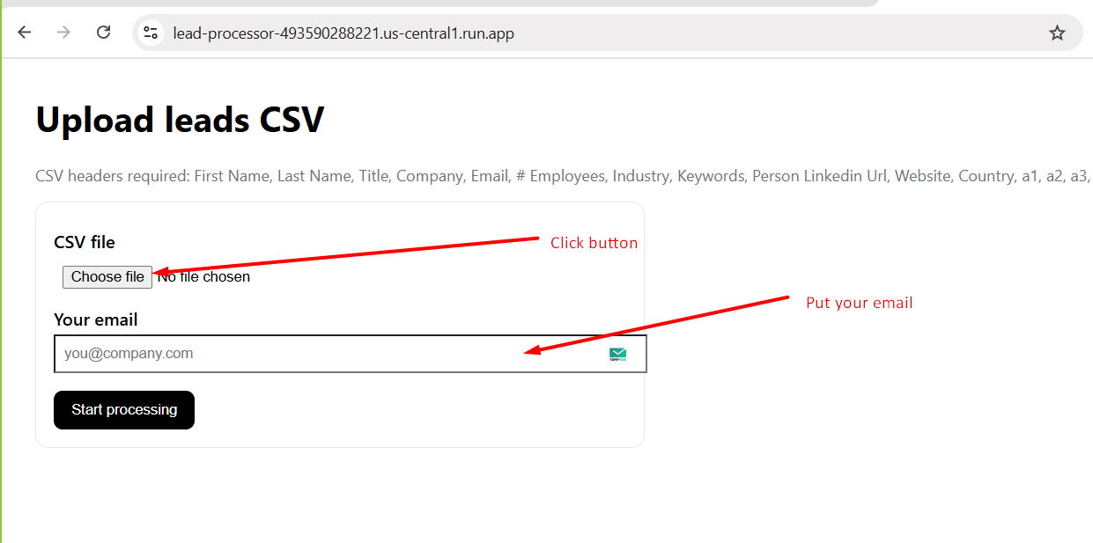
3. A screenshot of a computer

   AI-generated content may be incorrect.  
   you will get unique job_id.
4. After job is done, you will get csv file link in your email. No need to wait, you can close your browser.

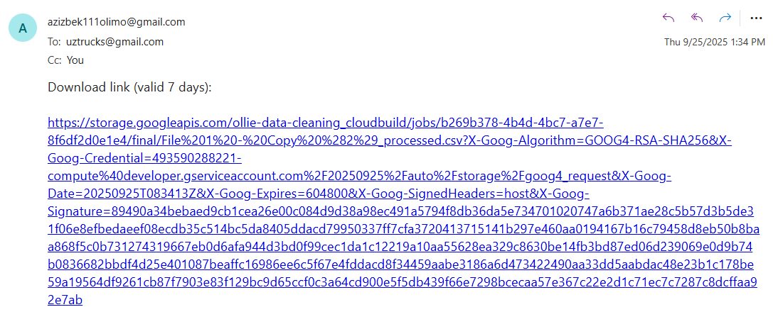

1. 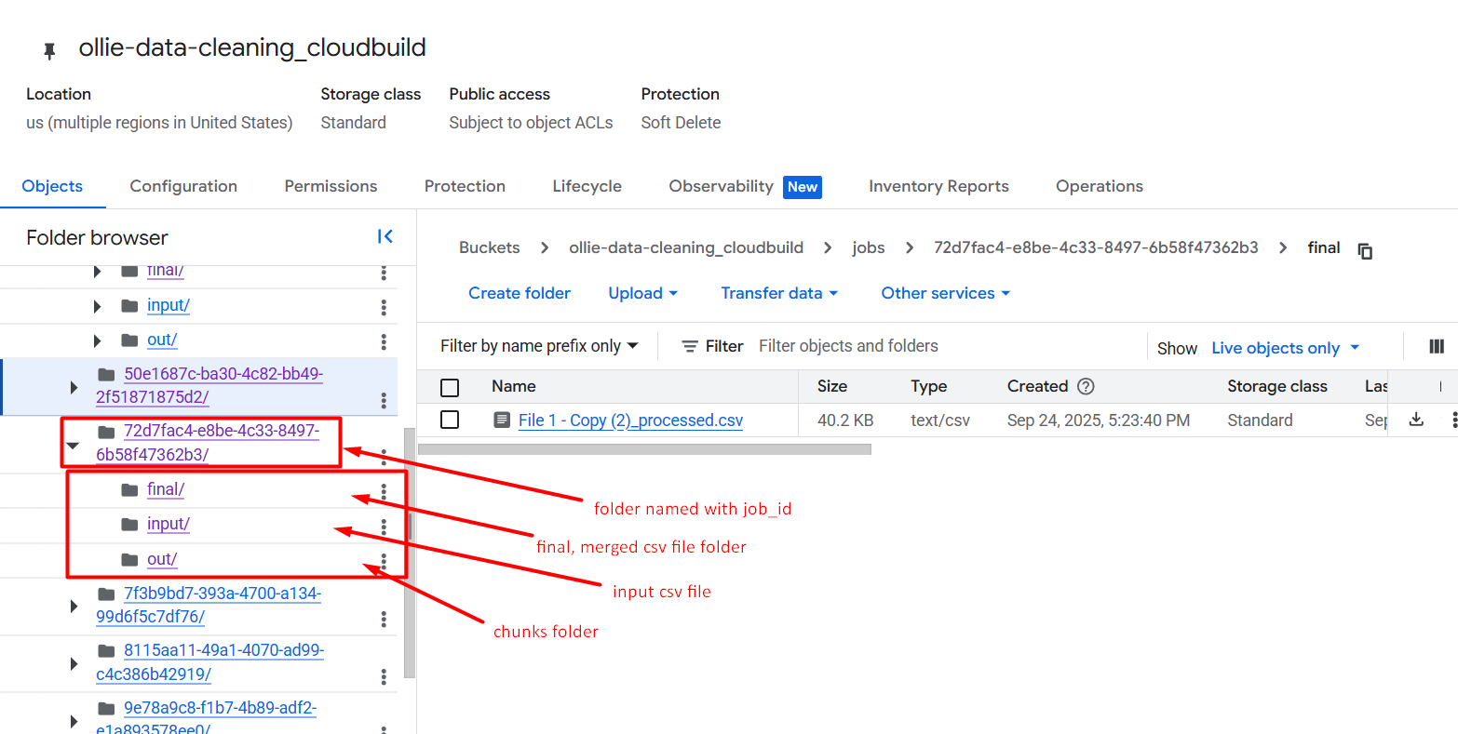

Every uploaded file will be stored in database

1. Later when you upload file, it will process it and store. Then you may check, filter information using UI (web-based frontend).