Consent page

***In-lab versions did not see this consent page

Consent Agreement: Implicit Social Cognition on the Internet
Studies at Project Implicit examine your ideas, beliefs, and opinions about different topics. You will be presented with a series of decision making tasks and a categorization task in which you will sort items into groups as quickly as possible. The study requires 10-15 minutes.
The study may help us understand how people make decisions in different situations, and provide an educational, engaging experience.
Project Implicit’s standard privacy policy applies to this study. To view the privacy policy in a separate pop up window, please click here.
Participation is voluntary, and you may end your participation at any time by closing the window. Contact Richard Klein (raklein@ufl.edu) if you have any questions about this study.
Who to contact about your rights in the study:
University of Florida Institutional Review Board (IRB02), P.O. Box 112250, Gainesville, FL 32611-2250
Telephone: (352) 392-0433; Email: irb2@ufl.edu.
By clicking the button below you are indicating that you have read the informed consent statements above and agree to participate.
Continue

Start screen
***In-lab the RA usually clicked past this screen prior to participant arriving
The study will begin in a separate window when you click below.
- For best results, minimize distractions and close other programs.
- The study uses a pop-up window and a temporary cookie. JavaScript must be enabled for the pop-up window to appear.
- Problems? Check with your experimenter, or if you are taking this online e-mail raklein@ufl.edu.
Do not exit this page. Doing so will automatically end the study.

See the green checkmark? Click Here to Begin.

Researcher/context questionnaire
*** In-lab, experimenters (usually) filled out this screen for participants. Online versions did not have this screen.

Researcher Questionnaire

IF YOU ARE A PARTICIPANT AND ARE SEEING THIS SCREEN, PLEASE ALERT YOUR EXPERIMENTER. Researchers, please answer all questions below. If you don't know how to answer a question, please leave it blank and leave a note in the comment box.

1. What is your gender?

Male

Female

Prefer not to answer

2. What is your race/ethnicity?

American Indian/Alaska Native

East Asian

South Asian

Native Hawaiian or other Pacific Islander

Black or African American

White

More than one race - Black/White

More than one race - Other

Other or Unknown

Hispanic or Latino

3. How many participants are taking this study during this timeslot? (That is, at the same time)

4. Were participants physically separated? (either by barriers or in separate rooms)

Yes, separate rooms, one participant per room

Yes, multiple participants per room but separated by barriers

No, participants were not separated (multiple per room, no barriers)

Other (please explain in comment box)

5. Is this the first study this participant will see during this session, or is this study being run after another study?

This study is being run after a different study

This study is being run alone or before another experiment

If this study is being run AFTER another study, please enter the name of the study that was run prior to this one (this should have been provided to you).

6. How were participants recruited?

University subject pool

Other subject pool

Completed in class

Fliers/advertisements/website announcements

Actively recruited from public areas

Other (please explain in comment box)

7. How were participants compensated?

Course credit

Paid money or entered into lottery

No compensation – volunteers

Other (please explain in comment box)

8. If you have any additional items to note or issues to clarify please explain those in this box:

Beginning of study intructions

***For most in-lab sites, this is the first screen participants saw.

Thank you for participating in our research! Before you begin, please make sure your browser window is maximized. This study is made out of many quick mini-studies that you will complete. Many of the tasks are completely different from each other, so don't worry if some of the questions seem out of place. For many of the tasks, you will simply answer a question or complete a short survey, while for others you may be asked to write down your thoughts, and for others you may be asked to rapidly categorize words and pictures. Please pay careful attention to the instructions and answer as honestly as you can. Your participation is important to the research process and we greatly appreciate it.
Please press the button below to continue.

Continue

The following pages were presented in random order (until the IAT study):

Retrospective Gambler’s Fallacy
“Common outcome” condition
Imagine that you are in a casino and you happen to pass a man rolling dice. You observe him roll three dice and one comes up 3, and two come up 6’s. Based on your imagined scenario, how many times do you think the man had rolled the dice before you walked by?
“Rare outcome” condition
Imagine that you are in a casino and you happen to pass a man rolling dice. You observe him roll three dice and all three come up 6’s. Based on your imagined scenario, how many times do you think the man had rolled the dice before you walked by?
DV:
Open response box
Imagined Contact
Muslim contact condition:
I would like you to take a minute to imagine yourself meeting a Muslim stranger for the first time. During the conversation imagine you find out some interesting and unexpected things about the stranger. (The continue button will appear after 1 minute)

Control condition:
I would like you to take a minute to imagine you are walking in the outdoors. Try to imagine aspects of the scene around you (e.g., is it a beach, a forest, are there trees, hills, what's on the horizon). (The continue button will appear after 1 minute)

Writing task (both conditions did this after imagining the scenario for 1 minute)
Describe as many aspects of the scenario you just imagined as possible: (Please do not use the "Enter" key, just type your thoughts in a paragraph).
<<Open response block was here>>
The continue button will appear after 1 minute.

Imagined Contact DV
How much do you intend to interact with Muslims in the future?
9 point drop-down scale: 1 – not at all, 9 – very much
How much time do you think you might spend learning about Islam in the future?
9 point drop-down scale: 1 – none at all, 9 – a lot of time
How important do you think interacting with Muslims is?
9 point drop-down scale: 1 – not at all important, 9 – highly important
How willing would you be to attend a mosque gathering to learn more about Islamic beliefs and practices?
9 point drop-down scale: 1 – not at all willing, 9 – very willing

Flag priming
Screenshot from flag prime condition: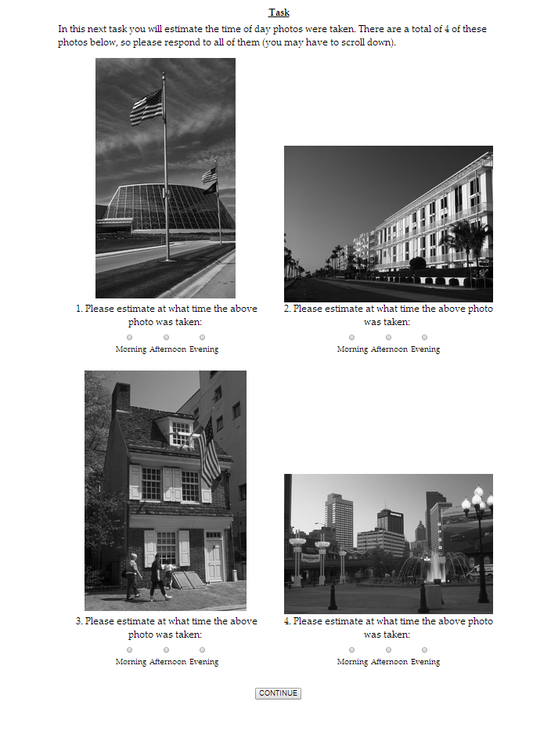
Screenshot from control condition:
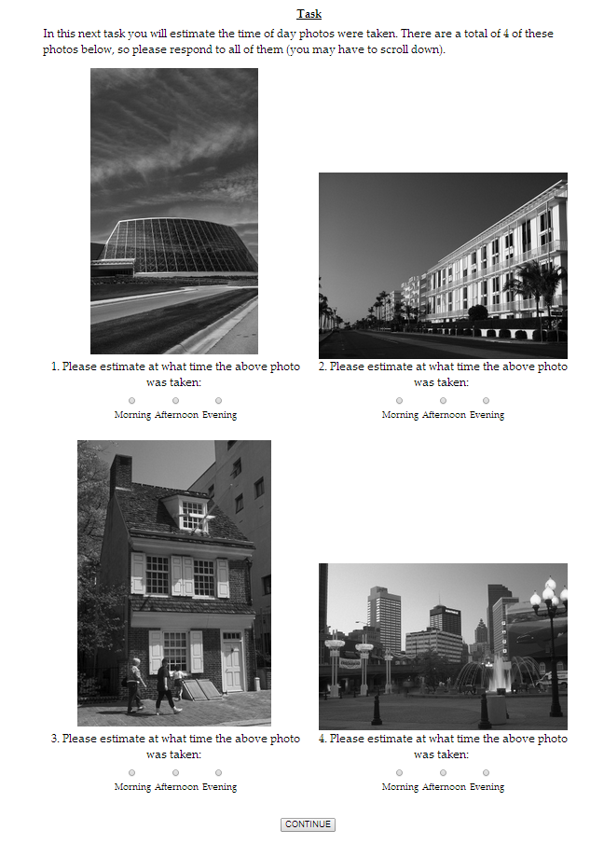
Flag priming DV:
All items were on 7-point scales (radio buttons):
For each statement below, indicate the degree to which you agree or disagree according to how you feel right now.
1) Laws designed to protect the environment pose too high a cost on businesses that contribute to the economy.
1 – Completely disagree
7 – Completely agree
2) A woman should have the right to choose what to do with her body, even if that means getting an abortion. <<Reverse scored>>
1 – Completely disagree
7 – Completely agree
3) The United States should not have invaded Iraq. <<Reverse scored>>
1 – Completely disagree
7 – Completely agree
4) Homosexuals should have the same right to marriage as anyone else. <<Reverse scored>>
1 – Completely disagree
7 – Completely agree
5) Affirmative action gives those groups with a history of oppression a chance to get ahead. <<Reverse scored>>
1 – Completely disagree
7 – Completely agree
6) Gun control laws are not nearly strict enough. <<Reverse scored>>
1 – Completely disagree
7 – Completely agree
7) It is important for our legal system to use the death penalty as punishment for heinous crimes.
1 – Completely disagree
7 – Completely agree
8) Stem Cell research has important implications for medical advances, and should be pursued at all costs. <<Reverse scored>>
1 – Completely disagree
7 – Completely agree

Norm of Reciprocity
(Both items displayed to all participants, order was reversed in “other country first” condition)

Do you think the United States should let newspaper reporters from North Korea come in here and send back to their papers the news as they see it?
Yes
No

Do you think North Korea should let American newspaper reporters come in and send back to America the news as they see it?
Yes
No

Disease Framing
“Saved” condition (positive outcome)
Imagine that the United States is preparing for the outbreak of an unusual disease, which is expected to kill 600 people. Two alternative programs to fight the disease have been proposed. Assume that the exact scientific estimate of the consequences of the program are as follows:
If Program A is adopted, 200 people will be saved
If Program B is adopted, there is 1/3 probability that 600 people will be saved and 2/3 probability that no people will be saved.
Which program would you choose?
Choose program:
Program A
Program B

“Will die” condition (negative outcome)
Imagine that the United States is preparing for the outbreak of an unusual disease, which is expected to kill 600 people. Two alternative programs to fight the disease have been proposed. Assume that the exact scientific estimate of the consequences of the program are as follows:
If Program C is adopted, 400 people will die.
If Program D is adopted, there is 1/3 probability that no people will die and 2/3 probability that 600 people will die.
Which program would you choose?
Choose program:
Program C
Program D

Sunk costs:
Paid condition:
Imagine that your favorite football team is playing an important game. You have a ticket to the game that you have paid handsomely for. However, on the day of the game, it happens to be freezing cold. What do you do?
9 point drop-down scale: 1 – Definitely stay at home, 9 – Definitely go to the game

Free condition:
Imagine that your favorite football team is playing an important game. You have a ticket to the game that you have received for free from a friend. However, on the day of the game, it happens to be freezing cold. What do you do?
9 point drop-down scale: 1 – Definitely stay at home, 9 – Definitely go to the game

Money priming
All participants filled out the following information, background varied by condition:
You will continue to do a variety of different experiments.
Because the studies are all different, it is important that you read each set of instructions carefully before completing each study.
PART 1:
Please answer the following questions about yourself.
What is your age?

What is your gender?
Male
Female
What is your ethnicity?
<<Open response>>
Please click below to continue to the next study.
Continue
Background of page for money condition:

Background of page for control condition:


Money priming screenshots:
Money condition:
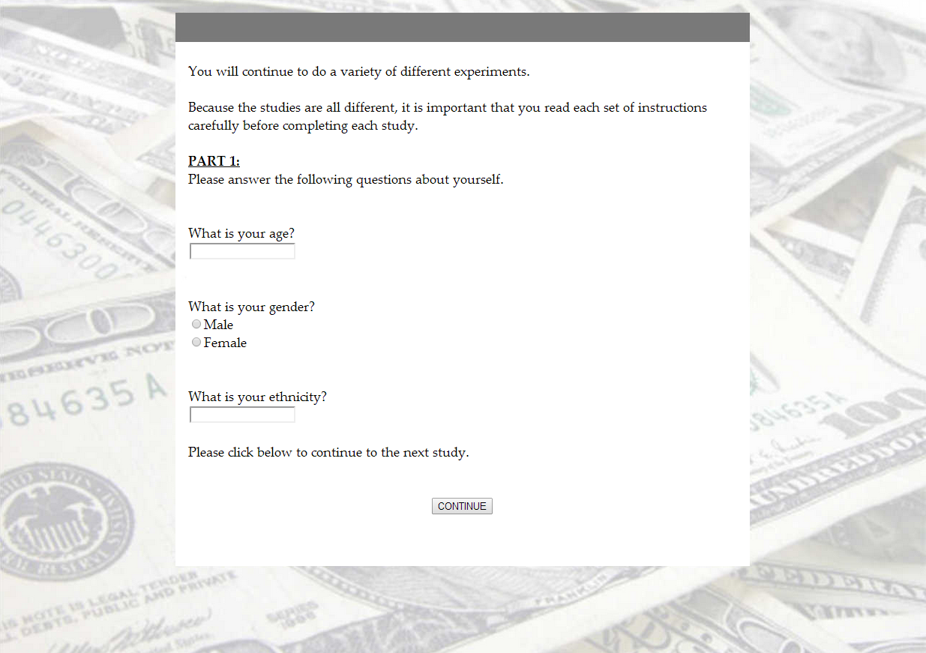
Control condition:
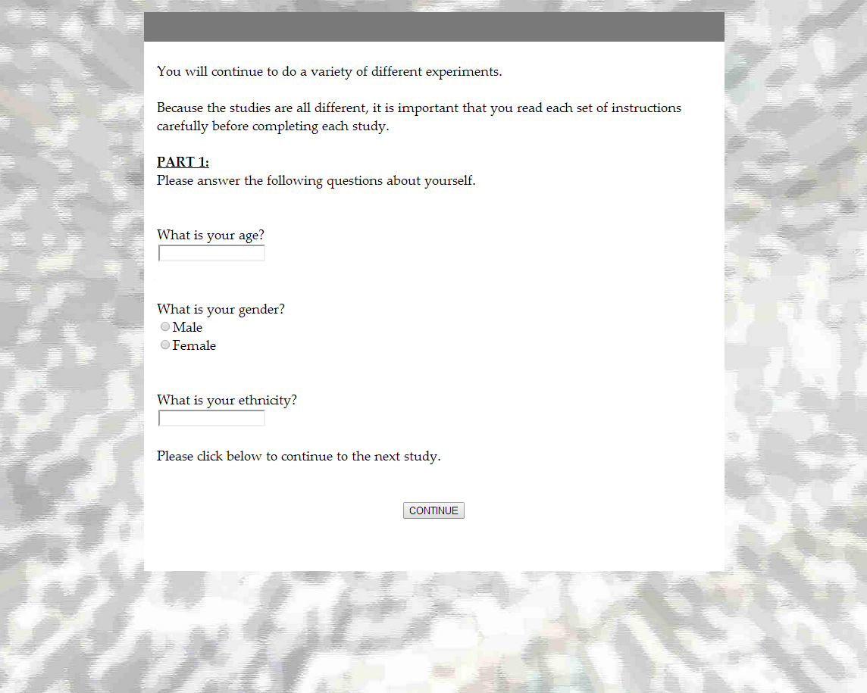
Money priming DV:

Please rate the extent to which you agree/disagree with each of the statements below: (Note that there are 8 questions, you may have to scroll down to see the rest)

1. In general, I find society to be fair.
1 - Strongly Disagree
2
3
4 - Neither Agree nor Disagree
5
6
7 - Strongly Agree

2. In general, the American political system operates as it should.
1 - Strongly Disagree
2
3
4 - Neither Agree nor Disagree
5
6
7 - Strongly Agree

3. American society needs to be radically restructured. <<Reverse scored>>
1 - Strongly Disagree
2
3
4 - Neither Agree nor Disagree
5
6
7 - Strongly Agree

4. The United States is the best country in the world to live in.
1 - Strongly Disagree
2
3
4 - Neither Agree nor Disagree
5
6
7 - Strongly Agree

5. Most policies serve the greater good.
1 - Strongly Disagree
2
3
4 - Neither Agree nor Disagree
5
6
7 - Strongly Agree

6. Everyone has a fair shot at wealth and happiness.
1 - Strongly Disagree
2
3
4 - Neither Agree nor Disagree
5
6
7 - Strongly Agree

7. Our society is getting worse every year. <<Reverse scored>>
1 - Strongly Disagree
2
3
4 - Neither Agree nor Disagree
5
6
7 - Strongly Agree

8. Society is set up so that people usually get what they deserve.
1 - Strongly Disagree
2
3
4 - Neither Agree nor Disagree
5
6
7 - Strongly Agree

Continue
Anchoring

Page displayed before the anchoring items:
We are interested in people's beliefs about the world around them. For each of the following 4 questions we would like you to give your best estimate. If you do not know the correct answer, just give your best guess.

Anchoring conditions displayed in random order, 1 per page:

Anchoring (babies) high condition:
Less than 50,000 babies are born per day in the United States. How many babies do you think are born in the U.S. each day?
<<DV was an open response box labelled “(babies)”>>

Anchoring (babies) low condition:
More than 100 babies are born per day in the United States. How many babies do you think are born in the U.S. each day?
<<DV was an open response box labelled “(babies)”>>

Anchoring (Chicago) high condition:
The population of Chicago is less than 5,000,000. What do you think the population of Chicago is?
<<DV was an open response box labelled “(people)”>>

Anchoring (Chicago) low condition:
The population of Chicago is more than 200,000. What do you think the population of Chicago is?
<<DV was an open response box labelled “(people)”>>

Anchoring (Everest) high condition:
Mount Everest is shorter than 45,500 feet. How tall do you think Mount Everest is?
<<DV was an open response box labelled “(feet)”>>

Anchoring (Everest) low condition:
Mount Everest is taller than 2,000 feet. How tall do you think Mount Everest is?
<<DV was an open response box labelled “(feet)”>>

Anchoring (SF to NY) high condition:
The distance from San Francisco to New York City is shorter than 6,000 miles. How far do you think it is?
<<DV was an open response box labelled “(babies)”>>

Anchoring (SF to NY) low condition:
The distance from San Francisco to New York City is longer than 1,500 miles. How far do you think it is?
<<DV was an open response box labelled “(miles)”>>
Frequency scales:

Low frequency condition:

How much television do you watch per day?

Drop-down scale with options:
Up to a half hour
Half an hour to an hour
One to one and a half hours
One and a half to two hours
Two to two and a half hours
More than two and a half hours

High frequency condition:

How much television do you watch per day?

Drop-down scale with options:
Up to two and a half hours
Two and a half to three hours
Three to three and a half hours
Three and a half to four hours
Four to four and a half hours
More than four and a half hours

Allowed/forbidden

“Forbidden” condition:
Do you think the United States should forbid public speeches against democracy?

Yes
No

“Allowed” condition:
Do you think the United States should allow public speeches against democracy?

Yes
No

Quote attribution

Liked target condition:
A quote similar to what follows was once spoken by George Washington: "I have sworn to only live free, even if I find bitter the taste of death."

Disliked target condition:
A quote similar to what follows was once spoken by Osama Bin Laden: "I have sworn to only live free, even if I find bitter the taste of death."

DV:
How much do you agree with this quote?

1 – strongly agree
2
3
4
5 – neither agree nor disagree
6
7
8
9 – strongly disagree

End randomization – The following pages were presented in the order they appear in this document:
Math/Art Implicit Association Test

IAT Categories:

Mathematics: math, algebra, geometry, calculus, equations, computation, numbers, Newton

Arts: poetry, art, Shakespeare, dance, literature, novel, symphony, drama

Pleasant Words: ambition, cuddle, excitement, glory, joy, love, paradise, pleasure, romantic, miracle

Unpleasant Words: agony, death, detest, disaster, humiliate, jealousy, punishment, stress, tragedy, war

Explicit DVs:

***Below are the measures for math. The measures for art were exactly the same except “math” was replaced with “art”. Participants were asked both sets of questions.

Feeling thermometer:
Please move the slider bar from the left (0 = cold/unfavorable) to the right (100 = warm/favorable) to indicate your overall feeling toward math. When the slider bar is in the location that indicates your overall feelings, please click "Continue".

0 = cold/unfavorable
100 = warm/favorable

If participants didn’t move the slider they received this prompt and could not continue until they moved the slider:
Please choose a position above before continuing!

Semantic differential scales:
Please rate how you feel about math on a scale from good to bad:
Very Good
Moderately Good
Slightly Good
Neither Good Nor Bad
Slightly Bad
Moderately Bad
Very Bad

Please rate how you feel about math on a scale from happy to sad:
Very Happy
Moderately Happy
Slightly Happy
Neither Happy Nor Sad
Slightly Sad
Moderately Sad
Very Sad

Please rate how you feel about math on a scale from beautiful to ugly:
Very Beautiful
Moderately Beautiful
Slightly Beautiful
Neither Beautiful Nor Ugly
Slightly Ugly
Moderately Ugly
Very Ugly

Please rate how you feel about math on a scale from delightful to disgusting:
Very Delightful
Moderately Delightful
Slightly Delightful
Neither Delightful Nor Disgusting
Slightly Disgusting
Moderately Disgusting
Very Disgusting

Please rate how you feel about math on a scale from approach to avoid:
Very Approach
Moderately Approach
Slightly Approach
Neither Approach Nor Avoid
Slightly Avoid
Moderately Avoid
Very Avoid

Please rate how you feel about math on a scale from unafraid to afraid:
Very Unafraid
Moderately Unafraid
Slightly Unafraid
Neither Unafraid Nor Afraid
Slightly Afraid
Moderately Afraid
Very Afraid

Instructional Manipulation Check
Instructions
Most modern theories of decision making recognize the fact that decisions do not take place in a vacuum. Individual preferences and knowledge, along with situational variables can greatly impact the decision process. In order to facilitate our research on decision making we are interested in knowing certain factors about you, the decision maker. Specifically we are interested in whether you actually take the time to read the directions; if not, then some of our manipulations that rely on changes in the instructions will be ineffective. So, in order to demonstrate that you have read the instructions, please ignore the continue button below. Instead simply click on the title at the top of this screen (i.e., Instructions) to proceed to the next screen. Thank you very much.
Continue
Click once to color it yellow, then click again to continue.
*** If participants clicked “Instructions” they passed, if they clicked “continue” twice they failed. Either way they continued to the next part without indication of whether they failed or passed.

Participant characteristics questionnaire

Questionnaire
You are almost finished with the experiment. Please answer the following questions about yourself, even if you have answered similar questions earlier in the experiment.

Sex:
Drop-down menu options:
Female
Male

Age
<<Drop-down menu from 11 to 100>>

Race:
Drop-down menu options:
American Indian/Alaska Native
East Asian
South Asian
Native Hawaiian or other Pacific Islander
Black or African American
White
More than one race - Black/White
More than one race - Other
Other or Unknown

Ethnicity:
Drop-down menu options:
Hispanic or Latino
Not Hispanic or Latino
Unknown

Country of Citizenship:
<<Drop down menu with 200+ options>>

If you selected “other”, please enter your country of citizenship here:
<<Open response box>>

Major (if current student):
Biological sciences/life sciences
Business
Communications
Computer and information sciences
Education
Engineering, mathematics, physical sciences/technologies
Health professions or related sciences
Humanities/liberal arts
Law or legal studies
Psychology
Social sciences or history
Visual or performing arts
Other

Political Identity:
Drop-down menu options:
Strongly Liberal
Moderately Liberal
Slightly Liberal
Neutral (Moderate)
Slightly Conservative
Moderately Conservative
Strongly Conservative

Native Language
Drop-down menu options:
English
Spanish
Other

If you answered “other” above, please type your native language here:
<<Open response box>>

Flag-prime moderators:

How much do you identify with Americans?
11 point drop down menu: 1 – Not at all, 11 – Very much

To what extent do you think the typical American is a Republican or Democrat?
7 point drop down menu: 1 – Democrat, 7 – Republican

To what extent do you think the typical American is conservative or liberal?
7 point drop down menu: 1 – Liberal, 7 – Conservative

Prior exposure items:

***Only collected for Project Implicit and MTurk samples due to time concerns

Below we have listed the "mini studies" you completed during this experiment. Please indicate if you have, prior to beginning this experimental session, learned about or taken part in previous research about these specific effects listed below.

1. Sunk Costs - You were given a scenario where you had a ticket to a football game and were asked how likely you would be to attend it in the freezing cold.

Drop-down menu response options for each question:
No, I have not seen this prior to this study
Yes, I have seen this prior to this study

2. Gain vs. Loss Framing - You were given a scenario where a deadly disease was spreading, and had to choose between two options: A) Save a certain amount of people for certain, or B) Risk saving everyone or saving nobody

3. Anchoring and Adjustment - You were asked to estimate the quantities of various items, and a number was included in the question (e.g. "The population of Chicago is greater than 200,000. What is the population of Chicago?")

4. Retrospective Gambler's Fallacy - You were told to envision a man who had just rolled some dice, and were asked to estimate how many times he had previously rolled the dice.

5. Low-vs-high Frequency Scales - You were asked to estimate how much time you watch television on either a scale ranging from "less than .5 hours" to "2.5+ hours", or a scale from ranging from "less than 2.5 hours" to "4.5+ hours".

6. Norm of Reciprocity - You were asked two questions regarding whether the U.S. should allow foreign reporters in, and whether foreign countries should allow U.S. reporters in.

7. Allowed/Forbidden - You were asked if public speeches against democracy should be allowed or forbidden.

8. Quote Attribution - You were asked to rate a quote spoken by George Washington or Osama Bin Laden.

9. Flag Priming - You were asked to estimate at what time of day pictures were taken. These pictures may have had American flags in them, or not. You were then asked to indicate your position on various political topics.

10. Money Priming - You were asked to fill out some demographic information, and in the background there may have been an image of money or not. You were then asked several questions regarding how you felt about the current American social system.

11. Imagined Contact - You were asked to imagine a scenario for 1 minute, and then write about that scenario for another minute. You were then asked several questions about your intentions to interact with Muslims in the future.

12. Math/Art Attitudes - You completed a categorization task (an Implicit Association Test) where you categorized items according to whether they were math or art, or good or bad. You were then asked several questions about how you feel about math and art.

13. Instructional Manipulation Check - You were presented a page with a lot of text and instructions. In the middle of the instructions you were told to ignore what the instructions were telling you, and to instead click on the top of the study page to continue.

Last page

You have finished the study.

When you click "continue", this pop-up window will close and your results will appear in the main browser window.

Click here to Continue

Debriefing
Debriefing
Thank you for your participation. Your participation is vital in helping to uncover the psychological processes that influence our everyday lives.
During this experiment, you completed 12 different tasks that have already been demonstrated and published in psychological journals. We bundled these tasks into one experiment and had you complete them here because we are curious if these results will be obtained in different participant samples and test-taking environments.
One study you completed was an Implicit Association Test. When someone asks us to report our attitude about something we consciously consider our preferences and decide how we feel. We typically call this form of an attitude an 'explicit attitude.' For the past 20 years, psychologists have been investigating a different type of attitude call an 'implicit attitude.' As the name implies, this type of preference does not require that a person consciously think about their preference. Rather, implicit attitudes are those attitudes that may exist outside conscious awareness or conscious control. As such, psychologists have needed to find indirect ways to study them.
Your Result on the Math-Arts IAT
In this study, preference was measured by timing the speed with which you made judgments in the computer task. The basic principle of the task is that you will be able to classify words when the groups are related (i.e., math and pleasant on the same key) faster compared to situations where the groups are not related (i.e., math and unpleasant on the same key). In this way we are measuring an implicit preference for math that does not require that you consciously consider your feelings about math. Instead, we assess the degree of association between concepts (i.e., math) and evaluation (i.e., pleasant and unpleasant). We argue that the speed with which you make these associations reflects your implicit attitude.
It is important to note that implicit attitudes are not more 'real' than our self-reported preferences. Our conscious attitudes help us decide how we want to behave with different groups of people, where we stand on political issues, or what we want to do next. Our current understanding of implicit attitudes suggests that they form through exposure in our environment.
In other parts of the study, you completed judgments about a variety of scenarios. These questions are common tasks in psychological research to investigate how people make decisions. For example, in one question you were asked to estimate the height of Mt. Everest. Some people were told that it was taller than 2,000 ft. Other people were told that it was shorter than 45,500 ft. It turns out that this initial number serves as an 'anchor.' People who are told it is 'taller than 2,000 ft' reliably estimate Mt. Everest to be shorter than people who are told that it is 'shorter than 45,500 ft'. We are collecting data for this study in various laboratory and Internet samples to see if tasks like these 'work better' in one setting versus another. Knowing this will help clarify when it is appropriate to do studies on-line compared to in the lab.
If you have any questions about this study or if you would like to find out the overall results, please email Richard Klein at raklein@ufl.edu.

