IMPLEMENTATION BRIEF
Professional Prompt for Claude
Mobile app fixes and platform improvements, rewritten as a production-ready engineering brief in English.

Scope rule
Unless an item explicitly mentions the website/web, treat every requirement in this document as a mobile-app requirement. If an item explicitly says both mobile and web, implement it consistently on both surfaces.

PROMPT TO CLAUDE
You are working on an existing production education platform. Review the current codebase and data model before making changes, identify the root cause of each issue, and implement production-ready fixes without breaking existing user flows. Use the project's existing architecture, state-management approach, design system, API conventions, and localization structure wherever possible. Do not hard-code temporary workarounds when a reusable solution is appropriate.
General implementation requirements
- Preserve backward compatibility and avoid unrelated UI or behavior changes.
- Keep all user-facing strings inside the localization system; do not scatter hard-coded translations across components.
- For mobile UI fixes, verify behavior on multiple screen sizes and more than one Android device/emulator profile. If the project also ships on iOS, verify the same behavior there.
- Use responsive, accessible UI patterns and provide clear feedback for user actions.
- Where data must be researched from the internet, prefer authoritative or official sources, normalize the data, remove duplicates, and do not invent records that cannot be verified.
- After implementation, report the root cause, the files/components changed, the test/verification steps performed, and any data sources used for regional/school data.
1 | Fix inconsistent rendering of the Azerbaijani letter “ə/Ə”  In the Parent Panel > Analytics area, the Azerbaijani letter “ə” is missing or rendered incorrectly on some phones. The same issue appears in the streak text in the top-right area of the platform. The problem is device-dependent, which strongly suggests a font/glyph/fallback inconsistency. Fix the rendering so Azerbaijani characters display correctly and consistently on all supported phones.  Acceptance criteria  - Audit the active font family, custom font assets, font weights, and fallback chain used by the affected UI components.  - Ensure the selected font and every required weight contain Azerbaijani glyphs, especially “ə” and “Ə”.  - Use a reliable Unicode-capable fallback instead of allowing unsupported glyphs to appear as boxes, blanks, or missing characters.  - Verify the Parent Analytics labels and the top-right streak text on multiple device profiles/OS versions.  - The fix must not alter typography elsewhere in a way that breaks the existing visual design.

2 | Make language switching update the entire platform, including subject names  When the user changes the application language, subject names in the Analytics section do not update. Review the localization flow and make language changes propagate immediately across the whole platform, not only in selected screens.  Acceptance criteria  - Subject names and every visible localized label must update immediately after a language change.  - Remove stale cached labels or component state that prevents re-rendering in the new locale.  - Use translation keys or localized data fields consistently rather than storing a previously rendered language value in UI state.  - Verify navigation labels, analytics, subject lists, streak text, forms, validation messages, and other visible application text.

3 | Refresh Admin Panel data automatically after edits in the mobile app  In the mobile Admin Panel, when an administrator changes data, the screen does not refresh automatically. The updated value becomes visible only after the user scrolls. Fix the state/data-refresh behavior so the UI reflects changes immediately after a successful update.  Acceptance criteria  - After create/update/delete operations, refresh or invalidate the relevant local/query state automatically.  - The user must not need to scroll, leave the screen, reopen the page, or perform a manual refresh to see the latest data.  - Avoid unnecessary full-screen reloads if the existing architecture supports targeted reactive updates.  - Preserve loading, error, and optimistic-update behavior in a predictable way.

4 | Add a professional “Copy Child ID” control in the Parent Panel on mobile and web  On both the mobile app and the website, add a copy action next to the child ID in the Parent Panel. The UI must look intentional and professional and must fit the existing design system.  Acceptance criteria  - Use a clear copy icon/button positioned next to the child ID without crowding the layout.  - Copy the exact child ID to the clipboard on tap/click.  - Provide immediate confirmation such as a localized toast/snackbar (“Copied”).  - Support accessibility semantics/labels and appropriate touch/click target size.  - Implement the feature consistently on both mobile and web.

5 | Complete the city/district list in child registration and add smart search  The child-registration location list currently contains mainly large cities and is missing districts/regions such as Hacıqabul. Review the full list of Azerbaijani cities and districts and add every missing location. Add a search box above the selector so users can find a location quickly.  Acceptance criteria  - Include all relevant cities and districts/regions, not only major cities.  - Use the correct Azerbaijani display names and avoid duplicate or inconsistent spellings.  - Add instant search that starts returning useful results after only a few typed characters.  - Search should be tolerant of Azerbaijani diacritics and close spellings. For example, searching “Hacı”, “Haci”, or “Haciqabul” should still be able to return “Hacıqabul”.  - Prefer normalized prefix/fuzzy matching rather than requiring an exact character-for-character match.  - Keep the selector usable on small mobile screens and with the on-screen keyboard open.

6 | Research and add schools for all cities and districts, including Admin Panel management  Research schools across all Azerbaijani cities and districts and add the school data to the platform. The data must also be available in the appropriate Admin Panel area so administrators can view and manage the schools in the correct regional context.  Acceptance criteria  - Use available web-research tools and prioritize official/authoritative education or government sources where possible.  - Cover all cities and districts represented in the registration flow, not just Baku or other large cities.  - Maintain a clear relationship between each school and its city/district.  - Normalize naming, remove duplicates, and preserve meaningful school numbers/names.  - Use an import/seed/data-migration approach appropriate for the project instead of manually hard-coding a large dataset into UI components.  - Ensure the Admin Panel can correctly display and manage the resulting school data.  - If a school cannot be verified reliably, do not fabricate it; report the gap separately.

7 | Introduce a moderate password-strength policy without disrupting existing users  The platform currently allows users to choose very weak passwords. Add a moderate password policy for newly created passwords. At minimum, a password must contain one uppercase letter and one special character. This must not retroactively invalidate or force-change passwords for existing accounts.  Acceptance criteria  - Apply the new rule when a new user/account password is created.  - Apply the same rule when an existing user chooses to change the password, and in any reset flow that asks the user to set a new password.  - Do not force existing users to change a previously accepted password solely because of this release.  - Enforce the rule on the backend as the source of truth, with matching client-side validation for immediate feedback.  - Provide clear localized validation messages explaining the uppercase and special-character requirements.  - Do not silently change authentication behavior for already-created profiles.

Definition of done
- All seven requirements are implemented with no regression in existing parent, admin, registration, localization, or authentication flows.
- Azerbaijani characters render correctly across supported mobile devices.
- Language changes update all visible localized content immediately.
- Admin edits appear without scroll-triggered refresh behavior.
- Child ID copy works on both mobile and web with clear feedback.
- The location and school datasets are complete to the extent supported by verified sources and are correctly linked in the Admin Panel.
- Password requirements affect only newly chosen passwords and do not force a migration for existing users.
- Provide a concise implementation summary and test checklist after completing the work.
Reference screenshots
Use these screenshots as visual context for the reported mobile-app issues. They are references only; implement the underlying root-cause fixes rather than matching a single device screenshot.
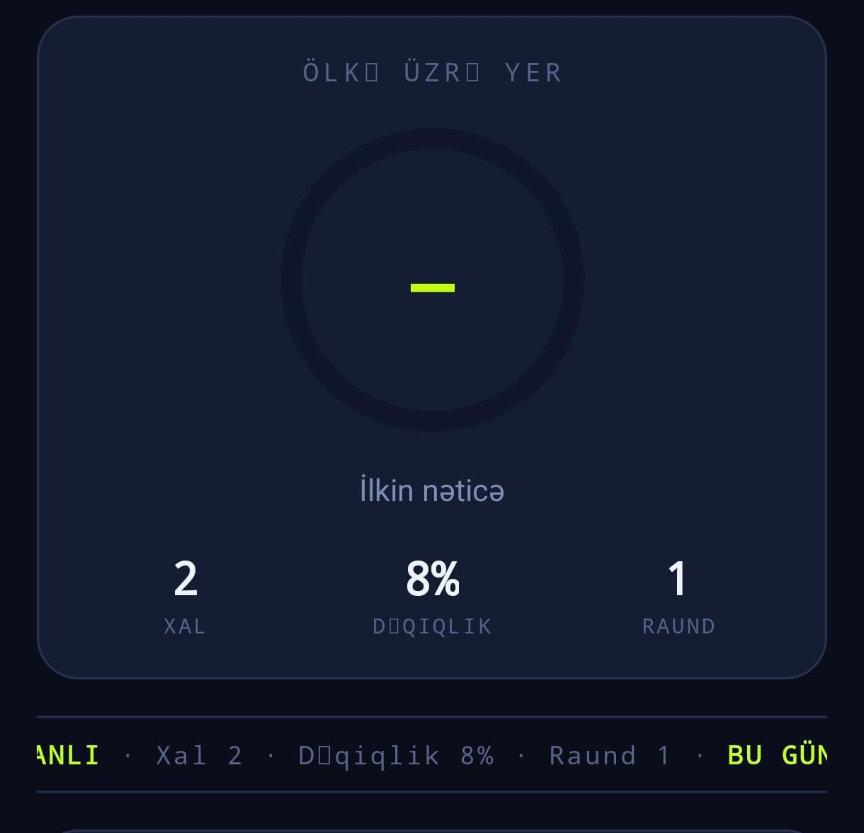
Reference 1 — Parent Analytics / Azerbaijani glyph rendering context


Reference 2 — Top-right streak text / Azerbaijani glyph rendering context

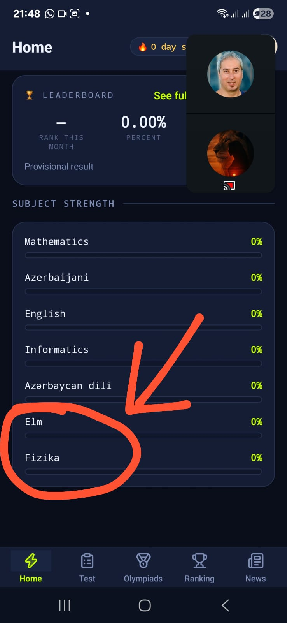
Reference 3 — Subject Strength list / subject-data context

