**HALP Quickstart** Please head to [**http://www.advising.tk/**](http://www.advising.tk/) and post feedback!

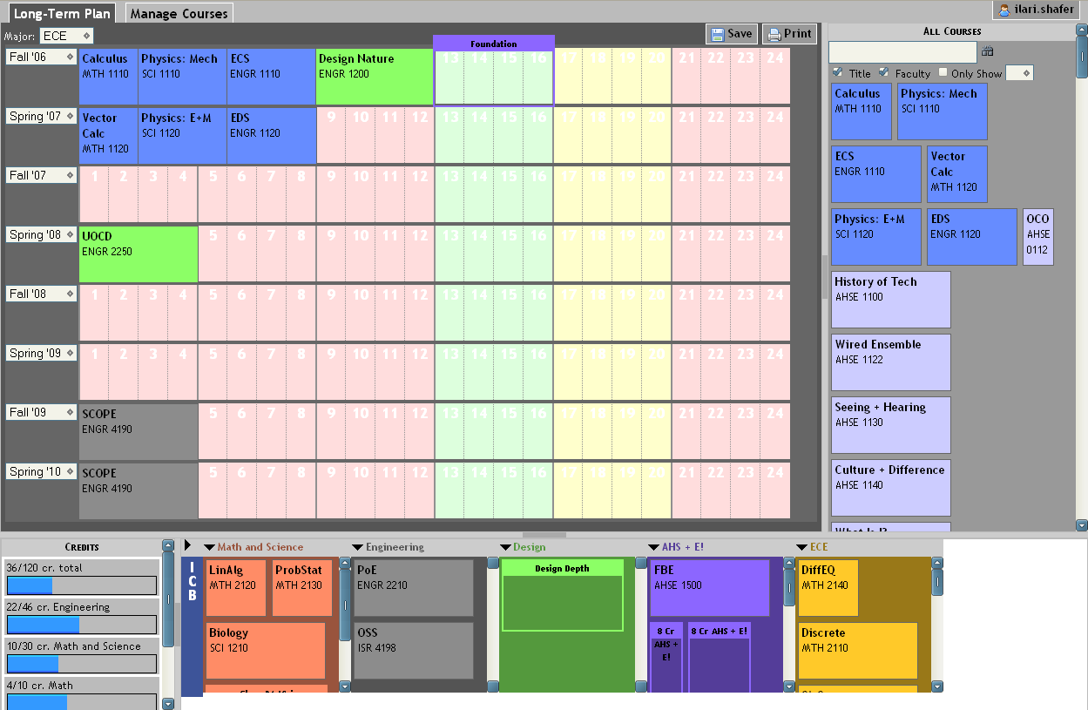

Log in here!

If you weren’t at Olin for a semester, use these (but they don’t save right now, sorry)

This will change your requirements in the bottom bins.

Print a copy for your adviser, and ask for feedback.

Search for courses that aren’t listed as requirements in the bottom bar with this pane.

This is a generic course that can be fulfilled with a number of options. Click on it to see the ones HALP knows about.

These are your “required” courses. Drag courses from these bottom bins onto your schedule. When they’re all gone, the bins will collapse and you’re “done.”

Manage Courses: This tab allows you to add/change courses in HALP. Everything is currently shared among all users.

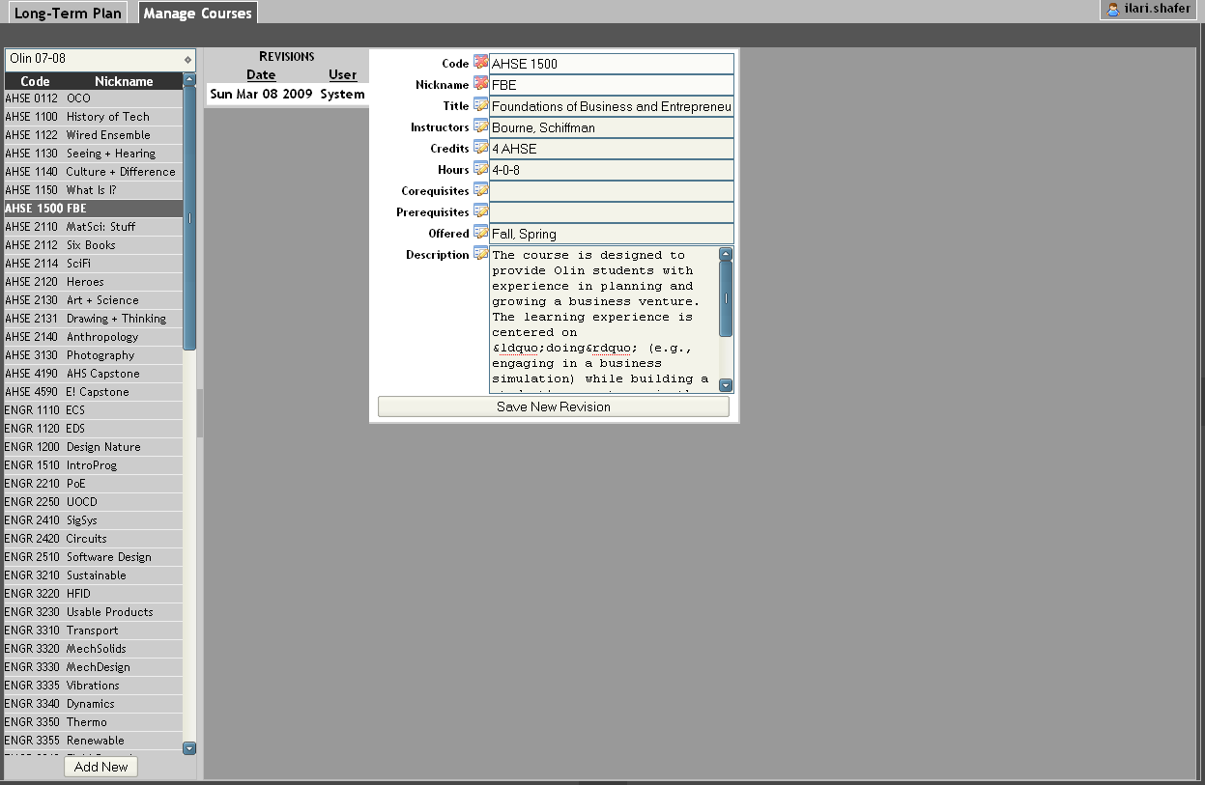

Did you take an off-campus course that isn’t listed? Select “off campus” from this list and “Add New” at the bottom to create it.

Change or update information about a class and click “save” to update the database.