Tibet Introductory Exploration
Sacred Lhasa, soft valleys, snowland light.
Lhasa · Nyingchi · 7–8 Days
A gradual highland route from Potala Palace and Barkhor streets to Nyingchi forests, lake water, canyon walls and distant snow peaks.
View Daily Route | Travel Readiness

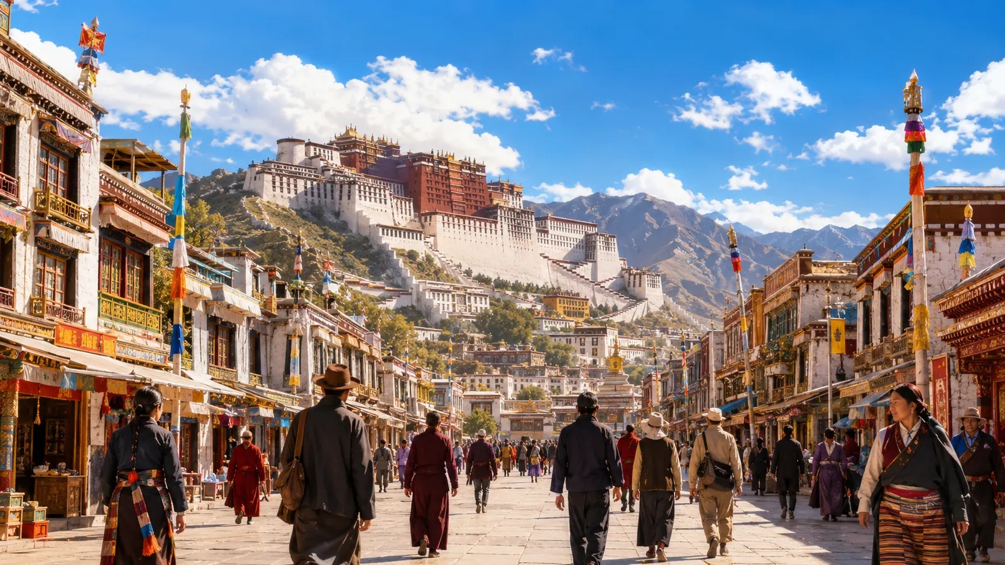
Route Rhythm
From highland city to snowland nature
The route opens in Lhasa, slows through monastery neighborhoods, then moves into Nyingchi’s river valleys, forests, lake water and canyon scale.
Day 1  Arrival light | Day 2  Sacred streets | Day 3  Monastery space | Day 4  Valley transfer | Day 5  Lake or forest | Day 6  Canyon scale | Day 7  Return rhythm

Route
Lhasa city rhythm    Potala skyline, Jokhang Temple area, Barkhor streets and tea houses create the first highland layer. | Monastery mountain space  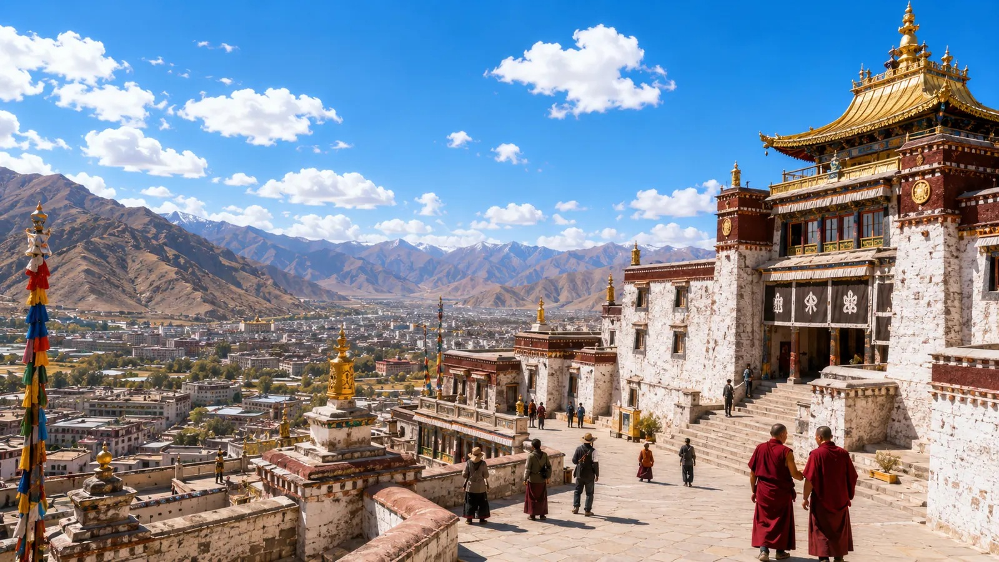  Sera or Drepung brings white walls, golden roofs, hillside views and a quieter walking pace.
Nyingchi soft nature  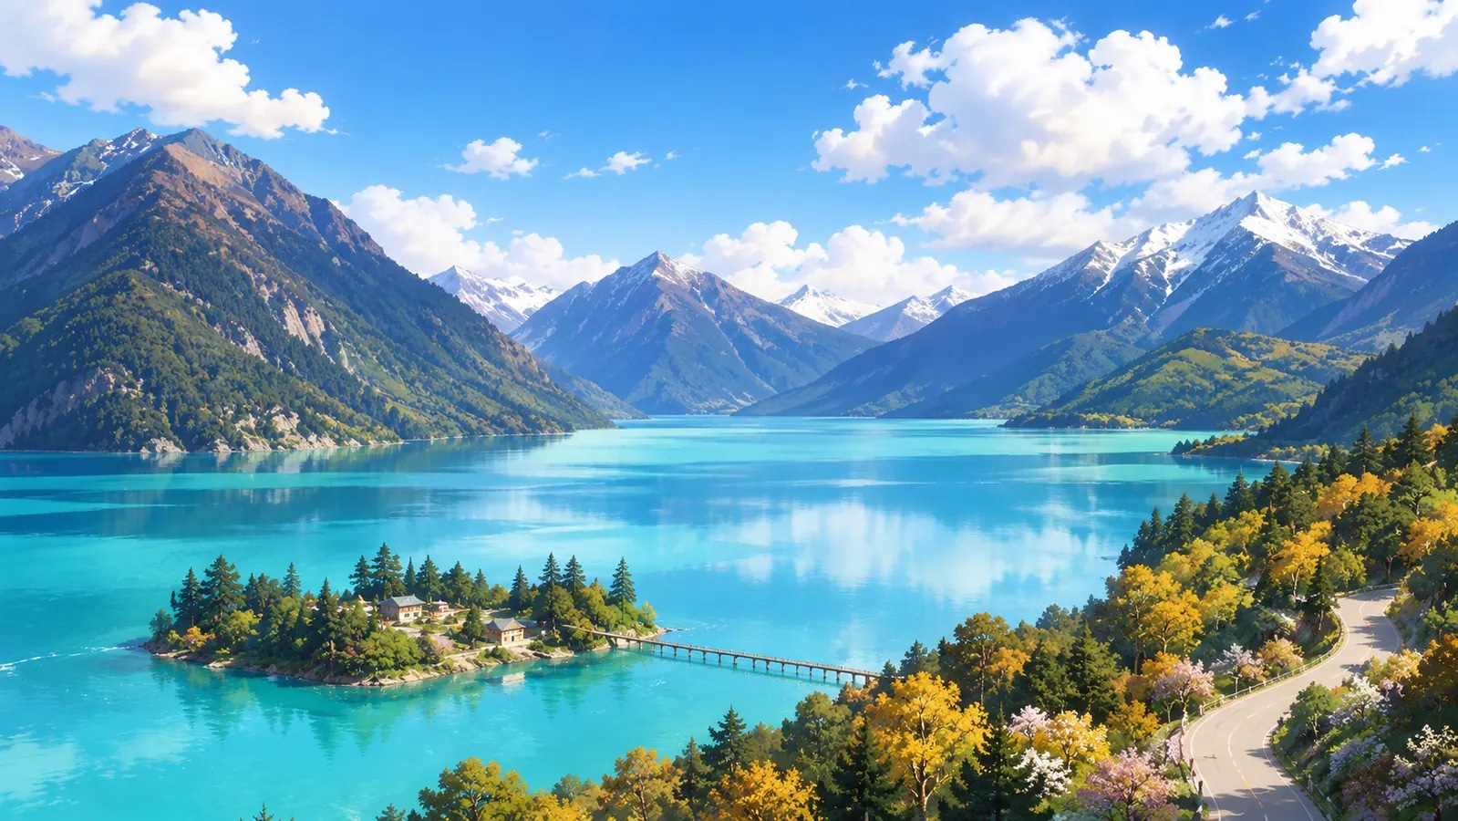  Basum Lake and Lulang shift the route into water, forests, meadow villages and open valleys. | Snowland scale  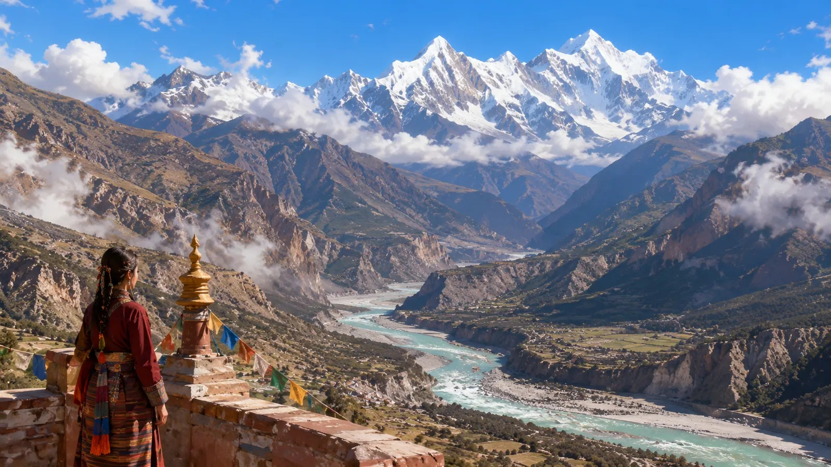  The Grand Canyon and Namcha Barwa form the route’s widest natural scene.

Taste  Local taste  Lhasa: sweet tea, Tibetan noodles, momo, thukpa, butter tea. Nyingchi: hot soup, valley meals, Lulang stone-pot chicken on the Lulang route. | Stay  Route base  Lhasa uses old-city or Potala-side areas. Nyingchi uses Bayi as the main base. Lulang forest lodging appears only on the forest branch. | Pace  Light start, wider scenery  Day 1–2 remain close and low-intensity. Nyingchi scenic days keep walking short and return time clear.

Days
Daily Route
A route that opens gradually
Food and rest stay light on arrival and transfer days, then turn toward tea houses, valley meals and forest-route lodging.
  Day 1 Arrive in Lhasa  Enter the highland light  Scene Check in, save the hotel address, keep the first walk close to the stay area.  Route Nearby streets, open sky, white walls, mountain lines.  Local Taste Tibetan noodles, porridge, warm soup, small cup of sweet tea.  Stay Lhasa old-city edge or Potala-view urban area. | 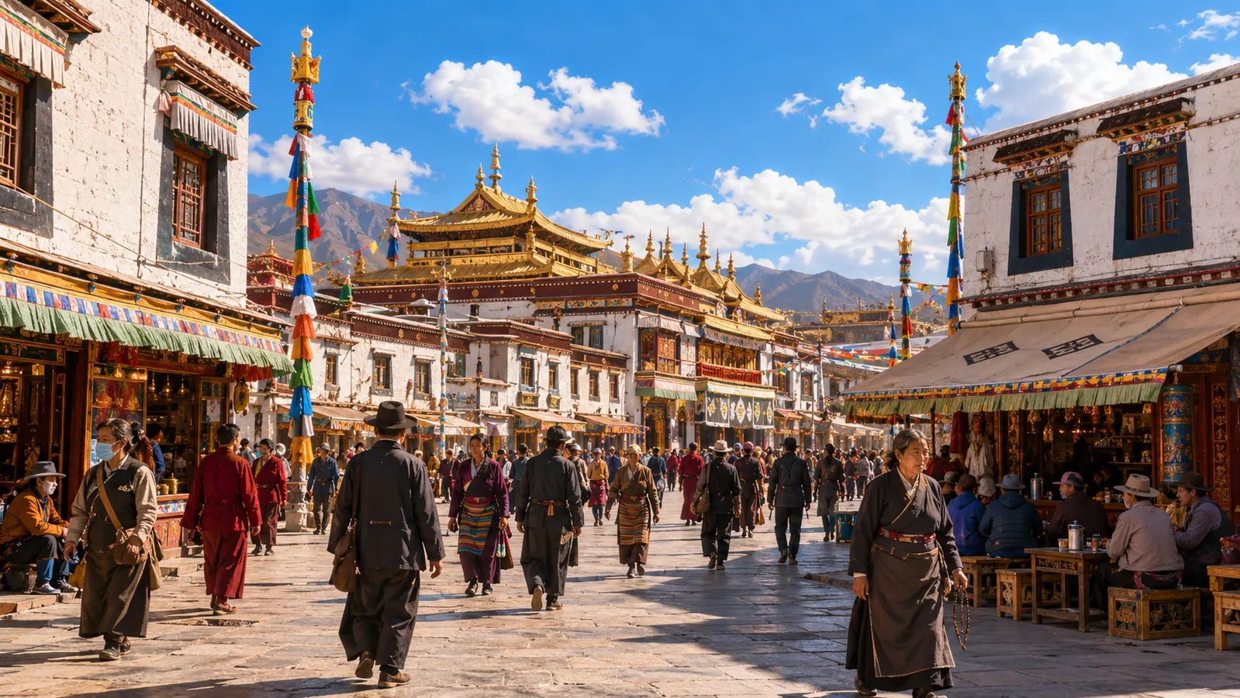  Day 2 Potala · Jokhang · Barkhor  Walk the sacred-city neighborhood  Scene Potala Palace skyline, Jokhang Temple area, Barkhor kora streets, tea-house pause.  Route Skyline view first, then temple streets and slow neighborhood walking.  Local Taste Sweet tea, Tibetan noodles, momo, butter tea in small portions.  Stay Barkhor edge or Potala-side city area.
  Day 3 Sera or Drepung Monastery  See monasteries against the mountain city  Scene Courtyards, white walls, golden roofs, kora routes and hillside views.  Route A monastery morning, a short afternoon walk, quiet evening near the stay area.  Local Taste Tea-house meal, thukpa noodle soup, tsampa with butter tea.  Stay Lhasa base with easy vehicle access. | 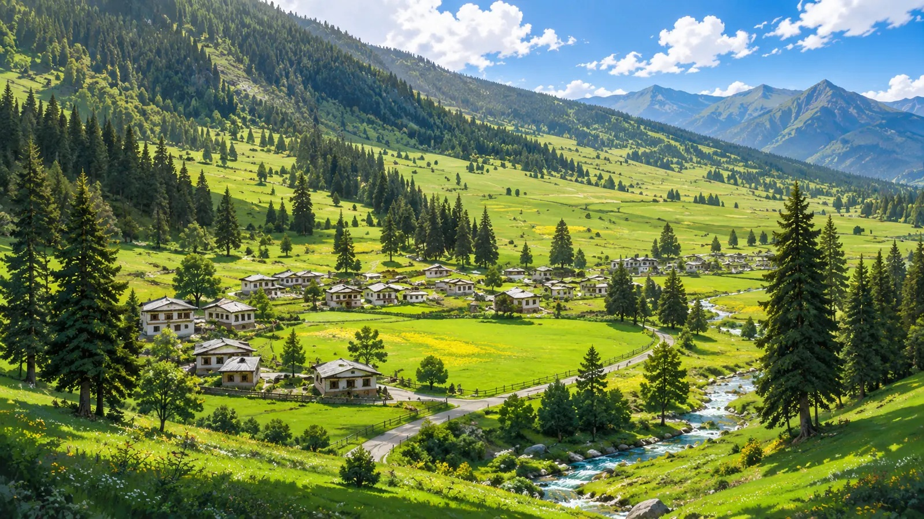  Day 4 Lhasa to Nyingchi  Move from sacred city to river valley  Scene The route leaves Lhasa and enters the Niyang River valley.  Route Transfer, check in, short valley walk, next-day route confirmation.  Local Taste Simple meal on the way, hot soup or a light Nyingchi meal after arrival.  Stay Nyingchi Bayi District for valley connections.

  Day 5 Basum Lake or Lulang Forest  Choose lake water or forest meadow  Scene Basum Lake brings turquoise water and forested shores; Lulang brings meadows and village layers.  Route A/B nature day: lake boardwalks or forest-meadow viewpoints.  Local Taste Basum route: prepared simple food and a hot return meal. Lulang route: stone-pot chicken or valley meal.  Stay Bayi base; Lulang forest stay only when the next route starts nearby. |   Day 6 Yarlung Zangbo Grand Canyon  Stand before river, canyon and snow peaks  Scene River valley, canyon walls, cloud movement and Namcha Barwa views.  Route Viewpoints and short walks, return before evening.  Local Taste Nyingchi soup, rice dishes, light hot meal after the scenic return.  Stay Nyingchi base near the return route.

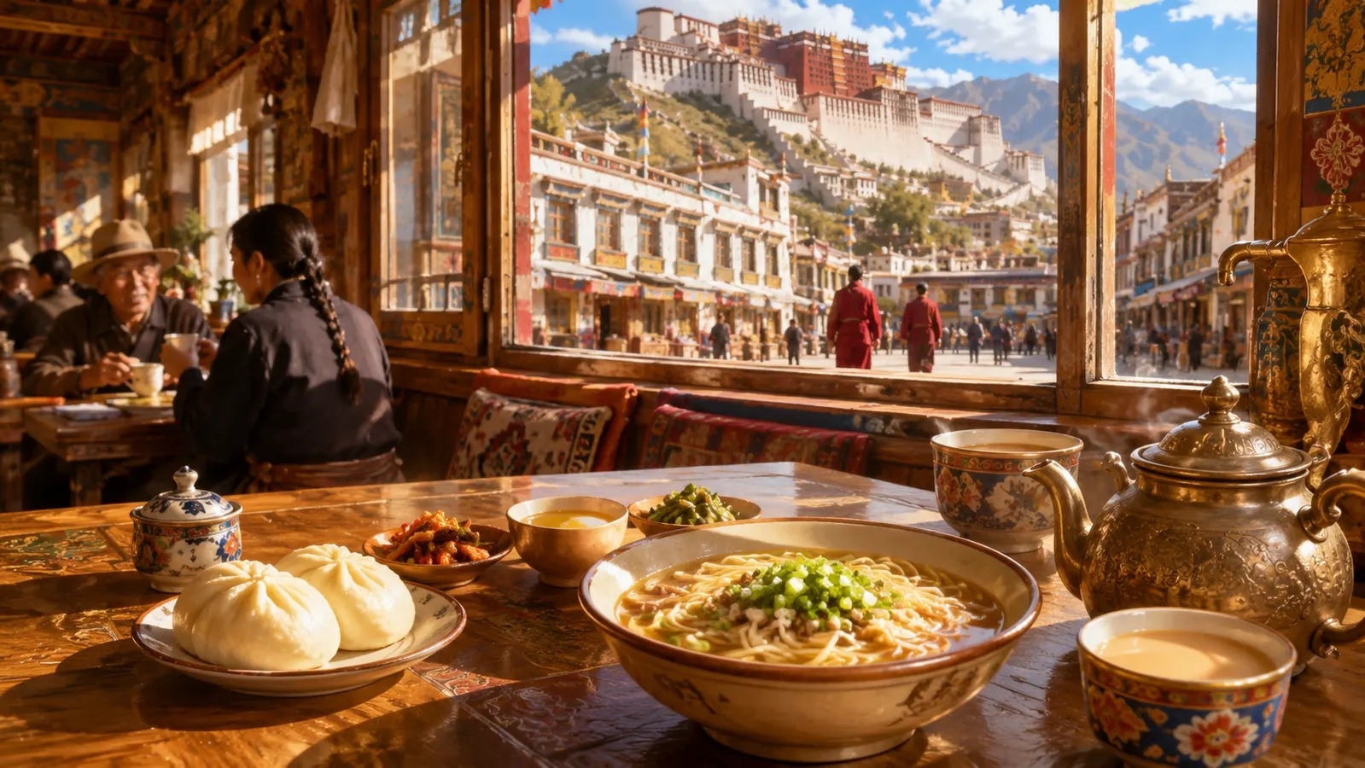 | Day 7/8  Return or depart  Close the highland route
Scene | Route | Local Taste | Stay
Departure preparation, short tea stop or last slow walk near the hotel. | Nyingchi departure, or Nyingchi–Lhasa return plus Lhasa departure day. | Light noodles, buns, tea, portable snacks and water for transfer time. | Lhasa or Nyingchi stay near the departure point.

Prepare
Travel Readiness
Prepared before arrival
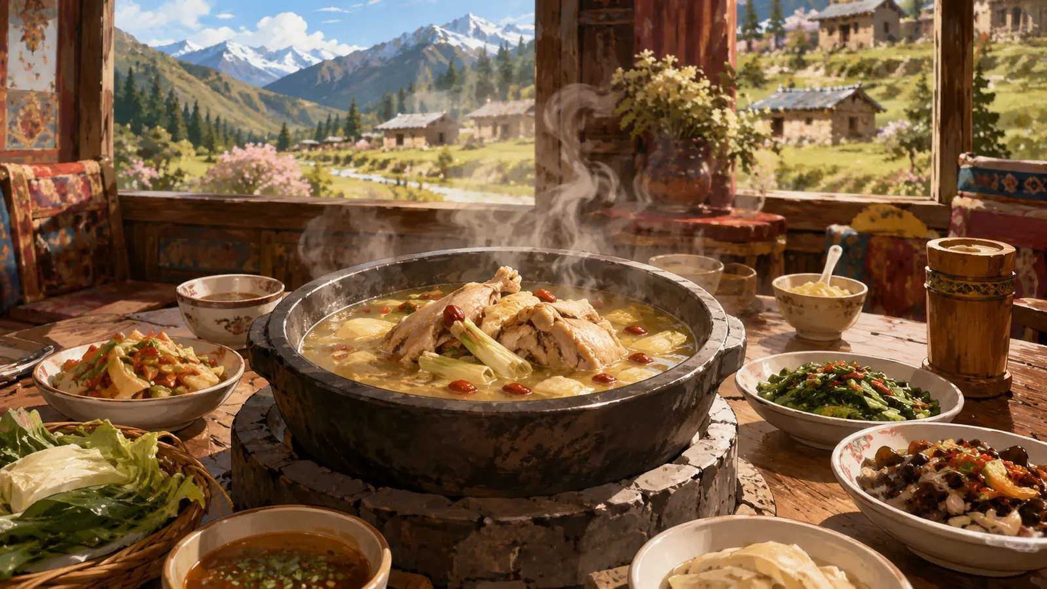 | Entry & addresses  Entry materials, hotel Chinese addresses, pickup points and scenic-area entrances are prepared before travel.  Highland pacing  The first two days stay close to Lhasa city areas; long walks and distant night travel are left out.  Monastery etiquette  Quiet visits, modest clothing, kora direction, photo boundaries and on-site instructions shape the monastery days.  Weather route  Clear days highlight lake and snow-peak views; misty days shift toward forest, village, canyon and short-walk scenes.

Tibet Introductory Exploration Route | Lhasa highland culture, Barkhor neighborhood life, Nyingchi valleys, forests, lake water, canyon walls and snow-mountain views.

