**Cross-Platform Mobile Application**

An Extra Project for CS464 practice

By

Olina ZHANG

Prepared Under the direction of Professor Henry Chang

School of Engineering

Northwestern Polytechnic University

117 Fourier Avenue, Fremont, CA 94539

April 2013

# ACKNOWLEGEMENTS

I would also like to thank Professor Henry Chang for sharing his time, knowledge and passion to guide and help me during this project.

I also would like to thank Professor YaLee Tsai for her lectures of CS464, which made a fundamental base for me to complete this project.

Last but not least, I would like to thank my classmates, Scott and so on, from the discussion with whom I gained many great ideas.

**CONTENT**

ACKNOWLEGEMENTS ii

ABSTRACT 4

1.0 INTRODUCTION 5

2.0 Software DESIGN 5

2.1 HTML5 5

2.2 Cascading Style Sheets (CSS) 5

2.3 JavaScript 6

2.4 jQuery 6

2.5 jQuery Mobile 6

3.0 IMPLEMENTATION AND RESULTS 6

3.1 Practice of HTML coding 6

3.2 Practice of CSS coding 8

3.3 Practice of JavaScript coding 8

3.4 Practice of jQuery coding 10

3.5 Practice of jQuery mobile coding 11

3.6 Demo: high-level mobile web-site for NPU 12

4.0 ENHANCEMENT IDEAS 16

5.0 CONCLUSION 16

6.0 BIBLIOGRAPHY 16

7.0 APPENDIX 17

# ABSTRACT

The technical report will cover topics on HTML, JavaScript and also jQuery, jQuery mobile that are all quite hot currently in the web industry especially for the mobile web applications.

# 1.0 INTRODUCTION

This project is aiming to build out a cross-platform web application specific for mobile devices. Some demo web pages for mobile devices will be created based upon the official NPU websites.

# 2.0 Software DESIGN

To achieve the goal of this project, following technology is needed:

## 2.1 HTML5

HTML (Hypertext Markup Language) is a standard to describe the content of webpages [1]. The current version, well known as HTML5, is still under-working but already widely adapted by most browser vendors. HTML5 syntax will be used in this project implementation.

## 2.2 Cascading Style Sheets (CSS)

Cascading Style Sheets (CSS) is a mechanism for defining styles and layouts such as fonts, colors and spacing [2]. The layout information is typically maintained in an external file, which could be referred to by other code, for example HTML.

CSS is defined as a standard. Currently the versions CSS 2.1 and CSS 3 are most widely used.

## 2.3 JavaScript

JavaScript is widely used together with HTML to build the webpages with all kinds of powerful functions [3]. The JavaScript is directly executed in the browser that contains a built-in compiler or interpreter for JavaScript.

## 2.4 jQuery

jQuery is a JavaScript library, which is small but offering rich features. It provides an easy-to-use API that works across a majority of browsers. Refer to [4] for an introduction of jQuery.

## 2.5 jQuery Mobile

jQuery Mobile a unified, HTML5-based user interface system framework for all popular mobile device platforms, built on the rock-solid jQuery and jQuery UI foundation. Refer to [5] for an introduction of jQuery mobile.

# 3.0 IMPLEMENTATION AND RESULTS

This project is implemented under Eclipse Web, Max OS 10.7.5.

## 3.1 Practice of HTML coding

Here is an example of web page written in HTML5 using div, id, link and picture:

<!DOCTYPE html>

<html>

<head>

<meta charset="utf-8">

<title>Northwestern Polytechnic University Mobile</title>

<link href="css/mobile.css" rel="stylesheet" type="text/css" />

</head>

<body class="home">

<p><img src="NPUlogo.jpg" alt="NPU Logo Picture"/></p>

<!-- Home -->

<div data-role="page" id="home">

<h2 id="hometitle">NPU Mobile</h2>

<div data-role="content">

<ul data-role="listview" data-inset="true">

<li><a href="#admissions/">Admissions</a></li>

<li><a href="#academics/">Academics</a></li>

<li><a href="#campus/">Campuss</a></li>

<li><a href="#newss/">News and Blogs</a></li>

<li><a href="#contacts/">Contact us</a></li>

</ul>

</div><!-- end content -->

</div><!-- end page -->

<p>This is the <a href="http://www.npu.edu">link</a> to the non-mobile webpage</p>

</body>

</html>

## 3.2 Practice of CSS coding

Apply below CSS format on the web page in 3.1:

<style type ="text/css">

body {

margin: 0px;

padding: 0px;

}

#home {

background: #aba;

width: 100%;

}

</style>

And the formatted web page looks like this:

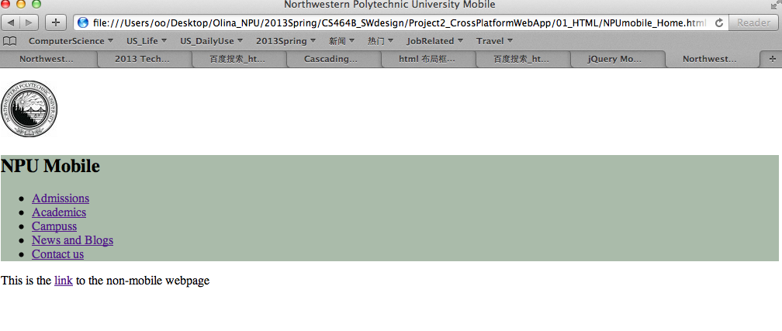

## 3.3 Practice of JavaScript coding

A small function written in JavaScript to convert mileage into kilometer inside the html file as below:

<!DOCTYPE html>

<html>

<head>

<title>Miles Converter</title>

<script type=*"text/javascript"*>

**function** updateFormAction(){

**var** miles = document.myform.miles.value;

**if** (miles==**null** || miles=="")

{

document.writeln("Please input the miles!");

**return**;

}

**var** kilos = miles*1.67;

document.myform.kilometers.value = kilos;

}

</script>

</head>

<body>

Please input the miles: <BR>

<FORM id=*"myform"* NAME=*"myform"* >

Miles: (*)<input name=*"miles"* type=*"text"* size=*"30"* maxlength=*"30"*><BR>

Kilometers:<input name=*"kilometers"* type=*"text"* size=*"30"* maxlength=*"30"*>

<input type=*"button"* value=*"Convert"* onclick="updateFormAction()">

</FORM>

</body>

</html>

The webpage looks like this:

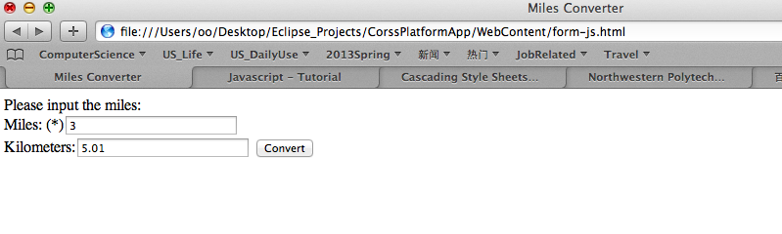

## 3.4 Practice of jQuery coding

**Create following 2 divisions (home and contacts) in one html file, which supposed to be 2 separated webpages:**

<div data-role=*"page"* id=*"home"*>

<h1 id=*"hometitle"*>NPU Mobile</h1>

<div data-role=*"content"*>

<ul data-role=*"listview"* data-inset=*"true"*>

<li><a href=*"#admissions"*>Admissions</a></li>

<li><a href=*"#academics"*>Academics</a></li>

<li><a href=*"#campus"*>Campus</a></li>

<li><a href=*"#newss"*>News and Blogs</a></li>

<li><a href=*"#contacts"*>Contact us</a></li>

</ul>

<ul data-role=*"listview"* data-inset=*"true"*>

<li data-theme=*"e"*>

<a href=*"http:/www.npu.edu"*>NPU Full Site</a>

</li>

</ul>

</div><!-- end content -->

</div><!-- end page -->

<!-- Contacts -->

<div data-role=*"page"* id=*"contacts"*>

<div data-role=*"header"*>

<h1>Contact Us</h1>

<a href=*"npu_mobile.html"* data-icon=*"home"* data-iconpos=*"left"* data-direction=*"reverse"* class=*"ui-btn-right"*>Home</a>

</div><!-- /header -->

<div data-role=*"content"*>

<ul data-role=*"listview"* data-inset=*"true"*>

<li>Tel: (510) 592 9688</li>

<li>Fax: (510) 697 8975</li>

</ul>

<ul data-role=*"listview"* data-inset=*"true"*>

<li data-theme=*"e"*>

<a href=*"http://npu.edu/contact.html"*>NPU Directory</a>

</li>

</ul>

</div><!-- /content -->

</div><!-- /page -->

**By adding the CDN hosted jQuery JavaScript library file into the HTML source code as below:**

***<script src="http://code.jquery.com/jquery-1.5.2.min.js"></script>***

**The web page comes out as following: (both home page and contacts page are placed on the same one page)**

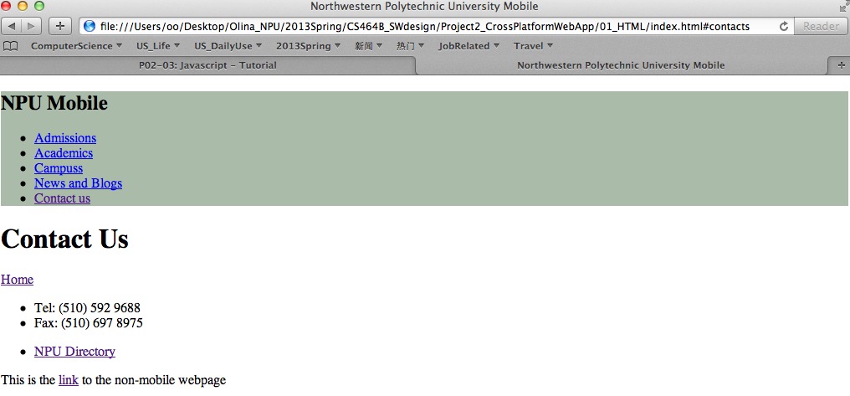

## 3.5 Practice of jQuery mobile coding

**On the same html source code file, add jQuery.mobile JavaScript library file as shown below:**

***<script src="http://code.jquery.com/mobile/1.0a4.1/jquery.mobile-1.0a4.1.min.js">***

***</script>***

**The web pages look just the same as expected: home page and contact page are separated, both in the perfect list-view!**

***Screenshot for the Home Page:***

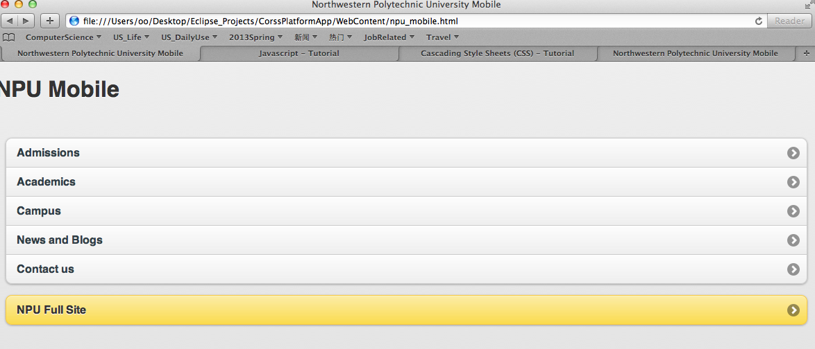

***Screenshot for the Contact page:***

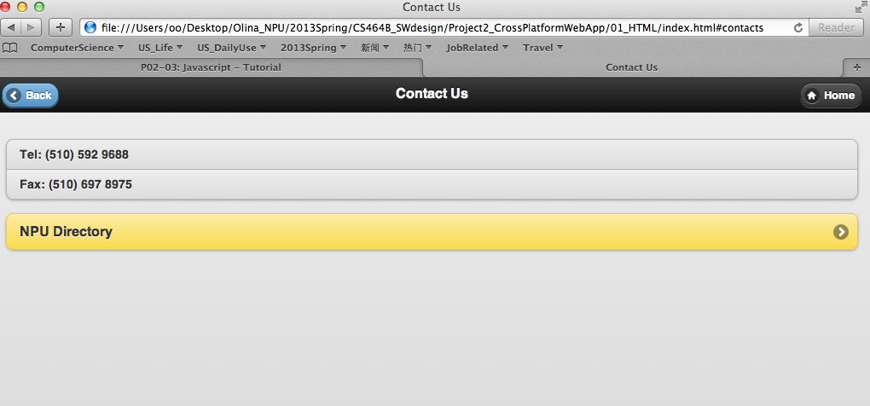

## 3.6 Demo: high-level mobile web-site for NPU

***Screenshot for the pages as below:***

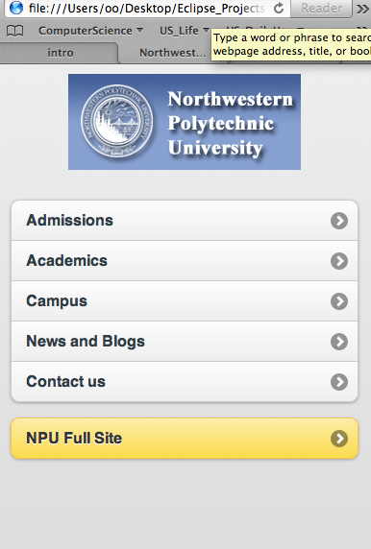

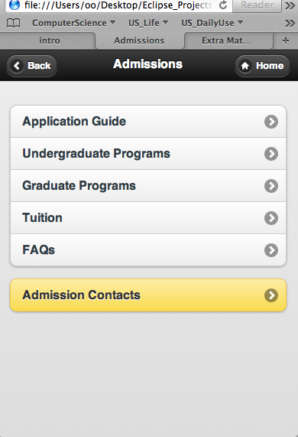

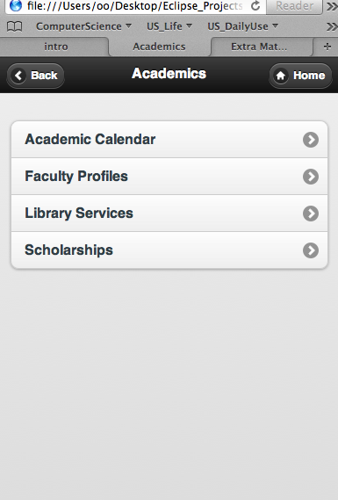

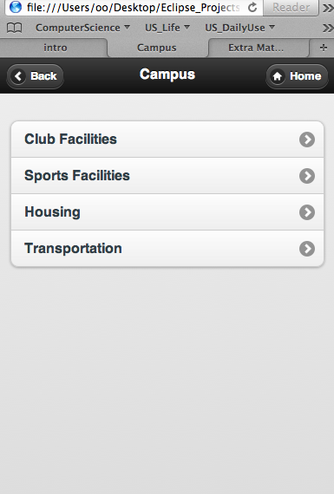

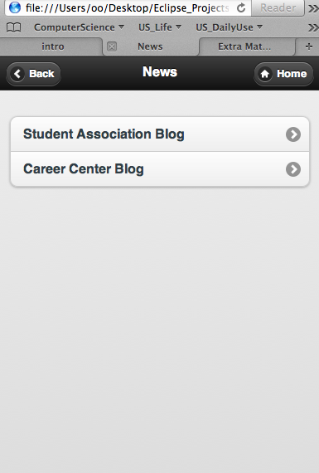

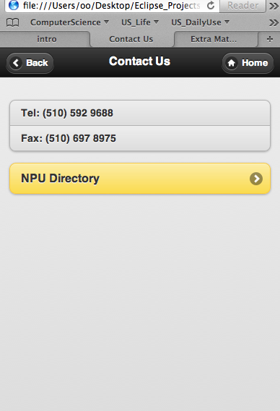

# 4.0 ENHANCEMENT IDEAS

REST tech. could be applied in further phase to achieve interaction with back-end server side, instead of merely providing static webpages

# 5.0 CONCLUSION

jQuery.mobile based on jQuery is very easy-to-use and powerful JavaScript framework which provides great supports to mobile applications.

# 6.0 BIBLIOGRAPHY

**[1]** [**W3C: "HTML5 Differences from HTML4"**](http://www.w3.org/TR/html5-diff/)

**[2]** [**W3C**](http://en.wikipedia.org/wiki/W3C)**: "**[**Cascading Style Sheets, level 2 revision 1**](http://www.w3.org/TR/2011/PR-CSS2-20110412/)**" CSS 2.1 specification**

**[3] JavaScript Tutorial:**

[**http://www.vogella.com/articles/JavaScript/article.html**](http://www.vogella.com/articles/JavaScript/article.html)

**[4] jQuery tutorial:**

[**http://www.w3school.com.cn/jquery/jquery_syntax.asp**](http://www.w3school.com.cn/jquery/jquery_syntax.asp)

**[5] jQuery-mobile tutorial:**

[**http://www.cnblogs.com/yuzhongwusan/archive/2011/11/24/2261571.html**](http://www.cnblogs.com/yuzhongwusan/archive/2011/11/24/2261571.html)

# 7.0 APPENDIX

Source codes for the NPU high-level mobile web-pages as screenshots in chapter 3.6:

<!DOCTYPE html>

<html>

<head>

<meta charset=*"utf-8"*>

<title>Northwestern Polytechnic University Mobile</title>

<link rel=*"stylesheet"* href=*"http://code.jquery.com/mobile/1.0a4.1/jquery.mobile-1.0a4.1.min.css"* />

<link href=*"css/npu_mobile.css"* rel=*"stylesheet"* type=*"text/css"* />

<script src=*"http://code.jquery.com/jquery-1.5.2.min.js"*></script>

<script src=*"http://code.jquery.com/mobile/1.0a4.1/jquery.mobile-1.0a4.1.min.js"*></script>

</head>

<body class=*"mobilepage"*>

<!-- Home -->

<div data-role=*"page"* id=*"home"*>

<div style="padding:*5px*; height:*100px*; text-align:*center*;" id=*"banner"* >

<img style="margin: *5px auto*;" src=*"pic//logo_npu.jpg"*>

</div>

<div data-role=*"content"*>

<ul data-role=*"listview"* data-inset=*"true"*>

<li><a href=*"#admission"*>Admissions</a></li>

<li><a href=*"#academics"*>Academics</a></li>

<li><a href=*"#campus"*>Campus</a></li>

<li><a href=*"#news"*>News and Blogs</a></li>

<li><a href=*"#contacts"*>Contact us</a></li>

</ul>

<ul data-role=*"listview"* data-inset=*"true"*>

<li data-theme=*"e"*>

<a href=*"http:/www.npu.edu"*>NPU Full Site</a>

</li>

</ul>

</div><!-- end content -->

</div><!-- end page -->

<div data-role=*"page"* id=*"admission"*>

<div data-role=*"header"*>

<h1>Admissions</h1>

<a href=*"npu_mobile_home.html"* data-icon=*"home"* data-iconpos=*"left"* data-direction=*"reverse"* class=*"ui-btn-right"*>Home</a>

</div><!-- /header -->

<div data-role=*"content"*>

<ul data-role=*"listview"* data-inset=*"true"*>

<li><a href=*"#appguide"*>Application Guide</a></li>

<li><a href=*"#undergraduate"*>Undergraduate Programs</a></li>

<li><a href=*"#graduate"*>Graduate Programs</a></li>

<li><a href=*"#tuition"*>Tuition</a></li>

<li><a href=*"#faqs"*>FAQs</a></li>

</ul>

<ul data-role=*"listview"* data-inset=*"true"*>

<li data-theme=*"e"*>

<a href=*"#contacts"*>Admission Contacts</a>

</li>

</ul>

</div><!-- end content -->

</div><!-- end page -->

<div data-role=*"page"* id=*"academics"*>

<div data-role=*"header"*>

<h1>Academics</h1>

<a href=*"npu_mobile_home.html"* data-icon=*"home"* data-iconpos=*"left"* data-direction=*"reverse"* class=*"ui-btn-right"*>Home</a>

</div><!-- /header -->

<div data-role=*"content"*>

<ul data-role=*"listview"* data-inset=*"true"*>

<li><a href=*"#calendar"*>Academic Calendar</a></li>

<li><a href=*"#faculty"*>Faculty Profiles</a></li>

<li><a href=*"#library"*>Library Services</a></li>

<li><a href=*"#scholarship"*>Scholarships</a></li>

</ul>

</div><!-- end content -->

</div><!-- end page -->

<div data-role=*"page"* id=*"campus"*>

<div data-role=*"header"*>

<h1>Campus</h1>

<a href=*"npu_mobile_home.html"* data-icon=*"home"* data-iconpos=*"left"* data-direction=*"reverse"* class=*"ui-btn-right"*>Home</a>

</div><!-- /header -->

<div data-role=*"content"*>

<ul data-role=*"listview"* data-inset=*"true"*>

<li><a href=*"#clubs"*>Club Facilities</a></li>

<li><a href=*"#sports"*>Sports Facilities</a></li>

<li><a href=*"#housing"*>Housing</a></li>

<li><a href=*"#transport"*>Transportation</a></li>

</ul>

</div><!-- end content -->

</div><!-- end page -->

<div data-role=*"page"* id=*"news"*>

<div data-role=*"header"*>

<h1>News</h1>

<a href=*"npu_mobile_home.html"* data-icon=*"home"* data-iconpos=*"left"* data-direction=*"reverse"* class=*"ui-btn-right"*>Home</a>

</div><!-- /header -->

<div data-role=*"content"*>

<ul data-role=*"listview"* data-inset=*"true"*>

<li><a href=*"#association"*>Student Association Blog</a></li>

<li><a href=*"#career"*>Career Center Blog</a></li>

</ul>

</div><!-- end content -->

</div><!-- end page -->

<!-- Contacts -->

<div data-role=*"page"* id=*"contacts"*>

<div data-role=*"header"*>

<h1>Contact Us</h1>

<a href=*"npu_mobile_home.html"* data-icon=*"home"* data-iconpos=*"left"* data-direction=*"reverse"* class=*"ui-btn-right"*>Home</a>

</div><!-- /header -->

<div data-role=*"content"*>

<ul data-role=*"listview"* data-inset=*"true"*>

<li>Tel: (510) 592 9688</li>

<li>Fax: (510) 697 8975</li>

</ul>

<ul data-role=*"listview"* data-inset=*"true"*>

<li data-theme=*"e"*>

<a href=*"http://npu.edu/contact.html"*>NPU Directory</a>

</li>

</ul>

</div><!-- /content -->

</div><!-- /page -->

</body>

</html>