1. Project Overview

My website will provide services to sell products per users’ requests, instead of pushing products to customers.

There are 2 different type of users in my system: customer and sales.
One customer gets himself/herself registered to the website and then he/she can submit his/her wishes to the system, one product per list. One ‘wish’ includes a title, detailed description about the wanted product, and the expected price.
The sales people will look into these wishes and process them one by one. If possible to make it at the expected price of customer, the sales person then update the wish-list into ‘offer’ and inform the link of offer to the customer.
Customer could browse all his/her wishes. Once any offer comes in, he/she can enter that offer and finally make the transaction, similar as other regular purchase.

2. List of Services

For customer:
- submit a wish
- browse all his/her own wishes
- get the detailed information about one offer which is linked to his/her wish
- purchase the offer which makes an order
- browse all his/her orders

For sales:
- get a list of all open wishes in the system
- update the wish status either to ‘offerable’ by adding an ‘offer’ or to ‘impossible’ by providing a reason explanation

3. Sketch of implementation

Possible HTML forms needed:
- form of a wish
- form of an offer

Possible servlets needed:
- post a wish
- post an offer
- make an order

Possible Views (.jsp) needed:
- customerHome: customer to browser his/her wishes and orders
- salesHome: sales to browse all the wishes in the system
-

Possible JAVA classes needed to represent the business objects:
- Cusomter: id, name, address, phone
- Sales: id, name
- Wish: id, description, wishPrice, status, offerId
- Offer: id, conclusion, description, offerPrice
- Order: id, orderDate, Customer, Offer

Possible DB tables needed:
- Customer: id(PK), name, address, phone, [username, password for authorization usage]
- Sales: id(PK), name, [username, password for authorization usage]
- Wish: id(PK), description, wishPrice, status(‘new’, ‘processed’), offerID(FK)
- Offer: id(PK), conclusion(‘offerable’, ‘impossible’), description (offer details or why impossible), offerPrice
- Order: id(PK), orderDate, customerID(FK), offerID(FK)

4. Use model
- Where does each type of user enter your application?
(i.e., specific web page(s))
- What other web pages will each user then progress to?
Be specific, based on your list from Item 3.

For customer:
- Enters in his/her homepage with lists of his/her wishes and orders
- By clicking one ‘processed’ wish, customer could get into the details of the result of that wish, either ‘impossible’ with some reasons, or ‘offerable’ with the details
- On the details of one offer page, customer could click ‘confirm to order’ button to make a purchase

For Sales:
- Enters in his/her homepage with lists of all wishes and orders in the system
- By clicking one ‘new’ wish, sales could get into the details of that wish and decide whether it is offerable or impossible with 2 separated buttons to select
- By clicking the ‘offerable’ button the sales goes into a form to create an offer, with detailed information, and the offeredPrice to fill. By clicking the ‘impossible’ button the sales goes into a form to decline a wish, with the detailed reason to fill. Both will link an offer entry to the original wish entry.

5. Deployment of MVC design pattern
Take the use case of customer looking into the details of one his/her own wish:
- Model used in the display: wish, offer
- View page: custWishDetails.jsp
- Controller (servlet): custWishDetailsServlet.java
- Services: CustomerServices.getWishDetails(int wishId)
- DAO: WishDAO.getWishById(int wishId)

6. Screenshots of Database tables
Database tables: Customer
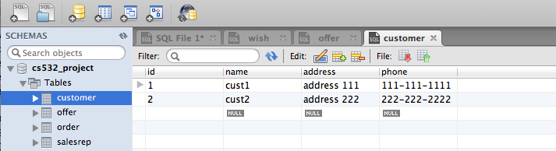

Database tables: Wish
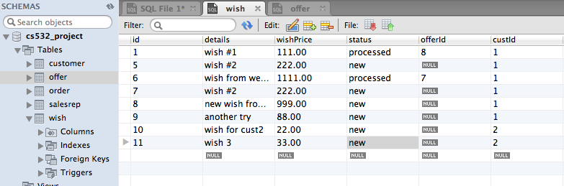

Database tables: Offer
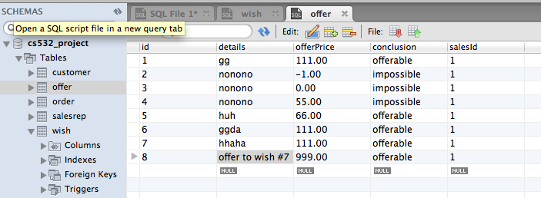

7. Screenshots of some web pages
Login page for customer:
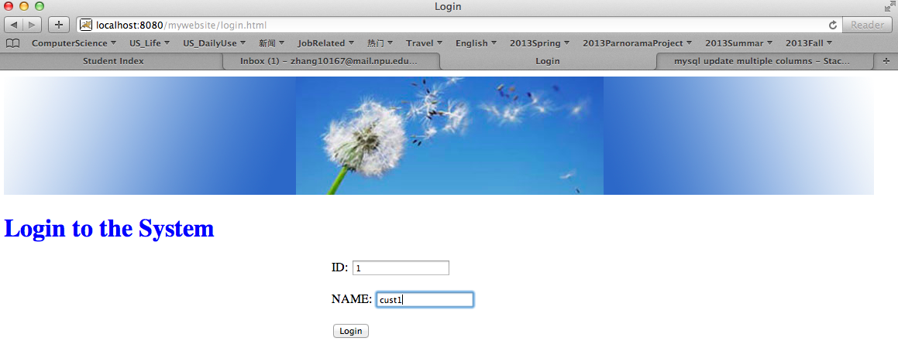
Customer Home Page:
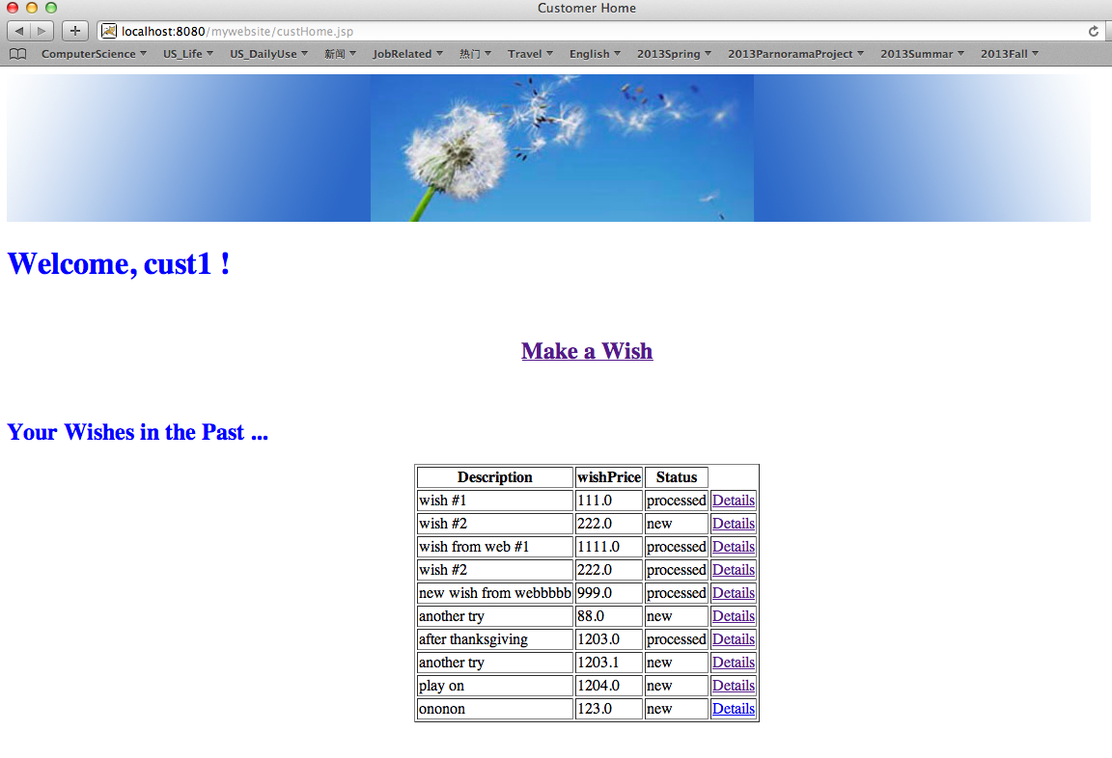

Customer: Make a new Wish
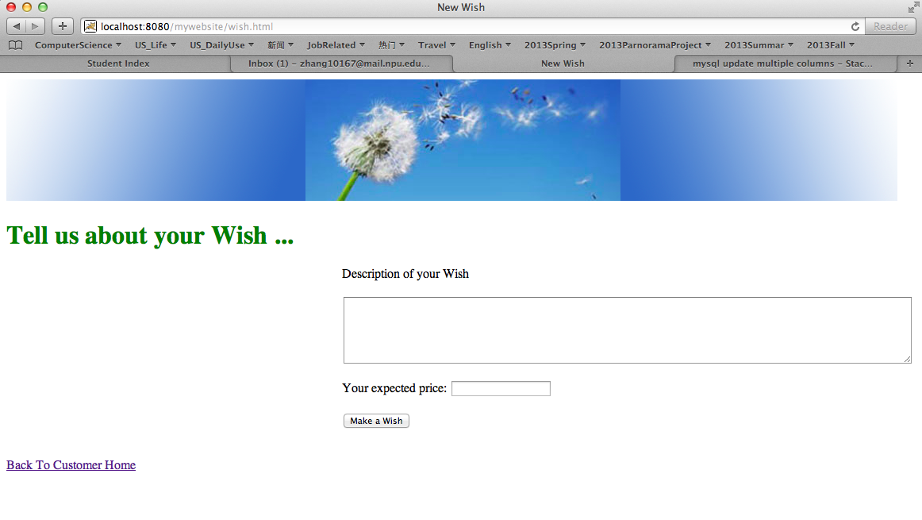
Sales: browser all open wishes (wishes in the status of ‘new’)

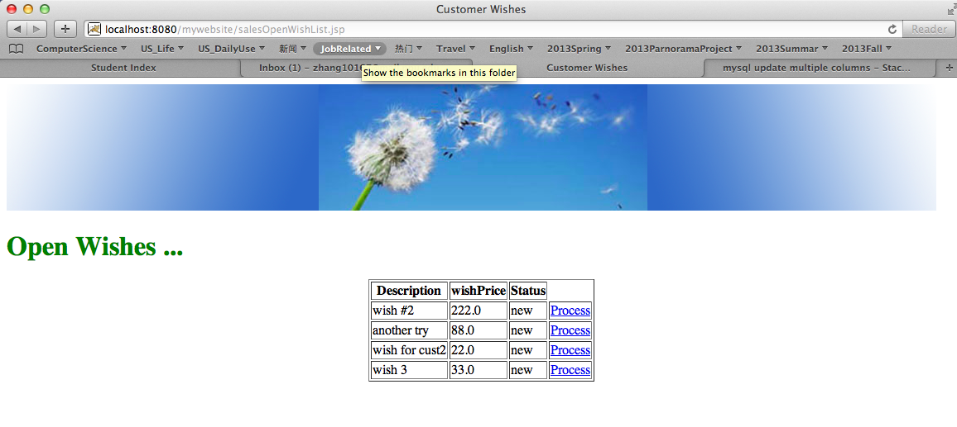

Sales: process one open wish

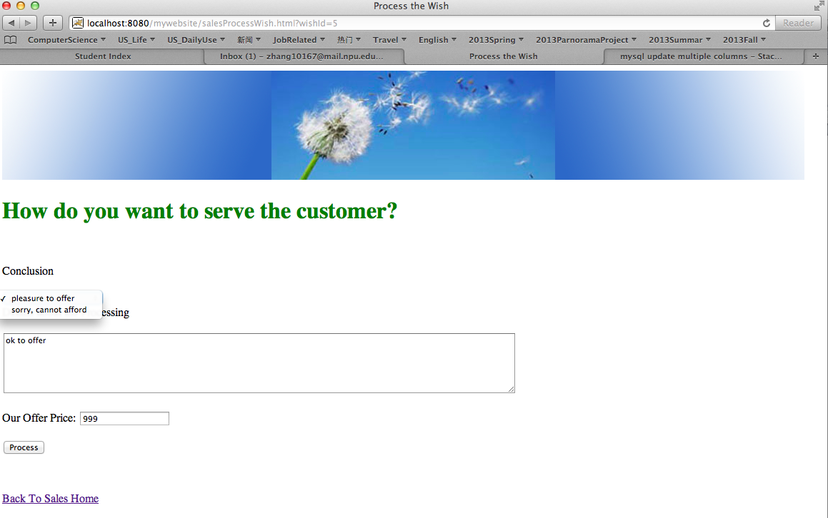
Note: when processing one open wish, it will operate on both wish and offer table.

