**COOK ASSIST**

**USER’S**

**MANUAL**

**for Oxfordshire County Council**

Prepared by: Oscar Lindenbaum

June 22nd 2020,

**USER'S MANUAL**

**TABLE OF CONTENTS**

Page #

1.0 GENERAL INFORMATION 1-1

1.1 System Overview 1-1

2.0 GETTING STARTED 2-1

2.1 Opening the application 2-1

2.2 Registering a Moderator 2-1

2.3 Logging in 2-2

2.4 Opening a chat 2-2

2.5 Exporting a chat 2-3

2.6 Sending a message 2-3

2.8 Logging out 2-4

2.9 Rejecting chats 2-5

2.10 Viewing Past Chat History 2-5

2.11 Cached Messages 2-1

3.0 USING AS A VICTIM 3-1

3.1 Opening the application 3-1

3.2 Sending a message 3-2

3.3 Toggling visibility of the messages 3-2

3.4 Opening a recipe 3-2

3.5 Service is not online 3-1

**1.0 GENERAL INFORMATION**

# GENERAL INFORMATION

## 1.1 System Overview

The Cook Safe application is for victims to discreetly contact the support services in a live chat.

Simple video showing usage [here](https://youtu.be/FijJGz1L0nc)

**2.0 GETTING STARTED**

# GETTING STARTED

## 2.1 Opening the application

To open the application, you simply need to navigate to ______, the app will automatically load in your browser window.

## 2.2 Registering a Moderator

To register a new user, you can select the ‘Don’t have an account? Register here’ Button.



Then enter the details for the new account in the required fields. The code will be provided to authorized persons to register new users.

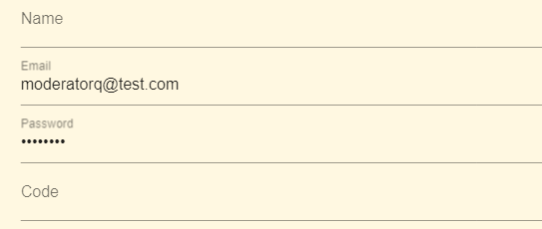

You will then be redirected to the login page.

## 2.3 Logging in

To login, first fill in the fields with your details.

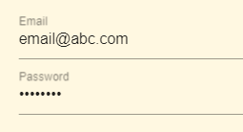

Once filled please press the login button.



Either you will be successfully signed in and automatically redirected to a new page, or a message will show detailing the problem (invalid credentials). The fields are all case sensitive.

## 2.4 Opening a chat

When chats are available they will be shown with their key and an icon.

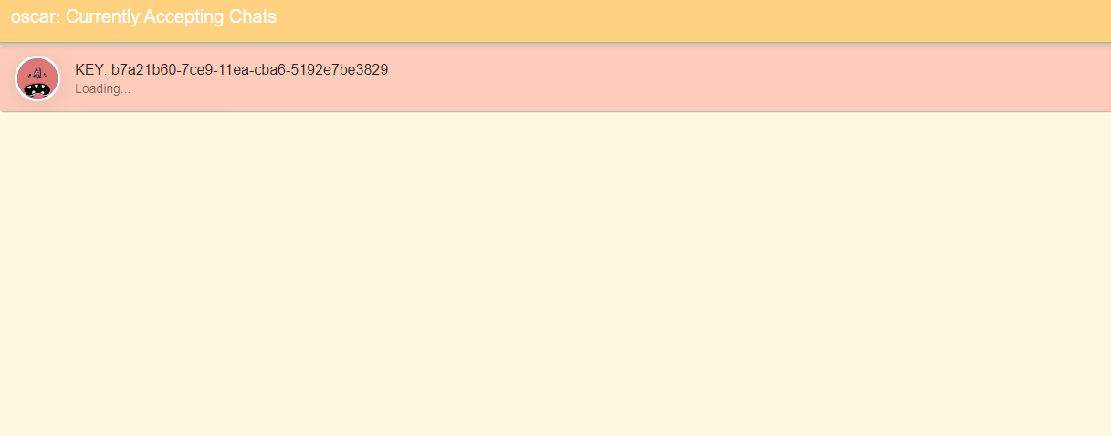

If no chats are open there will be none listed.

To open the chat simply click on the desired chat and you will be sent to a new page.

To exit the chat press the top right button and you will return to the screen before.



## 2.5 Exporting a chat

To export a chat simply press the download button in the top right corner.



This saves it to the cloud and can then be accessed at another time. **See 2.10**

## 2.6 Sending a message

Click on the field saying, ‘Enter message’. Type in your message and then send it by pressing the send button on the right-hand side. 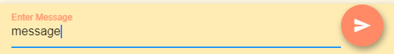

**2.7** **Closing a chat**

To close a chat, you will need to be on the screen listing all chats open. Then drag the desired chat to the left to reveal the close button, click this button.

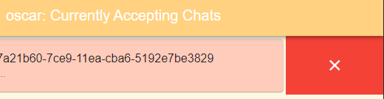

**IT IS IMPORTANT TO CLOSE ALL CHATS THAT ARE NOT NEEDED TO PREVENT SERVER OVERLOAD AND UNEXPECTED FEES**

**2.8** **Closing all chats**

Conveniently if you want to close all chats at the end of the day, you will find the option to do so in the menu. Open this by pressing the ‘PLUS’ button. If you cannot see the plus button it is because you are viewing on a larger display, you will be able to see these buttons along the top of the chat.



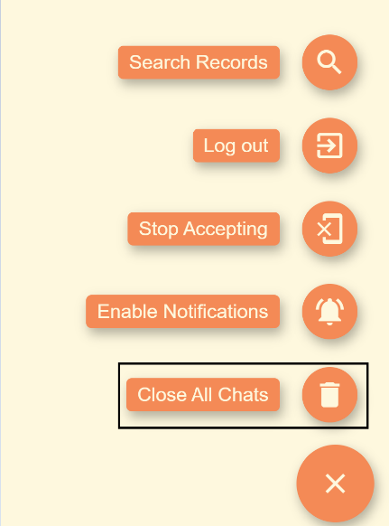

To Close the chat, press the close all chats button.

## 2.8 Logging out

To log out open the menu and press the log out button. This option might also be on the top of your screen if you are using a large screen.

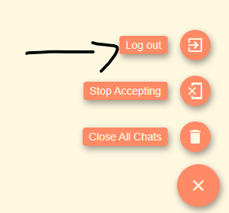

## 2.9 Rejecting chats

If you have many chats open, you might want to disallow any more to be created with yourself, do this by pressing the Stop accepting button. This option might also be on the top of your screen if you are using a large screen.

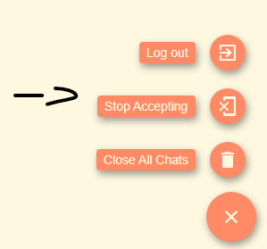

## 2.10 Viewing Past Chat History

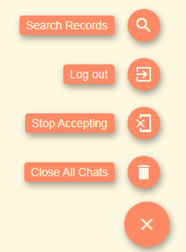

To view past chat history for a user, you have two options, either press the search button in the menu, or if the currently open victims chat has a past history, the database button will be visible (See figure 2).

Figure 2



If you are manually searching for a user, the records are labelled as [First Name First Letter][First Name Last Letter] [Last Name First Letter][Last Name Last Letter][DOB].

You can search using the bar on the top and then manually select a record.

You can then view the history for the user. They will be named by where they came from CACHE or which moderator user saved them, followed by the chats unique id.

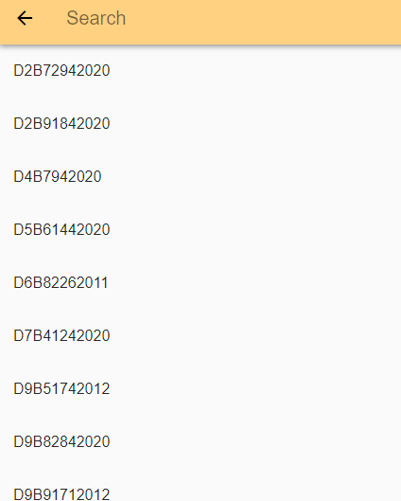

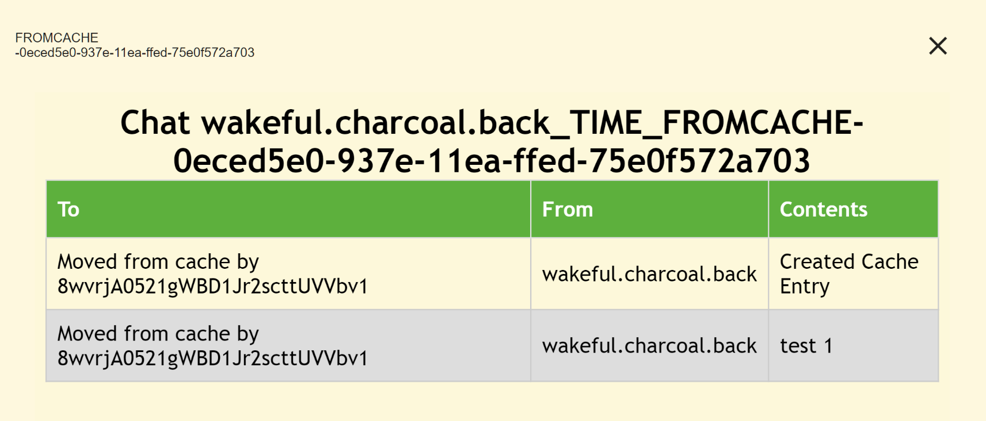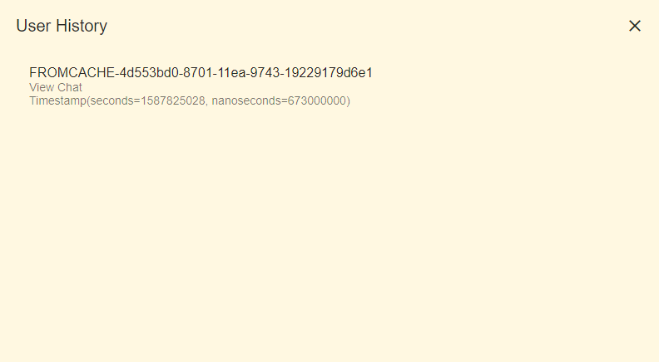Once a specific chat is selected it will be opened in another popup, where its data can be seen in a table view. (This will be improved to be more easily read, but is temporarily copied to the devices clipboard, which can then be pasted into any HTML viewer and It will render as a table.)

## 2.11 Cached Messages

If no moderators are online to receive messages, the messages will be collected and sent to the ‘cache’ for review.

If there are messages in the cache, the moderator will be presented with them when they login.

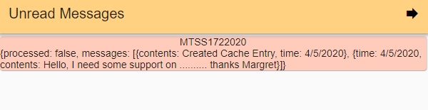

The moderators then have the option of continuing and ignoring the message temporarily by pressing the forwards arrow, or they can review the message.

To review the message the moderator only has to click on the chat they want to see and they are presented with two options.

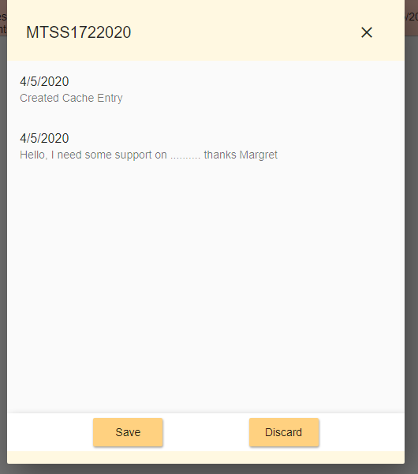

If they choose to save the message, it will be created as a record in the database so it can be seen when ‘Margret’ contacts again or can manually be searched and viewed.

If the moderator decides the message needs no further action or is spam, they can discard the message which deletes it from the cache and records.

**3.0 USING AS A VICTIM**

# USING AS A VICTIM

## 3.1 Opening the application

To open the application as a victim, navigate to ____ in your web browser. Once the terms and conditions are agreed to and details filled, a connection to any available moderator will be automatically created.

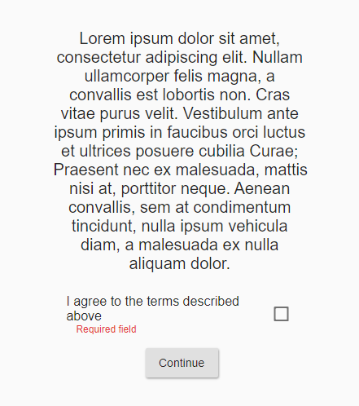 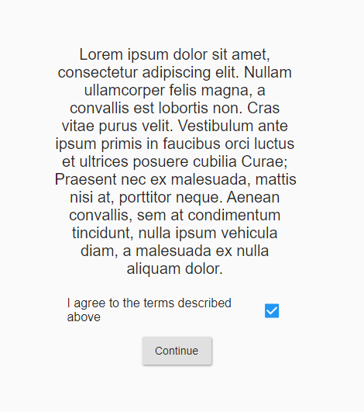 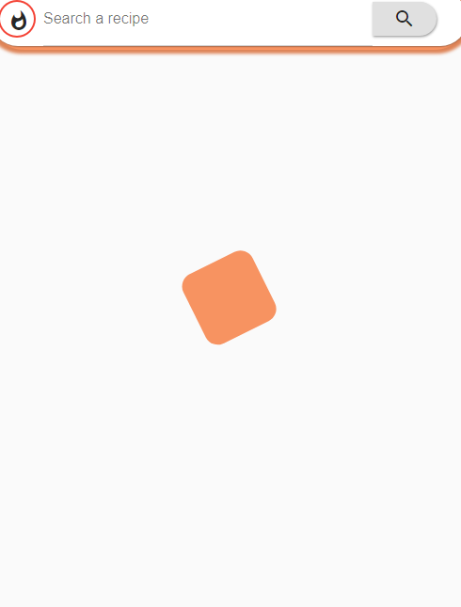

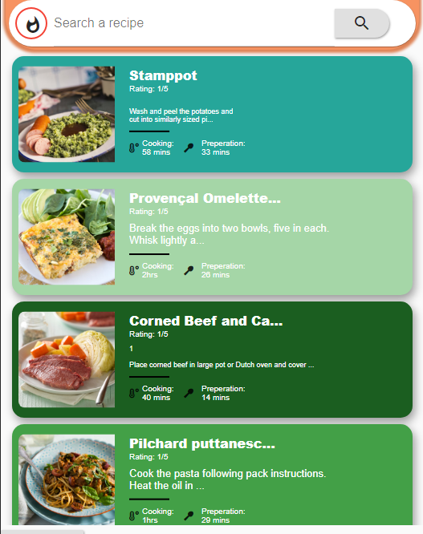

## 3.2 Sending a message

To send a message, press the ‘search a recipe’ button at the top, this field doesn’t search any recipes it only sends the contents of the field to the moderator.

To send the message press the search button and you will see a new ‘recipe’ appear.

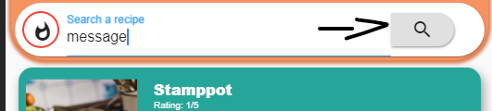

The new message is below, although it is disguised as a recipe for a Christmas pudding.



## 3.3 Toggling visibility of the messages

Messages can either be hidden or shown, this is changed by pressing the icon at the top left of the screen. It will either be highlighted in red, or black signifying its status.



Result

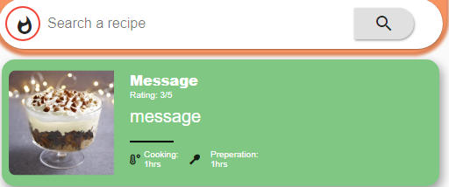

## 3.4 Opening a recipe

If you need to use the application normally, it will operate normally. To open a recipe simply tap on the card and you will be taken to a new screen with more information.

**If the message was too long to be seen in the preview, you can alternatively use this to view the message full screen**

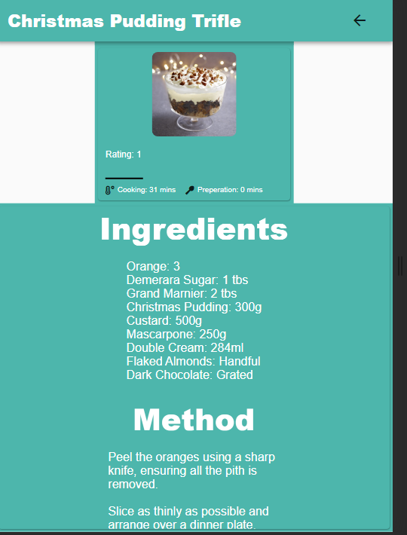

## 3.5 Service is not online

If there are currently no moderators online to have a real time chat, users will be presented the option to send a message, which will be replied to in due time.

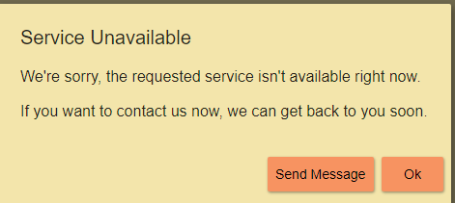

If they choose to send a message, they will get a new screen where they can enter their message and it will be sent to the team.

