

**COOK SAFE**

**USER’S**

**MANUAL**

**for COMPANY NAME**

Prepared by: Oscar Lindenbaum

April 12,

**USER'S MANUAL**

**TABLE OF CONTENTS**

Page #

1.0 GENERAL INFORMATION 1-1

1.1 System Overview 1-1

2.0 GETTING STARTED 2-1

2.1 Opening the application 2-1

2.2 Registering a Moderator 2-1

2.3 Logging in 2-1

2.4 Opening a chat 2-2

2.5 Exporting a chat 2-2

2.6 Sending a message 2-3

2.8 Logging out 2-4

2.9 Rejecting chats 2-4

3.0 USING AS A VICTIM 3-1

3.1 Opening the application 3-1

3.2 Sending a message 3-1

3.3 Toggling visibility of the messages 3-1

3.4 Opening a recipe 3-1

**1.0 GENERAL INFORMATION**

# GENERAL INFORMATION

## 1.1 System Overview

The Cook Safe application is for victims to discreetly contact the support services in a live chat.

**2.0 GETTING STARTED**

# GETTING STARTED

## 2.1 Opening the application

To open the application, you simply need to navigate to ______, the app will automatically load in your browser window.

## 2.2 Registering a Moderator

To register a new user, you can select the ‘Don’t have an account? Register here’ Button.



Then enter the details for the new account in the required fields. The code will be provided to authorized persons to register new users.

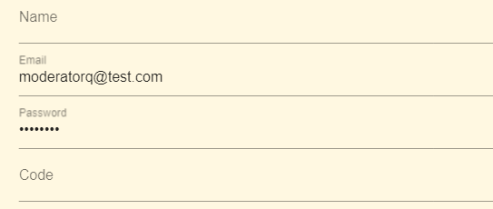

You will then be redirected to the login page.

## 2.3 Logging in

In order to login, first fill in the fields with your details.

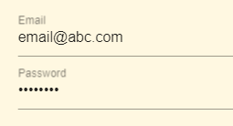

Once filled please press the login button.



Either you will be successfully signed in and automatically redirected to a new page, or a message will show detailing the problem (invalid credentials). The fields are all case sensitive.

## 2.4 Opening a chat

When chats are available they will be shown with their key and an icon.

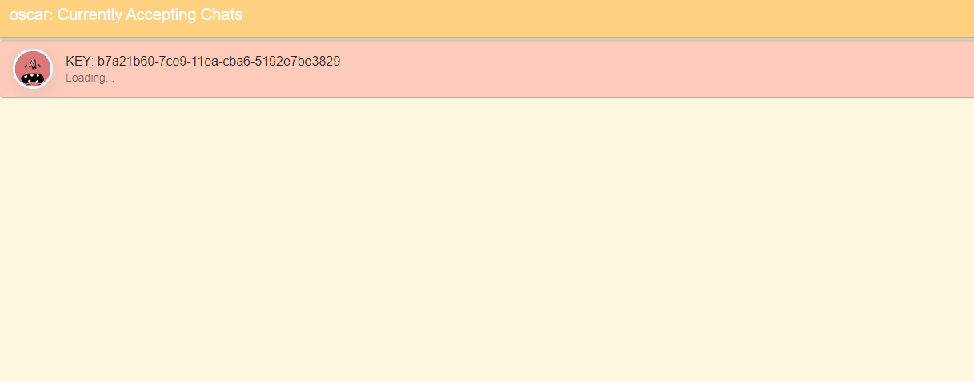

If no chats are open there will be none listed.

To open the chat simply click on the desired chat and you will be sent to a new page.

To exit the chat press the top right button and you will return to the screen before.



## 2.5 Exporting a chat

To export a chat simply press the download button in the top right corner.



___TODO____

## 2.6 Sending a message

Click on the field saying, ‘Enter message’. Type in your message and then send it by pressing the send button on the right-hand side. 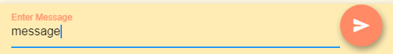

**2.7** **Closing a chat**

To close a chat, you will need to be on the screen listing all chats open. Then drag the desired chat to the left to reveal the close button, click this button.

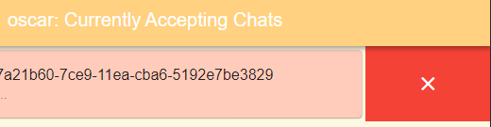

**IT IS IMPORTANT TO CLOSE ALL CHATS THAT ARE NOT NEEDED TO PREVENT SERVER OVERLOAD AND UNEXPECTED FEES**

**2.8** **Closing all chats**

Conveniently if you want to close all chats at the end of the day, you will find the option to do so in the menu. Open this by pressing the ‘PLUS’ button.



To Close the chat, press the close all chats button.

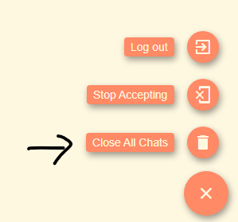

## 2.8 Logging out

To log out open the menu and press the log out button.

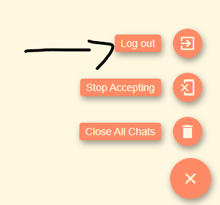

## 2.9 Rejecting chats

If you have many chats open, you might want to disallow any more to be created with yourself, do this by pressing the Stop accepting button.

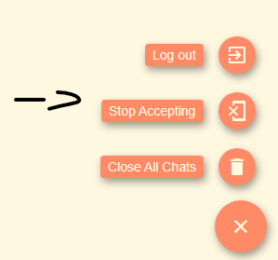

**3.0 USING AS A VICTIM**

# USING AS A VICTIM

## 3.1 Opening the application

To open the application as a victim, navigate to ____ in your web browser. Once the terms and conditions are agreed to, a connection to any available moderator will be automatically created.

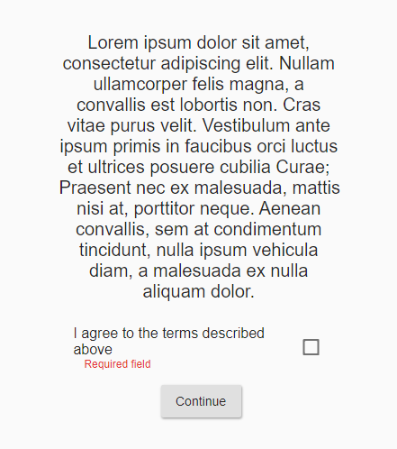 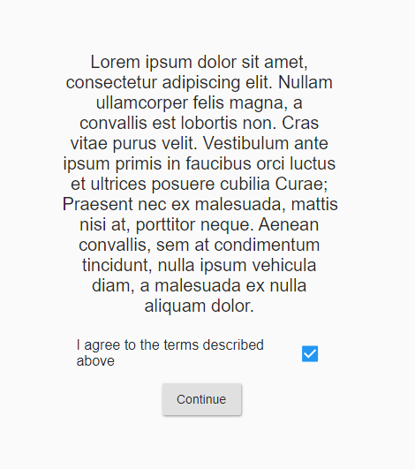 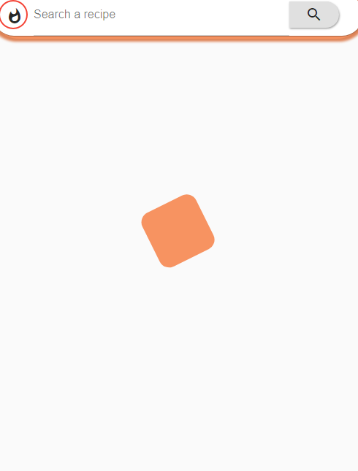

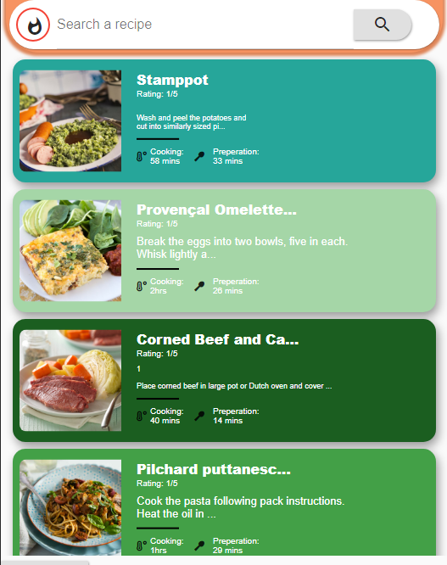

## 3.2 Sending a message

To send a message, press the ‘search a recipe’ button at the top, this field doesn’t search any recipes it only sends the contents of the field to the moderator.

To send the message press the search button and you will see a new ‘recipe’ appear.

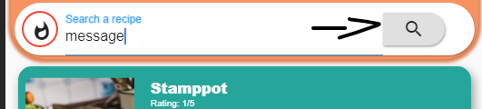

The new message is below, although it is disguised as a recipe for a Christmas pudding.



## 3.3 Toggling visibility of the messages

Messages can either be hidden or shown, this is changed by pressing the icon at the top left of the screen. It will either be highlighted in red, or black signifying its status.



Result

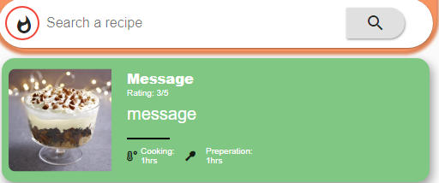

## 3.4 Opening a recipe

If you need to use the application normally, it will operate normally. To open a recipe simply tap on the card and you will be taken to a new screen with more information.

**If the message was too long to be seen in the preview, you can alternatively use this to view the message full screen**

