Setting
Some indeterminate time after a horrible apocalypse rendered most of the world hot and irradiated, civilizations cling to a few areas around the arctic ocean. The deep sea teems with hungry demons, and most trade or travel is performed with airships.
Locations beyond the arctic circle are sweltering, disease-ridden, and often irradiated. It’s rumored that pockets of survivors still live in some places of the world and some theorize that the south pole must be inhabited like the north.
However, no explorers have made it back to tell the tale, and even expeditions made to Iceland and the Scandinavian countries are fraught with risk.

World Locations (Lore)
Svalbard: The arctic archipelago where the story of the game takes place. As the permafrost thawed, the arctic shrublands transformed into a taiga spanning Meltwater and most of the Reach (central and south portions of Svalbard’s main island of Spitsbergen). Polar bears are rare, since they largely moved to Nordaustlandet when settlements expanded. The key settlements in Svalbard are Polaris (the capital), Svea, and Ny-Alesund.
(Iceland): Some airships have traveled here and come back with stories of boiling lava fields, humid jungles, and man-eating giants.
The Wasteland (Russia): Irradiated and inhospitable, overrun with undead creatures and demons. The source of the Blight resides somewhere here.
(Greenland):
(Nunavut, Canada, and Alaska):


Svalbard Geographic Regions
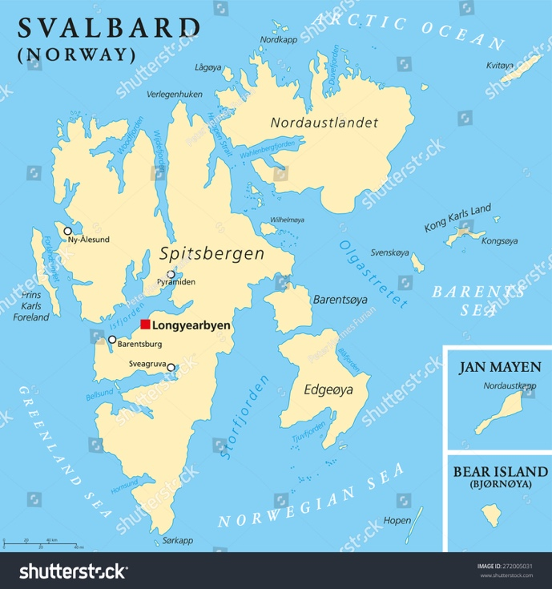
Bay of Kings (West Spitsbergen)
The Reach (Central Spitsbergen)
Meltwater (South Spitsbergen; Heer Land, Torell Land)
The Eastern Approach (Nordaustlandet):
(Barentsøya): Falls within the Sundered Lands, highly irradiated and dangerous.
Edge Island (Edgeøya): Rainy and wet. Falls partially within the Sundered Lands

Visitable Locations
- The Hand of Sorrow: A Syndicate slave ship carrying cargo from Edge Island to Ursa City.
- Ursa City (on Bear Island): City run by the Syndicate and controlled by two warring gangs. Located on Bear Island, to the south of Svalbard.
- Polaris (i.e. Longbearyen, in the Reach): The capital city of the Empire, located in the glacial highlands of Svalbard.
- Svea (in Meltwater): A city-state of the Empire, and the second largest city after Polaris, located in the largest meltwater river valley south of Polaris.
- (i.e. Barentsburg, ): A city-state of the Empire, west of Polaris.
- (i.e. Pyramiden, in the Reach): A city-state of the Empire, north of Polaris.
- (i.e. Ny-Alesund, in Fjordlands): A city-state of the Empire, far north-west of Polaris.
- Freehaven (): A recently built, walled settlement.
- The Barrows (): Deep in the Sundered Lands, this scientific-outpost-turned-stronghold is home to a cult of techno-ascendants.

Human Names

- Leif
- Astrid
- Soren
- Ingrid
- Njal

Syndicate
- Service Bot “SNDRI-51N” (mechanical): Medium health, melee, heal mechanical
- Survey Bot “CANIS-11K” (mechanical, agile): Low health, ranged
- Mining Droid “DVALN-49B” (mechanical, armored): High health, melee, charged stun attack
- Syndicate Slaver (biological): Melee health, melee, bleed attack, suppression talent

Companions
- Lyra (biological, melee, agile): Encountered fighting slavers onboard the Hand of Shadow. She owes Cassiopeia a life debt and acts as her bodyguard.
  - Joins the party: to rescue Cassiopeia on the Hand of Sorrow, then as a companion to Cassiopeia
  - Loyalty quest:
- Cassiopeia “Cass” (biological, ranged, psionic): Undercover Svean noble, running from an arranged marriage.
  - Joins the party: to escape the Hand of Sorrow, then to escape the besieged Ursa City
  - Loyalty quest:
- Soren Vex (biological, mechanical): A cyborg scavenger living in the slums of Ursa City with a vendetta against the Syndicate.
  - Joins the party:
  - Loyalty:
- Survey Bot “CANIS” (mechanical, agile): Purchased or won, this robot was originally intended to perform geologic surveys. Can be equipped with a variety of helpful modules.
  - Joins the party: Purchased or won in Ursa City
  - Loyalty quest: Find the geologist who Survey Bot was originally assigned to.

Blight
- Herald (psionic, blighted): A servant of the Blight- a destructive, apocalyptic cult. They carry a serum they use to infect victims with powerful psionics, turning the victims into Ghouls.
- Ghoul (biological, blighted): A person who has been infected by a Herald. Mindless, fast, and blind with rage.
- Armored Ghoul (biological, blighted): A Ghoul equipped with crude corrugated iron armor. Fast, but more durable than regular Ghouls.
Polaris
Act 1: Hand of Sorrow
- Cinematic: The traveler’s introduction
- Fight: Injured Syndicate Slaver
- Fight: Syndicate Automaton
Act 2: Ursa City
- Cinematic: Ursa City introduction

