Touchstones
- Frostpunk, Dougal Dixon’s After Man, and Fallout for the setting and tone. A better time is in the past. People struggle to survive in a world that has become inhospitable.
- Blades in the Dark: The cities of Svalbard are typically claustrophobic and the people in them trend towards distrust, crime, and corruption. The rough nature outside the cities is stark and beautiful, but dangerous and best viewed from a skyship, out of the reach of raiders, slavers, and hungry animals (or worse).
- Dragon Age Origins and Fallout New Vegas for the plot structure and world-map travel. A big horde of bad guys (Blight) is on its way to your world (Svalbard) and you must gain trust of disparate factions to ally together to stop the big bad in one big final battle.
- Sonny for gameplay: Three characters on the left, three on the right, take turns healing, buffing, attacking, etc. Equipment and XP are distributed from one central party inventory to characters outside of battle. Leveling up a character rewards upgrades to talents (“Sneak Attack”, “Crushing Blow”, etc.), abilities (STR, AGI, etc.), and skills (“melee”: melee bonus, “fortified”: health bonus, etc.).
- Dragon Age Origins, Fallout, Blades in the Dark, and Grimwild for the character structure, talent trees, and character classes/paths.

Setting
Two hundred years ago, the Cataclysm – a terrible, reality-bending, apocalyptic event – opened a rift around the equator and increased the temperature of the world significantly, plunging every civilization in the world into chaos. Refugees traveled to the far north, where cities built great barriers to keep out the terrifying creatures (demons) that entered through the rift.

People fled to colder regions as the weather warmed
Locations beyond the Arctic Circle became sweltering, disease-ridden, and irradiated. It’s rumored that pockets of survivors still live in some secluded places in the world and scholars theorize that the Antarctic continent on the south pole is a haven of human civilization.

The deep sea teems with hungry demon-spawn, trade and travel is managed with skyships
Across the sea in former Russia, the Blight (an army of undead following a Demon) has expanded its hold quickly. When the Blight besieges a city, it’s only a matter of time until the residents are turned into mindless, violent Ghouls and absorbed into the ever-growing army of undead soldiers.
A hundred years ago, the Blight was turned back when the nations of Nunavut (Canada) came to the aid of the Polar Empire, and the Demon leading the Ghoul horde was slain at the gates of Polaris. Since then, the Blight has stayed on the mainland though it's rumored that a new Demon has been gathering forces of darkness to march on Svalbard once again.
Since that time, the Polar Empire has become fractured and the Emperor's throne has lost much of the influence it once had. Relations with the Nunavut, once strong, have fallen into a
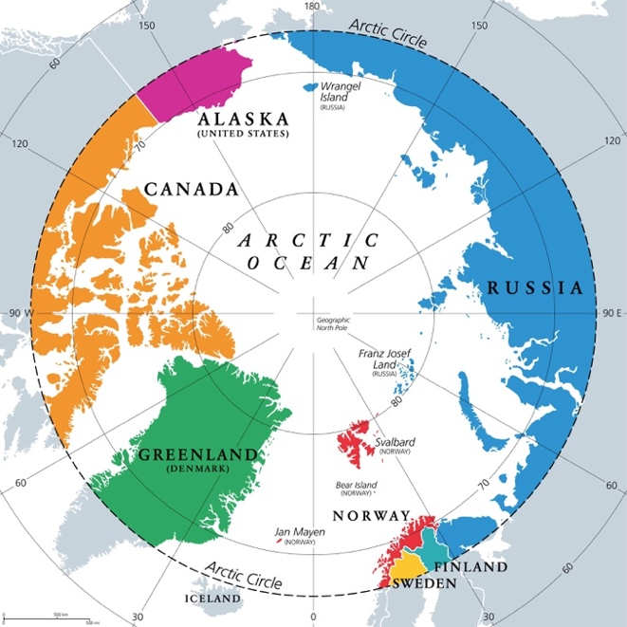
A map of the Arctic Circle (present day) will be worked into an artist’s conception of the post-apocalyptic game-world setting

The Wake (Magic System)
The Wake is an invisible trail shed by every living thing. For ages it was inaccessible, until the Cataclysm hundreds of years ago ruptured the barrier that sealed it away. Since then, some people can “attune” to the Wake, which can be described as plucking the strings of an incredibly complex, invisible instrument.
Attuning to the Wake allows for unnatural abilities like predicting the future, summoning elemental forces such as flame or ice, or influencing the weather.
Attuning, while powerful, is also unpredictable and often dangerous. Experienced Whispers spend time to prepare Totems, small artifacts that let them better control a specific interaction with the Wake. These artifacts must be replenished frequently as they deteriorate with use.
While a quality Totem is relatively reliable, hastily or crudely made ones may unleash unpredictable results or do nothing at all.

Locations
Svalbard: The arctic archipelago where the story of the game takes place. As the permafrost thawed, the arctic shrublands transformed into a taiga spanning Meltwater and most of the Reach (regions of Spitsbergen).
Polaris – Svea – Ny-Alesund – Bear Island – Barentsburg – Freehaven
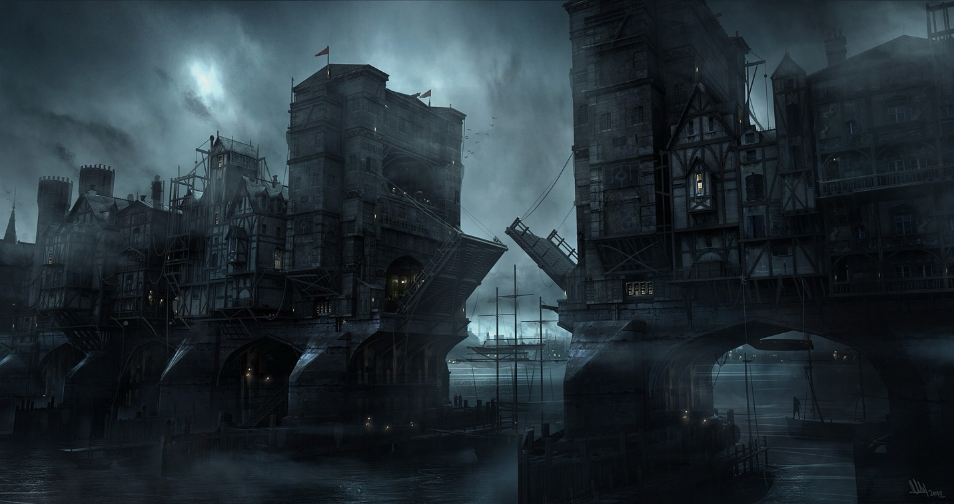
In ages past, the largest of Svalbard’s cities, Polaris, was known as Longbearyen.
Now, it’s the heavily fortified capital of the Polar Empire.
Mourning “The Cursed Expanse” (Russia): Irradiated and inhospitable, overrun with undead creatures and demons.
Murmansk
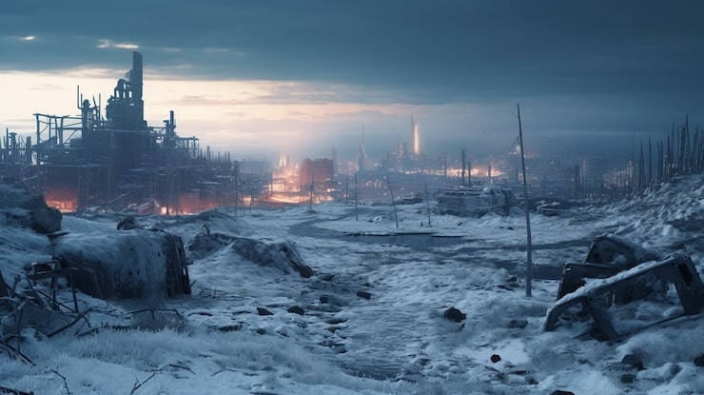
Murmansk was the last city to fall to the Blight – 25 years ago
Andaland “Land of Giants and Wolves” (Iceland): Some skyships have traveled here and come back with stories of boiling lava fields, humid jungles, and scaly, man-eating giants with glowing eyes.
Skalla
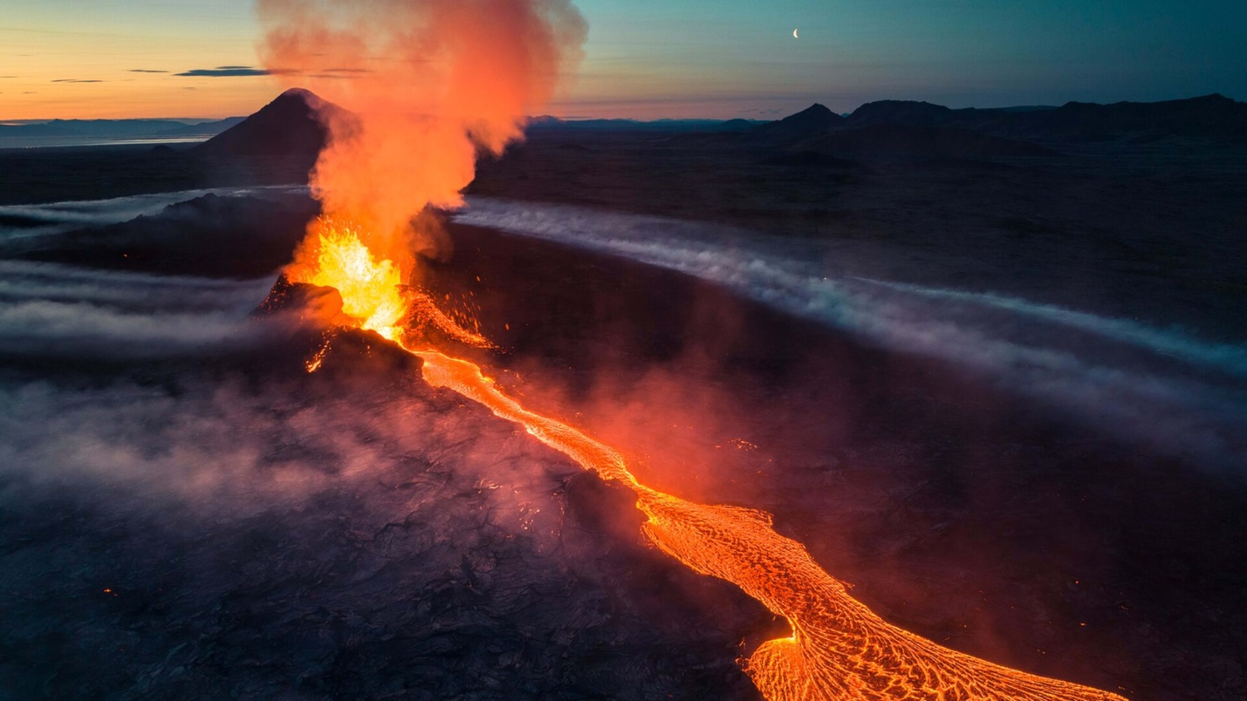
Eruptions are frequent and unpredictable, and the locals are hungry
Redwater Shore (Greenland): The ice sheet melted and revealed a massive, toxic lake. The lake mutates life around it over time: fauna here has grown much larger and more dangerous. As a result, the toxic shore around Redwater Lake is no place for long-term settlements.
Old Thule – Redwater Overlook
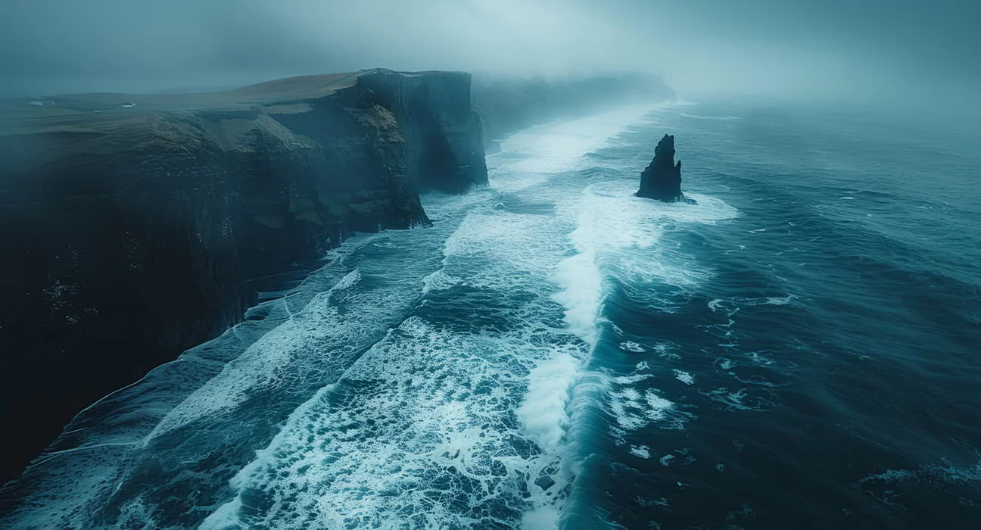
High cliffs form a bowl around the toxic Redwater Lake. An Iqaluit science post near the ruins of Old Thule is staffed mainly by repurposed automatons
Nunavut (Nunavut): The shallow-sea islands of former northern Canada face different challenges in the post-apocalypse. Travel generally happens by boat rather than by skyship (due to the shallow nature of the water connecting the islands, that has fewer dangers than the open Arctic ocean). Member states of the Coalition of Northern Cities practice free trade of goods and cultural heritage. Signal towers broadcast stories between nations on fixed cycles.
Iqaluit – Kivalliq – Qanirq – Tunniit
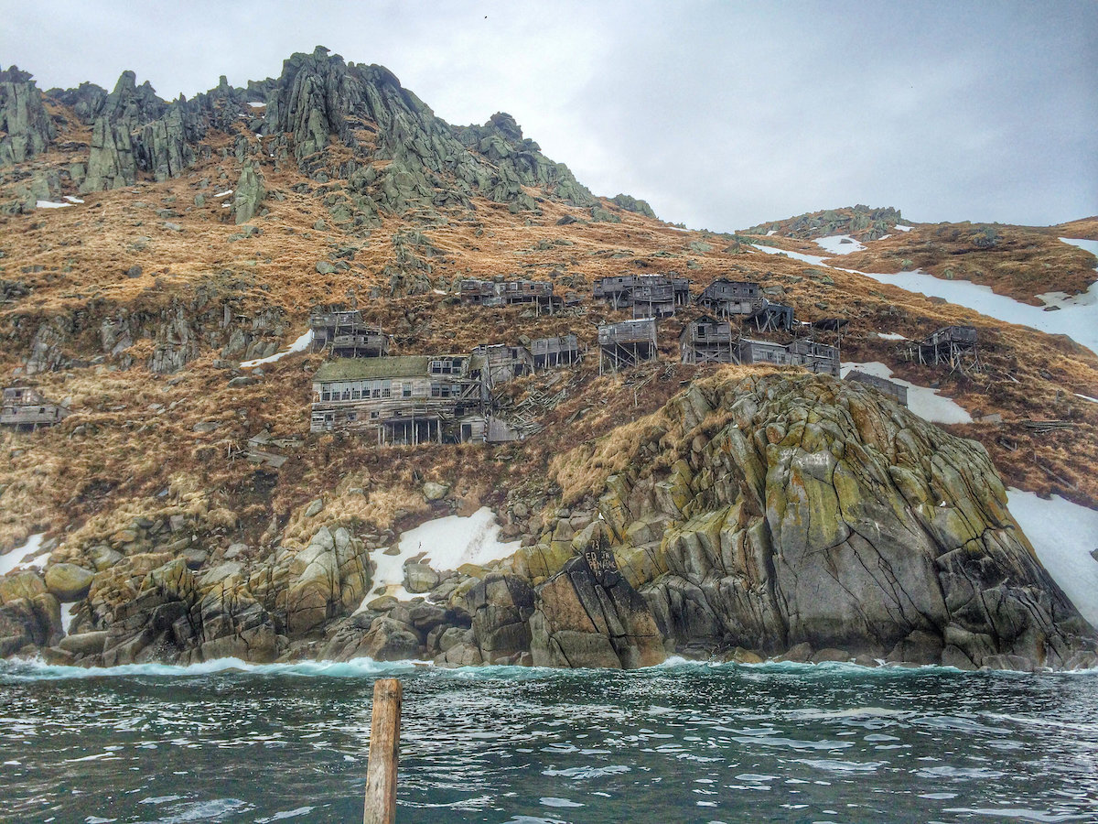
A border village in Qanirq built onto cliffs
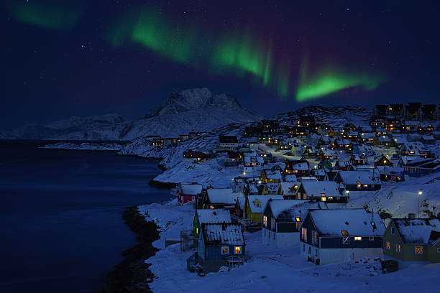
Tunniit – host of the annual Festival of Lights

Svalbard Geographic Regions
Bay of Kings (West Spitsbergen)
The Reach (Central Spitsbergen)
Meltwater (South Spitsbergen; Heer Land, Torell Land)
The Eastern Approach (Nordaustlandet): Heavily irradiated and extremely dangerous. This area is a frozen desert, with
(Barentsøya): Falls within the Sundered Lands, irradiated and dangerous.
Edge Island (Edgeøya): Rainy and wet. Partially within the Sundered Lands

Visitable Locations
- The Hand of Sorrow: A Syndicate slave ship carrying cargo from Edge Island to Ursa City.
- Ursa City (on Bear Island): City run by the Syndicate and controlled by two warring gangs. Located on Bear Island, to the south of Svalbard.
- Polaris (i.e. Longbearyen, in the Reach): The capital city of the Empire, located in the glacial highlands of Svalbard.
- Svea (in Meltwater): A city-state of the Empire, and the second largest city after Polaris, located in the largest meltwater river valley south of Polaris.
- (i.e. Barentsburg, ): A city-state of the Empire, west of Polaris.
- (i.e. Pyramiden, in the Reach): A city-state of the Empire, north of Polaris.
- (i.e. Ny-Alesund, in Fjordlands): A city-state of the Empire, far north-west of Polaris.
- Freehaven (): A recently built, walled settlement.
- The Barrows (): Deep in the Sundered Lands, this scientific-outpost-turned-stronghold is home to a cult of techno-ascendants.

Factions

Isolationists

Theocratic Zealots

Restorationist Empire
The Polar Empire: precarious since a young king has ascended now sits on the throne and his uncles try to leverage their relationships with him for power.

Radical Adaptationists
The Blight?

Decadent Slaver State
The Syndicate, Bear Island:

Lawless Freehold

Lore Timeline (In-Progress, Not player-facing)
The Cataclysm: ~2100s
- A rift to another dimension opens along the equator, all the way around the planet. It heats the world significantly, causing adverse effects to plant and animal life
- Demons come through the rift, spilling into the seas and onto land
- People flee to “safe zones” in the arctic
- Greenland’s icesheet melts, and the whole island becomes inhospitable
- Polar Empire is formed from cities in Svalbard, Norway, and Iceland
A Hundred Years Ago: ~2200s
- The Blight attacks Svalbard but is turned back with help from Nunavut
- A powerful artifact is moved to a secret vault
- The Syndicate is formed
- Seismic activity in Iceland awakens Jotunn (giants), who violently take over the island. Wars are waged against them, but ultimately the island is evacuated
- The Blight is not seen outside of Russia again
Present Day: ~2300s
- Syndicate grows powerful: runs illicit drugs, human trafficking, and protection rackets in all cities of the Polar Empire
- The walled city of Murmansk falls to the Blight
- The Emperor dies suddenly, leaving no apparent heirs to the Polar Throne. The Polar Houses squabble about who should take the lead and things begin to look tense
- Ursa City begins secret mining operations, seeking something deep under Bear Island. They’re hiring a lot of mercenaries and buying slaves from the Syndicate

Companions
- Lyra (biological, melee, agile): Encountered fighting slavers onboard the Hand of Shadow. She owes Cassiopeia a life debt and acts as her bodyguard.
  - Joins the party: to rescue Cassiopeia on the Hand of Sorrow, then as a companion to Cassiopeia
  - Loyalty quest:
- Cassiopeia “Cass” (biological, ranged, psionic): Undercover Svean noble, running from an arranged marriage.
  - Joins the party: to escape the Hand of Sorrow, then to escape the besieged Ursa City
  - Loyalty quest:
- Soren Vex (biological, mechanical): A cyborg scavenger living in the slums of Ursa City with a vendetta against the Syndicate.
  - Joins the party:
  - Loyalty:
- Survey Bot “CANIS” (mechanical, agile): Purchased or won, this robot was originally intended to perform geologic surveys. Can be equipped with a variety of helpful modules.
  - Joins the party: Purchased or won in Ursa City
  - Loyalty quest: Find the geologist who Survey Bot was originally assigned to.

Syndicate
- Service Bot “SNDRI-51N” (mechanical): Medium health, melee, heal mechanical
- Survey Bot “CANIS-11K” (mechanical, agile): Low health, ranged
- Mining Droid “DVALN-49B” (mechanical, armored): High health, melee, charged stun attack
- Syndicate Slaver (biological): Medium health, melee, bleed attack, suppression
- Syndicate Enforcer (biological, armored): High health, melee, ranged, reinforcements, buff ally
- Syndicate Captain (biological, psionic): High health, melee, ranged, reinforcements, freeze, extra turn
- Mining Husk (biological, mechanical): Medium health, melee, berserk, heal self

Blight
- Ghoul (biological, blighted): A person who has been infected by a Herald. Mindless, fast, and blind with rage.
- Armored Ghoul (biological, blighted): A Ghoul equipped with crude corrugated iron armor. Fast, but more durable than regular Ghouls.
- Centurion (demonic, blighted): A demon commander of the Blight who controls a group of Ghouls. Can turn humans into Ghouls.
- Demon Lord (demonic, psionic, blighted): Supreme leader of the Blight conquest.

