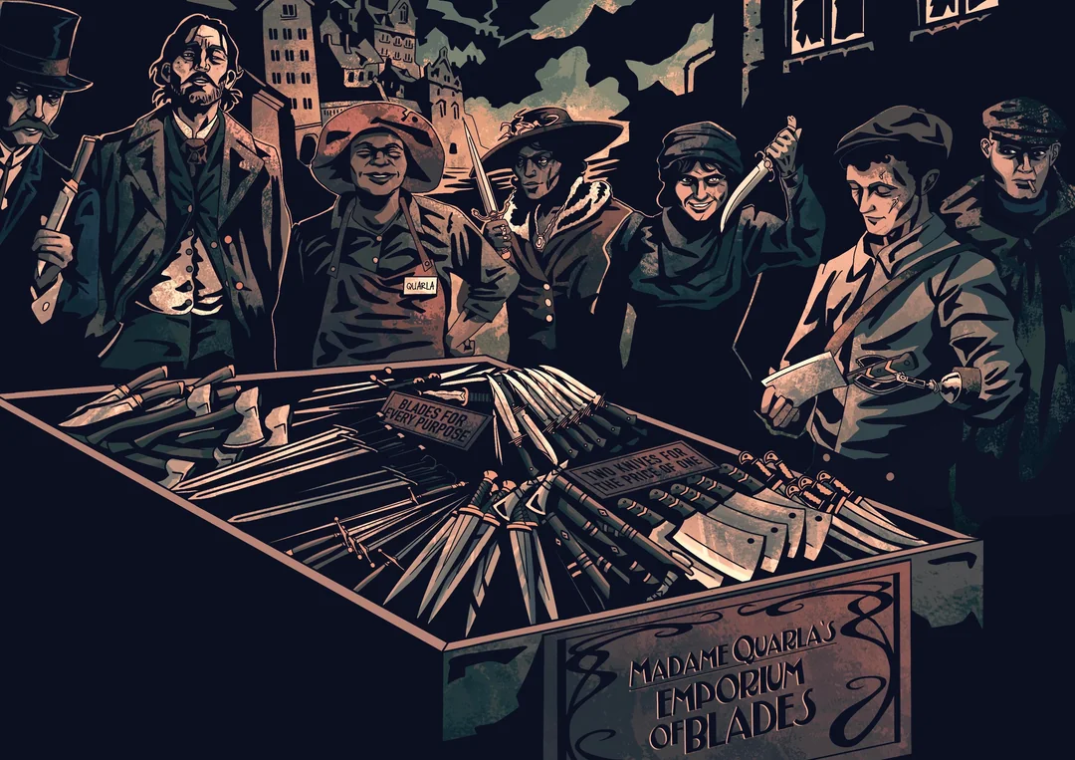 





On A Knife’s Edge



**Text  
Olin Kirkland**

**Art**[u/perryphery](https://www.reddit.com/user/perryphery/submitted/)

This work is based on Blades in the Dark (found at <http://www.bladesinthedark.com/>), product of One Seven Design, developed and authored by John Harper,  
and licensed for our use under the Creative Commons Attribution 3.0 Unported license (<http://creativecommons.org/licenses/by/3.0/>).

Each step of the wooden staircase creaks as you ascend to the upper level of the **Dimmer Mansion**. **Sister Roslyn** (servant, patient, arcane) ushers you down a hallway to a musty, windowless room where she unrolls a blueprint over a stone table. She gazes serenely out from under her hood.

“As you know, **Madame Quarla** runs a lucrative blade-smithing business within the city. Bluecoats, Billhooks, Revolutionaries, Grinders, and even the Imperial Military have contracts with her to forge the means to their violence. The Dimmer Sisters have no mercantile interest in the Duskvol knife trade. What we want is much more specific.”

Roslyn passes you a scrap of cloth with a sketch: A long, cruel-looking black dagger.

“We cannot enter the premises of Madame Quarla’s establishment ourselves, so we are tasking you with retrieving this item. You’ll be compensated double if you avoid detection.”

|  |
| --- |
| Approach & Obstacles |
| **Approach:** Quarla’s Shop stands at the edge of Nightmarket—a squat brick building squeezed between a tailor shop and a brightly lit tavern. The street is usually busy with merchants and common-folk. At night, this part of Nightmarket is given special attention by Bluecoat patrols.   |  |  |  | | --- | --- | --- | | **Stockroom:** Behind heavy doors, shelves strain under the weight of ingots, rolled parchment, and spare tools.  ❖ **Sheila** fetches supplies or seeks a quiet respite  ❖ Unsorted parcels | **Quarla’s Workshop:** A worn anvil draws the eye to the center of the room.  ❖ Drawings of knives and swords hang from the walls  ❖ Tables cluttered with tools  ❖ The **forge** glows eerily | **Private Rooms:** Curtains on the upper floor conceal goings-on from the street outside.  ❖ Elegant four-poster beds  ❖ **Lampblacks** wait expectantly to make a deal  ❖ A safe contains the dagger |   *“And for your own sake: whatever you do, don’t use the knife.”* |

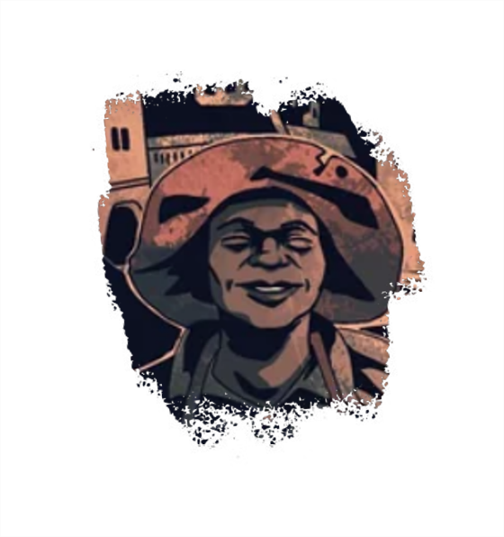 **Madame Quarla** is a squat woman with a wide grin, easily recognized by her wide-brimmed hat. While she’s eager to haggle a price, she has little patience for people with no intention to buy her wares. *(friendly, artisan)*

**Jamie Finch** manages Quarla’s security. He keeps a wary eye on rowdy customers and thieves alike. Rumor has it he owes Quarla for getting him out of a tough spot. *(bodyguard, loyal, tough)*

**Sheila & Brenda** have run the front of house for years. Recently, Brenda has gotten into some gambling debts that her sister doesn’t know about. *(stressed, impatient, argumentative)*

|  |
| --- |
| ****Rumors**** |
| |  |  |  | | --- | --- | --- | | **Ghostly Lover.** The shop is haunted by the Spirit of a suitor who died protecting Quarla.  ****1**** | **Safe at Last.** Within the shop’s safe is a secret portal that leads directly into the Ghost Field.  ****2**** | **That’s not a Knife.** Quarla didn’t forge the dagger herself—she found it on an expedition to the Deathlands.  ****3**** |   **Rumors run thick in the streets of Duskvol. These ones may or may not be true.** |

|  |
| --- |
| Scenes & Complications |
| |  |  | | --- | --- | | *Brenda sidles up to you. “You carry yourself like someone who appreciates a sharp blade. Care to browse our selection?”*  ❖ She sells you a **fine blade** (1 load)  ❖ Brenda will remember your face  ❖ She calls Jamie Finch to pat you down at the door. *“Just a precaution,”* she explains | *As you rifle through the items in the stockroom, Sheila enters, holding a tray of tea and looking agitated. “What are you doing here?” she asks.*  ❖ Sheila isn’t convinced by your argument  ❖ She reaches for a switch to trigger an alarm  ❖ Glancing around in panic, she pitches her scalding hot tea at you | | *Upon entering the workshop, the doors click behind you as Quarla’s forge glows blue and a wispy* ***Ghost*** *emerges from the hearth.*  ❖ The Ghost steals an item (1 load) from you  ❖ It paws through your memories, leaving you with an empty, haunted feeling  ❖ The entity becomes hostile to you (  4 )* | *Behind a wall-length curtain in Quarla’s bedroom is a massive, steel safe door—locked.*  ❖ Opening the safe makes noise, attracting the attention of Jamie Finch downstairs  ❖ You trip a silent alarm, and the room begins to fill with **Sleeping Sand**  ❖ The tools you’re using to open the safe break | | *Within the safe is an impossibly long corridor, at the end of which the dagger you seek lies on a short, marble pedestal. The edges of the corridor wave and blur like air on a hot day.*  ❖ As you proceed down the corridor, it twists and slides like a rope, throwing you off balance  ❖ Cruel voices whisper to you from the shadows | *Jamie Finch stops you as you move to leave. “I had a bad feeling I recognized your face,” he says, holding up a* ***wanted poster****.*  ❖ Jamie fires a shell from his shotgun at you  ❖ He lands a blow with the butt of his gun  ❖ He hurls a smoke grenade at your feet, impairing your vision with acrid fumes | |

* Start a progress clock  with four segments. For more information on clocks, check p. 15 of the Core Rulebook

In the foyer of the Dimmer Sister mansion, Roslyn turns the dagger over in her hands. Behind her, you can make out several other Dimmer Sisters standing around an empty, detached doorframe that stands in the center of the room. A pouch of coins lands heavily in your hands. Her tone is almost eager as she addresses you.

“It’s been a pleasure working together. You can show yourself out.”

She turns away from you and begins to walk towards her sisters.