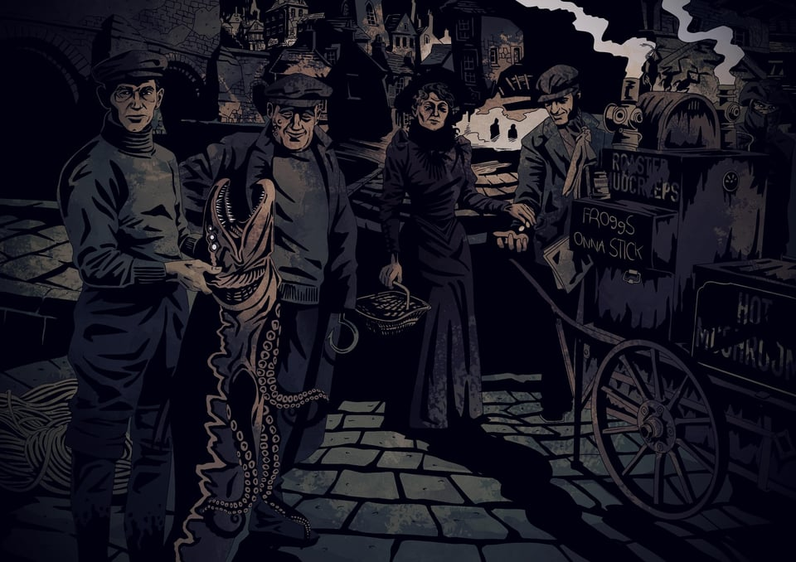



On A Kni fe’s Edge



**Text  
Lorem Ipsum**

**Art   
Lorem Ipsum**

**Lorem Ipsum**

|  |  |  |
| --- | --- | --- |
| Lorem ipsun staff fermen tum pos buere a gared?  ****1**** | Lorem ipsun staff fermen tum pos buere a gared?  ****2**** | Lorem ipsun staff fermen tum pos buere a gared?  ****3**** |

Each step of the wooden staircase creaks as you ascend to the upper level of the **Dimmer Mansion**. **Sister Roslyn** (servant, patient, arcane) ushers you down a narrow hallway to a musty, windowless room where she unrolls a tattered blueprint over a stone table. She gazes out serenely from under her hood.

“The Dimmer Sisters have no mercantile interest in the Duskvol knife trade. As you know, **Madame Quarla** runs a lucrative blade-smithing business within the city. Bluecoats, Billhooks, Revolutionaries, Grinders, and even the Imperial Military have contracts with her to supply the endless

Est placerat in egestas erat imperdiet sed. Nibh praesent tristique magna sit amet purus gravida quis blandit. Cras ornare arcu dui vivamus arcu felis bibendum ut tristique. Pellentesque eu tincidunt tortor aliquam. Felis bibendum ut tristique et egestas quis.

|  |
| --- |
| Approach & Obstacles |
| **Lorem Ispum:** Ut sem viverra aliquet eget sit amet. Urna id volutpat lacus laoreet non curabitur gravida. Est lorem ipsum dolor sit amet consectetur adipiscing.   |  |  |  | | --- | --- | --- | | **Turpis:** Urna condimentum mattis pellentesque id nibh tortor.  ❖ Lorem ipsun staff  ❖ Fermentum posuere  ❖ Dolor sit amet | **Turpis:** Urna condimentum mattis pellentesque id nibh tortor.  ❖ Lorem ipsun staff  ❖ Fermentum posuere  ❖ Dolor sit amet | **Turpis:** Urna condimentum mattis pellentesque id nibh tortor.  ❖ Lorem ipsun staff  ❖ Fermentum posuere  ❖ Dolor sit amet |   Bibendum enim facilisis gravida neque convallis a. Rhoncus aenean vel elit scelerisque mauris pellentesque pulvinar pellentesque. |

|  |
| --- |
| Scenes & Complications |
| |  |  | | --- | --- | | *Tristique et egestas quis ipsum* ***suspendisse*** *ultrices. Elementum nisi quis.*  ❖ Habitant morbi tristique senectus et netus  ❖ Eget velit aliquet sagittis id consectetur purus ut faucibus pulvinar  ❖ Platea dictumst vestibulum rhoncus | *Tristique et egestas quis ipsum* ***suspendisse*** *ultrices. Elementum nisi quis.*  ❖ Habitant morbi tristique senectus et netus  ❖ Eget velit aliquet sagittis id consectetur purus ut faucibus pulvinar  ❖ Platea dictumst vestibulum rhoncus | | *Tristique et egestas quis ipsum* ***suspendisse*** *ultrices. Elementum nisi quis.*  ❖ Habitant morbi tristique senectus et netus  ❖ Eget velit aliquet sagittis id consectetur purus ut faucibus pulvinar  ❖ Platea dictumst vestibulum rhoncus | *Tristique et egestas quis ipsum* ***suspendisse*** *ultrices. Elementum nisi quis.*  ❖ Habitant morbi tristique senectus et netus  ❖ Eget velit aliquet sagittis id consectetur purus ut faucibus pulvinar  ❖ Platea dictumst vestibulum rhoncus | |

**Lord Rowan** *(perceptive, shrewd) is a shrewd businessman.*

|  |
| --- |
| Word Bank |
| **Items:** item — item — item — item — item — item — item — item — item — item — item — item item — item — item — item — item — item — item — item — item — item — item — item — item |

|  |
| --- |
| ****Place Name**** |
| *Lorem ipsum dolor sit amet, consectetur adipiscing elit, sed do eiusmod tempor incididunt ut labore et dolore magna aliqua. In fermentum et sollicitudin ac orci. Convallis a cras semper auctor neque vitae tempus quam. Non nisi est sit amet. Tincidunt ornare massa eget egestas purus. Neque gravida in fermentum et sollicitudin ac orci phasellus.*  **Landmarks**   |  |  | | --- | --- | | **The Rowdy Rockfish.** In fermentum et sollicitudin ac orci. Convallis a cras semper auctor neque vitae tempus quam. Non nisi est sit amet. Tincidunt ornare massa eget.  ****1**** | **Wrin’s Wonders.** In fermentum et sollicitudin ac orci. Convallis a cras semper auctor neque vitae tempus quam. Non nisi est sit amet. Tincidunt ornare massa eget.  ****2**** | | **Tamily’s Fishery.** In fermentum et sollicitudin ac orci. Convallis a cras semper auctor neque vitae tempus quam. Non nisi est sit amet. Tincidunt ornare massa eget.  ****3**** | **Menhemes Manor.** In fermentum et sollicitudin ac orci. Convallis a cras semper auctor neque vitae tempus quam. Non nisi est sit amet. Tincidunt ornare massa eget.  ****4**** | |

|  |
| --- |
| ****Notable Inhabitants**** |
| |  |  |  | | --- | --- | --- | | **Jira.** Lorem ipsum dolor sit amet, consectetur adipiscing elit, sed do eiusmod tempor incididunt ut labore et dolore magna aliqua.  *(Bold, Tough)* | **Jira.** Lorem ipsum dolor sit amet, consectetur adipiscing elit, sed do eiusmod tempor incididunt ut labore et dolore magna aliqua.  *(Bold, Tough)* | **Jira.** Lorem ipsum dolor sit amet, consectetur adipiscing elit, sed do eiusmod tempor incididunt ut labore et dolore magna aliqua.  *(Bold, Tough)* | |

**Scene:** Lorem ipsum dolor sit amet, consectetur adipiscing elit, sed do eiusmod tempor incididunt ut labore et dolore magna aliqua.

**Streets:** Lorem ipsum dolor sit amet, consectetur adipiscing elit, sed do eiusmod tempor incididunt ut labore et dolore magna aliqua.

**Buildings:** Lorem ipsum dolor sit amet, consectetur adipiscing elit, sed do eiusmod tempor incididunt ut labore et dolore magna aliqua.

|  |
| --- |
| ****Traits**** |
| |  |  |  |  |  |  |  |  |  |  | | --- | --- | --- | --- | --- | --- | --- | --- | --- | --- | | |  |  | | --- | --- | | Wealth | ●●●● | | Safety | ●●●● | | Crime | ●●●● | | Occult | ●●●● | | Houston is the best place to make contact with whale-oil smugglers, but the darker corners are full of strange horrors.  You can take +**1🎲** to acquire an asset related to whale-oil here, at the cost of **2 stress**. | |